NADI Forest

The earth is shifting. In the presence of vanishing forests, decline in natural resources and unprecedented extinction of wild life, A new shift in thought need to occur; where structure and biology are forming together, reading each other and manifesting growth. Could humanity apply the same principles that led us to a mass growth in technology to create a new type of forest?

The Masdar’s NADI Forest is a new landscape typology that is not bound to human influence it is simply autonomous. An unpredictable mechanism that read the expectancy of a tree growth, a structure that does not mimic architectural forms; a malleable material technology that reads, enhance, and sustains a forest in the harshest environment.

Generations to come will experience this space differently it will grow in response to the given environment and will inspire people with its ever -dynamic form and its persistence.
NADI is named after Arabic word Ghataratal Nadi “which means dew.
Masdar City is a unique opportunity to explore this design, the harsh environment and a unique desert culture that are ideal grounds to stretch the limitation of technology and produce something that is still within the realm of dreams – a forest in the desert. On the shores of a warm sea in the heat and dry wind of the desert a new forest is arising – how would it feel?

How do we do it?

Smart Structure:
The key is to create technology that can co-existence with vegetation by incorporating a sensor that dynamically aids / protects trees to help them mature over time, by providing vital shade and moisture through imaging and real time data collection. We believe we can recreate a rainforest through this innovative piece of infrastructure that will show case / (demonstrate to) the world a new way of architectural form generation that works with nature and its people who inhabit within. 80 Number of stainless-steel posts 200mm in diameter which will be able to extend from 15 meters to 25 meters.

Extendable dynamic arms
The 200mm diameter stainless steel tree shape extendable post will contain four extendable branches on top that hold geometric designed networks of flexible solar panels. The branches will have a scissor like action that will have its independent locomotion that can integrate lifting and propulsion from a single power source, be it electric or solar/battery. It will be simple in maintenance and aesthetically ties in with the mesh photo-cell system above.

Flexible Solar cells:
Flexible solar panels act as a mesh that provides essential shade for plants and trees to survive under the heat. The mesh will extend gradually as it senses the plant maturity over time and gives more sun light to match their growing need. This means the height of posts will also reflect the growth of the trees under.

Planting:
NADI Forest could reduce the temperature by up to 10°C in some areas. "Eucalyptus grandis and palm species that are heat-tolerant, and mixed with exotic tropical plantation, that will be able to survive thanks to the dynamic shade structure above”. The tree cover would also bring more rain--about 700 to 1200 millimeters per year--and the photocell fabric helps reflect the sun's rays back into space. Maintenance will remain a key to the long term success but with all new technologies and careful planning we can make the first forest under solar panel shades possible.

Water mist system:
Designed to spray water on plants and people. The water will be harvested from fog (using the opportunity of location) and will be able to work with real-time fog detection and monitoring tool which Masdar Institute scientist are working on it.

Merging tree growth with renewable energy:
We want trees and we want renewable energy and any other step we take to merge the design and planning of these two important sources together that will bring a high value to the future of our cities. By locating NADI Forest in the innovation centre of sustainability of the world in MASDAR CITY, the city will aim show the whole world that we need to use our technologies to make the impossible happen.

Materiality:

Project fund is less than $20 per Watt
NEDI Forest is using an innovative Ancient Islamic art that has inspired this expandable Lightweight flexible solar photovoltaic (PV) modules using Auxetic effect.

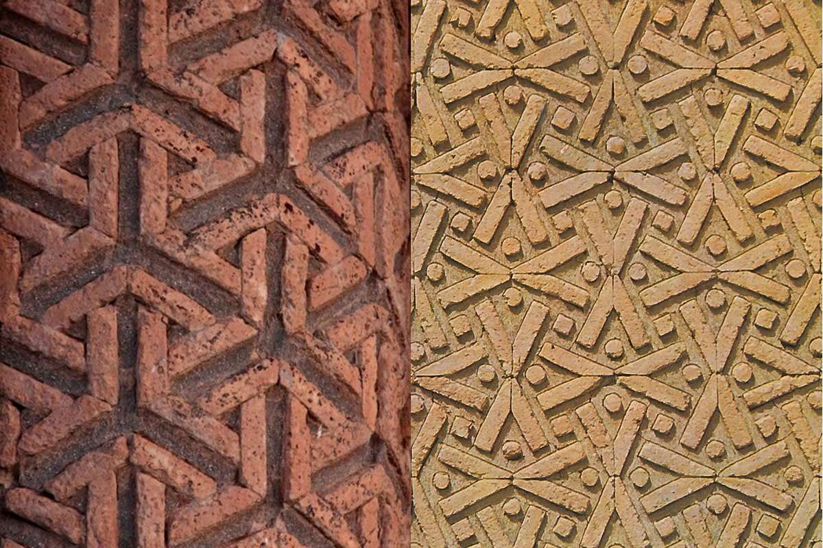
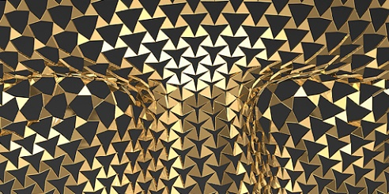

Islamic art is easily recognizable for its complex geometric designs. Now a team of Canadian researchers have found a way to use these patterns to create a material that expands when stretched without thinning out
Auxetics are structures or materials that have a negative Poisson's ratio. When stretched, they become thicker at the perpendicular to the applied force.

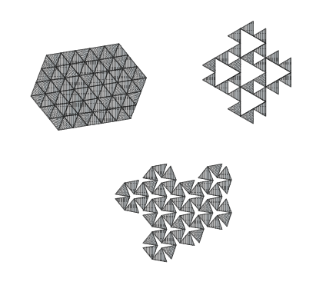

McGill University in Montreal, Canada, set out to create a material that would grow when stretched, yet keep its form. So, we will have the same number of solar panels and solar energy harvesting with different patterns and light allowance.

This occurs due to their particular internal structure and the way this deforms when the sample is uniaxially loaded.

Then, key structural characteristics of protection pads were evaluated through static analyses of FEA models. Finally, impact analyses were conducted through dynamic simulations of FEA models to validate the results obtained from the static analyses. Efforts were also made to relate the individual and/or combined effect of auxetic structures and materials to the overall stiffness and shock-absorption performance of the protection pads. An advanced additive manufacturing (3D printing) technique was used to build prototypes of the auxetic structures.

Further, it will offer potential to control the shape and height for the tree covering under this auxetic effect and it will expand and contract with growth of the trees without tearing and prevent leakage. Hence, it could be beneficial for the trees to improve quality of light when they are in their mature size and need more sunlight.

Renewable energy:

Overall: 3240MWh
Solar renewable energy: 2940 MWh

A dye-sensitized solar cell (DSSC, DSC, DYSC or Grätzel cell) is a low-cost solar cell belonging to the group of thin film solar cells. It is based on a semiconductor formed between a photo-sensitized anode and an electrolyte, a photoelectrochemical system.

Microbial fuel cells: Photosynthesis energy from plants (this energy generation method is inspired by 2018 LAGI 1st winner submission “LIGHT UP”): 300MWh

Plant-e develops products in which living plants generate electricity. To make this possible, Plant Microbial Fuel Cell (P-MFC) technology is used. This technology was developed at Wageningen University and was patented in 2007.

Impact on environment

Biophilic design and its benefits on the wellbeing of people and wants to improve human and nature relationship.
Biodiversity having this unique atmosphere in a city will be an inviting environment for animals and plants.
By drawing on the timeless importance of Trees and solar panels as a design element, NEDI Forest seeks to make the urban landscape productive while fulfilling its role as both art and green energy generator. It will provide multiple opportunities for future uses such as tree top walk (imagine this in Masdar City)
It will be stabilising a unique destination to millions of tourists who will see this WONDER of the modern world and will inspire the world.

