Hydrophyll
A desalination plant that uses solar energy to convert brackish water to potable water using gravity.
Introduction
Masdar city is seen as a model for a sustainable urban community of the 21st century. It is also home to the Masdar institute of Science and Technology which focuses on developing technology to harvest renewable energy. However, consumption levels in the UAE are very high. Per capita residential water consumption in the UAE is 3.5 times the world average. Power plants are usually located in the outskirts away from our vicinity as they are usually hazardous zones that are not suitable for living. This also makes it convenient for us to forget our impact on the environment. By bringing it into our living quarters in the form of a public space, we can be more aware and conscious of our consumption levels and also produce clean energy that would ensure well-being for everyone.
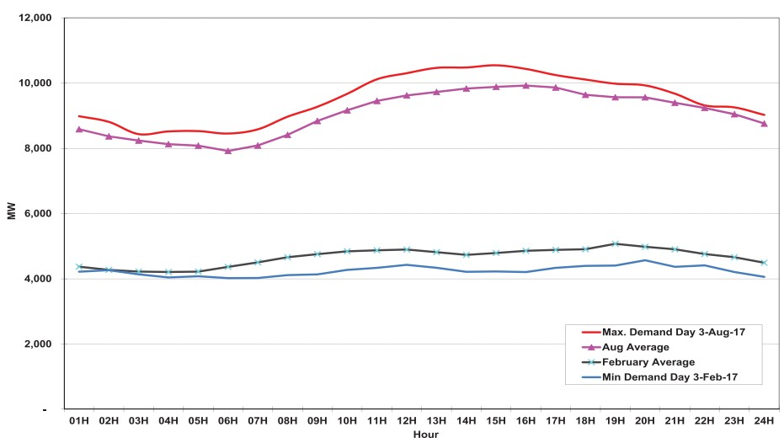
Figure 1: Abu Dhabi 2017 Maximum Month & Minimum Month Demand Profiles (Source: ADWEC’s Statistical Report 2017)
Fully built cities like Dubai, face a demand imbalance in power supply at its peak hours. The high temperatures in summer increases the load drastically (Figure 1). Almost 70% of the electricity produced is consumed by air conditioners. Thermal plants designed to cater for the summer, would function at half the capacity during winter. It is very clear that when one speaks of renewable energy, solar is the most efficient option for the middle-east. Currently, electricity is majorly produced through non renewable means such as burning fossil fuels. In the middle east, water and electricity are closely linked. 99% of the water used in the UAE is desalinated using 30% of the electricity produced. Two thirds of the water is desalinated using fossil fuel based thermal desalination. Only 1% of water is desalinated using renewable energy (Figure 2).
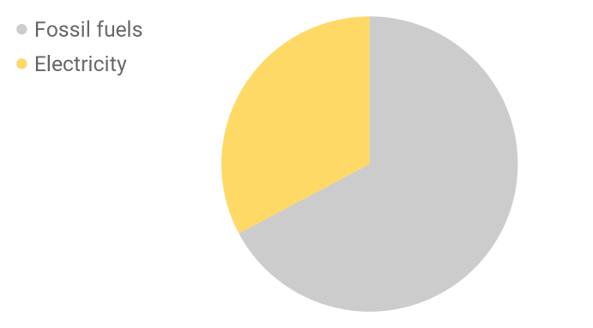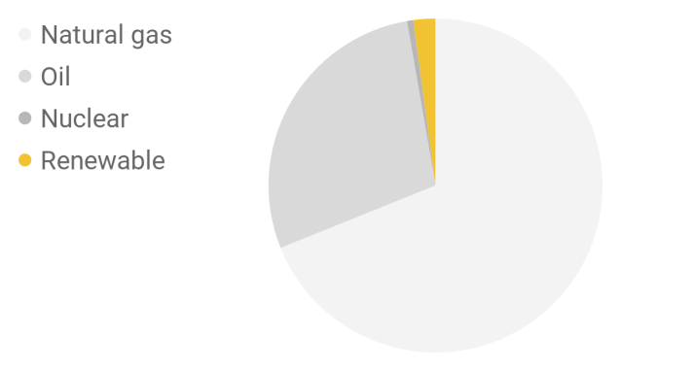
Figure 2: Overall energy used for desalination in the UAE (left), further distribution of energy source for electricity (Source: IEA)
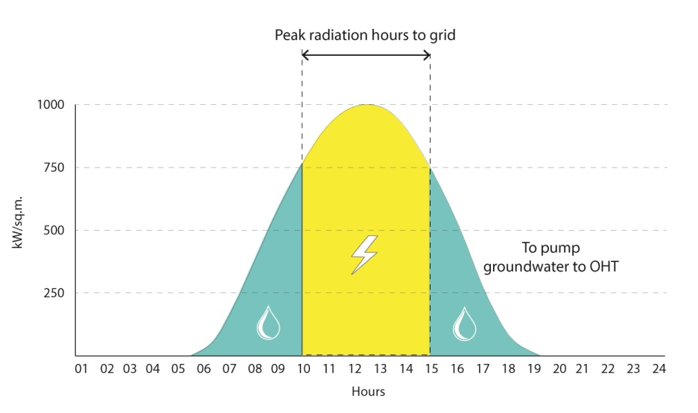
We believe that the solution to water and electricity for Masdar city is a decentralized co-generation plant. It’s operational flexibility allows it to be used as a demand response facility. During peak hours, it should cater to the electricity demand and at other times function as a desalination plant. Solar powered desalination plant has been tested by the Masdar institute and are found to be the most efficient way to go green [1]. The Hydrophyll aims to weave this co-generation plant into the urban fabric to decentralize the distribution of water and electricity, thereby saving on transmission loss as well. Going a step further, the Hydrophyll is a sculpture that houses a solar powered reverse osmosis plant that uses gravity rather than electricity. Decentralizing makes it possible to store water in tanks, as a form of energy.
Figure 3: Solar radiation in UAE (kW/sq.m) throughout the day on August 3 and the peak hour production is fed to grid and used to pump groundwater to OHT during other times (Source: Ladybug-Grasshopper)
Design:
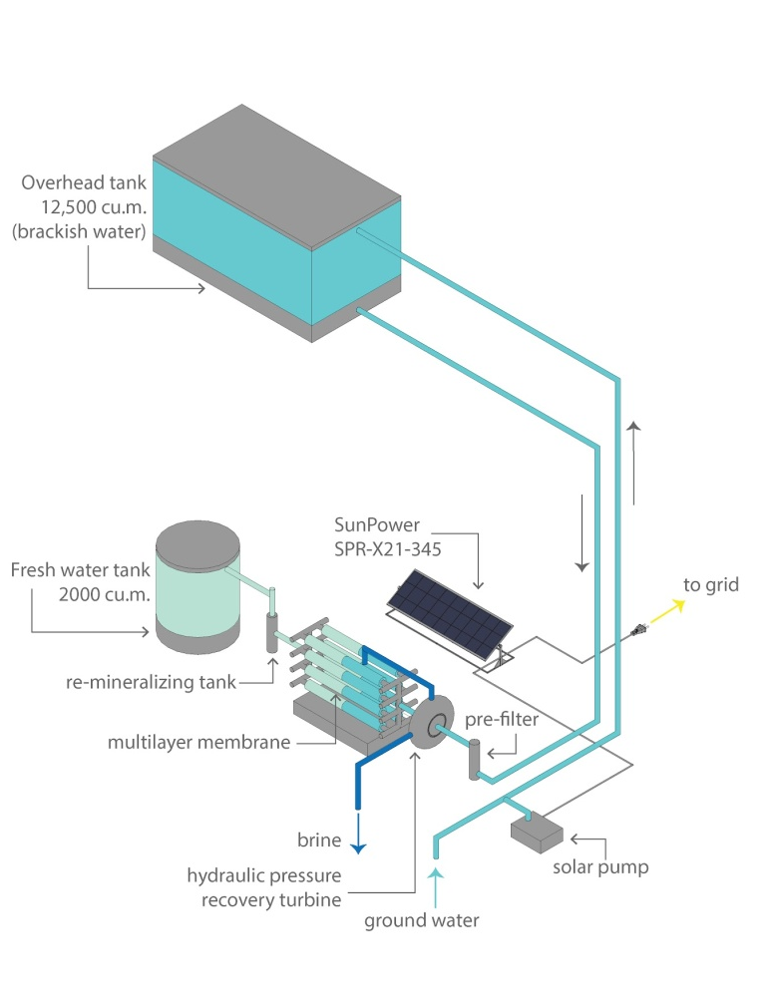
The co-generation plant blends together multiple functions- water and electricity generation as well as a leisure space for the residents of Masdar city. The form creates a canopy over the street keeping in mind, the solar right of the users of the adjoining buildings and partially shading the park beneath from the direct sun. The canopy serves two functions - water storage and houses the solar panels. With a capacity of 12,500 cu.m., the water tank is placed at a height of 40 metres, which is the minimum height required to desalinate brackish water using gravity. Figure 3 illustrates the components of the RO plant and the desalination process itself [2]. The top surface of the water tank is embedded with solar panels for an area of 16840 sq.m. to produce the electricity required to run the desalination plant throughout the day. SunPower SPR-X21-345 residential panels convert more sunlight to electricity by producing 38% more power per panel and 70% more energy per square foot over 25 years [3]. The columns act as channels for the water to flow and meet the membrane at the ground level. Underneath the canopy is a well shaded space which also acts as a pause point for the people of Masdar city to rest and unwind.

Plant capacity:
The peak demand hours for UAE is from 12 pm until 5 pm. The solar power generated during this time will be sent to the grid to cater to the rise in demand. During the rest of the day, the power generated is used to pump water. Following are the calculations for nameplate capacity and annual output.
Total Panel Area - 16840 sq.m
Area Per Panel - 1.5 sq.m
No of Panels - 11227
Watts per panel - 345 W
Nameplate capacity:
Electricity - 3870 kWp and
Water - 83.3 cu.m. of water
Avg. no of hours - to grid - 5 hours
Daily output (electricity) - 19.37 MWh
Daily output (water) - 2,000 cu.m.
Daily output (electricity) - 19.37 MWh
Annual output:
Electricity - 6107 MWh
Water - 730,000 cu.m of water
Thermal desalination plant - 2425 MWh (Annual power Consumption)
Solar RO with gravity plant - 0322 MWh (Annual power Consumption)
Annual Savings: - 2103 MWh

Dimensions and Materials used:
- Recycled steel: Steel is 99% recyclable. Recycling saves almost 55% of the energy used. In addition to this, it also saves the use of existing natural resources by reducing the stress on raw materials. It is used as reinforcement in the columns, the canopy and the underground water tanks.
- Green concrete: It has better workability than the conventional concrete and has been widely used in the middle-east. It also reduces the carbon dioxide emissions by 30%. By precasting the structure we can also save 10% of the cost.
- Rammed earth stabilized with carbon neutral cement: The dunes at the ground levels which would also serve as seating are made using rammed earth.
- Grasscrete: The checkered pattern of grasscrete minimizes the use of concrete in the walkways and also allows for Seashore paspalum to grow using the brine solution, which is a by-product of the desalination process itself.
Environmental impact statement:
The solar powered reverse osmosis plant uses gravity in the place of electricity. This allows us to cut down the electricity used in the process by almost eight times. The conventional thermal desalination process consumes 3.32 watt per litre whereas solar powered RO with gravity consumes 0.44 watt per litre. By catering to the peak hour demand, the Hydrophyll ensures the use of renewable energy and reduces the stress on thermal plants. The structure is designed by keeping in mind it’s environmental impact. It uses recycled steel and no carbon concrete or green concrete as the primary materials. A portion of the brine is used to water the vegetation in the park. We have chosen specific plants like the date palm, seashore mallow, mazari palm, acacias and so on. This reduces the volume of brine that is otherwise let into the sea.
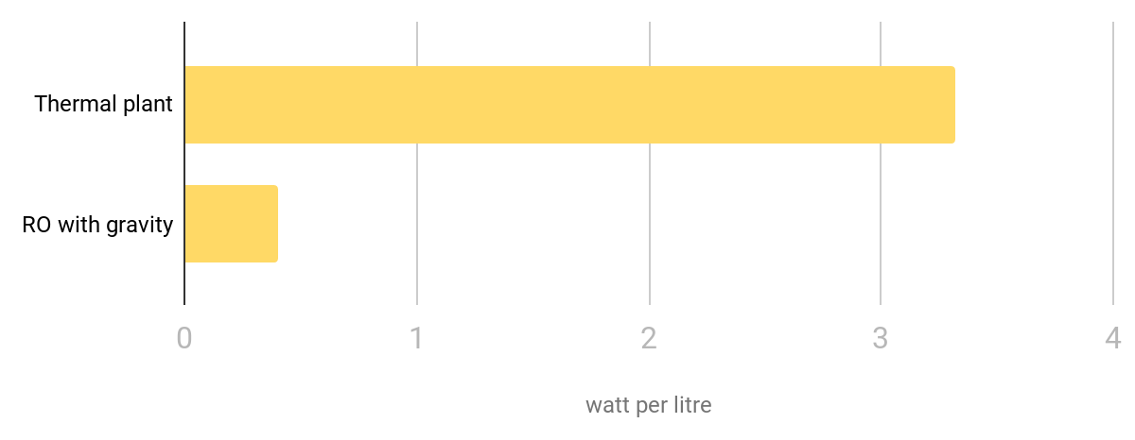
Figure 4: A comparison between a conventional Thermal desalination plant and a Solar RO with gravity desalination plant.
Applicability:
Currently, 70 desalination plants cater to the water demand of Abu Dhabi. Amongst this, one of the plants caters to almost 15% of the demand. According to the UAE State of Energy Report 2015, residents use about 550 litres of water (highest in the world) and 20 to 30 kilowatt-hours of electricity a day. This increases the stress on one plant and leads to transmission loss. In the Fujairah plant, one third of the electricity produced is lost in transmission and water desalination. The Hydrophyll, on the other hand, resolves the water and electricity demand at a local level. Decentralising brings the plant closer to the demand and reduces transmission loss. The canopy creates a lung space for people to unwind and relax. By bringing the industry to the backyard, one can be a little more aware of one’s footprint and its impact on the environment.
Cost:
Material | No | Units | Cost / Unit | Material Cost
Recycled Steel | 4,977 | tonnes | $1,890.00 | $9,406,530.00
Green Concrete | 20,484 | cu.m | $165.00 | $3,379,860.00
Panels | 11,227 | units | $564.00 | $6,332,028.00
Gravity RO | 2 | units | $400,000.00 | $800,000.00
Labour and Formwork | 17,430 | sq.m | $36.00 | $627,480.00
 |  | Total Cost |  | $20,545,898.00
 |  | Nameplate capacity (kWp) |  | 3873.2
 |  | cost per watt |  | $ 5.30
References
- Alsheghri, Ammar & Sharief, Saad & Rabbani, Shahid & Aitzhan, Nurzhan & Rios Galvan, Alejandro. (2015). Design and Cost Analysis of a Reverse Osmosis Plant Integrated with Solar Photovoltaic for Masdar Institute.
- Solar powered RO plant with gravity https://www.elementalwatermakers.com/solution-gravity/
- Solar panels used in the design https://us.sunpower.com/sites/default/files/media-library/data-sheets/ds-x21-series-335-345-residential-solar-panels.pdf
- https://www.iea.org/newsroom/news/2019/january/desalinated-water-affects-the-energy-equation-in-the-middle-east.html

