The Catcher

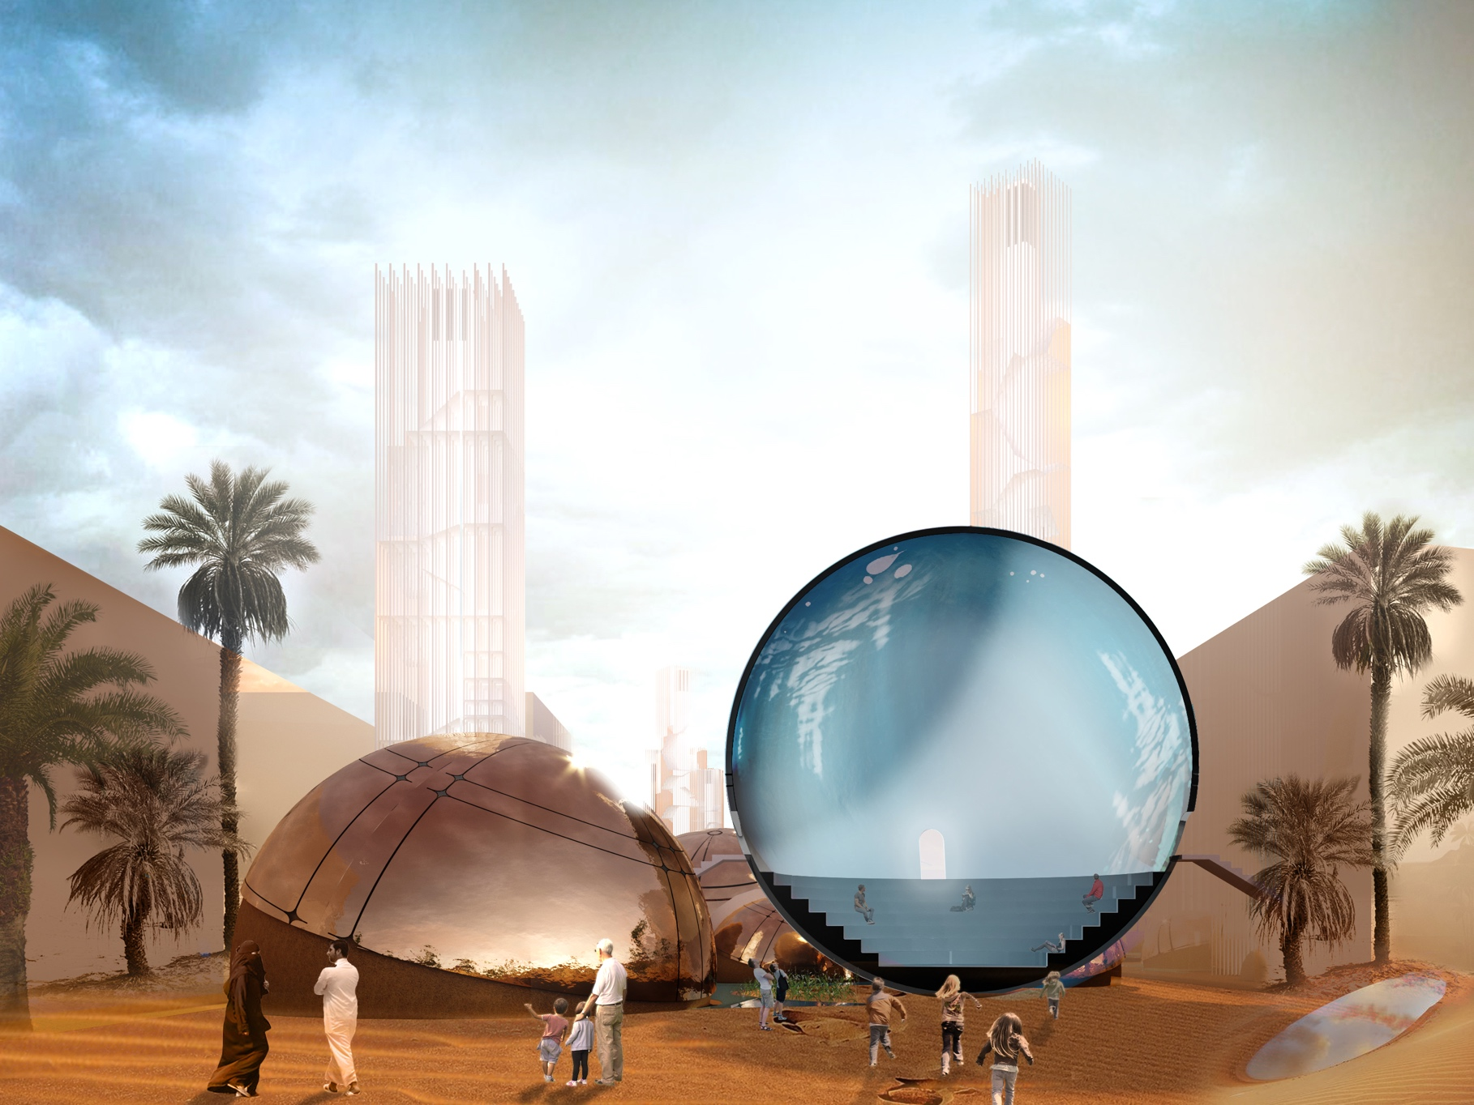

LAGI 2019 Abu Dhabi
Renewable Energy Can Be Beautiful

Description

Desert is a unique environment that challenges humanity’s ability to adapt. The Catcher project turns this challenge into an opportunity. It provides comfortable climatic conditions for users while minimizing footprint. It utilizes the available resources that include sun, groundwater, and wind. Merging ancient building traditions with modern technologies creates an effective and vibrant public space in the city of Masdar.

The Catcher is a complex of public facilities placed at the existing open lot. It consists of a number of clusters that can be built sequentially in phases. Each of them includes several earth domes arranged around a wind tower that serves as a system core, delivering cool air and desalted water into each dome, and supporting the surrounding landscaping.

The project tests a number of ground-breaking technologies of renewable energy generation and reuse, becoming a strategic asset for the city. Its unique image manifests both high-tech approach to design and vernacular sensitivity, establishes a new urban landmark, and keeps the surrounding landscape open to the public.

Technologies

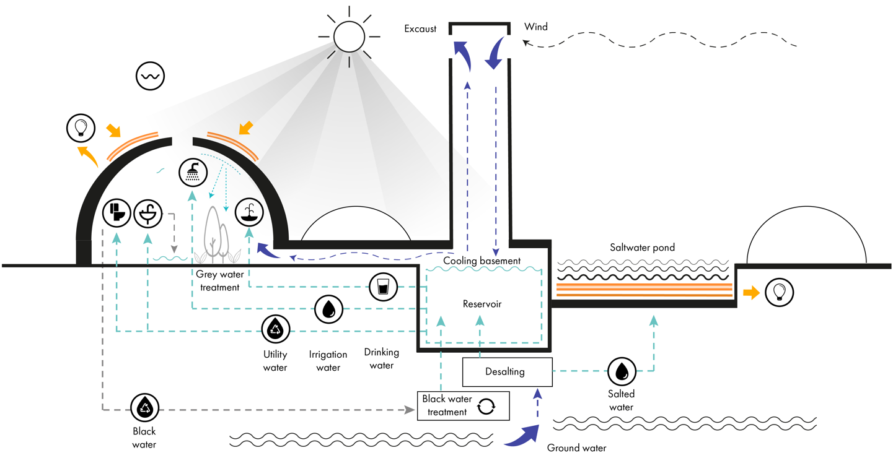

Technologies implemented in the project serve two goals. First, they utilize the overabundant resources to produce energy and sustain comfortable climatic conditions within the domes. Second, they create cyclic ecological systems within each cluster that stores and recycles used energy and water.

Materiality
The project speculates on the traditional image of the earth domes that were built for centuries in arid climates. Thermal mass of its adobe walls protects the interior from energy loss and helps to sustain comfortable climatic conditions all year round.
The wind towers are built of brick with a minimal supporting steel structure that is necessary due to the required height. They are painted with luminous paint that glows in the night, providing subtle evening illumination without adding to urban light pollution.

Solar
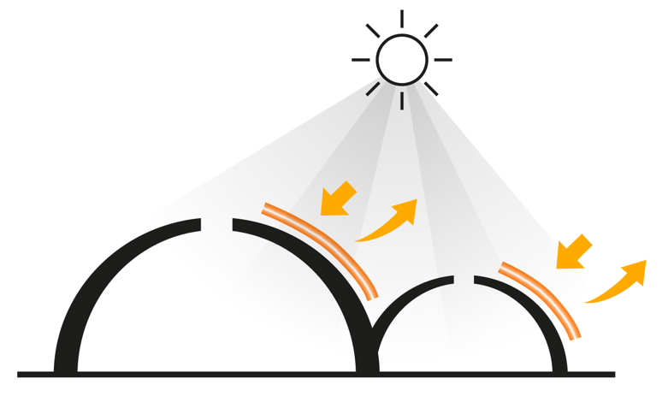
The exterior surface of the domes is covered by solar panels. This layer of modern technology complements the vernacular form and warm materiality of the adobe walls. The panels generate three quarters of the electrical energy on site that is stored in high-capacity batteries within each dome. Excessive energy can be redirected to the urban grid.
Carved skylights allow reflected sunlight into the domes, making use of the natural illumination without overheating the interior.

Wind
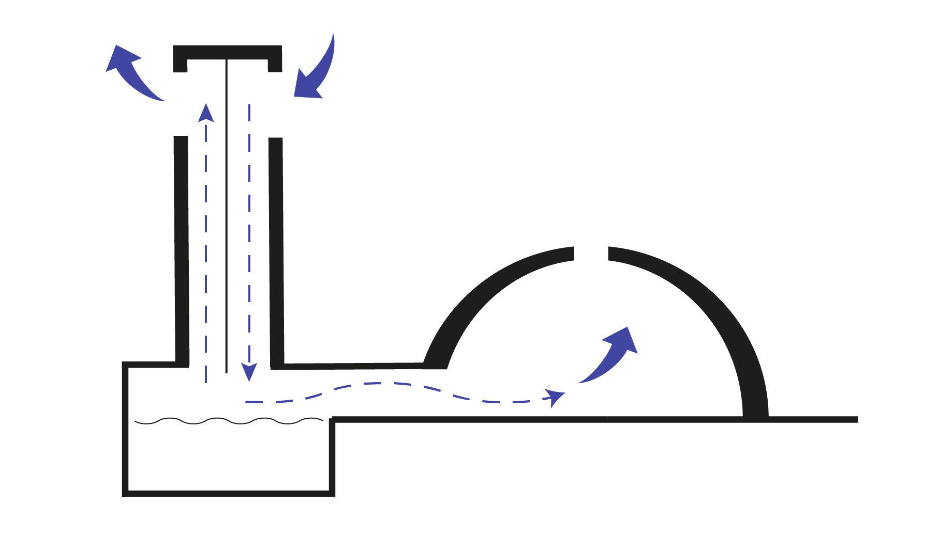
Technologies of the wind catchers and solar chimneys existed for centuries, spreading from the Persian countries to the Gulf. Each tower captures the prevailing wind at the height of 50-60 meters and redirects it to the water reservoir at the ground level. It cools and humidifies air that is then distributed to the domes. When there is no wind, the tower works as a solar chimney, letting the hot air to escape though a separate exhaust chamber. The hot air inside the domes escapes through the louvers that sometimes are also used as lightwells.

Water
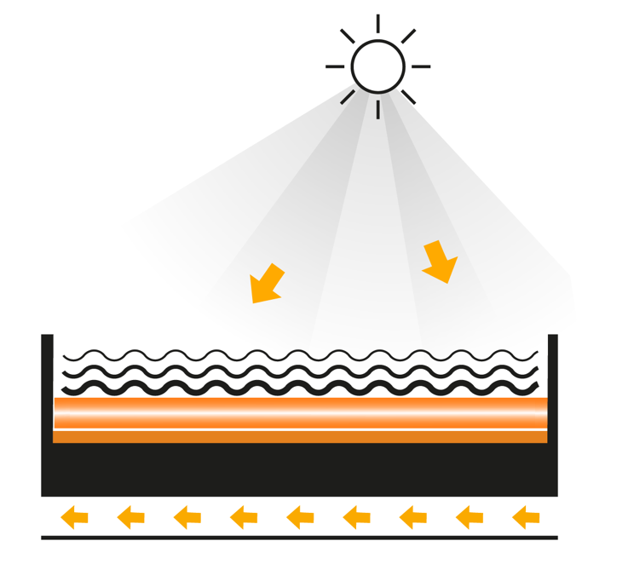
The area has a consistent supply of underground salted water due to its proximity to the ocean. It is excavated from a well under a wind tower and separated into highly saline and freshwater bodies.

Saltwater is redirected underground to the exterior ponds. Due to its natural qualities, it heats up under the sun in layers. The top layer heats up to 30°C while the bottom layer heats up to 100°C and is used for 24-hour energy generation by the Organic Rankine Cycle turbine.
Freshwater is stored in the underground reservoir at the bottom of the wind tower, serving the natural ventilation. It is also redirected to two water systems: irrigation (interior and exterior), and plumbing, including drinking water fountains that require an additional filtering process.

Greywater is redirected from plumbing fixtures first to pre-filtering device and then to a sequence of planters located within each dome. A number of soil-boxes are used for natural filtration process and for planting an interior garden. It creates biophilic environment that contributes to sustaining interior microclimate. Clean water is either stored in a water pool inside a dome, redirected to a reservoir under the wind tower, or back to the water supply systems.
Irrigation within the doms is provided by pulverizers located above the gardens. Water drops in the air refract sunlight and create visual effects, enhancing the unique experience within the complex.

Environmental impact statement

The Catcher uses the renewable energy of sun and water to generate approximately 4 million kWh annually. The use of the natural ventilation, illumination, and other passive building technologies helps to sustain comfortable indoor climate and minimize the need for air conditioning.
The main material used for the building is clay. It can be extracted not far from Abu-Dabi, thus simplifying logistics and minimizing transportation footprint. It is an ecologically neutral material during its whole life cycle, and can be easily recycled.
One of the values of the project is the delicate handling of the existing ecologies. Local flora and fauna are sustained on the site. Smart irrigation systems increase the biodiversity while cycled microecology within each custer minimizes the ecological offset on the landscape. Overall, the Catcher builds upon the time-tested building traditions with the upcoming technologies. It becomes a public attraction that spread ecological sensitivity among its visitors.

Nameplate capacity (in kWp)

Solar panels = 450 kWp
Salt lake energy = 150 kWp

Subtotal = 600 kWp

Annual kWh (kilowatt-hours)

Solar panels :

A * r * H * PR = E
9063 * 0,2* 2600*0,75 = 3 532 432 kWh/an

E = Energy (kWh)
A = Total solar panel Area = 9063 m²
r = solar panel yield = 20 %
H = Annual average irradiation on tilted panels (shadings not included) = 2600 kWh/m².an
PR = Performance ratio, coefficient for losses (range between 0.9 and 0.5, default value = 0.75) = 0,75

Solar pond (saltwater):

A * r * H = E

2045*0.1*2600 = 531 700 kWh/an

A = Total solar panel Area =2045 m²
r = efficiency factor = 10 %
H = Annual average irradiation on tilted panels (shadings not included) = 2600 kWh/m².an

Cost estimate

Domes

Material and building - 8280000 USD
Solar panels and batteries - 1993860 USD

Wind towers

Material and building - 415800 $
Stairs structure - 160000 USD

Exterior

Saltwater pools and turbines - 392000 USD
Landscaping - 791000 USD

Subtotal : 12 000 000 USD
wP = 600 000 / $20 USD per watt

