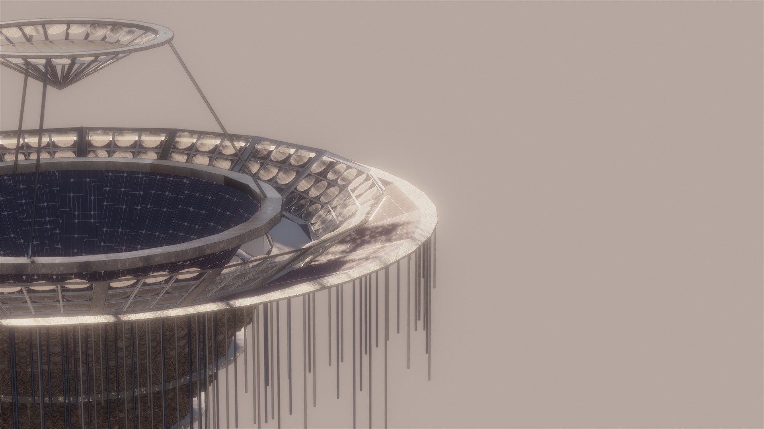

TAQA BURJ
THE ENERGY TOWER
PROPOSED DESIGN FOR LAGI 2019
─
Your Name
Your Company
123 Your Street
Your City, ST 12345

OVERVIEW OF DESIGN
TAQA BURJ IS AN INNOVATIVE PIECE OF PUBLIC ART WITH AN AWE OF VISUAL BEAUTY,EXPERIENCE OF WONDERMENT AND USE OF RENEWABLE ENERGY TECHNOLOGY.
THIS STRUCTURE IS DESIGNED TO PROVIDE A LANDMARK OF PUBLIC ART AS WELL AS TO GENERATE THROUGH RENEWABLE SOURCES.THE DESIGN IS MADE IN CONTEXT WITH THE TRADITIONAL DESIGN OF ARABIC CULTURE-ARABIC LATTICE-WORK IS USED IN DESIGN.
TAQA BURJ IS INSPIRED FROM STAGGERED CONCEPT OF DESIGN STRATEGY.IT CONSISTS OF EIGHT CIRCULAR DISCS OF FOUR METRES HEIGHT AND VOID OF TWO METRES LESS THAN THE RADIUS OF DISCS.THESE DISCS ARE IN INCREASING ORDER PLACED ONE ABOVE ANOTHER STARTING FROM SEVEN METRES RADIUS AT BASE DISC.
THE TOP OF THE TAQA BURJ IS FUNNEL SHAPED CONTAINING PV SOLAR PANELS AND CONE STRUCTURE WHICH RUNS THROUGH THE WHOLE TOWER TO BASE CONTAINING SPECIAL TYPE OF SOLAR PANELS.
TAQA BURJ IS TOPPED BY A LENS PLATE CONTAINING SUM OF TWENTY-FOUR BICONCAVE LENSES.

GOALS OF DESIGN
- TO PROVIDE VISUAL BEAUTY TO SURROUNDING AND SERVE AS A PUBLIC ART LANDMARK FOR THE NEIGHBOURHOOD.
- TO PROVIDE A EXPERIENCE OF WONDERMENT AND THOUGHT PROVOKNESS TO THE VIEWER.
- TO ENHANCE THE KNOWLEDGE AND PROVIDE AT LEAST SUPERFICIAL EDUCATION AND INFORMATION ABOUT THE GENERAL RENEWABLE ENERGY,THE TECHNOLOGY AND THE INTEGRATION OF IT WITH ART.
- AS RENEWABLE ENERGY TECHNOLOGY IS USED IN DESIGN,IT SHOULD SERVE THE PURPOSE OF SPREADING THIS TECHNOLOGY TO WORLDWIDE IMPLEMENTATION AND POSSIBLE FUTURE STORYTELLING.
- LAST BUT NOT LEAST,THE MOST IMPORTANT OF ALL,TO PROVIDE ENOUGH ENERGY TO THE NEIGHBOURHOOD FOR DAILY HOUSEHOLD ACTIVITIES AS WELL ENERGY STORAGE FOR OTHER BENEFICIAL PURPOSES.

THE TECHNOLOGY USED IN DESIGN
A BEAUTIFUL INTEGRATION OF CONVENTIONAL AND UNCONVENTIONAL ENERGY STRATEGIES ARE IMPLEMENTED IN DESIGN OF TAQA BURJ.
NAMELY ON BROAD SPECTRUM THREE TYPES OF ENERGY ARE USED IN TAQA BURJ:
1.PAVEGEN-ENERGY GENERATION THROUGH STEPS
2.PIEZO-ELECTRICITY-ENERGY GENERATION THROUGH APPLIED STRESS
3.LENS INTEGRATED SOLAR PANELS-ENERGY GENERATION THROUGH POWER OF SUN

II.PAVEGEN-ENERGY GENERATION THROUGH STEPS
EXCERPT FROM THE PRODUCER’S PAGE:
As pedestrians walk across the Pavegen system, the weight from their footsteps compresses electromagnetic generators below, producing 2 to 4 joules of off-grid electrical energy per step.
Power is generated when a footprint compresses the board from a depth of 5 mm to 10 mm. The triangular design maximizes power output and data capture, and its high durability and ease of install allow it to be seamlessly integrated into any location. Through electromagnetic induction by copper coils and magnets, each step produces from anywhere from 2 to 4 joules, which generates an average of 5 watts of energy: enough to operate an LED bulb for 30 seconds.This energy is stored in batteries that can power lights or other.
PAVEGEN IS A UNIQUE REVOLUTIONARY TECHNOLOGY INTRODUCED TO WORLD WHICH IS ALREADY BEING IMPLEMENTED IN SIDEWALKS,MALLS,SHOPPING COMPLEXES AND NUMEROUS OTHER PLACES.
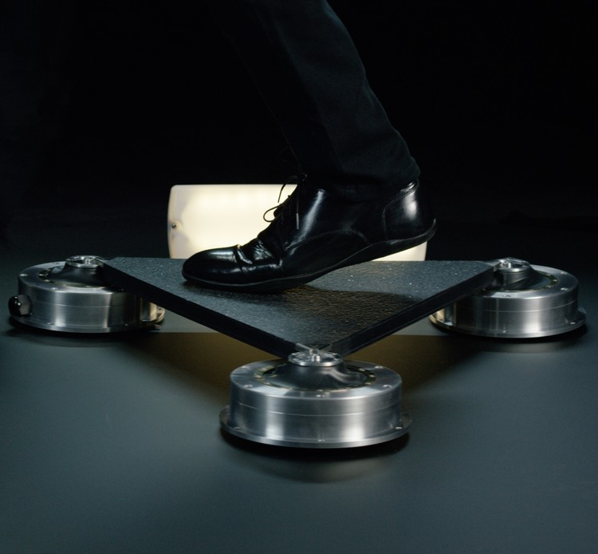

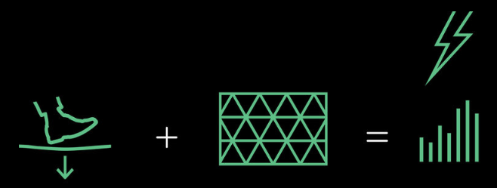
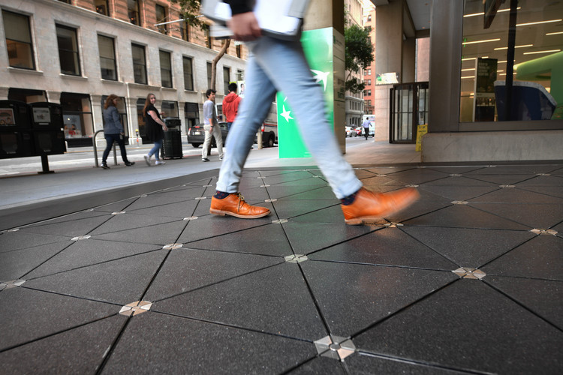

II.PIEZO-ELECTRICITY-ENERGY GENERATION THROUGH APPLIED STRESS
EXCERPT THROUGH RESEARCH PAGES:
Piezoelectric Effect is the ability of certain materials to generate an electric charge in response to applied mechanical stress. The word Piezoelectric is derived from the Greek piezein, which means to squeeze or press, and piezo, which is Greek for “push”.
When piezoelectric material is placed under mechanical stress, a shifting of the positive and negative charge centers in the material takes place, which then results in an external electrical field. When reversed, an outer electrical field either stretches or compresses the piezoelectric material.
FURTHER RESEARCH IN FIELD OF PIEZOELECTRICITY GENERATED NEW MATERIALS:
Quartz crystals were the first commercially exploited piezoelectric material and still used in sonar detection applications, scientists kept searching for higher performance materials.The intense research resulted in the development of barium titanate and lead zirconate titanate, two materials that had very specific properties suitable for particular applications.During World War II, research groups in the US, Russia and Japan discovered a new class of man-made materials, called ferroelectrics, which exhibited piezoelectric constants many times higher than natural piezoelectric materials.

PRESENT DATE PIEZOELECTRIC MATERIALS:
There are many materials, both natural and man-made, that exhibit a range of piezoelectric effects. Some naturally piezoelectric occurring materials include Berlinite (structurally identical to quartz), cane sugar, quartz, Rochelle salt, topaz, tourmaline, and bone (dry bone exhibits some piezoelectric properties due to the apatite crystals, and the piezoelectric effect is generally thought to act as a biological force sensor). An example of man-made piezoelectric materials includes barium titanate and lead zirconate titanate.

FURTHER RESEARCH AND ADVANCEMENTS WERE MADE IN THIS FIELD ENVIRONMENTALLY SAFE PIEZOELECTRIC MATERIALS WERE FOUND:
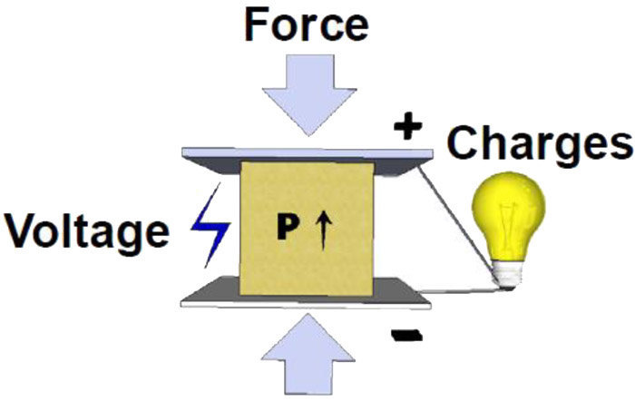
In recent years, due to the growing environmental concern regarding toxicity in lead-containing devices and the RoHS directive followed within the European Union, there has been a push to develop lead free piezoelectric materials. To date, this initiative to develop new lead-free piezoelectric materials has resulted in a variety of new piezoelectric materials which are more environmentally safe.
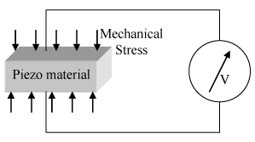
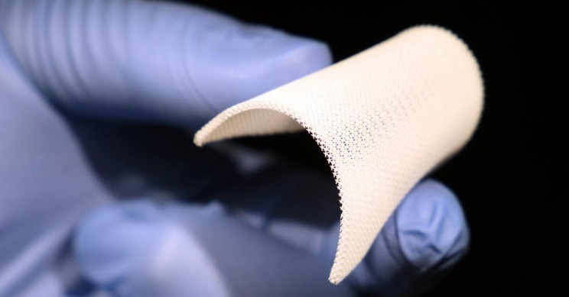

TAQA BURJ HAS AND ARRAY OF PIEZOELECTRIC TUBES HANGING FROM THE FUNNEL PART OF TOWER CONTAINING BATTERIES FOR STORAGE.
THESE TUBES ARE COMPOSED OF NUMBER OF DISCS THAT ARE FILLED WITH PIEZOELECTRIC MATERIALS WHICH ULTIMATELY GENERATE ENERGY WHEN WINDS BLOW.

III.LENS INTEGRATED SOLAR PANELS-ENERGY GENERATION THROUGH POWER OF SUN
TWO WAYS OF LENS INTEGRATED SOLAR PANEL SYSTEMS ARE USED IN TAQA BURJ,NAMELY:
I.LENS PLATE
II.LENS SHEET OVER INDIVIDUAL PANELS
THE BIGGEST PROBLEM WITH THIS ARRANGEMENT OF IS OF DAMAGING OF PV CELLS DUE TO HIGH INTENSITY CONVERGED SUNLIGHT.
TO CONTROL THIS PROBLEM, RESEARCHES WERE MADE IN THIS FIELD.
EXCERPT FROM A RESEARCH PAGE:
When sun-rays are focused to increase the intensity of light, temperature also increases at the focal point as sunlight contains infrared rays.Temperature of sunlight is low in the morning, gradually increases at midday and will decrease when evening approaches.
If the temperature of the focused sunlight crosses above 70°C, the Photovoltaic cells may damage. To avoid such critical situation, the amount of focusing of sunlight should be controlled by moving the lens away from or near to the Photovoltaic cells. Observations were taken in the aforesaid experiment by keeping the lens at different positions so that focusing effect of sunlight falls on the Photovoltaic cell can be varied.
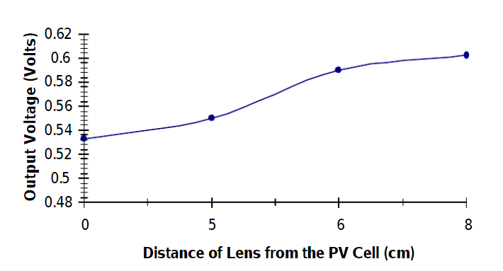
when the distance between the lens and the Photovoltaic cell approaches near to the focal length of the lens, the cell output increases and it will be maximum at Focal point.The temperature at the focal point increases when the lens approaches near to the focal point of the lens.

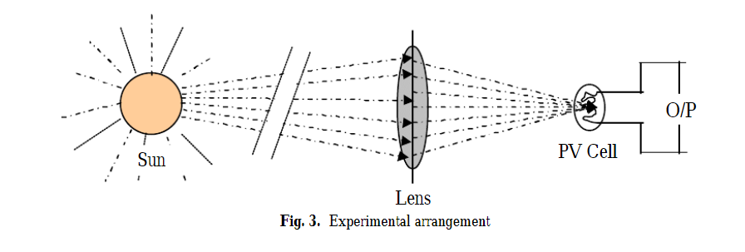

THE SECOND METHOD OF TEMPERATURE CONTROL IS A ONE INNOVATIVE TECHNOLOGY DEVELOPED BY COMPANY-IBM WHICH GOES AS FOLLOWS:
IBM incorporated a liquid metal thermal cooling system onto ordinary PV cells. The cooling system is comprised of liquid indium and gallium placed between the PV cell and a cooling block. When the panel is exposed to sunlight, the cell transfers the heat to the cooling block, lowering temperatures of more than 1,600 degrees Celsius to just 85 degrees, preventing the panel’s meltdown. The cooling system is what prevents the meltdown of the solar cells.

ENERGY CALCULATIONS:

Three types of energy sources have been used in the design:

-solar photovoltaic panels

-PAVEGE::energy produced due to pressure of footsteps on pavement

-piezoelectric tubes

SOLAR ENERGY:

A total of about 40 solar PV cells have been used.

The wattage of each panel is 300W.

Hence, total wattage of all panels is 12000W=12kW.

Assuming an average of 6 hours' exposure to sunlight per day, the total solar energy produced by each tower per day is:

ENERGY= 12kW*6hrs = 72kW-hrs.

Total solar energy produced by each tower per year= 72*365= 26.28 MW-hrs.

COST:

Assuming an installation cost of 3$ per Watt of solar energy,

Cost of installation of solar energy= 3$*12kW = 36,000$.

PAVEGEN:

The power output here is 5W for every step that penetrates 5-10mm into the tiles.

Assuming 1 person traverses the tower per day(~400 steps),the energy output per day is: 5W*400 steps = 2000W = 2kW.

Energy output per year = 2kW*365 days = 730kW-hrs.

COST:

Assuming an installation cost of 5$ per watt,

Cost of installation of Pavegen = 2kW*5$ =10,000$.

PIEZOELECTRIC RODS:

The total number of piezoelectric rods used in each tower are about 300.

Power produced by each tube = (72W/1000W)*0.0666(CAPACITY FACTOR) = 4.8W.

Assuming 20 hours of wind a day,

Energy output per tube per day = 4.8W * 20hrs = 96 W-hrs.

Energy output per tube per year = 96*365 = 35.04kW-hrs.

Total piezoelectric energy produced by each tower per year = 35.04*300 = 10.5 MW-hrs.

COST:

Assuming an installation cost of 5$ per watt,

Cost of installation of piezoelectric tubes = 5$*300*4.8 = 7200$

TOTAL INSTALLATION COST OF EACH TOWER = 7200$ + 10,000$ + 36,000$ = 53,200$

PEAK OUTPUT ENERGY CALCULATIONS:

SOLAR ENERGY:

ASSUMING 10 HOURS OF EXPOSURE TO SUNLIGHT PER DAY, PEAK OUTPUT = 120 kW.

PAVEGEN:

ASSUMING 1 PERSON(400 STEPS) PER DAY,

PEAK OUTPUT = 2 kW.

PIEZOELECTRIC TUBES:

ASSUMING 24 HOUR WIND FLOW PER DAY,

PEAK OUTPUT = 34.56 kW.

BASIC BUILDING MATERIALS USED IN TAQA BURJ:
- GREEN CONCRETE
AS RAW MATERIAL FOR CONSTRUCTION OF TOWER AS WELL AS INNER FUNNEL TUBE
- RECYCLED STEEL
FOR THE FRAMEWORKS OF LENS PLATE AND THE LENS SHEETS.COMMONLY USED IN MASDAR FOR VARIOUS CONSTRUCTION MATERIAL.MOREOVER, STEEL HAS HIGH BOILING POINT WHICH IS A OPTIMUM MATERIAL FOR THIS ARRANGEMENT.
- ALUMINIUM
FOR THE HYDRAULICS SUPPORT FOR LENS PLATE.ALUMINIUM IS READILY AVAILABLE WITH PROVIDED DURABILITY AND TEMPERATURE RESISTANCE.
- DRIED CORAL AND GYPSUM COMPOSITION
AS AN EXTERNAL FACADE DETAIL OF TAQA BURJ.WIDELY USED IN VARIOUS BUILDINGS OF MASDAR FOR FACADE DETAILS
- TIMBERWOOD/PALMWOOD
FOR THE ARABIC LATTICE OF THE TAQA BURJ.MASDAR HAS HIGH PERCENTAGE OF USING TIMBER IN CONSTRUCTION AS WELL FOR FACADE DETAILS.

ENVIRONMENTAL IMPACT SUMMARY:
THE TAQA BURJ IS A VERY ENVIRONMENT-FRIENDLY DESIGN― ALL THE THREE DIFFERENT TYPES OF ENERGY SOURCES USED ARE EMISSION FREE, AND DO NOT HAVE ANY NEGATIVE IMPACT ON THE ENVIRONMENT, IN ANY WAY.
THE FIRST ENERGY SOURCE IS ENERGY PRODUCED BY SOLAR PHOTOVOLTAIC CELLS, WHEN BI-CONVEX(CONVERGING) LENSES FOCUS SUNLIGHT ONTO THEM. HERE, HEAT ENERGY FROM THE SUN IS CONVERTED INTO ELECTRICAL ENERGY WITHOUT ANY EMISSION, OR ANY NEGATIVE ENVIRONMENTAL IMPACT.
THE SECOND SOURCE OF ENERGY IS A TECHNOLOGY CALLED PAVEGEN, WHERE ENERGY IS PRODUCED BY SPECIALLY DESIGNED PAVING TILES, WHEN PRESSURE IS APPLIED ON THEM DUE TO FOOTSTEPS, ETC.
THE THIRD SOURCE OF ENERGY IS PIEZOELECTRIC RODS― TUBES THAT CONTAIN PIEZOELECTRIC MEMBERS(DISCS), AND CONVERT MECHANICAL ENERGY PRODUCED BY THE TUBES ( DUE TO THEIR MOVEMENT IN THE WIND AND BREEZES) INTO ELECTRICAL ENERGY. THIS PROCESS IS ALSO COMPLETELY EMISSION FREE AND ECO-FRIENDLY.

REFERENCES:
FOR PIEZO-ELETRICITY:
https://www.nanomotion.com/piezo-ceramic-motor-technology/piezoelectric-effect/
FOR PAVEGEN:
http://www.pavegen.com/about

https://www.archdaily.com/911965/sidewalks-that-generate-energy-through-the-steps/?utm_source=Whatsapp&utm_medium=IM&utm_campaign=share-button

FOR SOLAR PANELS:
https://ilovemysolar.com/can-a-magnifying-glass-on-solar-panels-produce-more-energy/
RESEARCH WHICH WAS MADE OVER TEMPERATURE CONTROL:
https://www.researchgate.net/publication/237296549_CONVERGING_LENS_SOLAR_CONCENTRATOR_AND_THEIR_POSITION_CONTROL_USING_A_MICROPROCESSOR_FOR_INCREASING_THE_EFFICIENCY_OF_SOLAR_PHOTOVOLTAIC_ENERGY_CONVERSION

