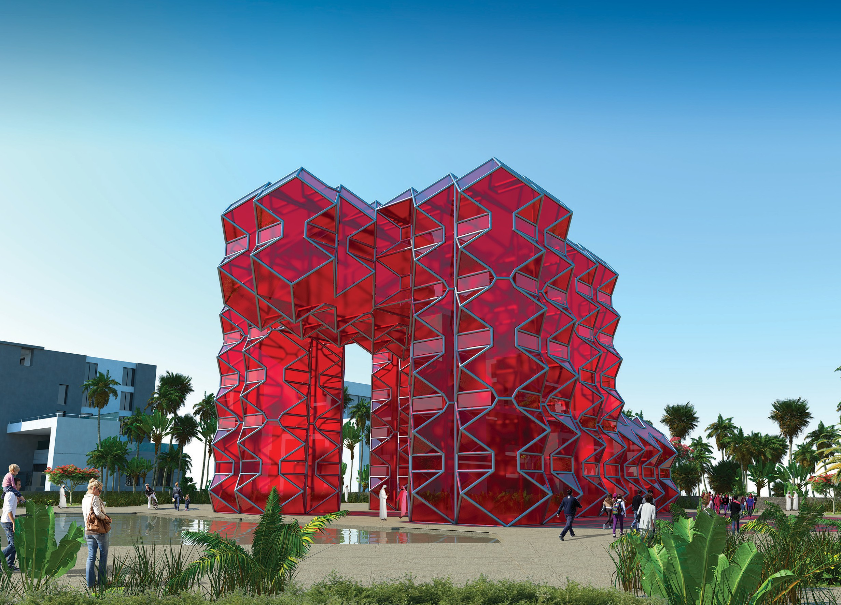
RED GIANT
LAGI Art competition 2019 - Abu Dhabi, Masdar city

CONTENTS

- Red Giant, The sculpture

- - Red Giant: the area

- – The space used

- – Project feasibility

- - Urban connections

- - Abu Dhabi atmospheric conditions

- - Technology

- - Calculations

- - Cost

- Environmental impact

- - Bibliography and sitography

- RED GIANT The Sculpture

The project is focused around a sculpture: a strong symbolic and human landmark positioned in the centre of the competition area.
A panoramic piazza surrounds the artwork and links the two sections of the North Green Finger.

The dimensions of the huge form are H 18 x 24 x 33 and it is a sculptural composition of rotated cube elements whose geometry and rhythm recall the arabesques so distinctive of Emirian culture.
That same geometry will be continued in the paving of the piazza with cement elements in different shades of the colour sand.
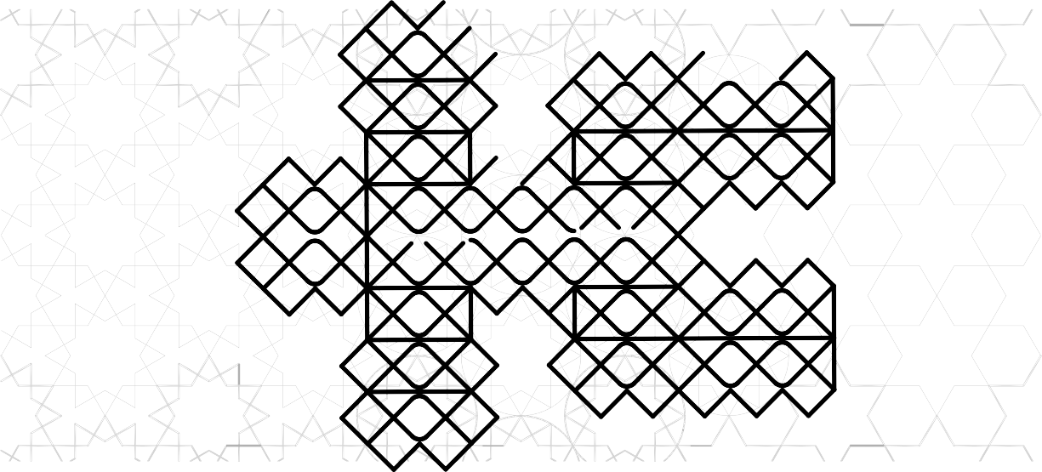

Similarly to the framework, the supporting structure is made of tubular steel with coloured glass
plates attached to create the surfaces of the shapes. The faces exposed to the sun throughout the course of the day are equipped with semi-transparent solar panels while the faces that never see the sunlight are only covered with a coloured film.

The shadow of the structure will create a red play of light, as though looking through a ruby.
The artist proposes the colour red but is willing to discuss other possible options from the coloured glass currently available.

After sunset, the structure is illuminated from the inside by LED strips secured to various parts of the structure in line with the geometry.
Even in the dark, therefore, the Red Giant will be a point of reference visible from a distance.

The massive shape manages to convey both a sense of power and lightness due to the transparency and tension of its geometric shapes.

The particular facets that characterise the surfaces of the Red Giant are not purely aesthetic; they also function to increase the absorption of light by bouncing it back from facet to facet and therefore proportionally increasing the energy produced.

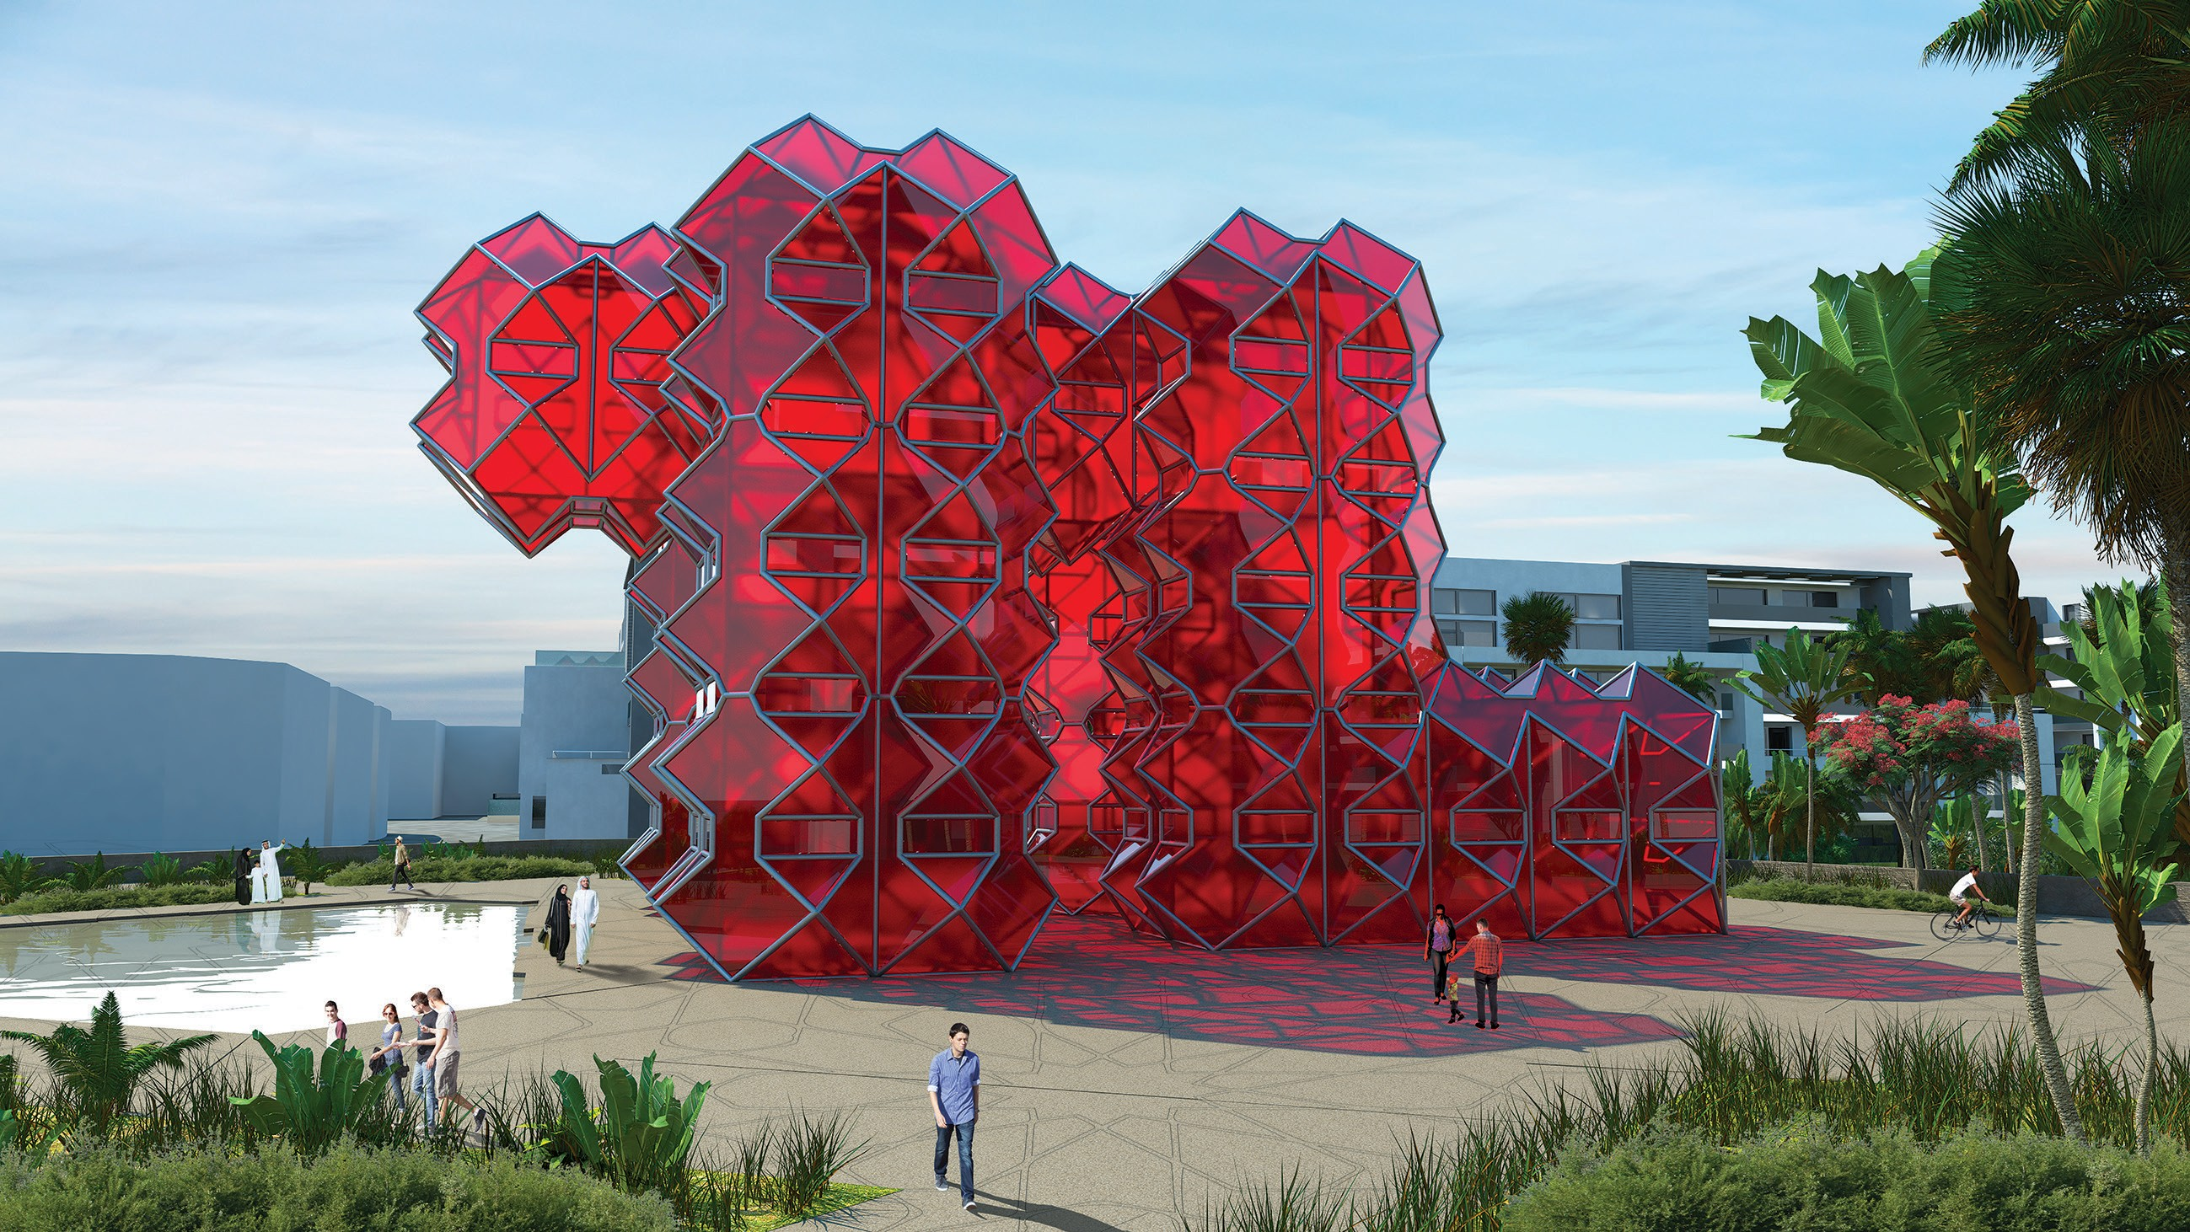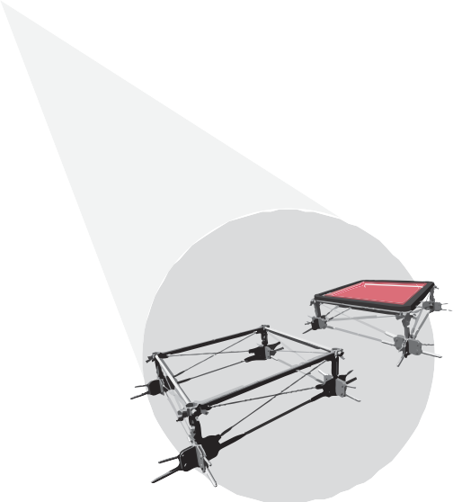

The shape

The sculpture is made of a supporting tubular steel structure to which photovoltaic glass surfaces are applied.
The mingling of faceted volumes offers a changing rhythm of transparencies and reflections, casting colored shadows.

The supporting structure

The supporting structure of the sculpture was designed taking inspriation from the already existing structure of the Louvre Pyramids whose steel poles and glass segments reach a height similar to that of the red Giant.

- 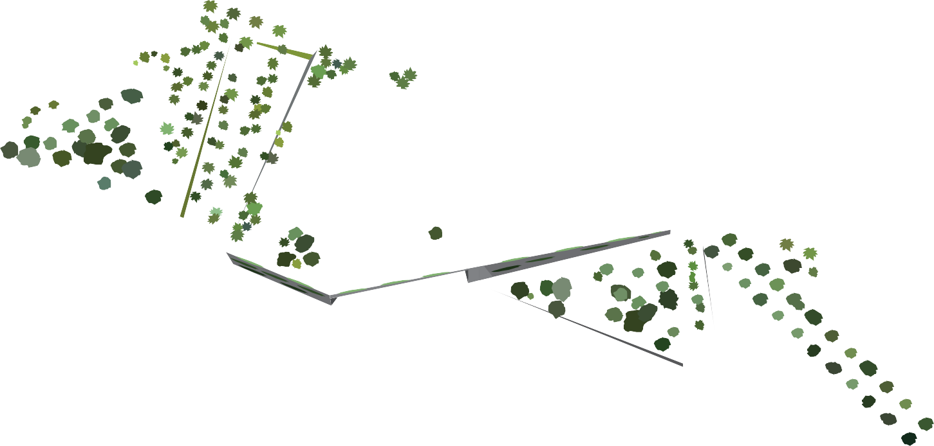RED GIANT - The Area

Although the sculpture is an imposing mass, clearly visible even from a distance, it only oc- cupies approximately 3% of the area provided for in the competition.
This was a precise design choice: to create a central focus with a unique and representative artistic work without occupying an excessive space in the North Green Finger and therefore leaving a vast area for parks and recreational activities.

In addition to the piazza, this proposal also suggests the creation of an open-air theatre on a slight slope and a multi-functional covered space below, to cover an area of 1,500 metres2. Access to these facilities is via the GRT Loop.

The preliminary park design considers the different perspectives offered by the area by using different geometrical designs and viewpoints aimed at directing emotional tension towards the sculpture but also offering moments of surprise and serenity depending on the paths taken by the public.

One very important aspect of the project is the decision to connect the two different sections of the park divided by the GRT Loop with the creation of the suspended panoramic piazza. This makes it possible to exploit a greater area, allows visitors to enjoy the park uninterrup- ted by traffic and creates a vast panoramic location.
In the same way, great focus was placed on the urban fabric surrounding the North Green Finger, creating paths that interconnect the various surrounding areas.

3 - The SPACE USED

The project is designed to generate the most possible energy in the smallest possible space.
As mentioned earlier, the sculpture only occupies 3% of the total area (1% if we consider the actual footprint of the work). Despite the small space allocated to the art installation, it has a high energy yield: the ratio between the energy generated and the space occupied is in fact 5.8 kW/m2, which has the great advantage of leaving 24,208 m2 of usable park space.

The project therefore provides for greater liveability of the total area, with a minimum area used for energy production.

- Overall sculpture dimensions: 792 m2

- Usable area dimensions: 25,000 m2

- Surface occupied by the sculpture: 215 m2

- Energy/total area ratio: 147,168 kWh/25,000 m = 5.8 kW/m2

- Energy generated/area used: 147,168 kWh/792 m = 185 kW/m2

Box size: 792 m2 Footprint: 215 m2

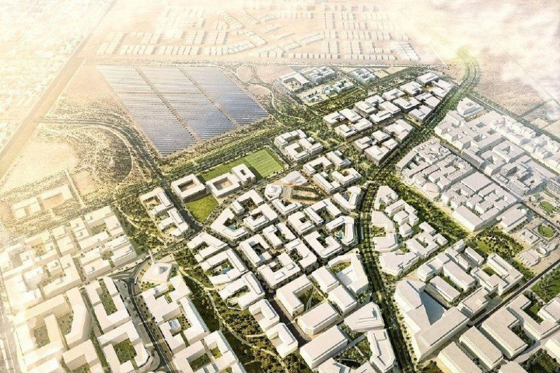
PROJECT FEASIBILITY

From the earliest stages of conception, all artistic and design choices were directed towards the sustainability and real feasibility of the project.

The dimensions proposed are the result of an approach aimed at maintaining a balance between the monumental scale of the art installation, the costs of realisation and the best use of the area by local residents.

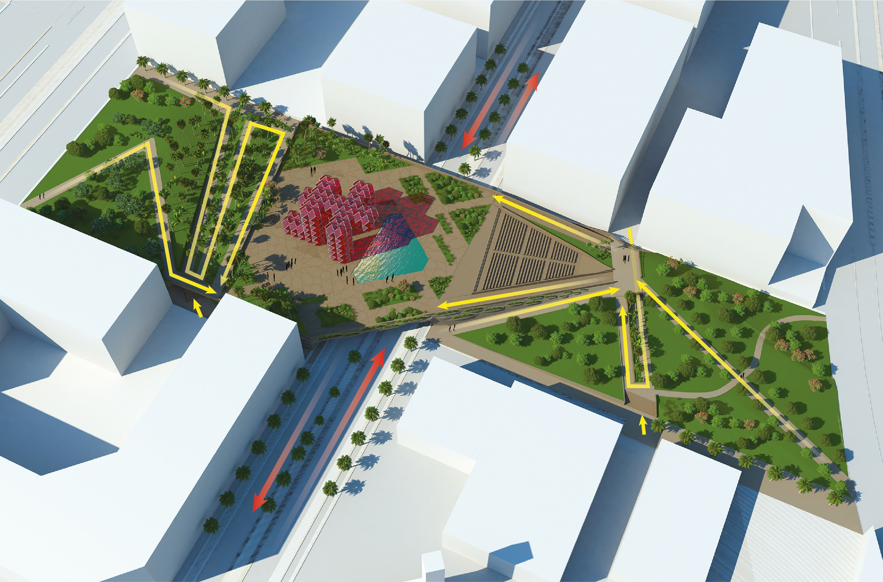
URBAN CONNECTION

Area integration with Masdar City 2030

- ABU DHABI ATMOSPHERIC CONDITIONS

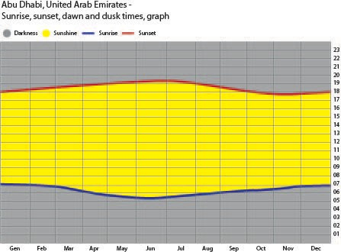

 | Jan | Feb | Mar | Apr | May | Jun | Jul | Aug | Sep | Oct | Nov | Dec
Insolation, kWh/m /day | 3.73 | 4.63 | 5.15 | 6.17 | 7.05 | 7.16 | 6.77 | 6.57 | 6.05 | 5.16 | 4.13 | 3.51
Temperature, C° | 19.16 | 20.30 | 23.37 | 27.76 | 32.52 | 34.60 | 36.31 | 36.25 | 33.66 | 29.51 | 25.10 | 21.32
Wet days | 1.1 | 3.2 | 3.2 | 1.0 | 0.0 | 0.0 | 0.0 | 0.0 | 0.0 | 0.0 | 0.0 | 1.9
Precipitation , mm | 7 | 22 | 15 | 6 | 1 | 0 | 0 | 1 | 0 | 0 | 0 | 6
These data were obtained from the NASA Langley Research Center Atmospheric Science Data Center; New et al. 2002

TECHNOLOGY

Technical details

Solar panels used: Amorphous Silicon PV Glass

Colour of panels used: Red Light

Transparency: 30%

Efficient ratio: 28 Wp / m

LED details:

Color | Neutral White
Color temperature | 4000/6000 K
Energy ratingA | A
Cost ($ / m ) | 10
Energy consumption ( W / m ) | 7,5
Total lenght ( m ) | 600

CALCULATIONS

Average irradiated area: 1,500 m

Peak power: average area x efficient ratio = 1,500 m x 28 Wp / m = 42 kWp Annual energy generation: peak power x 8,760 h x 40 % = 147,168 kWh Tubular LED lights energy consumption: 7.5 W / m x 600 m = 4,500 W Annual LED lights consumption: 4,500 W x ( 8,760 h / 2 ) = 19,710 kWh Total annual energy generation (inclusive of LED consumption by night):
147,168 kWh - 19,710 kWh = 127,458 kWh (considering a twelve-hour use per day)

Quantity of CO2 emissions avoided: 0.4332 kg/Wh x 147,168 kWh = 31,876.58 kg

- - COSTS

Cost margin: peak power x $ 20 / W = $ 840,000
tot. 664,229 $

Sculpture components | Quantity | Cost Actual Costs
Amorphous Silicon PV glass |  | 260,000 $*
Tubular steel structure (Ø=20 mm)** | 197.767 ton. | 1,890 $/ton. 373,779 $
Colored Glass |  | 24,450 $
Tubular LED lights | 600 m | 10 $ / m 6,000 $

Additional costs at 20% (export, labour): $664,229 + ($664,229 x 20% ) = $797,074
Approximative calculations show that the total cost falls within the cost margin

*Future reductions in cost of photovoltaic technology must also be considered: research suggests that the cost of solar panels will fall by at least 20% by 2025.
$260,000 - ($260,000 x 20%) = $208,000

** Calculations for tubular framework:

Total length of tubular elements = 8,393.5 m Tubular diameter = 20 cm
Steel density = 7.5 g / cm3

Total tubular volume = 8,393.5 m x (20 cm / 2) x 3.14= 26,368,957.9379 cm3

Total tubular mass = 7.5 g / cm3 x 26,368,957.9379 cm3 = 197,767,184.53 g = 197.767 ton

- ENVIRONMENTAL IMPACT STATEMENT

This project has virtually no environmental impact: the structure is designed to be made of recycled steel and the glass parts are potentially reusable. Thanks to the joint systems between the various modules, the structure itself can potentially be disassembled and used in other contexts.

Solar panels do not produce any kind of emission that might be harmful to the surrounding environment; in fact, they replace other methods of energy production that are harmful to our planet. The LEDs used for the nocturnal illumination of the sculpture are powered by the battery that conserves the energy produced during the day.

The choice to create large green areas (a large park of 24,000 m2) certainly adds further value to the project in terms of environmental impact. The preservation of an open green space also generates important environmental benefits such as the channelling and circulation of air within the neighbourhood.

- BIBLIOGRAPHY & SITOGRAPHY

https://news.energysage.com/solar-panel-efficiency-cost-over-time/ https://www.onyxsolar.com/colored-transparent-photovoltaic-glass http://www.metra.it/aluminium/EN/case-history-industry-big-scale-industry-alumi- nium-structure-for-the-louvre-
museum-pyramid-255.aspx http://facadesconfidential.blogspot.com/2011/10/louvre-pyramids-revisited.html https://en.climate-data.org/asia/united-arab-emirates/abu-dhabi/abu-dhabi-3217/
https://www.worldweatheronline.com/abu-dhabi-weather-averages/abu-dhabi/ae.a- spx
https://www.mepc.org/abu-dhabis-alternative-energy-initiatives-seizing-climate-chan- ge-opportunities
https://gulfbusiness.com/delivering-successful-energy-transition-uae/ https://cleantechnica.com/2019/02/26/stage-set-for-record-low-tariffs-as-abu-dhabi- issues-2-gigawatt-solar-eoi/
https://www.mordorintelligence.com/industry-reports/solar-photovoltaic-market https://www.swissinso.com/technology
https://www.masdar.ac.ae/ https://issuu.com/cbt55/docs/2015_10_25_masdar_phase_2_dmp_resub http://re.jrc.ec.europa.eu/pvg_tools/it/tools.html#PVP https://news.energysage.com/solar-panel-efficiency-cost-over-time/

NASA Langley Research Center Atmospheric Science Data Center; New et al. 2002 Best Practices in Photovoltaic System Operations and Maintenance 2nd Edition NREL/ Sandia/Sunspec Alliance SuNLaMP PV O&M Working Group
PV System Operations and Maintenance Fundamentals, Josh Haney, Adam Burstein, Next Phase Solar. Inc.
Abu Dhabi Electricity Sector: Features, Challenges and Opportunities for Market Inte- gration, Shahid Hasan, Turki Al Aqeel, Iqbal Adjali, Yagyavalk Bhatt, 2019 International construction market survey 2017, Turner and Townsend
A filed guide to renewable energy technology, land art generation initiative, Robert Ferry, Elizabeth Monoian
Other supporting files from LAGi.

