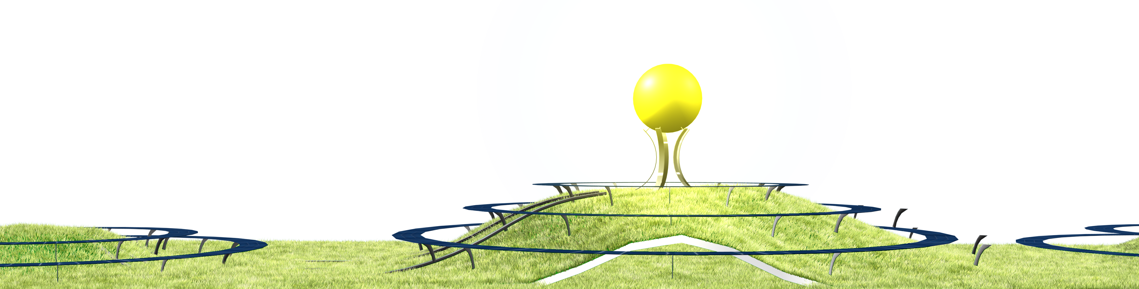

THE HUMAN ELEMENT

To return to the source is to return to the sun and give thanks for the solar energy it supplies the earth. This not only involves light, but the energy for wind generation and the support of life. We continue the relatively early steps of tapping into this energy more sustainably by using solar panels and wind turbines. In this playground-like proposal, the human element will be added to this mix to emphasize our role in this cycle. The Human Element will also encourage movement, exercise, and play. It will capture the abundant energy created by humans that also ultimately owes its livelihood to the sun.

In addition to the wind and photovoltaic elements that are finally accepted as viable in modern society, the human energy will be captured and converted to electrical or potential energy with two main methods:
- Muscle movement
  - stationary cycles
  - “weight” machines
  - Merry-go-rounds
- Gravity capture (similar to how hydropower plants work)
  - slide with integrated generator elements on slide base
  - elevator that only goes down due to human weight
  - bouncing area (generation by displacement)
Human Element plans to create more than 1200 MWh per year. The structure will provide an aesthetic multi-use playground-like space for sliding, picnicking, relaxing, sheltering and walking. The artwork will also incorporate solar panels and integrated wind turbines that take advantage of the wing-like shape of the structure. The movement of the visitors to the design will be used directly in the electrical grid or stored by raising heavy elements within the sculpture structure.

The three hill’s dimensions are about 60 meters in diameter and 6 meters tall. The main hill is 80 meters in diameter and 10 meters tall. The additional sun sculpture adds another 10 meters to the base of the sun, and 10 meters for the sun LED sphere.

Energy Breakdown
Solar Panels – 280W x 2880panels >> 806kWp (x4hrs) =
1177 MWh/year

Wind Turbines – 1kW x 10 micro wind turbines = 10kWp (x24hrs) =
87 MWh/year

Joy (slides) – 200W x 20 slides (448sqm) = 4kWp (x8hrs) =
11 MWh/year

Gym (including generation cycles) – 150Wx20machines = 3kWp (x8hrs) =
9 MWh/year

Budget approximation:
The budget is conservative in light of the recent price reduction in solar panels (under $2/Watt installed, but I am using the $3/Watt approximation) and other sustainable technology.

2880 280 Watt Solar Panels 8KWp $24000 ($3/Watt installed)
10 1000 Watt Wind Turbines 10KWp $20000 ($2/Watt installed)
20 Slides with generation coil 4KWp $20000
20 Gym Machine (bike, weights) 3KWp $20000
Gym Housing Structure (40 square meters) $50000
Landscape hills and excavation $50000

Materials used:
Due to the weather conditions, the structure material supporting the main dome to house the gym will be either stainless steel or galvanized steel. Exterior components supporting the solar panels and main sun sculpture would be stainless steel. Non-supporting elements including solar panel frames may be aluminum. Slides would be constructed of concrete as is common for alpine slides.

In addition to the energy created, energy saved must also be accounted for. The resources available in the Human Element allow residents to return to the land. By using the outdoor gym, megawatt hours of energy are saved due to the naturally ventilated spaces underneath the structure that would have otherwise been wasted on air conditioning in an indoor gym. The structure also has the potential of saving energy used in other traditional structures if used for other uses including outdoor retail, and other indoor events under the hill.

Possible bonus:
Water storage in the humps is possible with the soil serving as insulation and ground serving as thermal mass.

Environmental Impact Summary
Besides utilizing proven sustainable technology elements, it is important that we understand that being green does not have to be a joyless adventure. Being green can be fun, and with the cleaner air can lead to more joyful experiences like picnics and concerts in the park.

The established studies on climate change constantly prove the importance of alternative energy solutions. This project will create the already established environmental impact, but will also enhance livelihood. More importantly, the environmental impact for our future children and grandchildren will be immeasurable.

