SURGE

AWE & ENLIGHTENMENT

SURGE represented the awe of nature, the pursuit of the spirit of classical aesthetics and recognition of technological innovation. The aim of this proposal is to make full use of the natural resources , and synergies as a whole between nature, human and culture.

Green Portal
Inspired by local climate and the unique traditional Arab aesthetics, the proposal is trying to create an oasis of high aesthetic and ecological value, which is supported by extraordinary technologies in the field of engineering and energy.

Resource Habitat
SURGE combines a number of cutting-edge technological innovations into a simple design that captures the infinite energy contained in nature through a variety of energy collection methods. The annual output of 9,582,345MWh of clean energy will be used by the surrounding residential, commercial and research and development institutions.

Connected Entity
SURGE's unique visual image reminds people of the awesome power of nature, triggers people's perception of existence. This is a place for passage, gathering, relaxation and contemplation, combines historical and future perspectives to express respect to the great heritage of Arab art and culture.

INGENUITY & BUILDABILITY

SURGE responses to local climate and culture, while balancing aesthetics, economy and safety. With the size of 300m*70m*45m(average high clearance 25m). The main shelter is composed of identical energy harvesting units interconnected in chains, which is low cost, simple in construction, and also adaptable to variations in space and light. The unit maximizes the collection of energy in both upward and downward directions. Transparency in the material makes large scale shading sculpture feel lighter. Ultra-fine columns provide reliable support and unobstructed view, make natural ventilation and people's free activities possible.

Technical specifications:
1. Environment energy analysis
After studying the local wind/water/solar energy enrichment, our team came to the following conclusions:
(1) Considerable solar energy. The local solar radiation amount is about 5.6k-5.9k per month on average, which is enough to meet the upper limit of energy collected by photovoltaic materials.
(2) Abundant wind energy. From the perspective of the whole year, the average wind speed is about 25km/h, and it is dominated by the northwest wind across the whole site, which also lays a good foundation for wind collection.
Therefore, in terms of energy, our team chose the stable solar power generation as the main energy source, the flapping friction Nano-generator generating mechanical energy by wind energy and the piezoelectric pavement collecting the mechanical energy of pedestrian walking pressure as the additional energy source.
2. Device structure and mechanism introduction
2.1 Device structure introduction
2.1.1 Device for solar and wind energy
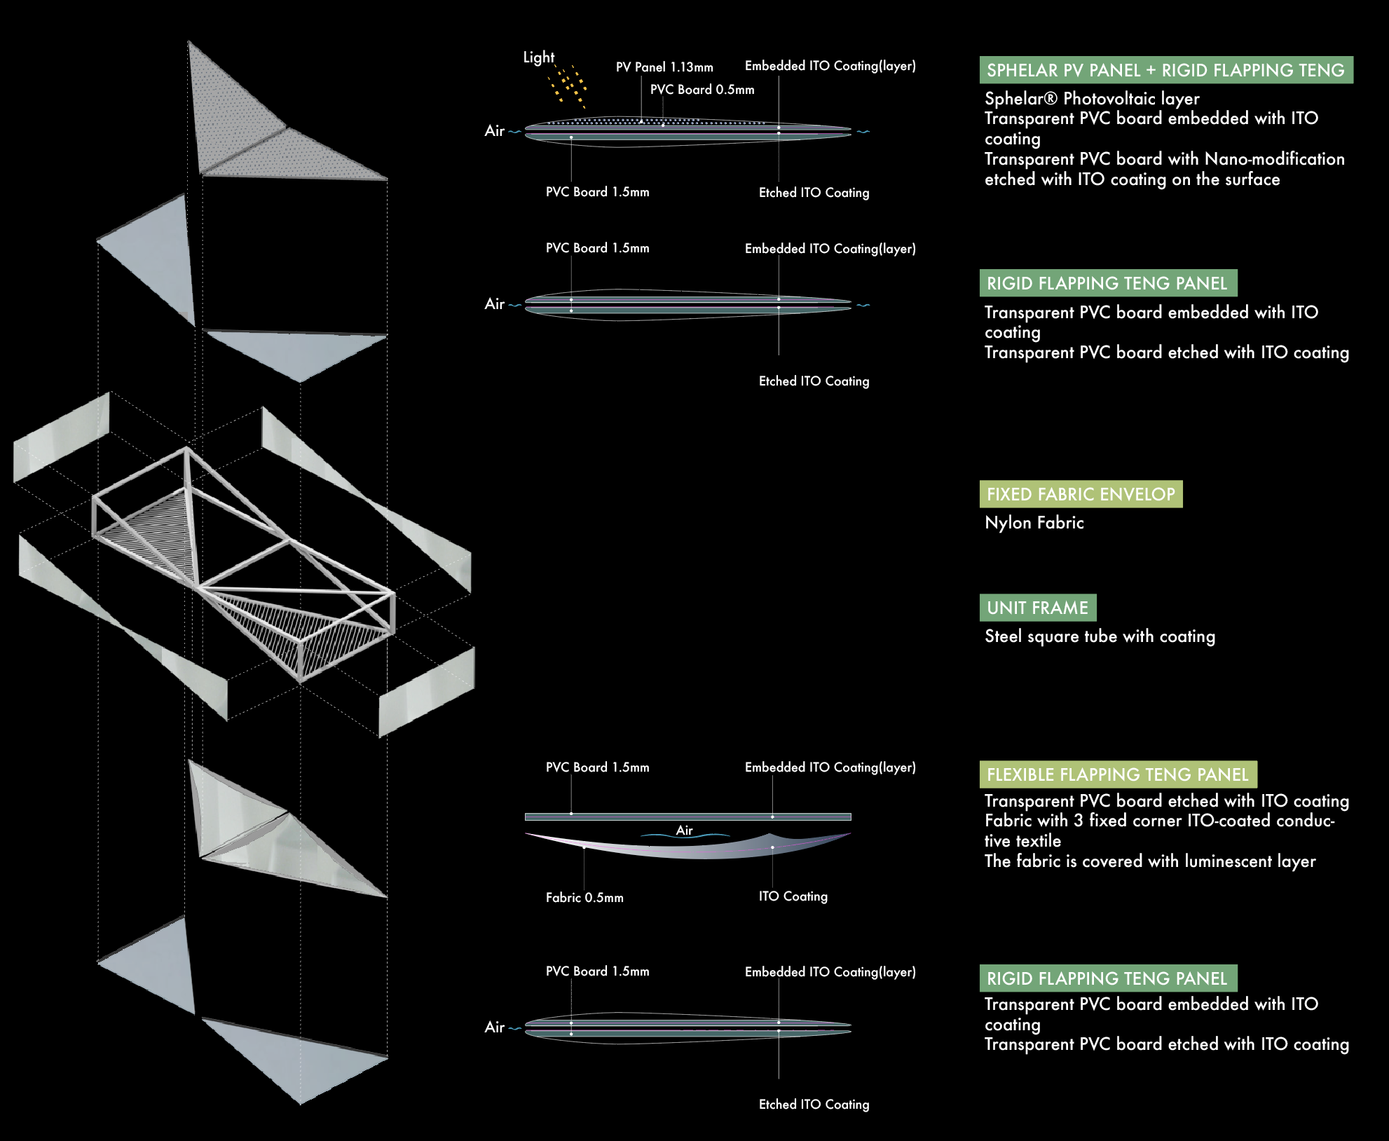
The energy harvesting unit consists of three types of different beating units:

Type 1 is a pair of rigid flapping units, which is composed of three layers(from top to bottom): the photovoltaic layer, the transparent PVC board embedded with a layer of ITO coating and the transparent PVC board with Nano-modification (roughening modification)which etched with ITO coating on its upper surface.
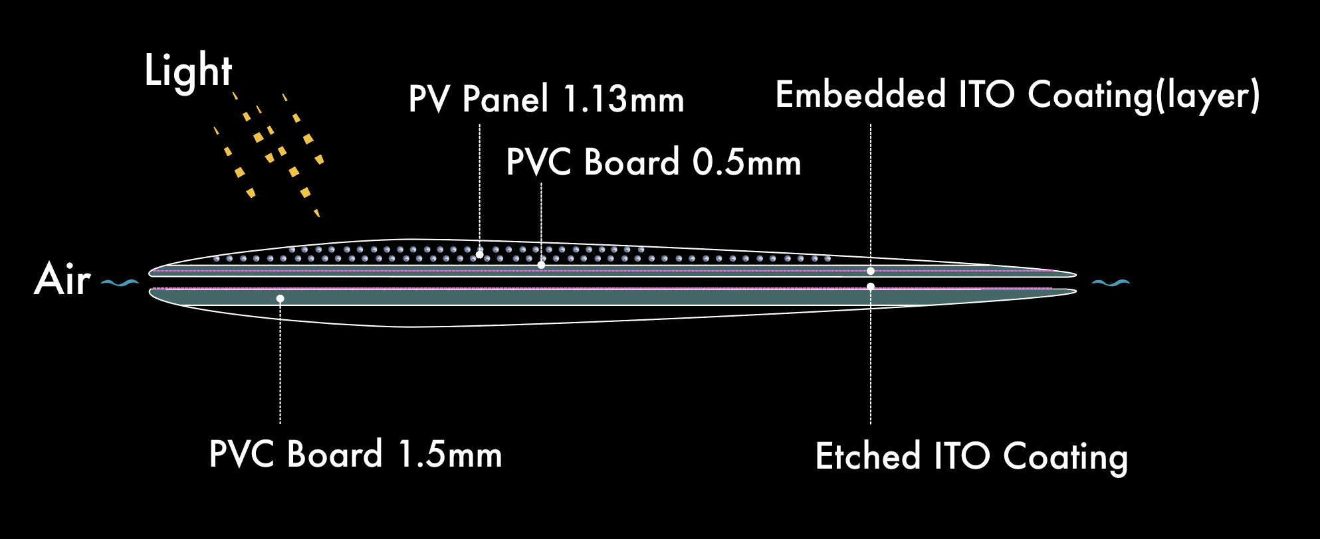
Type 1

Type 2 is a pair of rigid flapping units,
containing a PVC board embedded with ITO and a PVC board etched with ITO. 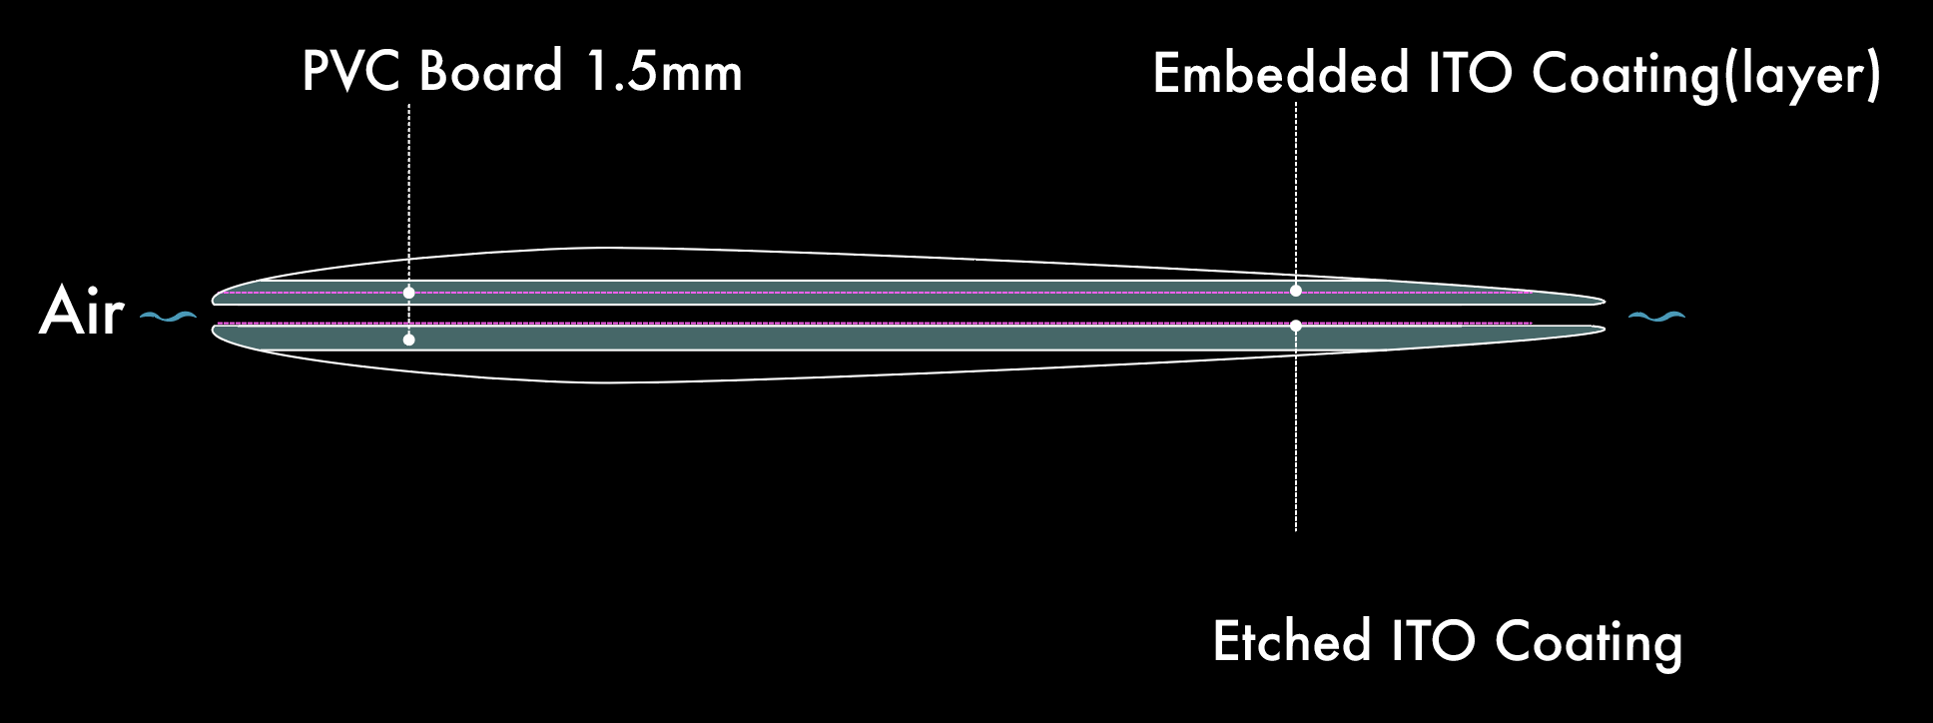
Type 2

For rigid flapping units, one corner of the upper floor is fixed, and the other two corners can be moved in the vertical direction.

Type 3 is a pair of flexible flapping units, including transparent PVC board embedded with a layer of ITO coating, and the conductive textile coated by ITO.
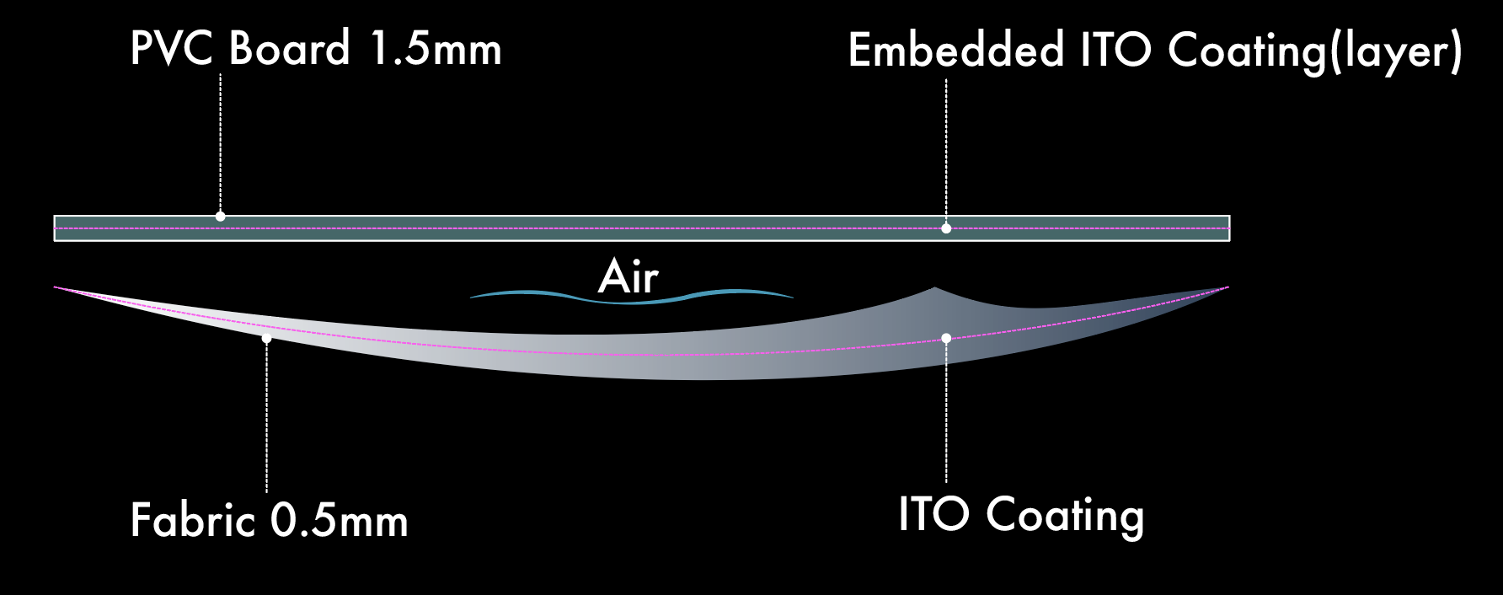
Type 3

2.1.2 Piezoelectric pavement
Piezoelectric pavement has been developed for many years. The piezoelectric material is embedded in the pavement in the form of cells, each of which is connected by a substrate. At the same time, rubber pad is embedded in the bottom of the unit to reduce damage and ensure resonance frequency.
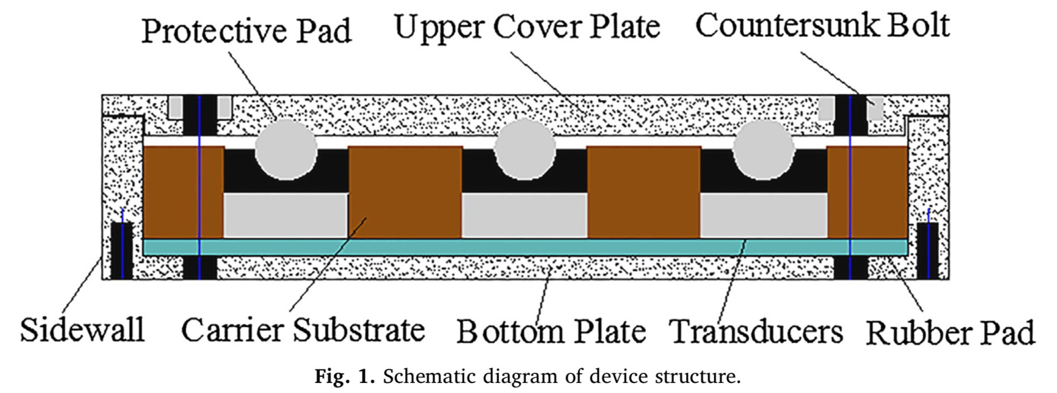
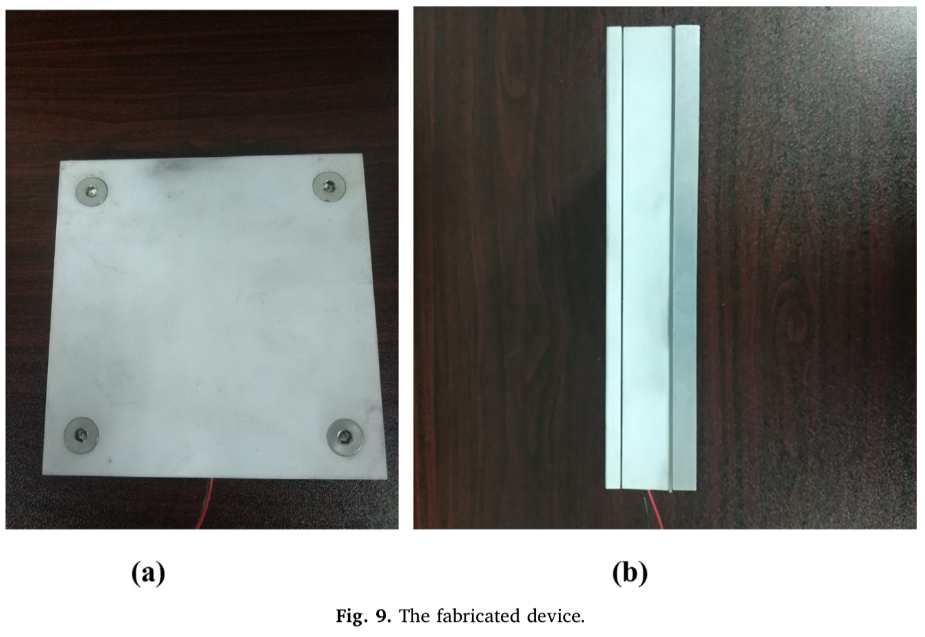
2.2 Device mechanism introduction
The upper surface of each rigid flapping unit is curved and will be subject to upward wind pressure after strong winds due to the theory of fluid continuity and Bernoulli's theorem[1]. When the upward force exceeds the gravity, the slapper will be lifted upward. At this time, due to the uneven wind pressure, the wind will quickly enter the lower surface of the flap plate, and the flaping plate will fall down. As a result, the flap plate can perform a quick and periodic flap under the wind speed exceeding a certain threshold. For the loose flexible flap unit, the fabric will repeatedly flap the upper layer of PVC under the action of wind[2].
In the process of flapping, according to the basic theory of triboelectric nanogenerator[3], materials with different electron gain and loss abilities can generate potential difference after contact and separation. As a result, our device can steadily collect the electricity generated by the conversion of wind and solar energy.

3. Capacity calculation
3.1 Device for wind energy
Due to the limitation of space, we only give the final calculation formula and derived results in this part. To simplify the model, we use similar work[4] to estimate our device productivity under ideal conditions and obtain the rigid slapping power per square meter is 2.86W/m² , the flexible slapping power is 2.88 W/m².
3.2 Device for solar energy
For photovoltaic panels, we use spherical power's BIPV series we use sphere power's BIPV series with a peak power of 24.6w per square meter[5].
3.3 Piezoelectric pavement
For piezoelectric pavement according to various theoretical calculation methods for different connection modes and our team choose one in this project[6]. Under the condition that loading is 0.7MPa and pedestrian contact frequency is 15hz, it can be calculated that the power of piezoelectric pavement per square meter is 2.4w.
3.4 integrative computation
After considering the brittleness of slapping plate, overall load bearing and local wind conditions, we limited the wind speed threshold to 6m/s and estimated the slapping frequency to be 1hz, while lift coefficient of the wing is estimated as 1.5. Thus, the total ideal power can be obtained as 303868w（wp）.
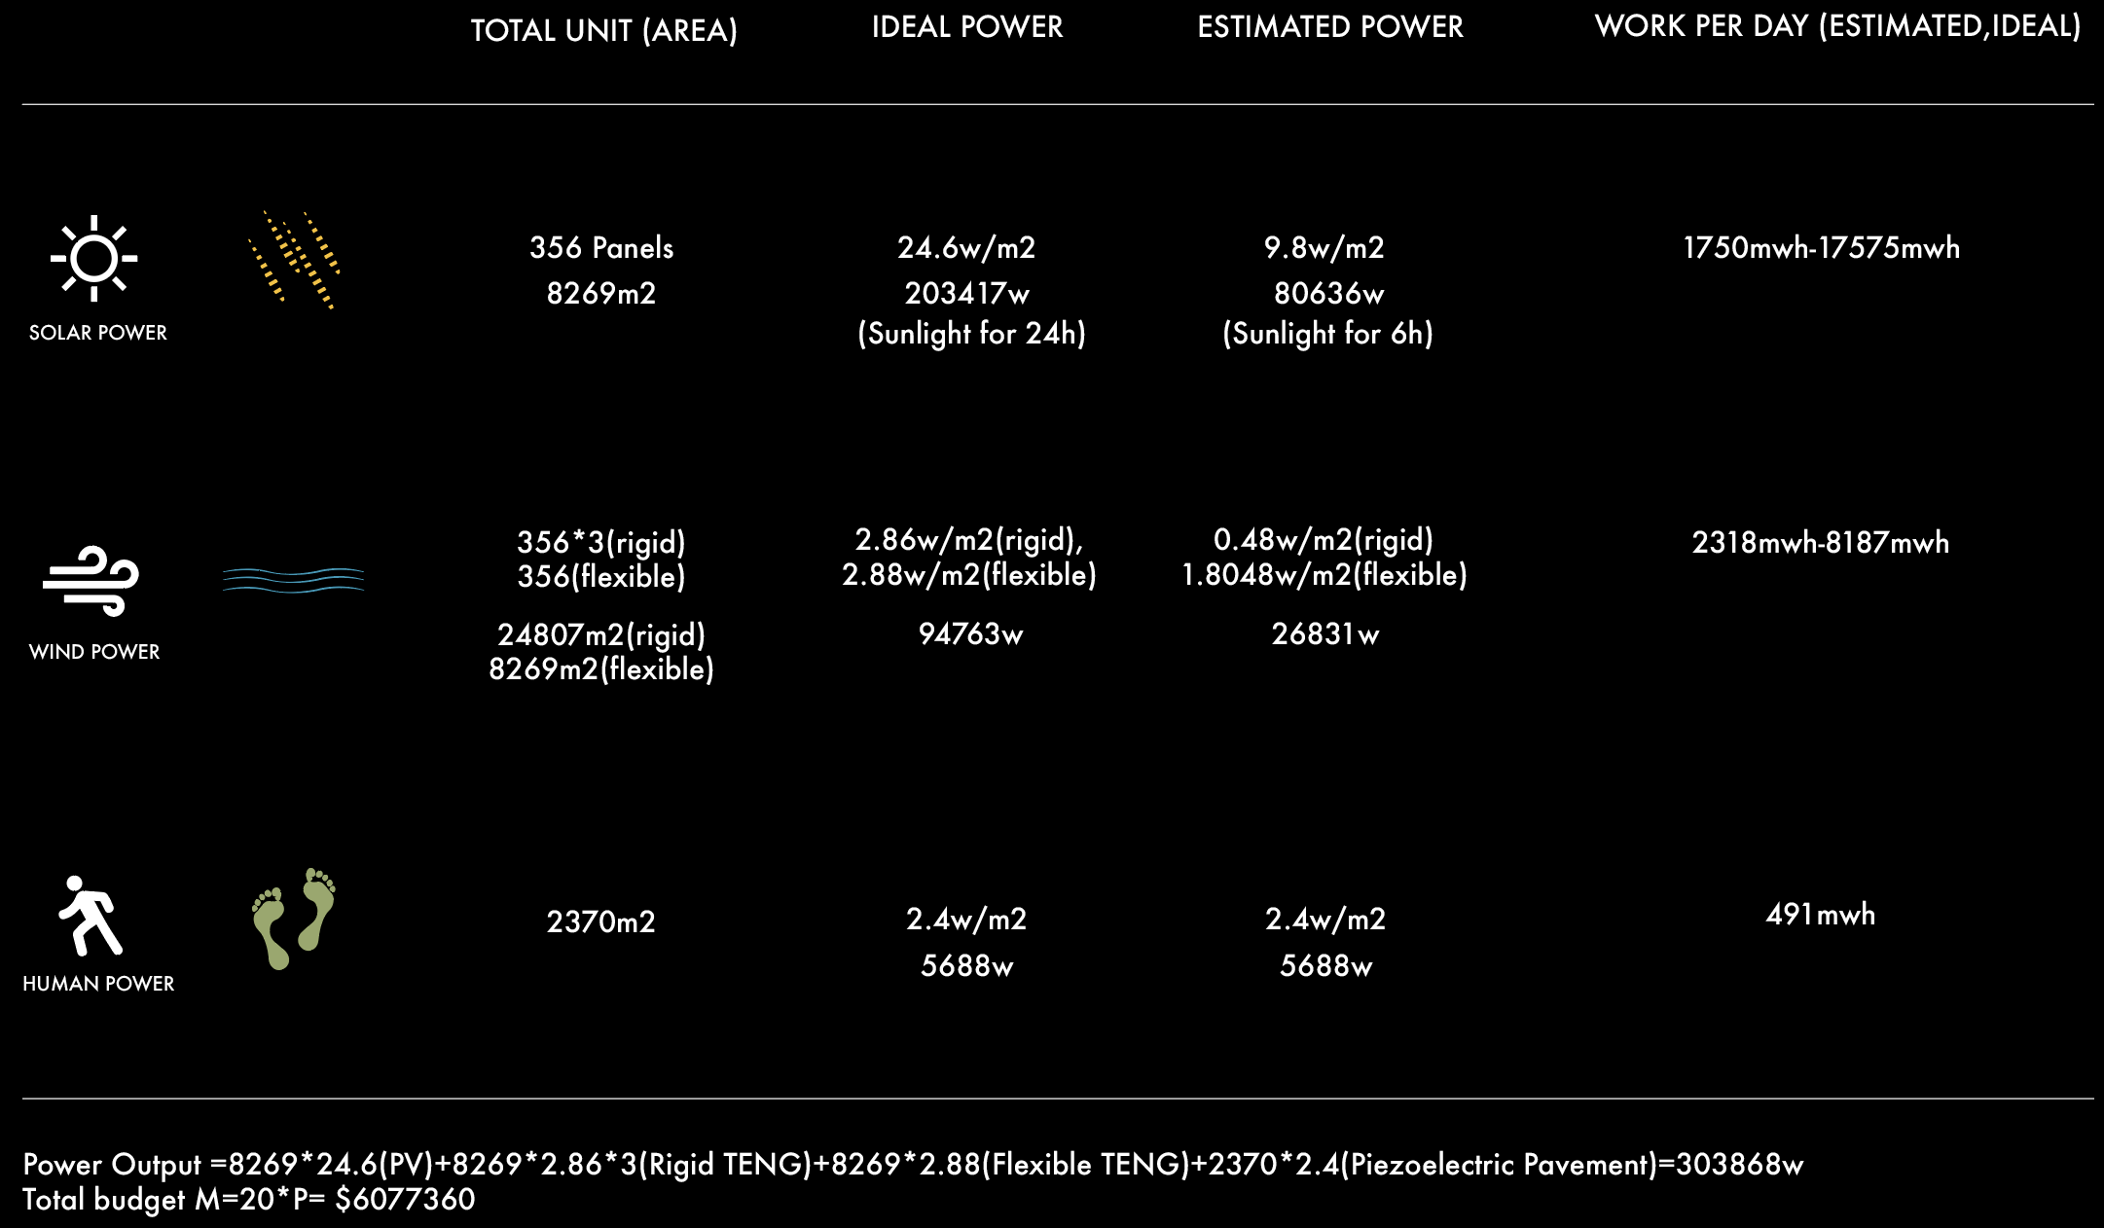
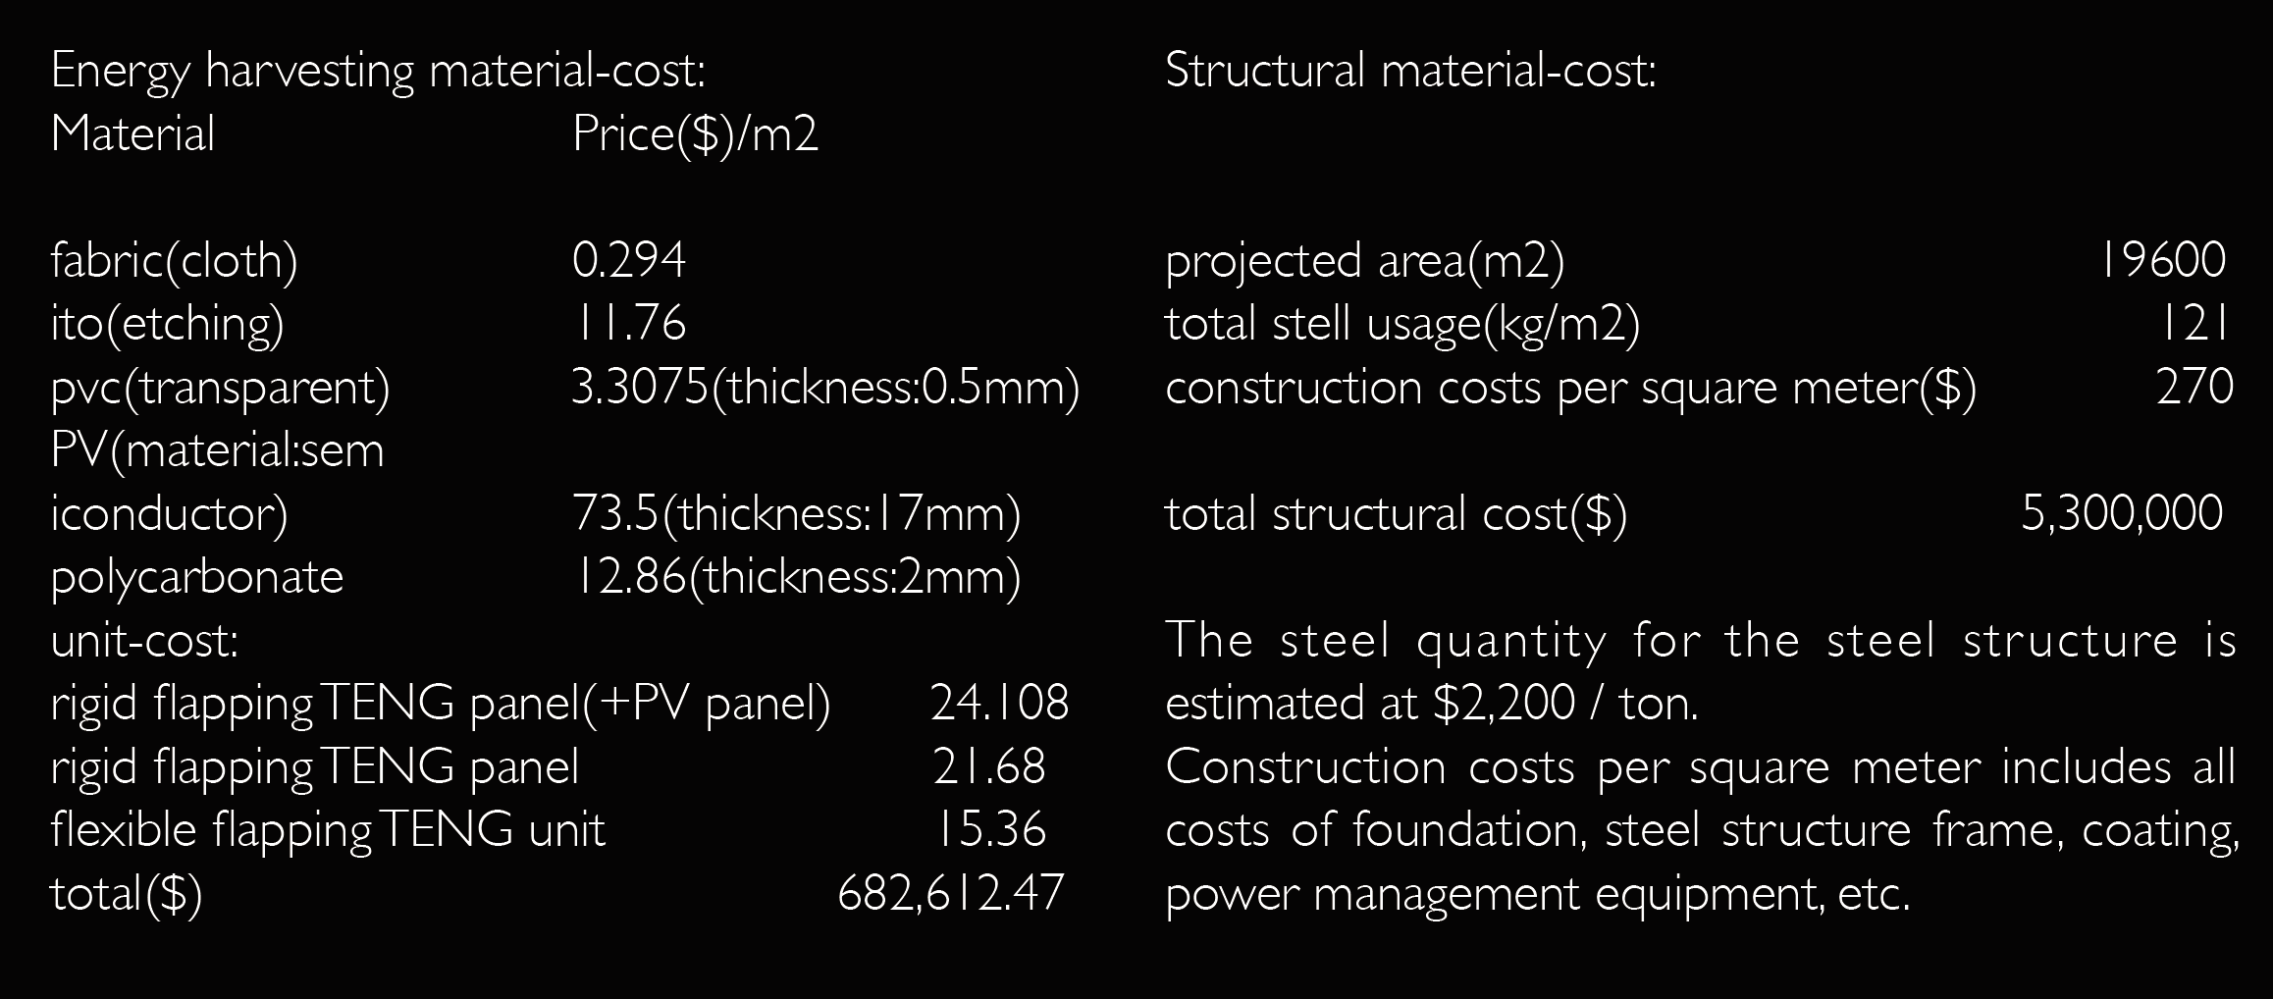

ENVIRONMENTAL IMPACT

The unit itself captures light and winds, connected to each other to form a light-wind penetrating shelter that filters violent sunlight, meanwhile enhance air movement, channelling pleasant breeze in the site, reduce water demand for irrigation of the park, which is suited to a hot and dry climate.
SURGE does not produce emissions – greenhouse or otherwise – nor any physical or airborne waste products. The structure is composed of recycled and renewable materials and, whenever possible, local materials with low transit impact. The steel structure is composed of recycled steel bar stock welded into custom shapes and is designed for clean deconstruction. PVC boards are biodegradable and can be recycled. Steel cable is locally available and easy to transport. Monocrystalline silicon PV glass panels, PVC boards and fabrics are distributed locally. The fabric can be made from recycled plastics such as water bottles and containers, reducing the amount of waste and landfills.
Due to the park is located in a crowded area, the piezoelectric pavement of the park should provide easy construction and recyclability. The device is made of aluminium, polypropylene and steel which is easily accessible in the local building market. The device offers maintainability so that if a power-generation pavement is damaged, the device can be recycled.

References: [1] Munson B R, Okiishi T H, Huebsch WW, et al. Fluid mechanics[M]. Singapore: Wiley, 2013. [2] Wang S, Mu X, Wang X, et al. Elasto-aerodynamics-driven triboelectric nanogenerator for scavenging air-flow energy[J]. ACS Nano, 2015, 9(10): 9554-9563. [3] Niu S, Wang S, Lin L, et al. Theoretical study of contact-mode triboelectric nanogenerators as an effective power source[J]. Energy & Environmental Science, 2013, 6(12): 3576-3583. [4] Yang B, Zeng W, Peng Z H, et al. A fully verified theoretical analysis of contact‐mode triboelectric nanogenerators as a wearable power source[J]. Advanced Energy Materials, 2016, 6(16): 1600505. [5] Nakata J. Spherical cells promise to expand applications for solar power[J]. Asia Electronics Industry (AEI), 2001, 2001: 44. [6] Wang C, Zhao J, Li Q, et al. Optimization design and experimental investigation of piezoelectric energy harvesting devices for pavement[J]. Applied energy, 2018, 229: 18-30.

