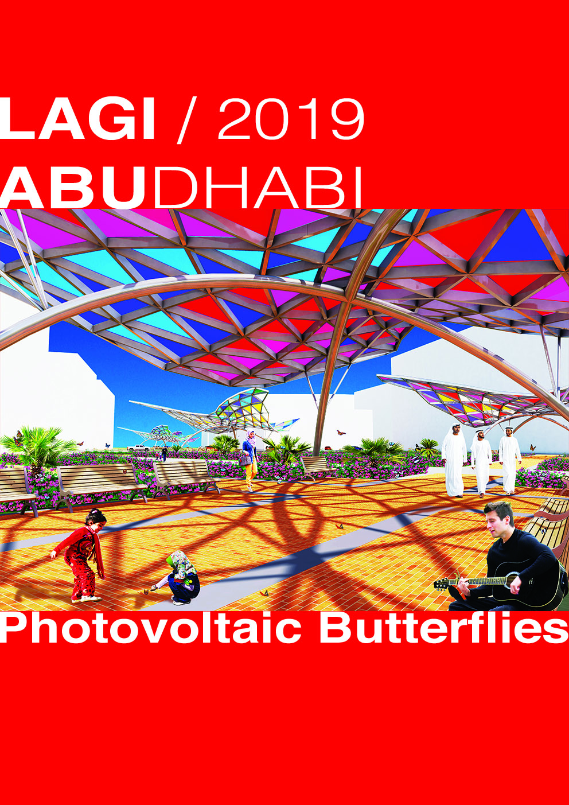
DESIGN DESCRIPTION.
The design of the renewable energy infrastructure is made up of five sculptures that resemble a group of butterflies that cross the space in a northerly direction, whose colored wings are made of photovoltaic glass, and mostly have a slope of 25 degrees facing south optimize electrical production. The structure of the wings is a double curvature plane aimed at the structural optimized.

The design of the park is inspired by the balance between nature and human habitat, presenting two paths, one of free form that represents nature and is the continuation of the proposed master plan of Masdar City, and another in the form of a grid that represents the city. The green areas between both paths include species of palms native to the place, and are bordered by plants that attract butterflies, so that they inhabit the park permanently.
TECHNOLOGY USED IN THE DESIGN.
The technology used to generate electricity is amorphous silicon PV glass.
CAPACITY IN kWp.
The capacity expected is 114 kWp.
ANNUAL kWh.
The annual energy expected to be generated for the five sculptures is 221,926 kWh.
PRIMARY MATERIAL USED IN THE DESIGN.
Sculptures | Quantity | Units | Unit value | Final value
Amorphous silicon PV colored glass. | 1975 | Square meter | 190 | 375250
Metallic structure. | 2400 | Kilogram | 1,8 | 4320
Foundations. | 10 | Cubic meter | 180 | 1800
Total value of the sculptures | 5 | US dollars | 77474 | 381370

Park | Quantity | Units | Unit value | Final value
Granular sub base | 11971 | Square meter | 4 | 47884
Stoneware pavers. | 6689 | Square meter | 35 | 234115
Concrete pavers. | 3346 | Square meter | 39,5 | 132167
Cast concrete floor. | 1938 | Square meter | 22,5 | 43605
Green areas and gardening. | 11103 | Square meter | 7,5 | 83272,5
Electrical wiring (underground). | 231 | Lineal meter | 64,5 | 14899,5
Urban furniture. | 1 | All in value | 21510 | 21510
Total value of the park | 1 | US dollars | 577453 | 577453

ENVIRONMENTAL IMPACT SUMMARY.
The environmental impact is positive, generating clean energy and including large green areas and species of butterflies in the habitat. Likewise, the use of recyclable materials such as steel and glass in the sculptures and the use of the same materials from the surrounding floors minimize the impact of the environment.
