SOLAR PRESENT

Narrative

Solar - Relating to or determined by the Sun.
Present - In a particular place; Existing or occurring now; A gift.
Solar Present is a portal to Masdar City in Abu Dhabi and it is inspired by the moments when the Sun touches Earth as it enters and exits the East and West horizons. We use proportion, shape, orientation and the elements to connect the portal’s dimensions with other spheres in our solar system and the people experiencing it.

The Portal contains three sculptures made of earth harvested from the site. Each sculpture corresponds to a moment of the Sun’s trajectory around Earth.

Where the Sun rises, there is a sculpture dedicated to desalinate water using direct solar heat. The desalinated water is used for site irrigation and to provide a cooling mist throughout the portal. The center, is a sculpted elliptical underground breezeway that provides shaded gathering areas throughout the day while connecting the East and West parts of the site. The Sun’s exit holds a rammed earth spherical-quadrant oriented to maximize solar exposure to its spiral made of standard modules of monocrystalline silicon photovoltaics.

Sculpture Characteristics:

Sun Sculpture:
- Provides a gathering shaded area below.
- Generates 1,500 MWh annual capacity.
- Uses standard sized pv panels arranged in a visually pleasing spiral form.
- The pv batteries and systems are contained inside the sculpture and away from sight
- Lights up during night and special events
- Net zero electricity

Underground Breezeway:
- Connects the East and West portions of the site
- Contains shaded seating and gathering areas.
- Cooler temperature by using earth’s thermal mass.
- Air cooling mist for human comfort.
- Provides a space for safe pedestrian crossing under the street level.
- The breezeway lowest point is at 7m below grade [the water table is at 10m-13m below grade].

Water Sculpture:
- Solar water desalination plant.
- Doubles as a rainwater collection tank.
- Collects / produces up to 248,000 liters per month. It satisfies the site’s water demands.
- The water is used for landscape irrigation and micro-climate air cooling mist.
- Net zero water balance
- 2,000,000 liter tank capacity for additional recycled water reservoir.
- Has the capacity to serve as water storage for neighboring buildings as part of the recycled water program.

Technologies Used

Sun Sculpture Technology:

The Sun Sculpture uses standard size modules of high efficiency monocrystalline silicon photovoltaics in this proposal. The following pages show the cut sheets of the solar panel product used for our proposal energy analysis. However, the Sculpture’s design allows it to accommodate a diverse range of rectangular shape photovoltaic products. The diagram below illustrates the Sun Sculpture technology in more detail:

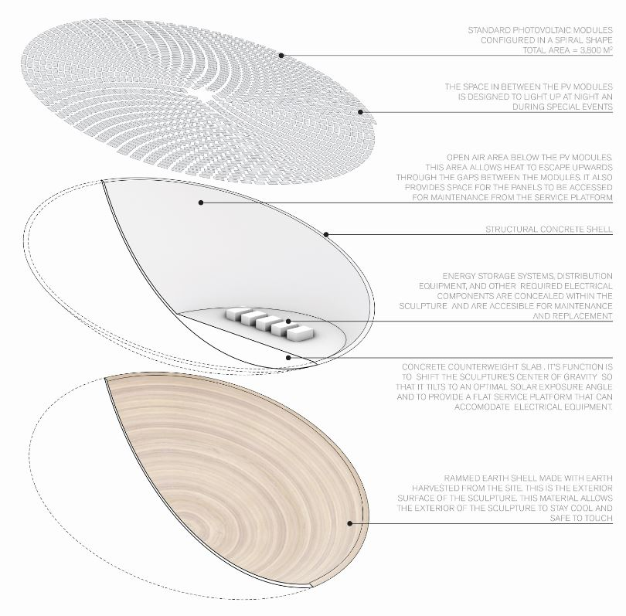

Water Sculpture Technology: [Passive Technology]

The Water Sculpture uses solar heat to perform as a water desalination plant. This passive technology enables the sculpture to satisfy the site’s water demands - including landscape irrigation and a micro-climate air cooling mist proposed for the site. The diagram below explains the sculpture’s components in more detail:

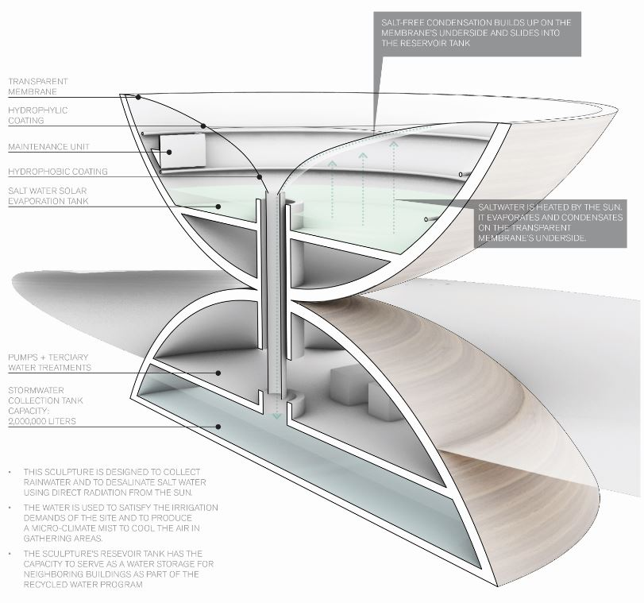

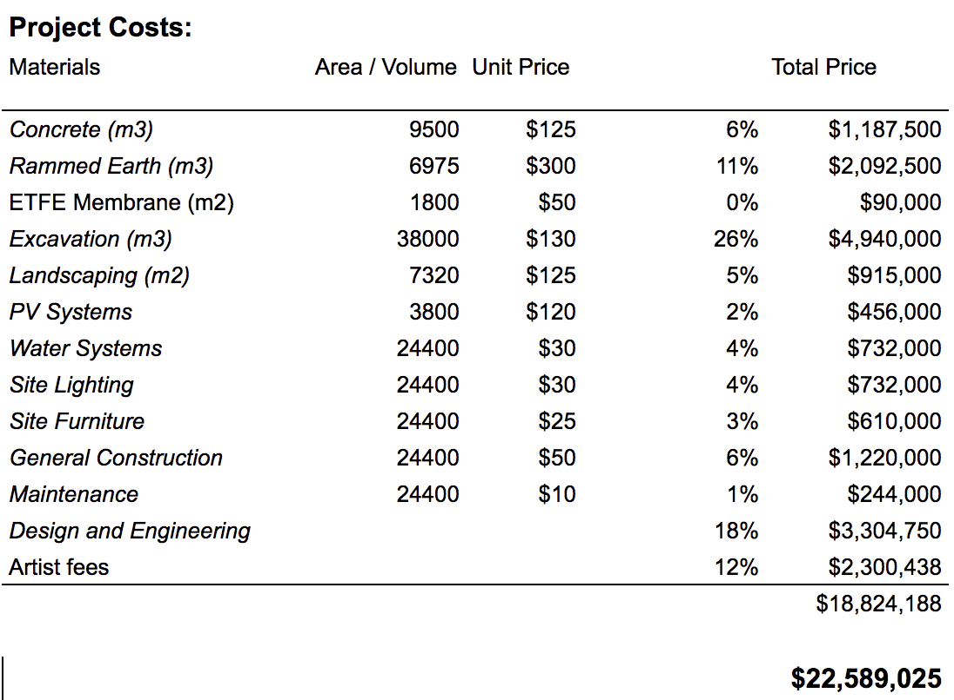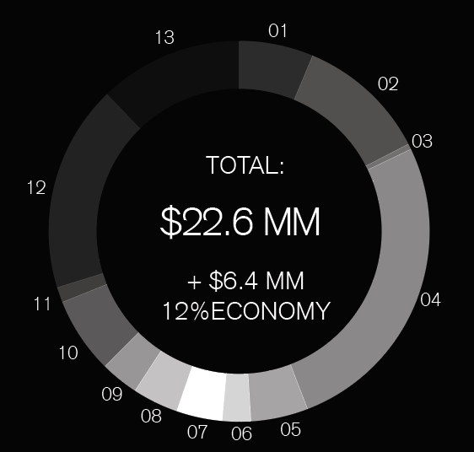

Environmental Impact Summary

The project creates a balance between its environmental elements. The Sun Sculpture can produce up to 1,500 MWh annually and harvest up to 2,000,000 liters of water per year for the site’s water needs. The Water Sculpture is optimized to collect rainwater on-site and use passive solar heat to evaporate saltwater and collects the condensed water in a tank so it can be used for site irrigation. The site plants will benefit from this renewable reservoir and in return, it will create a more comfortable environment for people in the urban landscape. The collected water can also be served as a mist to create microclimates for gatherings and public use. The water demand is throughout the year in balance with a net zero water use with the potential to connect with an urban recycle water program.

The electricity is provided by standard modules of photovoltaics in the Sun Sculpture. They can produce enough electricity for the site and share with the urban grid. The annual power generated can offset up to 1,000 tons of eCO2. The project incorporates local earth for additional thermal mass and the onsite energy and water harvesting. All the materials considered result in an embodied carbon of 700 tons of eCO2. With a rapid potential to balance the embodied carbon, the site can become carbon neutral in a short period, along with water and energy neutral.

Water Evaporation Study
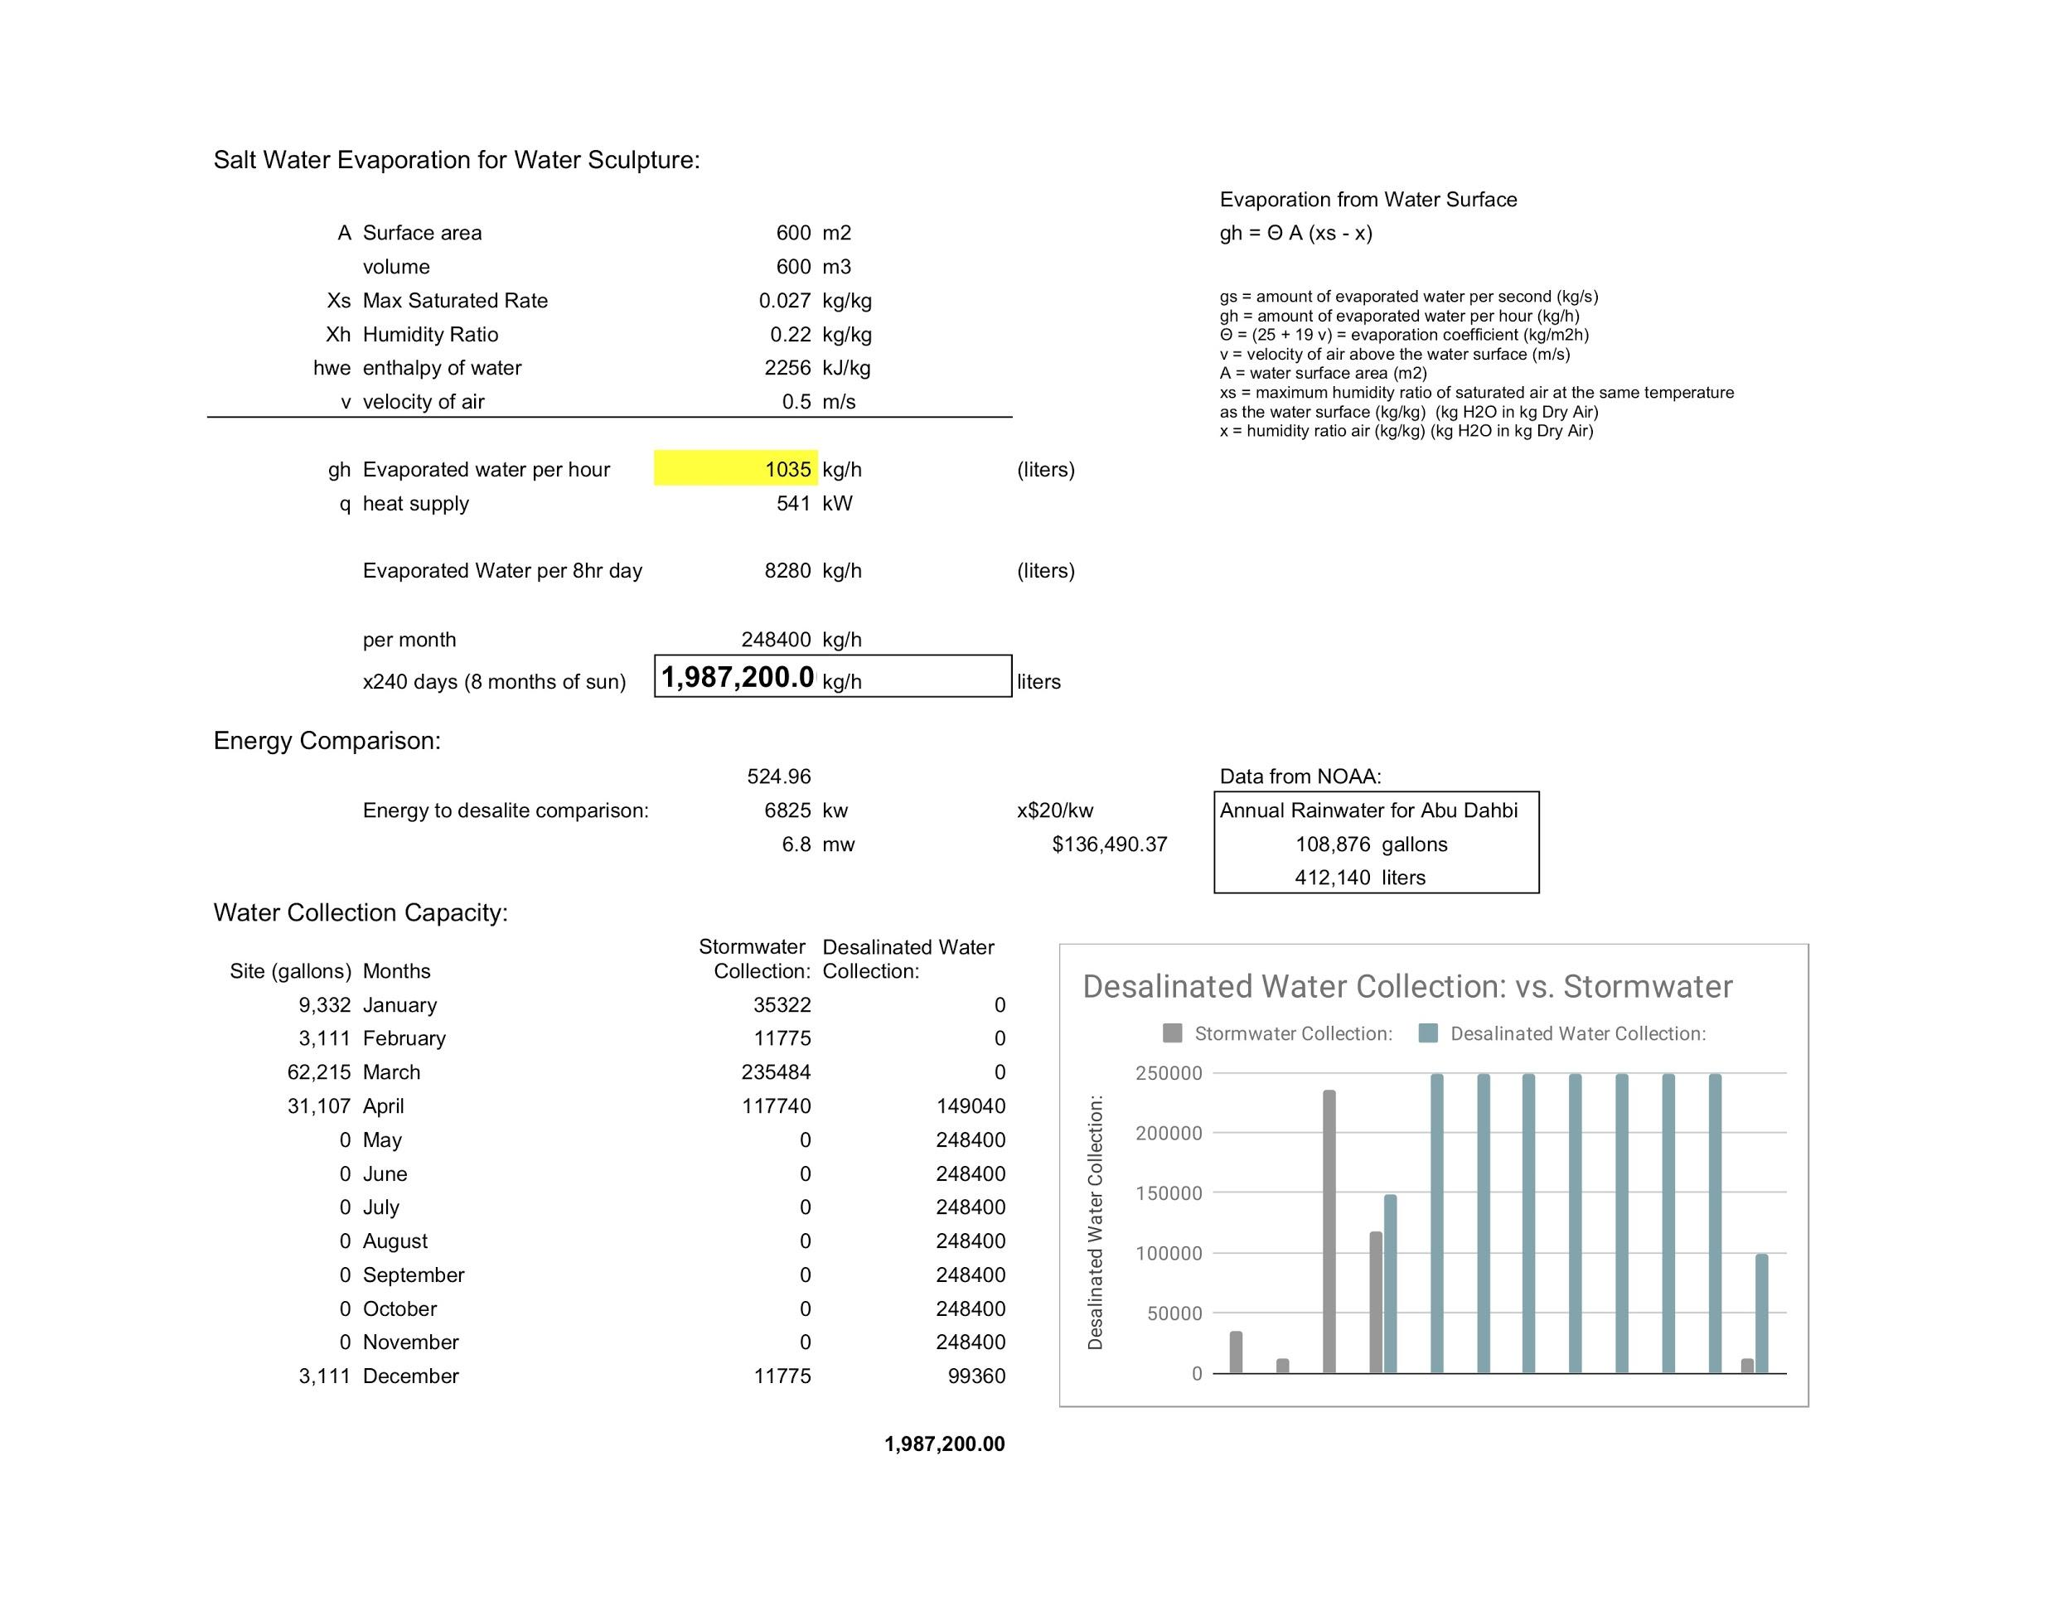

Photovoltaics Solar Energy Study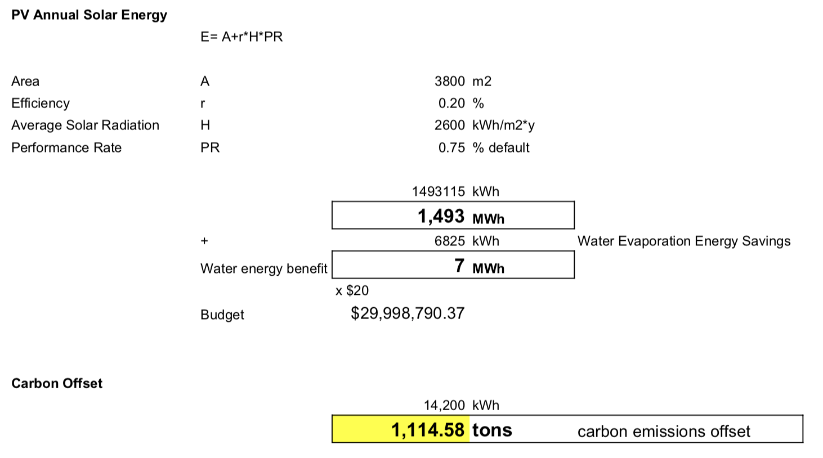:

Additional Photovoltaics Solar Energy Study:

