LAGI 2019

Masdar

Oasis

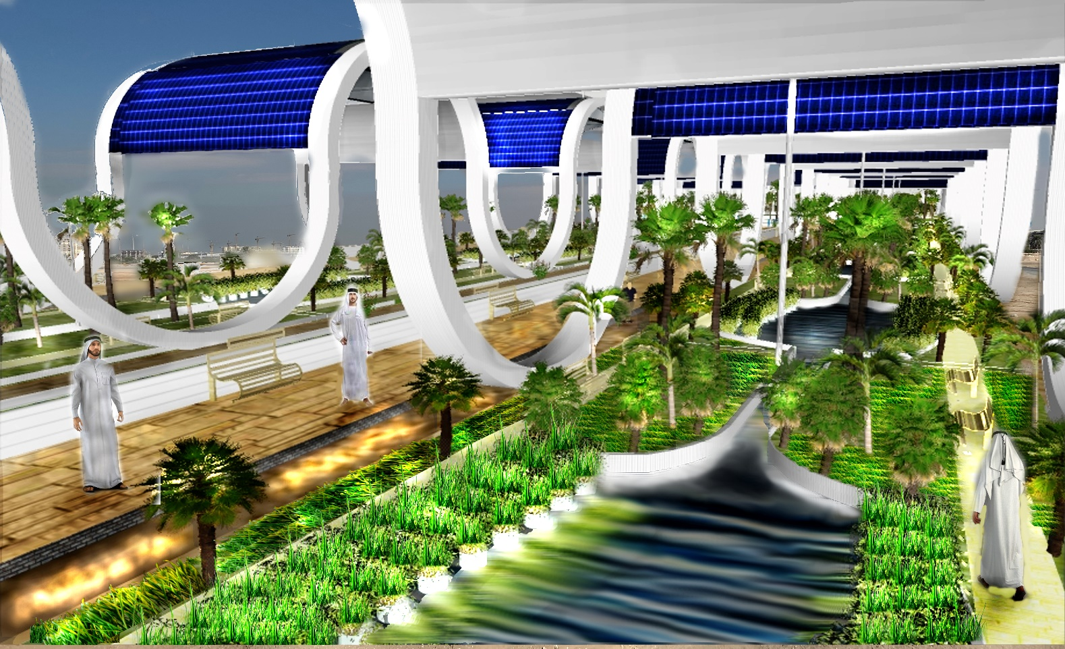

Introduction:
Traditionally, the most important environmental problem relating the large land use of PV modules is that under their surface there’s no life, this fact is caused by the total absence of light and space. Oasis provides an original and buildable solution for this challenge.
The very important connection between energy and environment is at the center of the project. The whole idea is to create an ecosystem under solar panels that is able to support with energy produced by itself (in a passive and active way) and to harvest new energy for Masdar City from natural resources.
Visitors can appreciate how a correct use of energy and modern technologies can bring life to an ecosystem able to produce even more energy.
The objective is to show the impact that energy has on the environment, showing that even in an arid climate it can be brought to life a “Green area”, an ecosystem naturally cooled in which can live different types of plants (overall palms),grasses and algae, all of these fed by water that, due to the natural cooling system and the same structure, has a very low evaporation rate (so there’s no the need to substitute it).
The project integrates well with the surrounding landscape and Masdar city prospect. The corrugated structure reminds to the Mangrove plants that characterize UAE natural reserves. Also, non-linear shapes can integrate well into the Arabian architecture, expecially in the new born city of Masdar.

Energy Generated
Technology used | Energy generated(Mwh/ year) | Capacity | Efficiency | Surface/Volume: | Cost:
Thermal energy (small and big spheres) | 182 Mwh | 450 w/m² | 50% | 2,43 m²(small)  29,2 m²(Big) | 25099 $
Electrical energy (small and big spheres) | 72,8 Mwh | 180w/m² | 50% | 2,43 m²(small)  29,2 m²(Big) | 36725 $
Microbial fuel cells | 1,95 Mwh | 0,5 w/m³ | 80% | 0,06 m³ | 19500 $
Flexible PV: | 1264 Mwh | 239 w/m² | 0,24% | 1,23 m² * | 262321 $
Transparent PV: | 213 Mwh | 239 w/m² | 0,20% | 1196 m² | 44879 $
Total: | 1714 Mwh |  |  |  | 388524 $

*Because the photovoltaic is flexible and is curved, the power generated depends by the angle between the normal to the surface and the incident ray. In this project all the surface is approximated with a series of smaller surfaces (1,23 m² ) each one inclined 1° differently between 14° and 90° (76 differently-inclined surfaces). The power generated is the sum of all these surfaces following the formula:
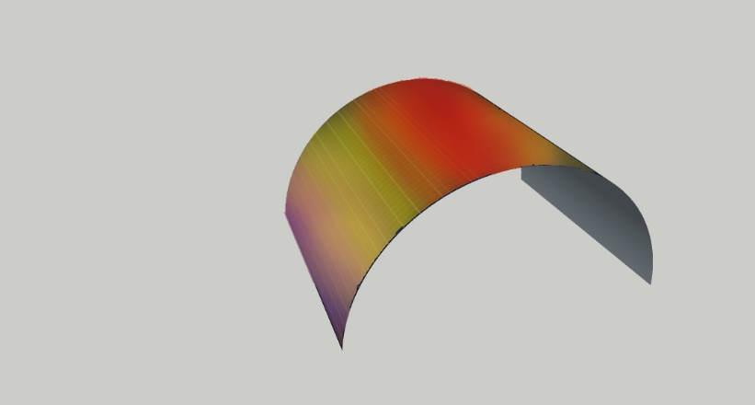
239 w/m² *1,23m² *0,24*0,7*sin(a) With a°= angle between the surface and the ray (14<a<90)

Technology used:
- Flexible photovoltaics: Multi functionalized silica nano-particles in a siloxane matrix
(Using nanotechnologies +4% efficiency from normal PV )
-Self cleaning: A relevant problem of PV in the desert is the large amount of water used to clean the modules from sand brought by wind. With nanotechnologies is the same material that has the ability to clean itself, saving energy and money. Also the semispherical shape of the modules limits the settlement of sand, increasing the efficiency.
- hydrophobic: Due to the use of nanoparticles inside the matrix water leans on the surface with contact angle of 107,1° (with contact angle >90° the material is considered hydrophobic)
-heat resistant: After different stages of R&d, this material can resist to temperatures higher than 150°, increasing the efficiency and safety.
Tickness: 200-400 nm due to the production on a nanoscale, due to this characteristic the panel can have different shapes
+4% efficiency
Transparent: nanoparticles used can be smaller than the length of waves of light, so the panel does the photoelectric effect and let light pass through it.
Silica chemistry is less-hazardous and more affordable.
-Spherical PV+T: Similar to Rawlemon
-Microbial Fuel Cells: Emerging technology with a bright future, in this project are used algae (best fit in acquatic environment) and juncus effuses (best fits in desertic climate), proven to have a good efficiency.

Environmental impact valutation:
The whole project takes care about environmental factors like the quality of water and air, the land contamination and the use of soil and the safety of the visitors. The water used in the artwork is not in direct contact with drinkable water, and is frequently pumped (using the same energy produced in the artwork) in order to avoid stagnation. The great number of plants and algae avoids 17100 kg/co2 per year. Bacteria and microorganism in water are not dangerous for humans. The whole project does not cover land because an optimal sunlight is granted.

