Climate Canopy

The main idea of designing this structure is to create a public space for visitors and future citizens of the Masdar city with unique features. Considering the context of the region has played a vital role in the architecture of the artwork and because of the hot climate of the Masdar city, a wide roof was designed to provide the comfort of the people under it. This roof that inspired from THE UAEs topography that mainly consists of sandy deserts. The material‏ of the structure is transparent which provides daylight during the day.
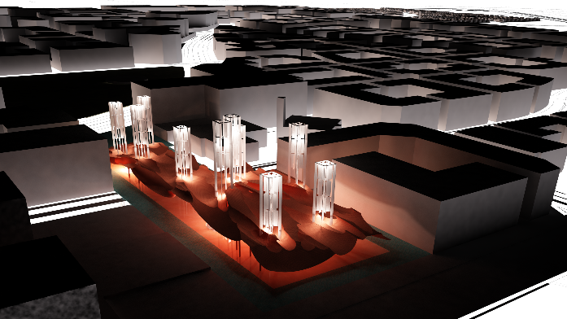
Night view

For generating sustainable energy we inspired from the wind catchers which is a traditional Persian Gulf coastal architectural element to design a unique turbine system element that the energy generating from turbine rotation transfer under the roof that moves fans and causes natural ventilation in public space and generates electricity.
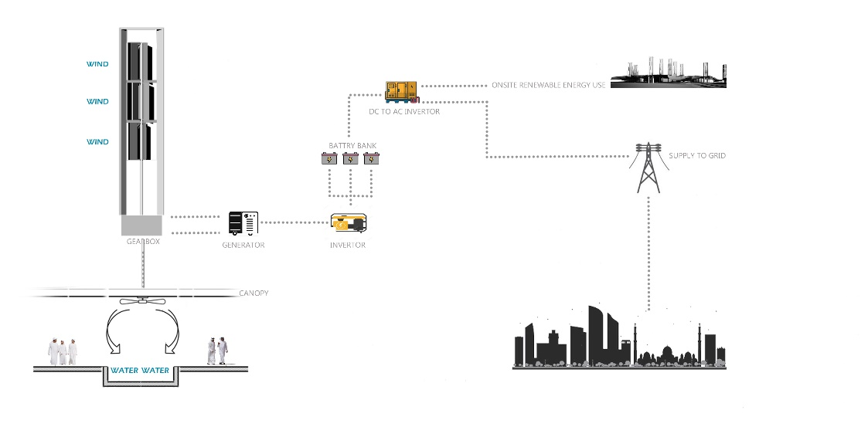
diagram of generating energy from vertical turbine

The space under the roof provides opportunities for recreation, events, and interaction all night long. It is always active all day long.
The road under the roof structure provides a place to pause and experience a resilient destination that makes people feel inspired by local culture.
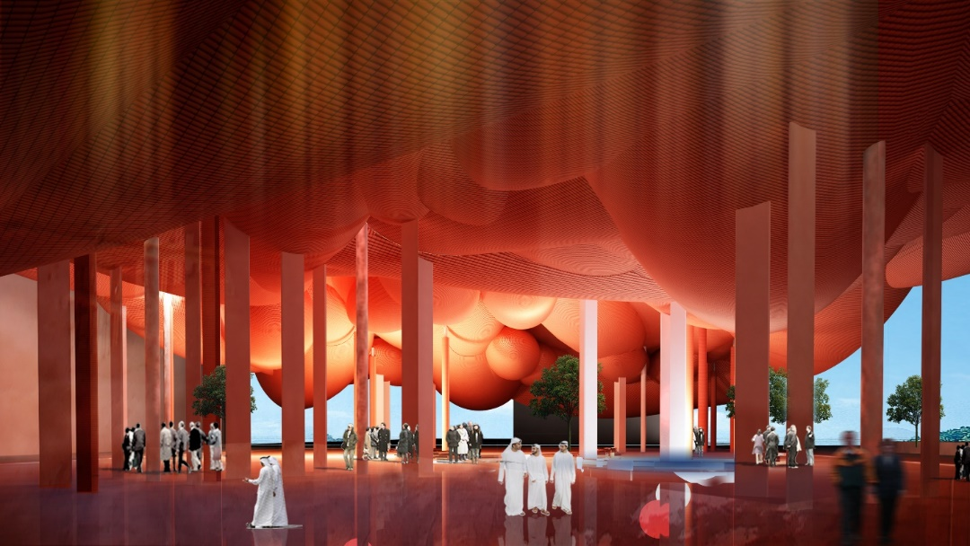
Under space of the roof

Environmental impact summary:
.It doesn’t generates any greenhouse gas emmisions
.Using wind power as a energy source is one of the renewable energy
.It doesn’t have any negetiveimpact on human or habitats

Annual kWh (kilowatt-hours) of energy expected to be generated:
according to average wind direction and velocity , it is estimated that each turbine structure would generates 10 kwh energy . the annual kwh is approximately 224000 kw.

