DESERT BIOME
a photovoltaic cactus garden

Idea and environment impact statement

The primary task is to build a device able to generate carbon-neutral electricity, harvesting energy from the environment in an efficient and cost-effective way. The goal is to create at the same time an extra value for the place.

If the primary objective is to produce electricity, what can be the added value we give with our design?
Aesthetic, for sure! And then? Something else, something more?

We decided to take a flight to Abu Dhabi to investigate something more about the place, to understand what to do.
We found a country with extreme climatic conditions; we understood that the elements we were called to work with were sun and shade, heat and coolness, dryness and water. In a word the climate. The environment.
Enhancing, locally, the climatic quality, creating a better habitat in terms of microclima, shade, water. This was the goal to achieve. The “extra value” to give.
With the goal of developing a site-responsive, climate-responsive design solution, sure that an answer is already there in Nature, we started questioning the native plants of world’s hottest and desertic areas and how they responded to local condition developing appropriate solutions and using readily available resources.
Observation of nature’s behaviors and stratagems became a limitless resource to develop appropriate innovations and gave us an image of what architecture potentially can be.
Do think of a cactus. How it works in such a perfect and simple way, continuously taking and giving back from and to the environment, enhancing the microclimatic quality of the places where he sits.

The cactus in its evolution has developed devices and stratagems to survive in adverse conditions of extremely hot, dry climate where annual rainfalls are very low.
With its robust skin it protects itself from the sun and with its spines during the night it collects dew water and direct it towards the ground near its roots.

But what it’s even more interesting about this very refined survival system is that it does not only benefit the single plant but it generates positive effects on a larger scale for the environment and other small plants and living being. The presence of the cactus with its shade and its system of atmospheric humidity collection in fact creates at its foot a shaded and humid environment, favourable for the installation and proliferation of other plant and animal species that get free benefit from this microclimatic condition.

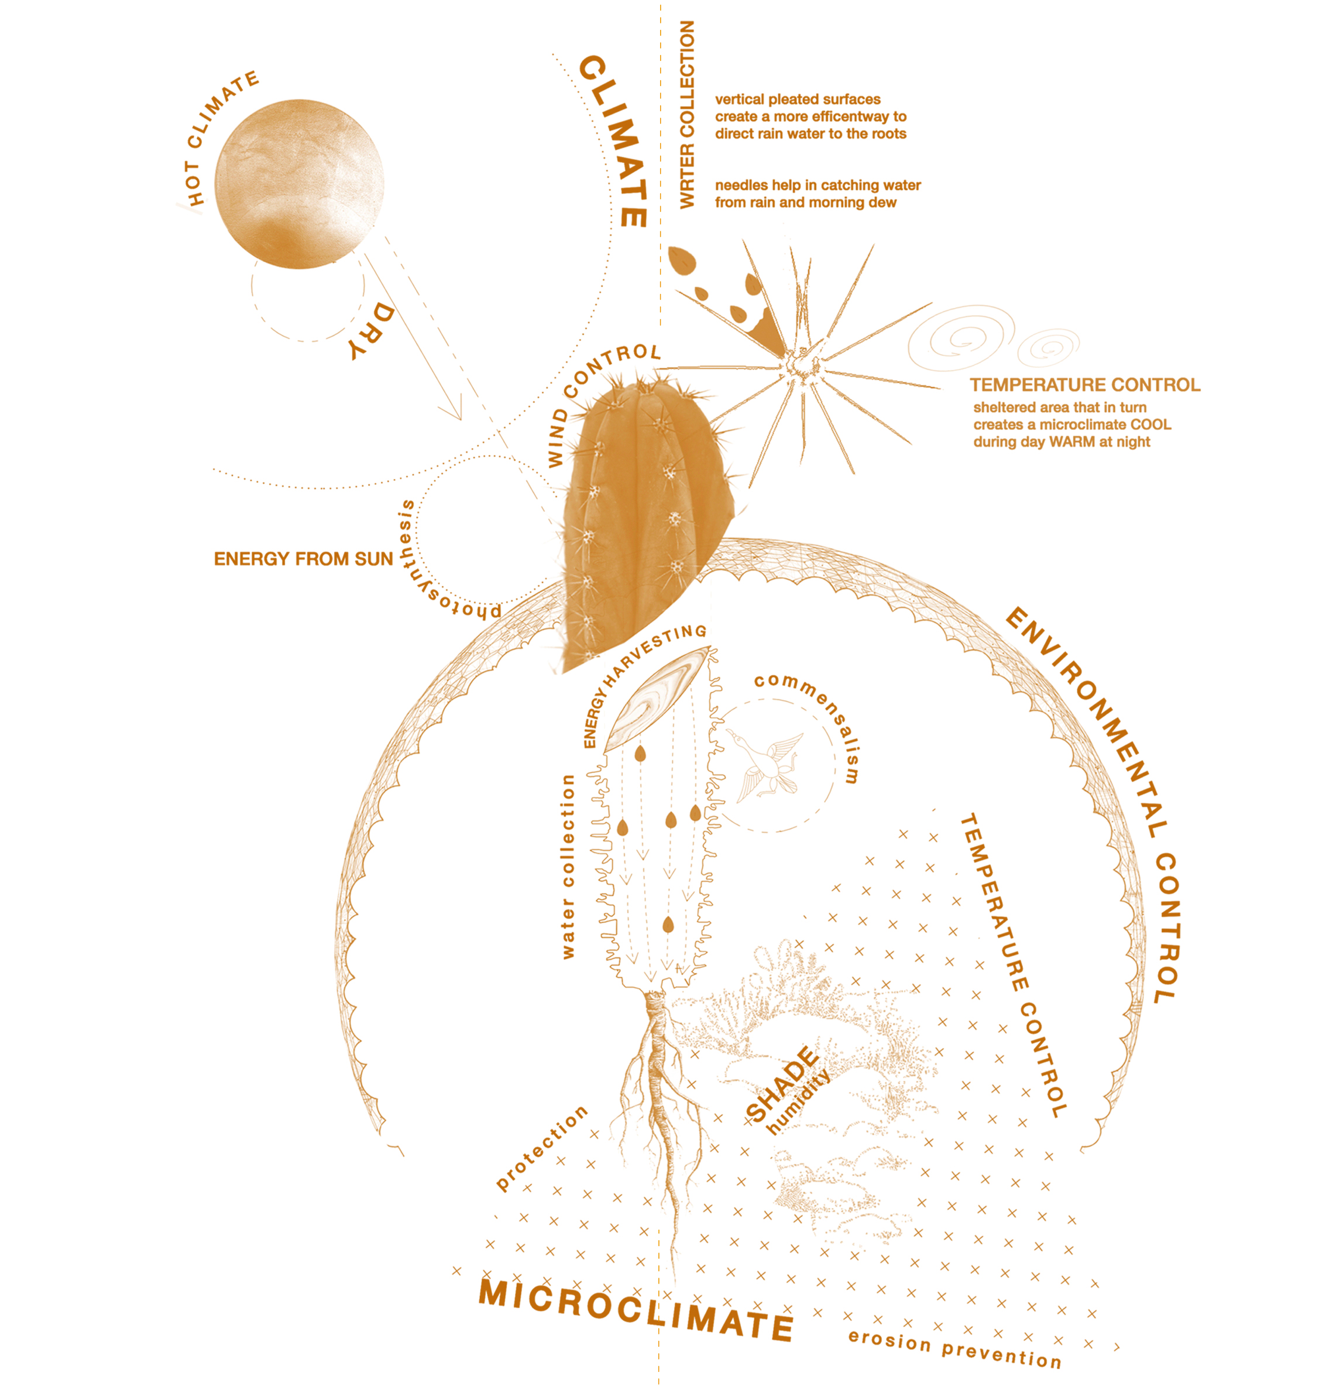

Imagine if similarly, every time that we capture energy from the sun, we could at the same time giving back something to the place, creating a better habitat in terms of microclima, shade, water.

The solution to two of the Abu Dhabi’s (and World’s) most pressing questions: post-carbon energy supply and climatic control, in one of the world’s hottest regions, could be simpler than many previously thought. A Cactus. A photovoltaic cactus garden.

Project, dimensions, material and technologies

The project is configured as a cluster of four "Solar Cacti" raised from the ground and connected by a system of paths and elevated walkways.
Each Cactus is a technological device designed to produce electricity from the sun and wind, to collect water from the atmosphere and at the same time to create a favourable microclimate mitigating, locally, the dry-hot desertic climatic conditions of the place.

Each Cactus contains at its feet a lush green oasi with innumerable plants, trees and water bodies. A cool and shady place where visitors but also different animal species can find shelter and relief from the external heat.

The favourable, extraordinary microclimate and environment inside our “Artificial Cacti” has been achieved through the shading of solar radiation, the increase of air humidity and the creation of wet areas/water bodies.

The shade is obtained thanks to the skin and external structure of the Cactus and through large solar curtains hung inside the Cactus, while the water is collected by night condensation of atmospheric humidity on the spines of the Cactus: long carbon poles that dot the outer surface of the structure.
All these three devices also have the main function of producing electricity:
The outer skin is coated with mass produced standard photovoltaic modules with an efficiency of 22%; the solar curtains are made of fiber-glass fabric with embedded PV cells (13% efficiency) and the spines are piezoelectric vibrators that transform wind-induced vibratory movements into electrical energy.
The four Solar Cacti have a variable footprint between 630m2 (the smallest two) and 2800m2 (the biggest one), and heights between 25m and 60m and they have the following sizes:

Cactus1 (O): footprint area: 2800m2; base diameter: 60m; height: 35m
Cactus2 (I) and Cactus3 (I): footprint area: 630m2; base diameter: 28m; height: 60m
Cactus4 (o): footprint area: 1360m2; base diameter: 40m; height: 25m

They are made with a still truss structure that combines modularity, economy, and construction speed with the ease of future disassembly, extension or update.
The elevated walkways are also made out of steel structure, following the same logic.
The systems of production and distribution of electricity and water are integrated with the main structure of the Cactus and the water storage is managed by a system of pounds and underground storage tanks
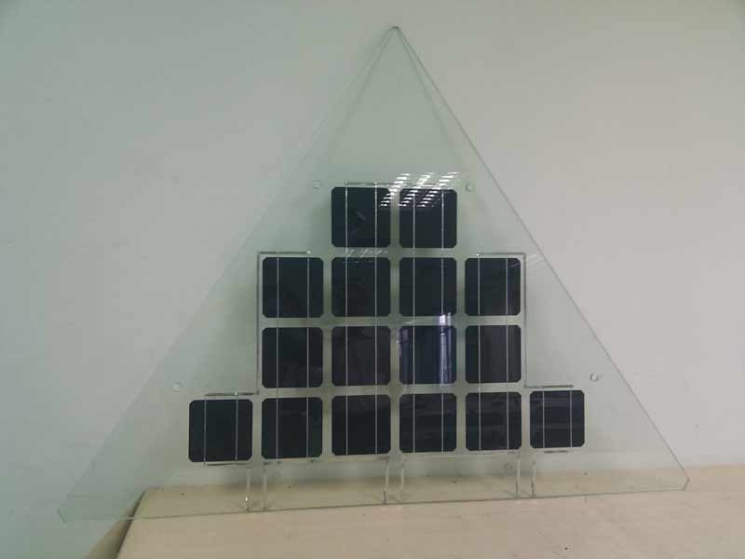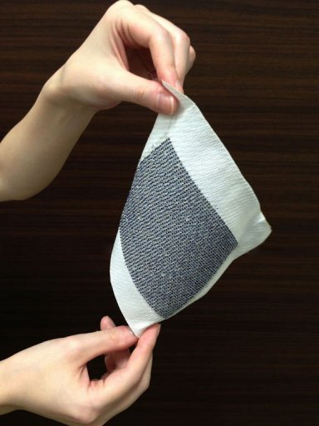
PV skin’s modules PV curtain’s fabric
Photovoltaic energy production

Annual average irradiation on tilted panels (shadings not considered)* 2285 kWh/m2.an

PV skin
solar panel yield (efficency) 22%
Performance ratio, coefficient for losses 0.75

Cactus1 (O)
Surface 2826 m2
Energy 1064 MWh/an
Power 621 kWp

Cactus2 (I)
Surface 2684 m2
Energy 1011 MWh/an
Power 590 kWp

Cactus3 (I)
Surface 2684 m2
Energy 1011 MWh/an
Power 590 kWp

Cactus4 (o)
Surface 1384 m2
Energy 521 MWh/an
Power 304 kWp

sub total energy: 3608 MWh /an
sub total power: 2105 kWp

PV curtains
solar panel yield (efficency) 13%
Performance ratio, coefficient for losses 0.75

Cactus1 (O)
Surface 5800 m2
Energy 1291 MWh/an
Power 754 kWp

Cactus2 (I)
Surface 4730 m2
Energy 1053 MWh/an
Power 614 kWp

Cactus3 (I)
Surface 4730m2
Energy 1053 MWh/an
Power 614 kWp

Cactus4 (o)
Surface 2960m2
Energy 659 MWh/an
Power 385 kWp

sub total energy: 4056 MWh /an
sub total power: 2367 kWp

Wind energy production
Average wind speed in Abu Dhabi 8,8 m/s
Annual average energy 91,25 kWh/m2.an

Piezoelectric vibrating needles

Cactus1 (O)
Surface 2826 m2
Energy 257 MWh /an

Cactus2 (I)
Surface 2684 m2
Energy 244 MWh

Cactus3 (I)
Surface 2684 m2
Energy 244 MWh

Cactus4 (o)
Surface 1384 m2
Energy 128 MWh

sub total energy: 873 MWh /an

Photovoltaic total annual energy: 7664 MWh /an

PV skin: 3608 MWh /an
PV curtains: 4056 MWh /an
Total: 7664 MWh /an

Photovoltaic total nameplate capacity: 4,5MWp

PV skin: 2105 kWp
PV curtains: 2367 kWp
Total: 4472 kWp ≅ 4,5MWp

Piezoelectric 873 MWh /an

Average annual moisture harvested 354m2

Estimate bill of quantities:
landscaping 7500 m2
elevated paths 940 lm
pounds and waterbodies surface 2100 m2
underground water storage volume 220 m3
total concrete 12400 m3
total steel 1080000 kg
total solar skin 9580m2
total solar skin 18200m2
carbon fibre wind-vibrating pipes 22050ml

Total cost estimate (order-of-magnitude): $ 75M USD
$ 17 USD cost per watt installed (< $ 20 USD per watt)

