Heaven to Earth Art Installation
LAGI 2019
Masdar City Abu Dhabi

Concept
Source of Life is Sun.
Source of Art is Inspiration.
Source of Architecture is Space.
Source of Tradition is Culture.
Source of Complexity is Simplicity.

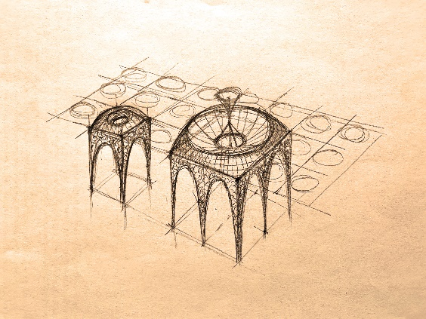

Heaven to Earth Art Installation taps into sources of solar energy and human knowledge in order to provide a simple and powerful example. Example of urban art that seamlessly merges technological progress and cultural tradition.

New architype is created - solar power plant and shaded public plaza combined in one harmonic piece. It becomes an instant new landmark where people can freely meet, relax, discuss, learn, enjoy, experience urban life.

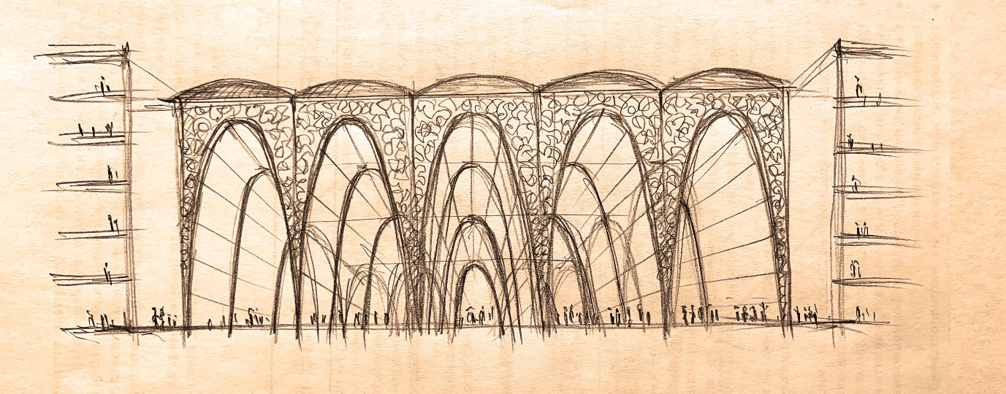

Metered rhythms of arches and domes resemble both ancient spiritual places and new industrial marvels. Carefully proportioned roof openings let the sunlight flood the structure. Its intricate patterns inspired by Kufi calligraphy and traditional Arabic writing dissolve it into ever changing delicate play of gentle light and shadows like in a magic forest.

Installation’s structural concept is simple: unit module 12 by 12 metres is repeated to cover almost the entire site in order to harvest maximum energy and effectively shade the plaza underneath. Module’s domed roof is clad in monocrystalline PV panels to harvest solar energy and transform it into electricity. Two larger courtyards measuring 24 by 24 metres feature advanced concentrated PV arrays with parabolic mirrors for maximum efficiency.

Heaven to Earth Art Installation celebrates timeless qualities of tradition, surprise of artistic expression and the promising sustainability of new technologies. It is part of the human quest for deeper knowledge and better life in harmony with nature.

Technology
Heaven to Earth Art Installation is made of 100 custom modules measuring 12 by 12 metres by 20 meters in hight. Each module has a domed roof covered with 120 m2 monocrystalline PV panels with standard capacity of 200W/m2 which results in 24kW total capacity per module. Total capacity of the installed 100 modules is 2.4 MW.
Two larger modules measure 24 by 24 meters. They feature advanced Concentrated PV (CPV) technology that works with parabolic solar mirrors and reach efficiency up to 40%. Their capacity is 50 kW each and total capacity of all 102 modules is 2.5 MW. This results in 15 MWh daily output assuming 6-hour sun days and the annual output is 5.5GWh.
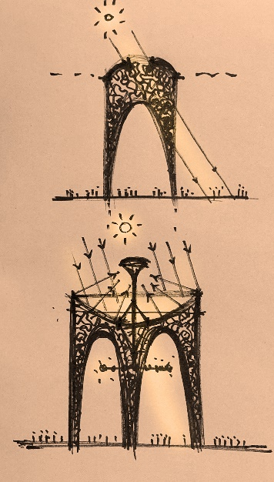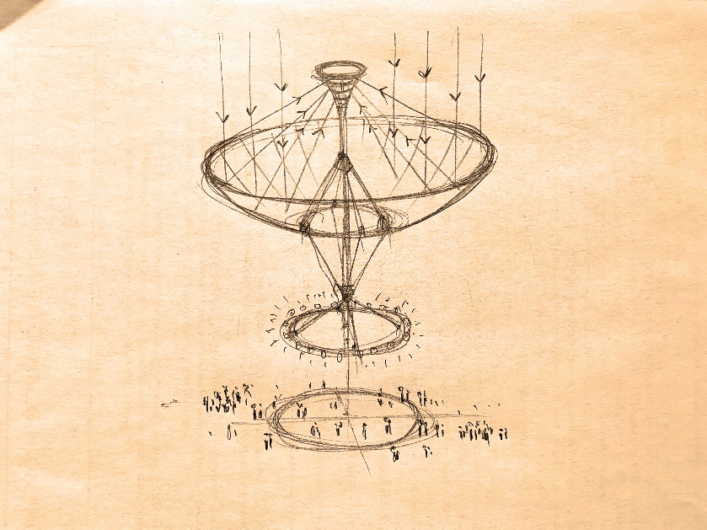

Construction cost of each module is estimated at $250 000. Total construction budget for the Heaven to Earth Art Installation is $25 M. This means $10 cost per Watt capacity.

Parametric and artistic methods are used to lighten the structure by laser cutting intricate patterns inspired by Arabic writing and stylized Kufi calligraphy. Kufi calligraphy is particularly interesting because it turns actual texts into abstract compositions while keeping them readable to the enlightened beholder. Kufi is used traditionally as architectural ornamentation in the Arabic building tradition. Its mathematical beauty make it timeless and attractive to the eye and the mind.

