DUNESCAPE:LAGI 2019

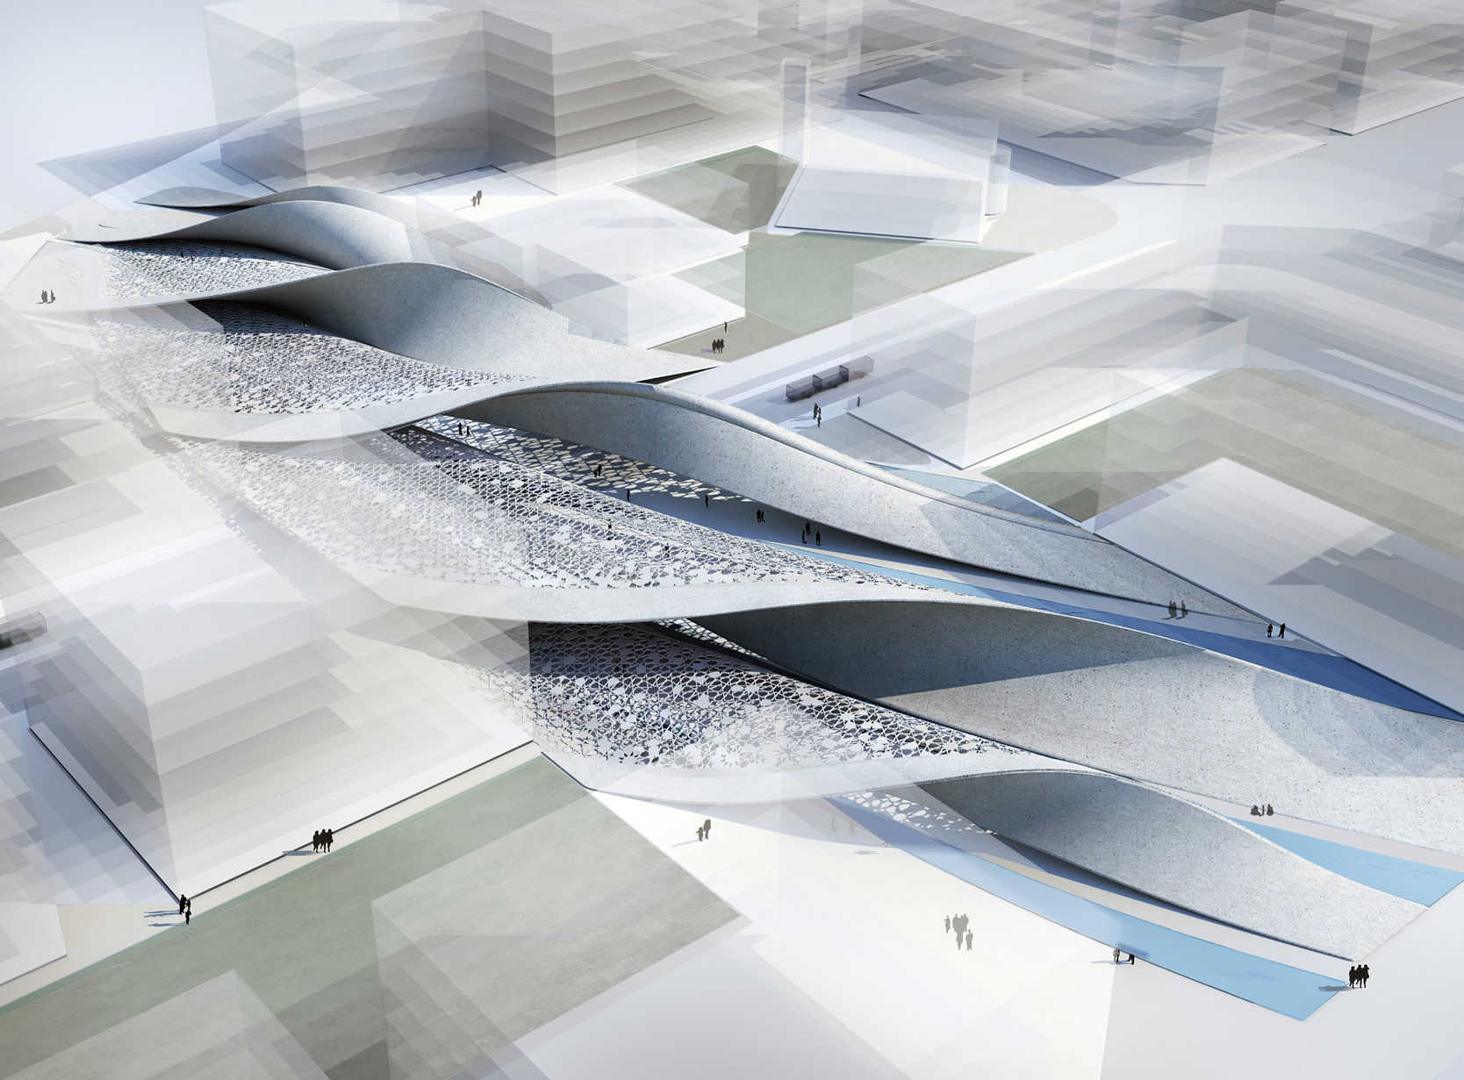
DuneScape

The Land Art

Return to the Place:
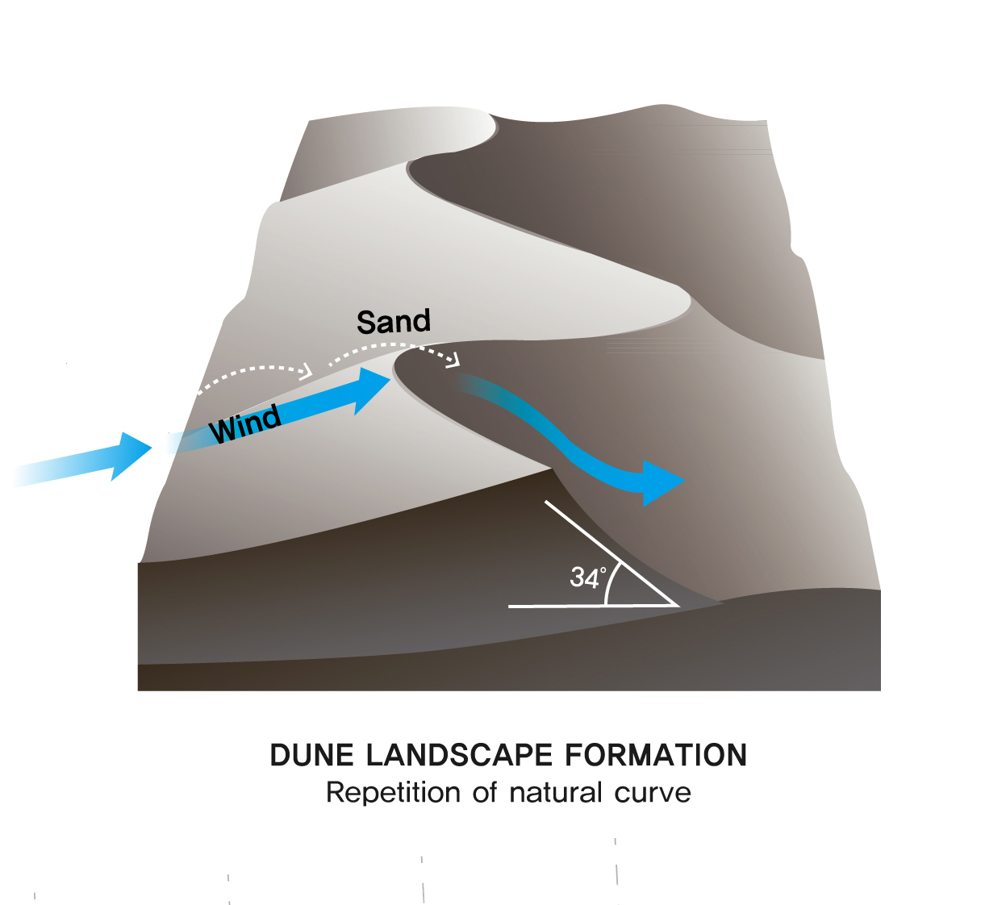
Inspired by the natural topography of the desert climate, the project aims to provide a public environment that is reminiscent of the nature that used to surround Abu Dhabi's everyday life. The dynamic, undulating forms of sand dunes created by only the wind and the movement of the land, itself is an art well beyond any human creation. The endless suspenseful ridge curves generate emotions of longing and the surfaces present deep contrast based on their relationship with the sun. The specific landscape is calm yet powerful offering the most intriguing art from created by nature.
Dune Scape proposes a scenario of an outdoor space where people of Abu Dhabi can return to their origins and regain a sense of place. In lieu of placeless shading and green spaces, the kind of public space will reattach the people back with the indigenous nature while letting them comfortably repose and interact.

The Pray:
Praying, a ritual that is repeated five times a day for many people in Abu Dhabi, is considered as the most important activity of the day for many Muslim people. While working, relaxing transferring to different locations, people need to cease to reconnect with the god. Design of our day to day environment should provide spaces where people can effortlessly place themselves in the moment of uniting mind and body, gratitude, recollection. The morphology of the Dune Scape is created orienting towards the Mecca with the intention to provide public spaces where people can seamlessly move from one activity to praying whenever they need to.

Sustainable Well-being:

Considering the local climate conditions in Abu Dhabi with high outdoor temperatures in summer and zenithal sun positions demand specific strategies for providing comfortable outdoor spaces. Many modern developments including the Masdar City itself the design includes as many passive means to cool spaces and introduce breeze to the daily lives of people. These passive design strategies include narrow streets, gravity cooling, stack effect towers as well as thermal mass to buffer the temperature swings.

Dune Scape design also incorporates these passive strategies to create livable microclimate conditions while harvesting energy from nature. The ridges create natural landform where the high and low regions generate natural air flow through the hollow spaces within the structure supplying cooled air to the pedestrian level. Ceramic cladded landform serves as thermal mass reducing the sensible temperature during the day time. The bifurcated pedestrian walkways in between the dunes are intentionally narrowed to receive enough shadow during most of the daytime while the sun is high. The undulating overhead surfaces cladded with the flexible BIPVs will be the main feature creating diverse shapes and patterns of shadows depending the time of the day.

Energy and Technology:

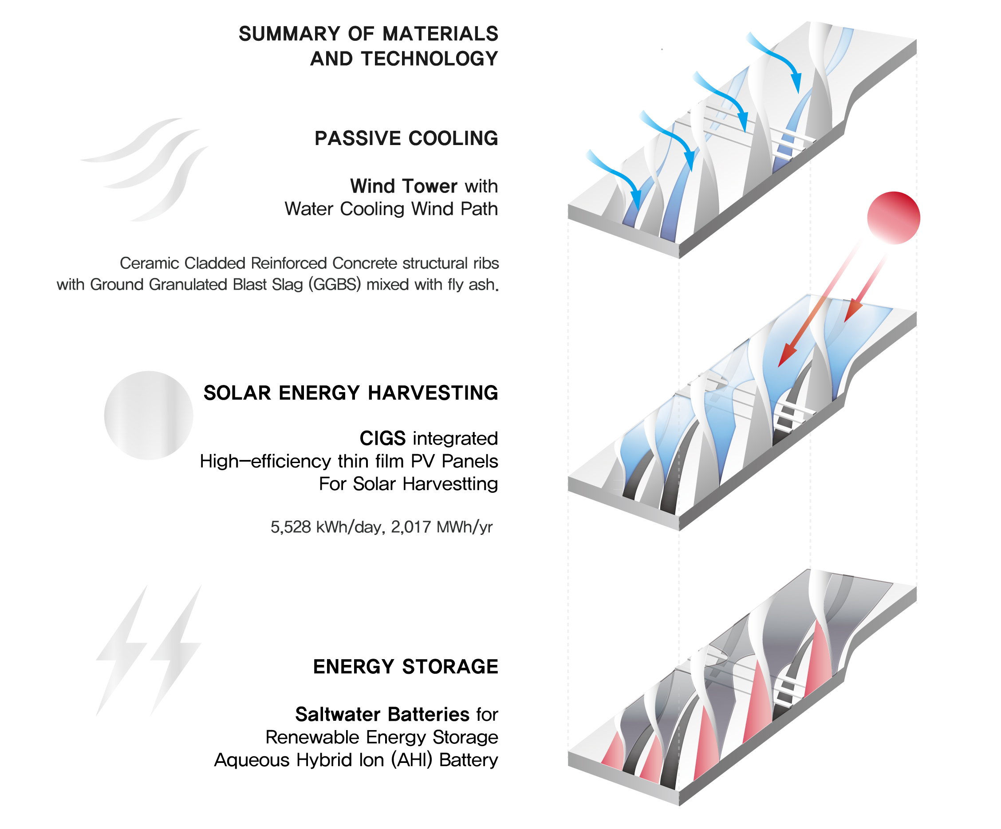
Sun: Windward Surface
Comparisons of the different renewable energy sources and their potentials available in Abu Dhabi show clearly the highest potential for solar energy with more than 2,000 kWh/m²a horizontal irradiation.
The Dune’s windward surfaces are formed with flexible CIGS integrated panels oriented facing the solar direction to optimize the quantity of harvest. 6,010 m² array of panels scattered throughout will produce average of 5,528 kWh daily, and 2,017 MWh annually. CIGS high-efficiency thin-film photovoltaic modules will provide flexibility for creating the intended morphology as well as the maximum efficiency(+-21%) available among the viable thin-film technologies. 5.84 peak sun hours and 25% losses due to various technical limits are assumed for the overall output calculation.

Storage: Leeward Surface
One of the major obstacles in the field of renewable energy has been the energy storage. The traditional lithium-ion batteries are hard to build on a scale that fits the grid needs and their short lifespan, safety concerns have been also the constraints. Among the latest technologies which solve many of these problems is the Saltwater batteries which runs on water and common salt. The long-life cycle is also considered as the main benefit.
Proposed site’s groundwater salinity is very high which provides the best source for accommodating the Saltwater batteries. Ground water will be extracted to accommodate the use which than will be treated for desalination providing cleaned water for the outdoor ablutions and evaporative cooling.

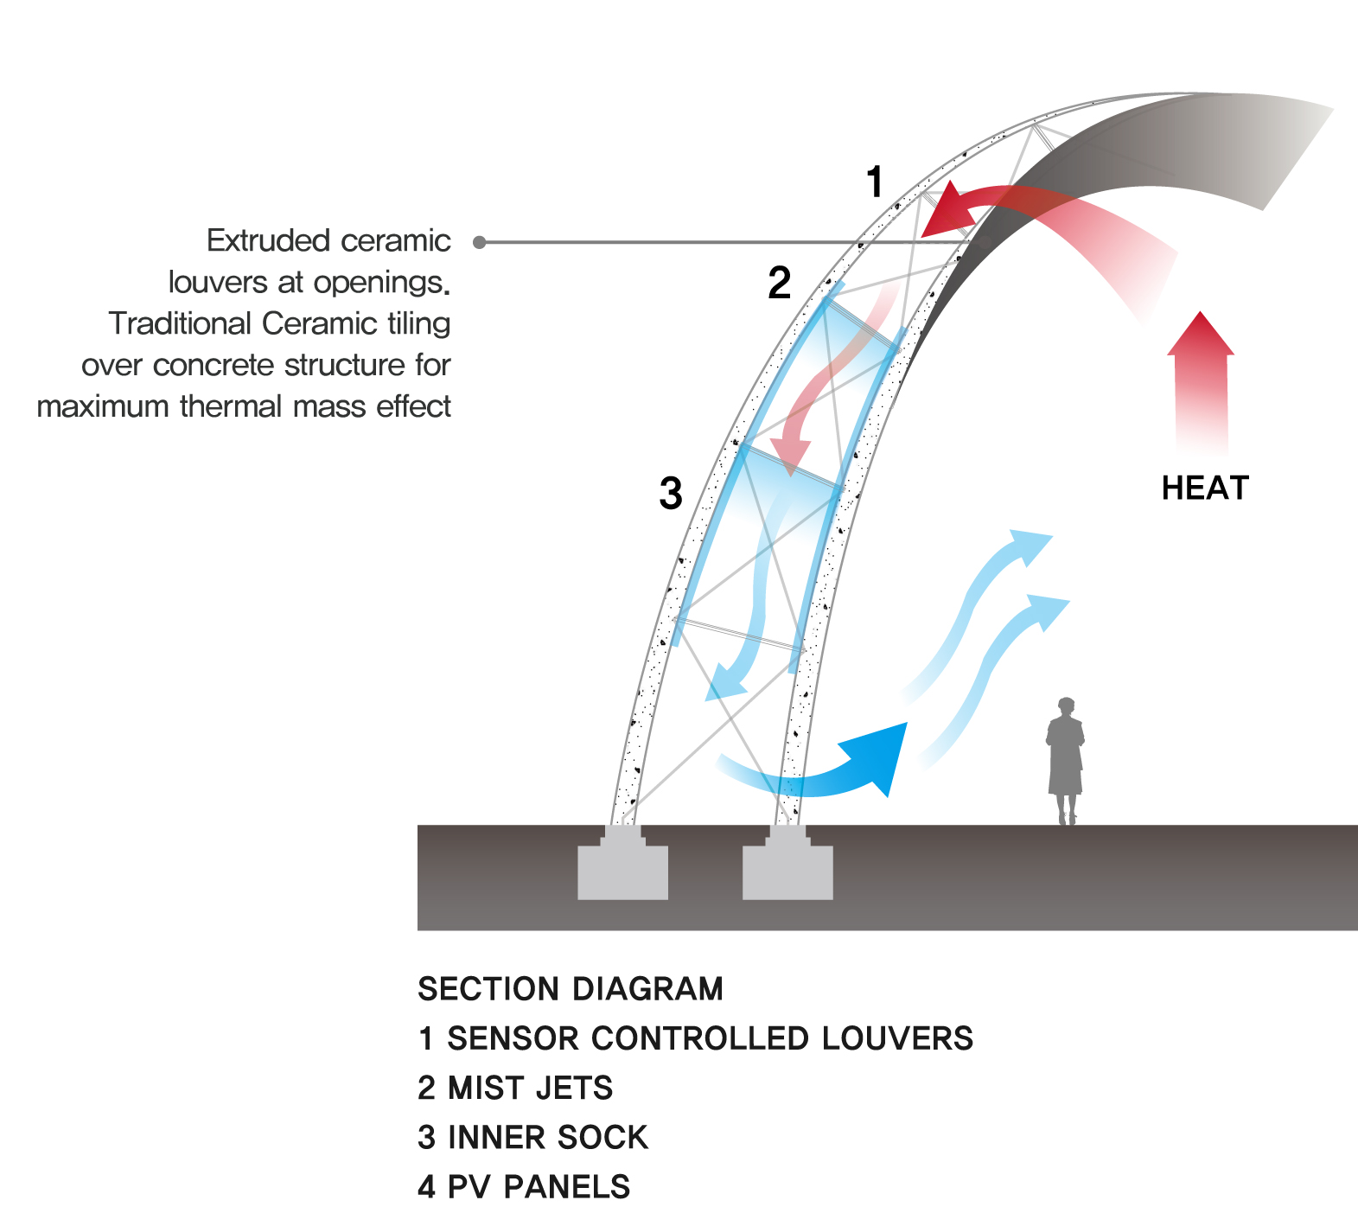
Air Circulation: Ridge
A wind potential with an annual mean velocity of ~ 4 m/s at 10 m height can be rated as not efficient, compared to a typical wind power location with minimal 5 m/s mean velocity. In lieu of an unrealistic proposal for the wind harvesting for energy generation, the project proposes a passive system for natural airflow inspired by the traditional Arabic wind towers. The build-up of positive pressure inside the ridge structure automatically creates a negative pressure on the outside, which will create an internal siphon effect. The openings facing the prevailing wind direction, the cleaner air at the high points will be pulled in and then cooled while traveling down the ridges finally supplying refreshed air at the pedestrian level.
Summary of materials and technology used:
- Ceramic Cladded Reinforced Concrete structural ribs with Ground Granulated Blast Slag (GGBS) mixed with fly ash.

- SoloPower SP3S high-efficiency thin-film with Copper Indium Gallium di Selenide (CIGS):
5,528 kWh/day, 2,017 MWh/yr

- Salt Water Battery: Aqueous Hybrid Ion (AHI) Battery

- Steel plate fabricated PV support (reduced carbon footprint compared to aluminum extrusions)

- Extruded ceramic louvers at openings. Traditional Ceramic tiling over concrete structure for maximum thermal mass effect

- Small-scale solar-driven groundwater desalination plant for supply of clean water at outdoor ablutions.

Environmental Impact Assessment:

A transition to a sustainable future depends on mobilizing social and cultural resources associated with a re-animation of place. DuneScape attempts to create this immeasurable value by reconnecting to the local morphology with the minimum material resources. The primary material used for the structural component is reinforced concrete with GGBS, PFA instead of the carbon-intensive cement. With the traditional ceramic tiles as the final finish, the newly created public space will become integral part of the natural landscape. All substrates supporting PVs will be fabricated from steel plates which contains far less embodied energy compared to the aluminum extrusions.

Previous researches around the proposed site indicate minimum potential for the wind energy and Dunescape focuses harvesting the solar as the primary source of renewable energy. The orientation of the windward surfaces where the thin-film solar panels are placed, has been optimised for the maximum performance. The collected energy will provide the electricity needed by the Dune Scape–lighting, operating groundwater desalination plant, water pumps etc.- allowing self-sustaining infrastructure with zero operational GHG emissions. The DuneScape has the capability of generating average 2,017 MWh zero carbon electricity per a year which will be stored at the Saltwater batteries, the surplus will be shared for operation of infrastructural needs within the Masdar City. Responding to the local climate and site conditions, DuneScape’s include various passive design features such as the natural ventilation through the constructed ridges providing comfort to the outdoor spaces without any energy use and negative environmental impacts.

