Polychromatic Courtyard

75,638 colored transparent solar panels cover voids over the buildings and streets to create a gigantic space being filled with ever-changing colors of light. Sunlight is colored by passing through the solar panel and mixed again with the color of arrival surface such as building façade, street pavement or people’s skin. Movement of sun generates countless number of colors on the surface and spaces. People on the street and building will experience this beautiful moment of polychromatic sun shower and this experience will increase the value of the space. Energy generated from the panels will supply more than 650 residential and offices nearby. At nighttime, LEDs on the bottom surface of main beam structure will lit the panels to create different feel beautiful atmosphere. Type of panel used is 40W thin film transparent amorphous silicon solar panel with 50% transparency, and less than $2 is used for generating 1W meaning $18 per watt is used for structure construction.

Technology

High efficiency amorphous silicon thin film solar panel
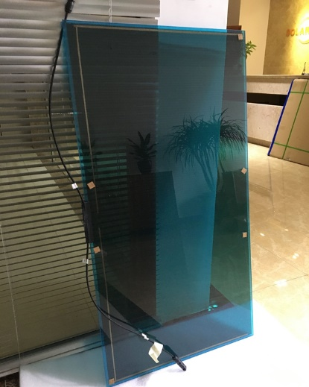
Transparency : 50%
Efficiency : >14.0%
IP rating : IP 65
Voc : 116V
ISC : 0.49A
Vpm : 90.5V
Ipm : 0.44A
Max. Power : 40W
Colors : natural, red, blue, green, yellow or customized

Nameplate capacity in kWp (peak output measured in kilowatts of power)

40W / (1.2mX0.6m) = 55.6kWp

Annual kWh (kilowatt-hours) of energy expected to be generated by the design under average site conditions

0.040kWh (One solar panel capacity) X 6 (4 hours full sun, 4 hours half sun) X 30 (one month) X 12 ( a year) X 75,638 (total number of panels) = 6,535,123kWh

Dimensions, list of primary materials used in the design, and an order-of-magnitude conceptual cost estimate

Overall size : 90m X 270m X 36m
75,638 solar panels
One panel size : 1200mm X 600mm X 6.8mm (40W thin film transparent amorphous silicon solar panel, 50% transparency)
75,638 panel holding steel structure components including batteries
One panel holding steel structure component size : 100mm X 600mm X 50mm
I beam steel beam 1 meter depth with wires being connected to city’s smart grid : combined length of 3,690m
I beam steel girder 0.2 meter depth with wires being connected to the beams’ wires : combined length of 28,800m
24 steel concrete columns : height 35m, 600mm diameter
Conceptual cost estimate : solar panels with holding structural component and batteries 6 million USD, structural elements including beams, girders and columns 3 million USD : total 9 million USD

Environmental impact summary

More than 70,000 transparent solar panels block UV as well as generate energy. Blocking UV from the air can decrease the temperature of the courtyard and maintain the lower one during the daytime. At nighttime, on the contrary to the daytime, higher temperature air from the ground and the buildings can stay longer with aid of the roof to maintain pleasant air temperature. Because of the shape of the courtyard which is tunnel type with 270m length, we can expect better natural ventilation. Accelerated natural ventilation can decrease the temperature more. With additional landscape design using trees, shrubs and reflecting pool, we can get even better pleasant environment with evaporation effect.
In addition to these environmental functions, this place create and offer ever-changing beautiful sceneries to the visitors and users. More than 70,000 transparent solar panels are colored with 30 different colors and they dye sunlight with 30 different colors. 30 different colored lights are overlapped, mixed and affected each other to generate thousands of colors. Thousands of colored light are also mixed with the colors of final surfaces such as pavement, building’s façade, people’s skin or animals. Movement of sun makes this change constant and everlasting. Within a certain period of time, visitors can experience changing colors of environment, buildings and people as well as themselves. These unique and beautiful memories and experiences enrich people’s recognition on environment and renewable energy. If we use typical opaque solar panels, we cannot expect these sceneries or experiences. It is similar effect with the case of sports. Someone who had not been interested in a certain sport get excitement after joining and experiencing the sport on the stadium or field.

