DESIGN PHILOSOPHY AND BRIEFINGS

THIS POWER PLANT WAS DEVELOPED WITH 2 PRIME CONSIDERATIONS:
- TO AMPLIFY THE CULTURAL HERITAGE OF THE CITY.
- TO MAKE THE SITE ACCESSIBLE, USEFUL AND ATTRACTIVE TO THE PUBLIC.
SPECIAL ATTENTION WAS GIVEN TO GENERATE ELECTRICITY IN A SUSTAINABLE WAY AND THE MATERIALS USED FOR CONSTRUCTION ARE ECO-FRIENDLY AND HAVE REDUCED CARBON FOOTPRINT ADHERING TO THE MOTTO OF MASDAR CITY.
A LOT OF SPACE IS MADE AVAILABLE FOR THE PUBLIC WITH ENORMOUS NUMBER OF RECREATIONAL ACTIVITIES THAT CREATE AWARENESS FOR ELECTRICITY CONSERVATION AND SUSTAINABLE DEVELOPMENT.
SYMBOLIC REPRESENTATION OF THE CULTURAL HERITAGE OF UAE IS EXHIBITED IN MANY WAYS AND THE ANCIENT BEDOUIN AND ISLAMIC ARCHITECTURAL ELEMENTS ARE RETAINED WITH SOME CHANGES.
ALL MAJOR SUSTAINABLE ENERGY HARNESSING METHODS LIKE WIND, SOLAR, PIEZO-ELECTRIC MATERIALS ARE DEPLOYED EFFICIENTLY. ONE OF THE MAIN CONSIDERATION WAS TO BE, PRAGMATIC. SO THE MAIN SOURCE OF ELECTRICITY GENERATION IN THIS DESIGN IS PROCURED BY SOLAR PANELS WHICH ARE ALREADY WELL TESTED AND ESTABLISHED IN THE MARKET AND IT IS ALSO DEPLOYED IN AN ARTISTIC MANNER. WIND ENERGY IS ALSO HARNESSED USING THE WIND TOWER METHOD BUT IN A SMALL SCALE.
THE ROAD WHICH WAS PASSING THROUGH THE SITE IS ALLOWED TO GO THROUGH AN UNDERGROUND TUNNEL AND FROM THE TUNNEL ONE CAN ENTER THE PUBLIC PARK ABOVE, USING ELEVATORS.
A DEPRESSION OF 4M IS CREATED FROM THE GROUND LEVEL WHICH IS THE PLACE WHERE WE HAVE 2 HUGE STAGES AND 2 SMALL STAGES ALONG WITH SITTING ARRANGEMENTS. THE OTHER SIDE OF THE ROAD HAS UNDERGROUND BIOGAS PLANT, THE ACCESS TO WHICH IS RESTRICTED TO AUTHORISED PERSONELL ONLY.
ALL THE EXCAVATED SOIL IS SPREAD EVENLY OVER THE NORMAL GROUND LEVEL; SO THAT THE SOLAR PANELS GO HIGH UP, TOWARDS THE SKY; AWAY FROM SHADOWS AND OBSTACLES.ADDITIONAL TO THESE ENERGY GENERATION METHODS; WE HAVE SPACE FOR AGRICULTURE; SINCE THE TEMPERATURE IS HARSH IN THE GIVEN SITE, WE USED THE TRADITIONAL WIND TOWER METHOD LOCALLY CALLED “BARJEEL”, ALONG WITH CHILLED WATER BEING SPRAYED TO MAINTAIN THE DESIRED TEMPERATURE. THE AGRICULTURAL ACTIVITY ARE SUPPOSED TO TAKE PLACE IN PODS WHICH ARE KEPT AT A HEIGHT OF 7 METERS TO 18 METERS FROM THE GROUND LEVEL AND THOSE PODS ARE ACCESSIBLE TO PUBLIC.
KEY FEATURES OF OUR PROJECT INCLUDES:
- PRODUCTION OF FLOWERS, VEGETABLES AND MEDICINAL HERBS: MORE THAN 200 PODS FLOATING IN THE AIR, EACH OF 40M² AREA, IS CAPABLE OF HOSTING LOCAL/EXOTIC FLOWERING PLANTS, TRADITIONAL/EXOTIC VEGETABLES, MEDICINAL HERBS THUS RESTORING THE LOST CULTURAL MEDICINES.

- ROAD WITH PIEZO-ELECTRIC MATERIAL: AROUND HALF A KM LENGTH OF ROAD WILL BE FABRICATED WITH PIEZO-ELECTRIC MATERIAL, WHICH WILL GENERATE ELECTRICITY.

- HYDROPONICS METHOD FOR PLANTATION: INSTEAD OF USING SOIL FOR AGRICULTURE, WHICH IS LIKELY TO INCREASE THE LOAD OF POD; WE PROPOSE TO USE HYDROPONICS METHOD; WHICH CONSUMES 80%LESS WATER, AND THE REQUIRED WATER FOR IRRIGATION WILL BE OBTAINED AFTER RECYCLING THE SEWAGE WATER, WHICH WAS COLLECTED FOR GENERATING BIO GAS.

- BIO GAS PLANT: WHEN WE SAW THE SITE TO BE IN THE MIDDLE OF THE CITY; THE FIRST METHOD TO PRODUCE ENERGY THAT WE COULD THINK OF WAS BIO GAS. ALL THE WASTE WATER AND SEWAGE WILL BE DIRECTED TOWARDS THE SITE, WHERE IT WILL BE STORED IN A DIGESTER AND ALLOWED TO DECOMPOSE ANAEROBICALLY, THE RELEASING GAS WILL BE USED TO FUEL VEHICLES OR TO PRODUCE ELECTRICITY. THE BIOGAS PLANT IS COMPLETELY ISOLATED FROM THE PUBLIC PLACE, MAKING THE SITE SAFE FOR PUBLIC.

- ALCON AND PEARL: A VERY LARGE FALCON SCULPTURE WITH AN OVER AMBITIOUS WINGSPAN OF 40 M (CAN BE REDUCED TO DESIRED SIZE). FALCONRY AND PEARL DIVING WERE THE MAJOR SOURCE OF LIVING FOR THE NATIVE PEOPLE IN OLD TIMES; THE SCULPTURE OF TWO FALCONS FACING EACH OTHER WITH THE PRECIOUS PEARL IN BETWEEN SYMBOLISES THE SIGNIFICANCE OF THOSE SOURCES.

- FALCON SCULPTURE CAPABLE OF GENERATING ELECTRICITY: THE OUTER SIDE OF THE FALCON’S WINGS ARE EQUIPPED WITH SOLAR PANNELS EMBEDDED IN AN ARTISTIC WAY, ENABLING THE SCULPTURE TO GENERATE ELECTRICITY, BUT THE PROBLEM IS- THE SHADOW CAST BY NEARBY BUILDINGS, TO TACKLE THIS PROBLEM, WE PROPOSE TO USE SPHERICAL LENSES. THESE LENSES WILL BE PLACED ON TOP OF THE HIGHEST POD IN SUCH A WAY THAT THE SUN RAYS ARE ATTENUATED ON THE WINGS OF THE FALCON; THUS AMPLYFING THE ELECTRICITY GENERATION TREMENDOUSLY (CONCENTRATED SOLAR POWER).

- TESLA COIL SHOW (ITS OPTIONAL; AS A LOT OF ELECTRICITY WILL BE WASTED) : ONCE IN A FIXED WHILE, THE SITE WILL HAVE AN ELECTRIC SHOW TO EXHIBIT –HOW BEAUTIFUL SUSTAINABLE ENERGY IS . THE INNER SIDE OF FALCON’S WING WILL HAVE ELECTRIC DISCHARGE NODES AND THE PEARL WILL HAVE CONDUCTORS; BOTH THESE COMPONENTS WILL COMPLETE A TESLA COIL SET UP. THIS WILL CREATE A SHOW WHERE THUNDER WILL FALL FROM THE WINGS OF THE FALCON RIGHT ON THE PEARL; MAKING IT A BEAUTIFUL SHOW TO WATCH.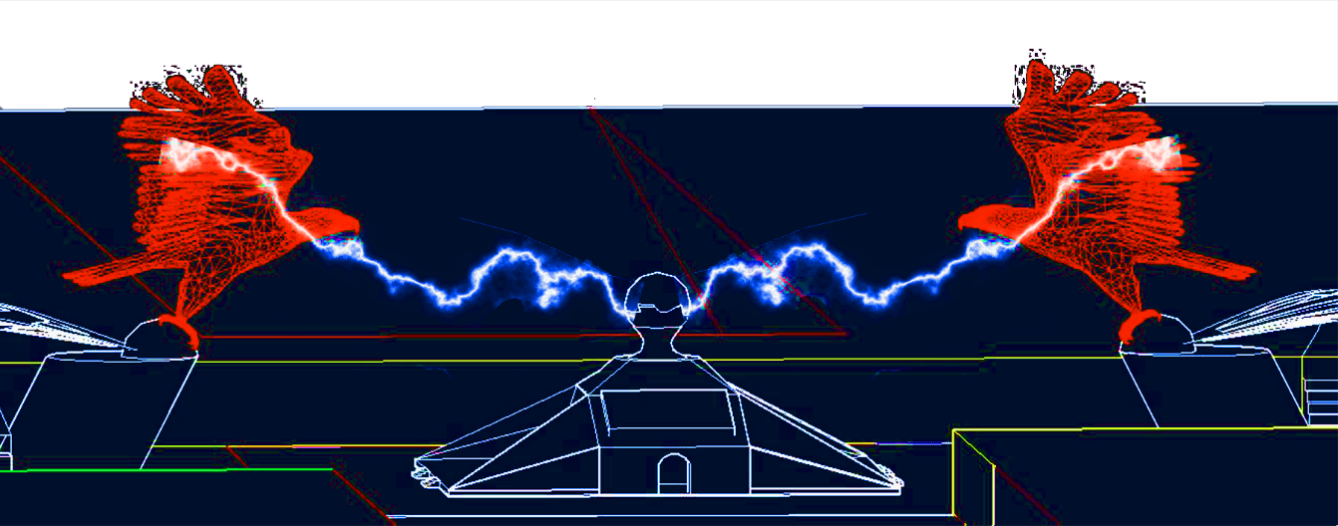

- WIND TOWER: THE WIND TOWER IS A 7 METER LONG TOWER, WHICH CAPTURES THE WIND AND DIVERTS IT TO THE GLASS HOUSE BELOW, ALONG THE WAY, A NOZZLE SPRAYS COLD WATER ACCORDING TO THE TEMPERATURE REQUIREMENTS OF THE PLANTS IN THE GLASS HOUSE. THE WIND IS THEN DIRECTED DOWNWARDS VIA, POROUS BASE OF THE POD.

- NUMEROLOGY IN DESIGN MEASUREMENTS: THE NUMBER 7 IS OF MUCH IMPORTANCE IN ISLAMIC CULTURE (DATA OBTAINED FROM INTERNET). SO MANY DIMENSIONS IN THE DESIGN ARE TAKEN IN MULTIPLES OF 7. FOR EG: THE HEIGHT OF THE WIND TOWER IS 7M, THE CENTRAL STAGE WITH PEARL ON TOP IS A SQUARE OF SIDE 21 M, THAT IS, A MULTIPLE OF 7 AND EACH SECTION IS OF 7 METER IN LENGTH, THE DIAMETER OF THE CYLINDER IN WHICH THE FALCON STANDS IS OF 7 METER, THE WIDTH OF THE POD IS 7 M.

- OTHER ATTRACTIONS: SINCE THE PODS ARE ON THE UPPER LEVEL FROM THE GROUND. THE GROUND HAS A LOT OF SPACE, WHICH CAN BE USED FOR RECREATIONAL ACTIVITIES LIKE : MORNING JOGGING WHERE THE SHOES WILL BE PROVIDED BY US WHICH WILL BE ABLE TO CHARGE THE VISITOR’S PHONE; ROWING EXERCISE ,WHICH WILL GENERATE A RELATIVELY GOOD AMOUNT OF ELECTRICITY; PIEZO-ELECTRIC DANCE FLOORS; LAZER TAG GAMES WITH FLOOR FABRICATED WITH PIEZO ELECTRIC MATERIAL – THESE ACTIVITIES ARE NOT INTENDED TO GENERATE ELECTRICITY BUT TO CREATE AWARENESS AND INTEREST AMONG PEOPLE TOWARDS A CLEAN,HEALTHY AND SUSTAINABLE FUTURE.

DIMENSIONS
THE NET AREA COVERED BY THE PODS AREA : 15,815 m²

AREA COVERED BY SOLAR PANELS : 15,140 m²

DIMENSION OF THE POD : 10 m X 7 m

RADIUS OF BASE ROD : 1 m

RADIUS OF WIND TOWER ROD : 0.50 m

LONGEST HEIGHT OF THE POD : 18 m

SHORTEST HEIGHT OF THE POD :7 m

VOLUME OF LAND EXCAVATED : 1,79,701.76 M²

AREA OF LAND ELEVATED : 16,107 M²

MATERIAL AND OBJECTS USED

THE CONSTRUCTION OF THE FALCON CAN BE DONE USING RECYCLED STEEL AND LOW CARBON CONCRETE, OTHER DOME LIKE SECTIONS CAN BE MADE USING OLD STEEL AND PLASTIC SHEETS. THE CONSTRUCTION OF PODS WILL NEED – ISULATING GLASSES, LOW CARBON STEEL -TUBULAR SECTIONS AND ADHEREING TO THE MASDAR CITY SUSTAINABILITY PLAN, WE PROPOSE TO USE PLAM TREE WOOD AS THE BASIC MATERIAL FOR CONSTRCUTION OF THESE 7 X 10 Meter PODS, EVEN THE CONSTRUCTION OF WIND TOWERS WILL BE DONE USING THIS MATERIAL.
THE WINDOWS OF THE CENTRAL HALL AND THE CEILING OF THE SITTING AREA WILL BE MADE WITH TRADITIONAL WINDOW PATTERNS, SO THAT THE SHADOW CAST BY THE WINDOW AND CEILING REMIND THE VISITORS ABOUT ARABIC ART OF CREATING PATTERNS USING SHADOWS.
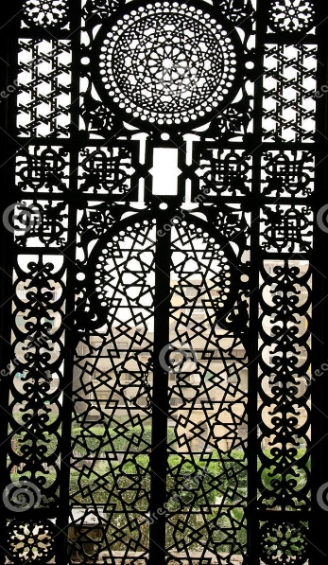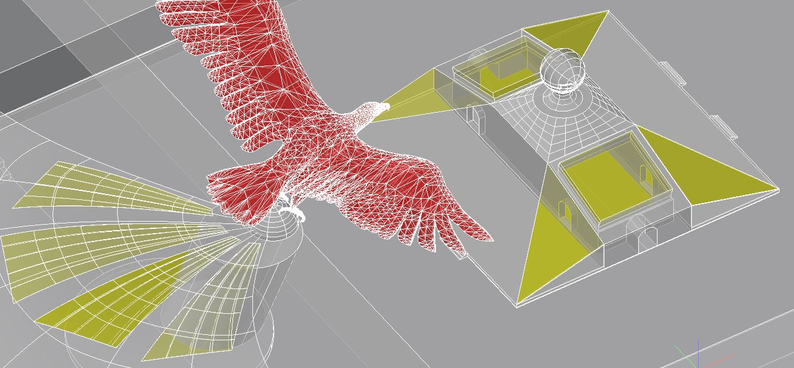
ALL THE YELLOW MARKED AREA IN THE RIGHT IMAGE WILL BE MADE USING THE PATTERNS SHOWN IN THE LEFT IMAGE.

ROUGH APPROXIMATION OF MAJOR MATERIALS REQUIRED

STEEL (LOW CARBON): 1242.18 m³
PALM TREE WOOD OR ANY OTHER WOOD (CONDITIONED): 1431.0 m³
INSULATING GLASS : 16,770 m²
CONCRETE: 996.38 m³

ENERGY GENERATION ESTIMATION

FOR SOLAR PANELS:
PEAK CAPACITY 89,931.6 KWh | ANNUAL CAPACITY 3282 MWh

FOR WIND TOWERS:
PEAK CAPACITY 1341.6 kWh | ANNUAL CAPACITY 489648 kWh
(wind tower produce less electricity as the turbine is very small, around 1 meter)

FOR BIO GAS PLANT:
(more electricity can be produced if biogas is used, but “according to us” fueling the car with clean fuel is much more important)

TOTAL ANNUAL CAPACITY: 3282.48 MWh

COST ESTIMATION OF THE PROJECT

STEEEL AVERAGE COST PER M³ 654 USD | 654 X 1242.18 = 812385.72 $

WOOD AVERAGE COST PER M3 172 USD | 1431 X 172 = 246132 $

GLASS WORK PER M2 IS 19 USD | 16770 X 19 = 318630 $

CONCRETE WORK PER M3 IS 108 USD | 996.38 X 108 = 107609.04 $

COST OF SOLAR PANELS PER M2 34.65 USD | 15140 X 34.65 = 524601

TOTAL APPROXIMATION: 2009357.76 USD, ONLY FOR THE COST OF MAJOR ITEMS.
ENVIRONMENTAL IMPACT ASSESMENT

THE IMPACT OF THIS PROJECT ON THE ENVIRONMENT IS FRIENDLY; THE BIOGAS BEING GENERATED CAN BE USED TO FUEL CNG CARS THUS ELIMINATING HARMFUL CARBON ELEMENTS FROM THE ENVIRONMENT.THE SAME BIO GAS CAN BE USED TO GENERATE ELECTRICITY.THE TOWERS PROVIDE PEOPLE WITH SHADE AND A PLACE FOR RECREATION. AGRICULTURAL ACTIVITIES ARE BEING PERFROMED IN EACH PODS WITH ADVANCED HYDROPONICS METHOD WHICH ENSURES LESS WATER IS WASTED. THE MATERIALS USED FOR CONSTRUCTION IS MAINLY “WOOD” WHICH IS HAS NEGLIGIBLE CARBON FOOTPRINT.THE STEEL BEING USED WILL HAVE LOW CARBON CONTENT, JUST AS USED IN OTHER PROJECTS OF MASDAR CITY.

CONCLUSION!!
THE SITE BECOMES A “SOURCE” OF CLEAN ELECTRICITY!!!
A “SOURCE” OF CLEAN FUEL!!!
A “SOURCE” OF AWARENESS AND INSPIRATION!!!
A “SOURCE” OF RECREATIONAL SPACE!!

HENCE THE CITY NAME MASDAR !!!

--------------------------------------------------------------

