Vaulted Visions
LAGI 2019

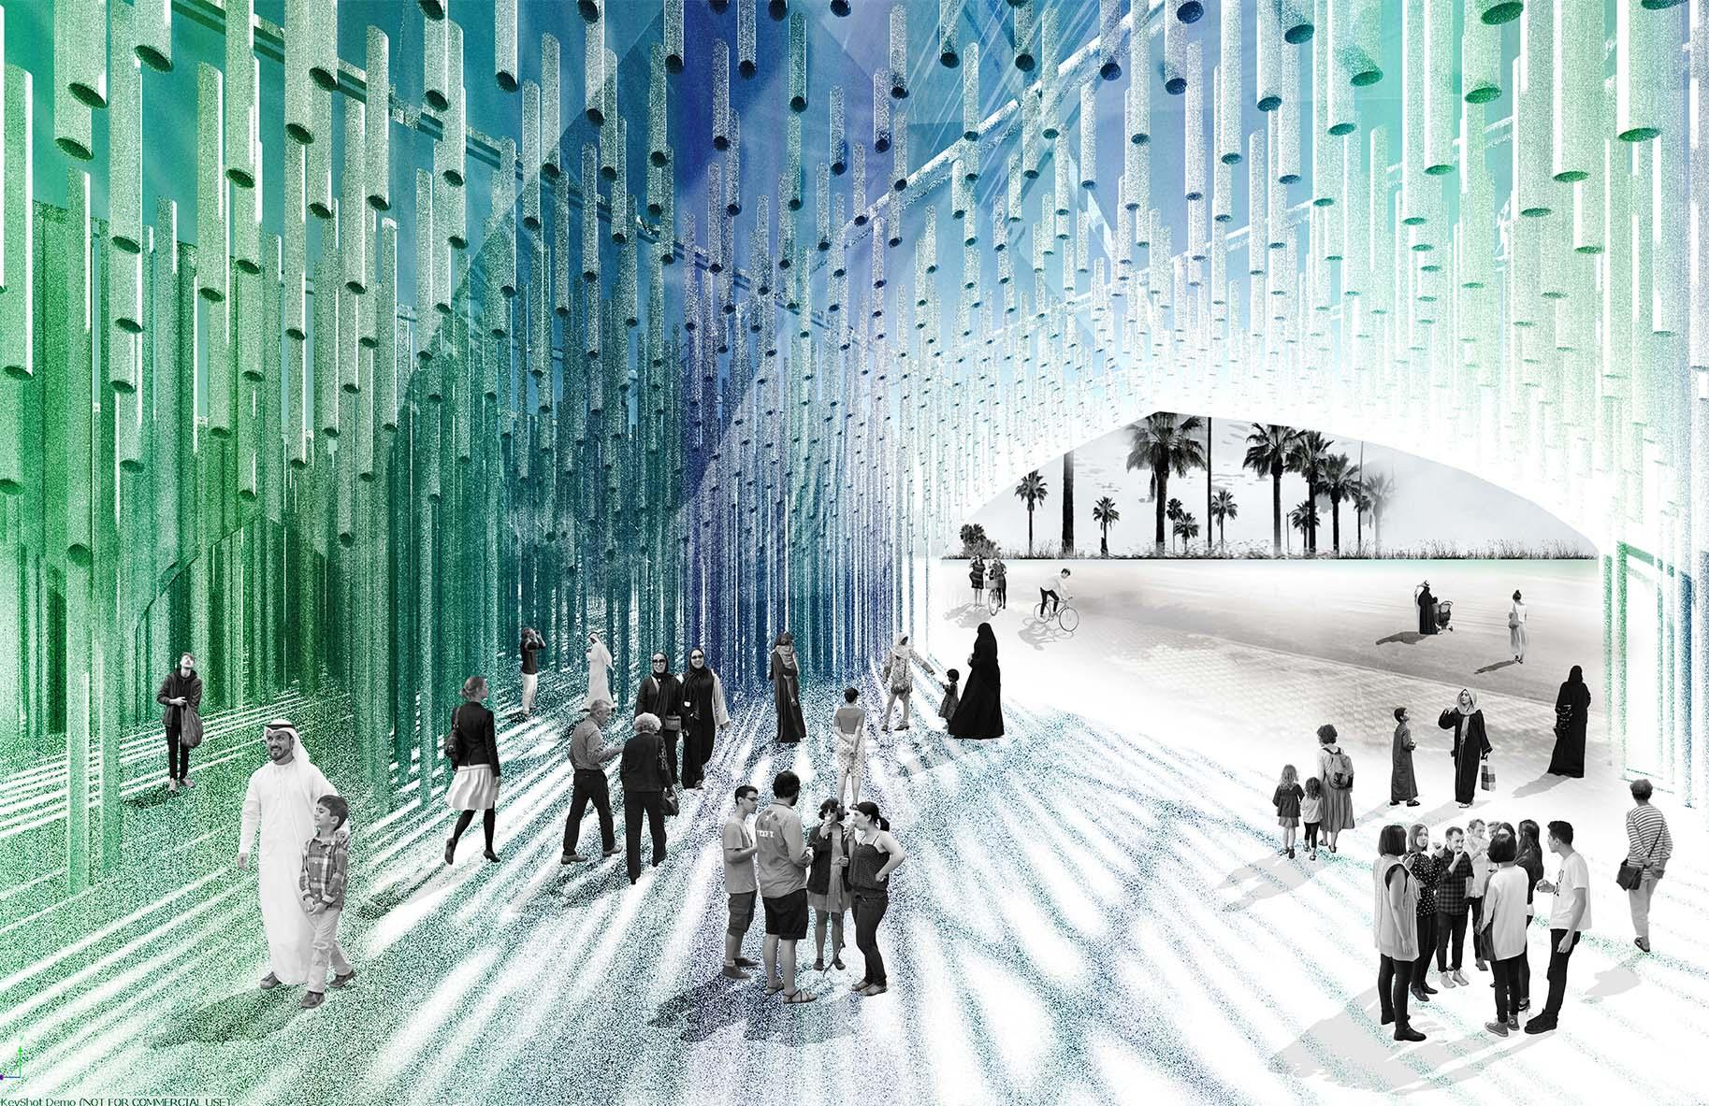
1.0 INTRODUCTION

Theme
Grounded in the region’s architectural influences, Vaulted Visions stimulates the user’s senses by weaving them through an energy journey composed of solar and algae biofuel production. The design of this structure aligns with Abu Dhabi’s 2030 vision in that it capitalizes on the resources available (abundant sun and sea) and adheres to the fabric of life and cultural design qualities present. “Identity and Opportunity” are exemplified in this structure and have been an underlying goal in all aspects of design. The installation sets an example of Carbon Negative/ Carbon Neutral construction by utilizing multiple technologies that produce and contribute to producing 1750 MWh of energy, 215,000 gallons of Biofuel and mitigating 1,502 Metric Tons of Carbon Annually.

Cultural Context
Vaulted Visions is a journey through the traditional souqs and mosques of Abu Dhabi, with vaulted spaces and mosaic colors composed of vertical members reminiscent of palm leaves in vernacular housing. It is a return to the cultural source, merged seamlessly with an elaborate energy experience. On the inside, the structure provides a series of rich spatial interactions as the user walks through the intricate vaults and experiences the light filtered through the suspended algae tubes and the overhead solar structure. A wide range of experiences are designed that include double height overhead arches to intimate courtyards seamless connected through a ramp- all of which are designed with a progression of technological spectacles.
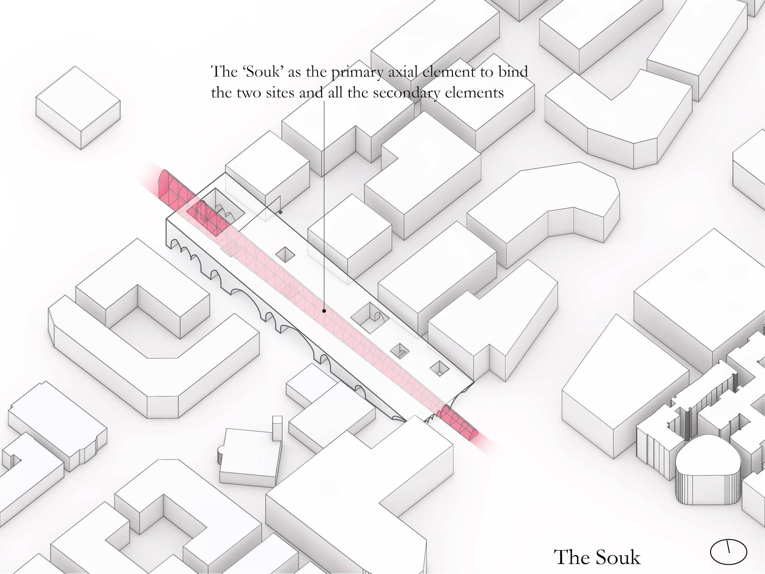

Thermal Comfort, Community Interaction and Climate Response
We recognize that one of the main challenges in the use of the installation is extreme weather conditions in Abu Dhabi. The installation was designed to keep in mind wind, sunlight, shade and a few other factors to maximize outdoor thermal comfort. Designed shading solutions, courtyards and passive cooling strategies work together to combat the high temperatures in order to truly activate the outdoor space. Informed by radiation analysis and thermal comfort analysis, the installation mass exists as a porous volume that shields the user from direct sun, while selectively allowing in elements such as wind for evaporative cooling and diffused light across the solar cells and algae tubes. The placement of the solar cells capitalizes on areas of high solar exposure while providing shading, echoing Masdar city’s urban livability standards and scale for maximum comfort and delight.

The various spaces are designed to keep in mind the levels of interactions of the multiple programs that the site surrounds. From small gathering spaces to large communal courtyards, each space inside the structure is designed for promoting ‘interaction’. Special carved our spaces ‘the niches’ are also designed as semi-private enclosures for each program.

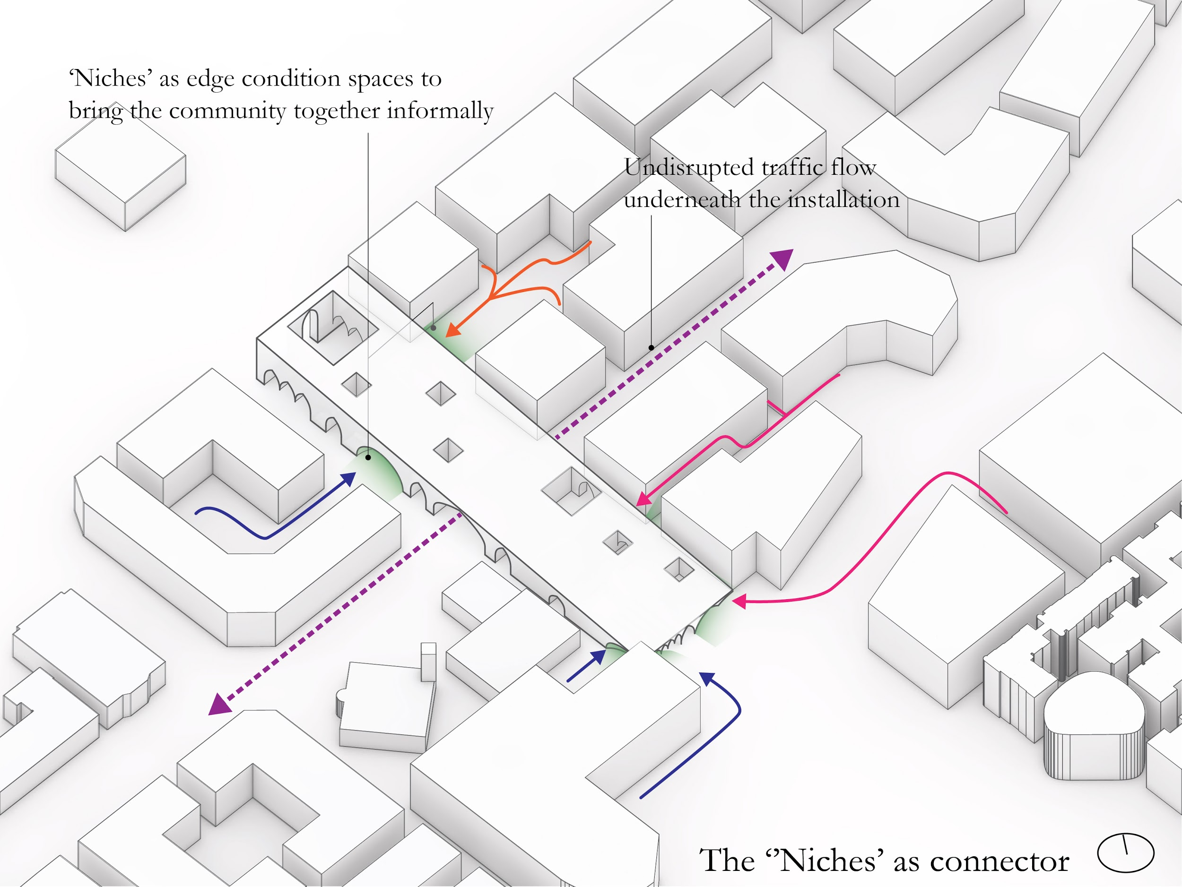
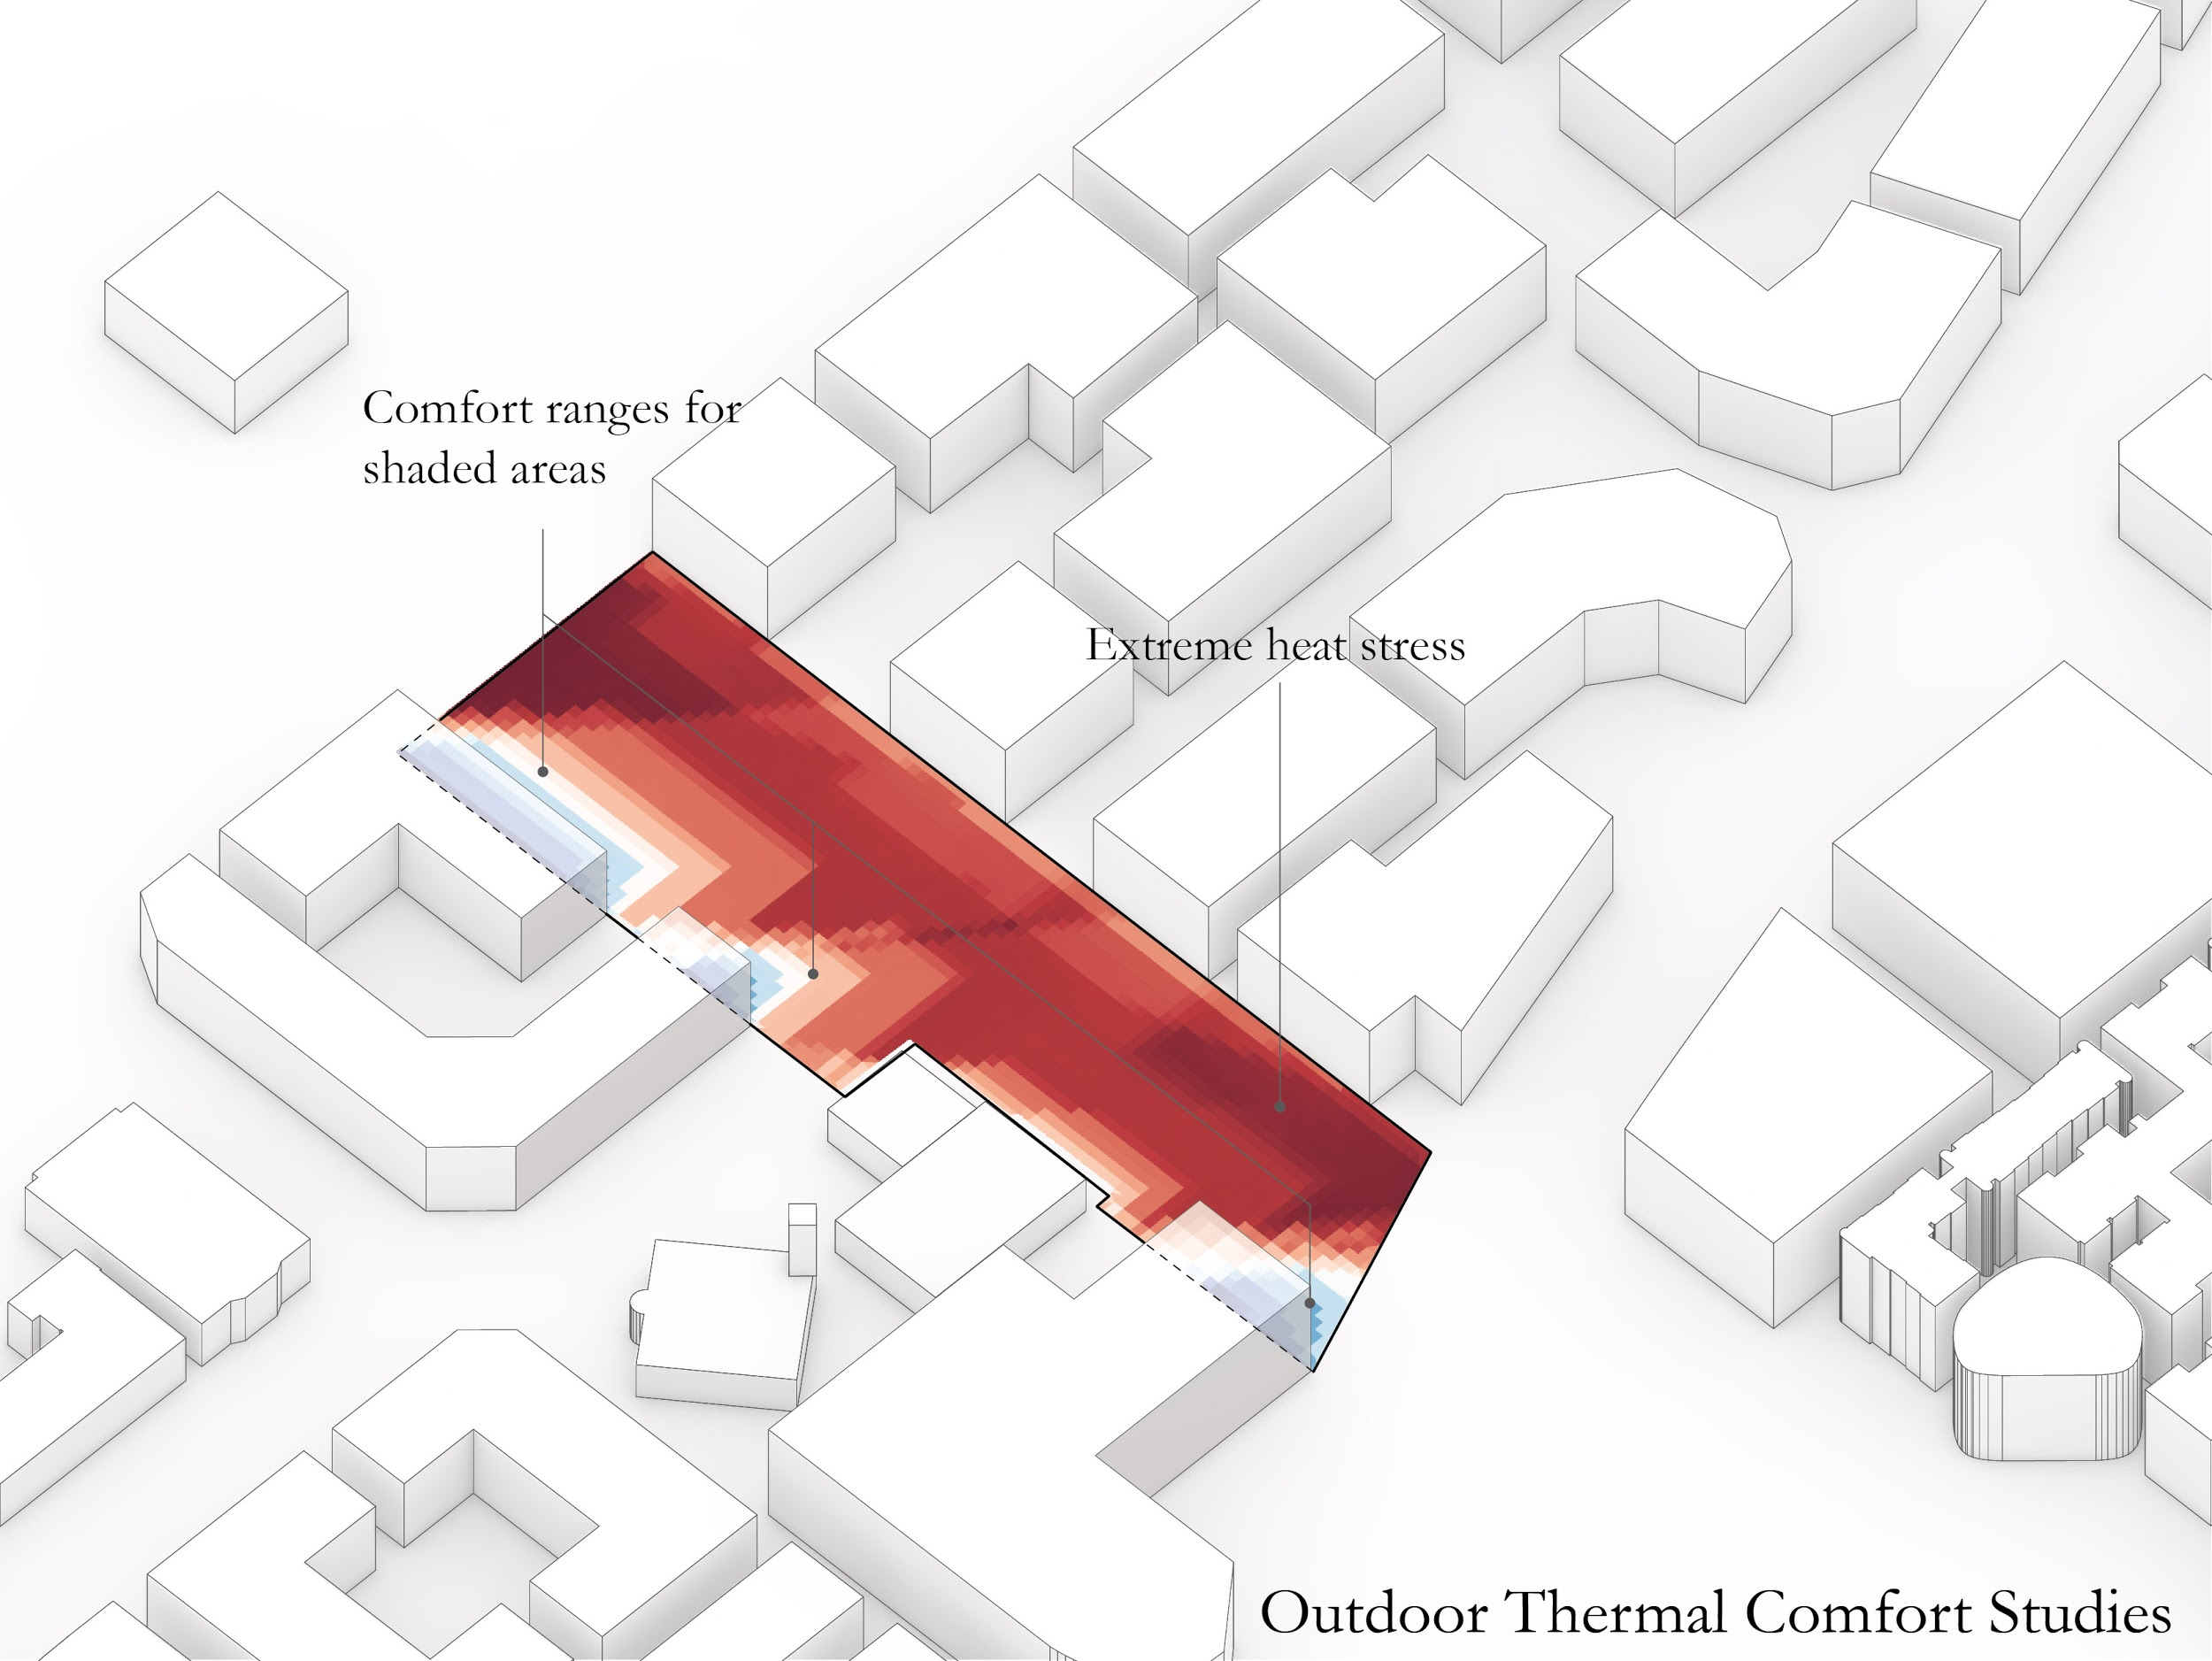

Technologies Used
Abu Dhabi and Masdar institute are at the forefront of cutting edge research in energy technologies. We believe that it is imperative to acknowledge the ongoing research at Masdar which opens up opportunities for knowledge harvesting and collaboration. We have hence selected technologies that are currently being researched at both the Masdar Solar Hub and Seawater Energy and Agriculture Systems (SEAS) and have referenced studies carried out there. The central spine of the structure acts as a living lab, fusing the algae production work areas with the educational experience of the user. A balance between technological ambition and grounded feasibility is needed in order to realize the design of this installation.

2.0 ENERGY AND CARBON
“How ‘clean’ is your clean energy?”

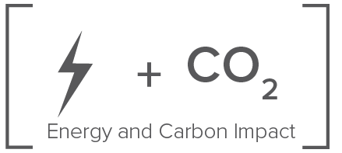
The world faces an acute energy crisis and the recent elevated effects of climate change has made the situation dire. We believe that it is critical to address the CO2 emissions question alongside the energy ‘source’ question.

Our energy strategy is centered on the production of Electricity through the use of low-impact Solar PV and Biofuel through the use of Algae. These technologies were selected carefully with the resources available in Abu Dhabi in mind and are currently also being employed in the UAE market. We were able to achieve an annual clean electricity production of 1750 MWh, a reduction in atmospheric CO2 of 780 Metric Tons through sequestration and a reduction in CO2 emissions of 722 Metric Tons equivalent from clean energy production.

Solar Energy
A Building integrated thin-film array is employed on the roof of the structure which generates 1750 MWh annually with an efficiency of 18%. The thin modules offer superior performance in hot climates, compared to silicon modules which is an important factor in the climate of Abu Dhabi. This can power approximately 214 houses annually at a peak rated capacity of 1,073 kWp. The product specs are mentioned in references.
Reference: https://flisom.com/wp-content/uploads/2019/01/Datasheet_eFlex_2.3m_rev.pdf
http://miasole.com/products-3/
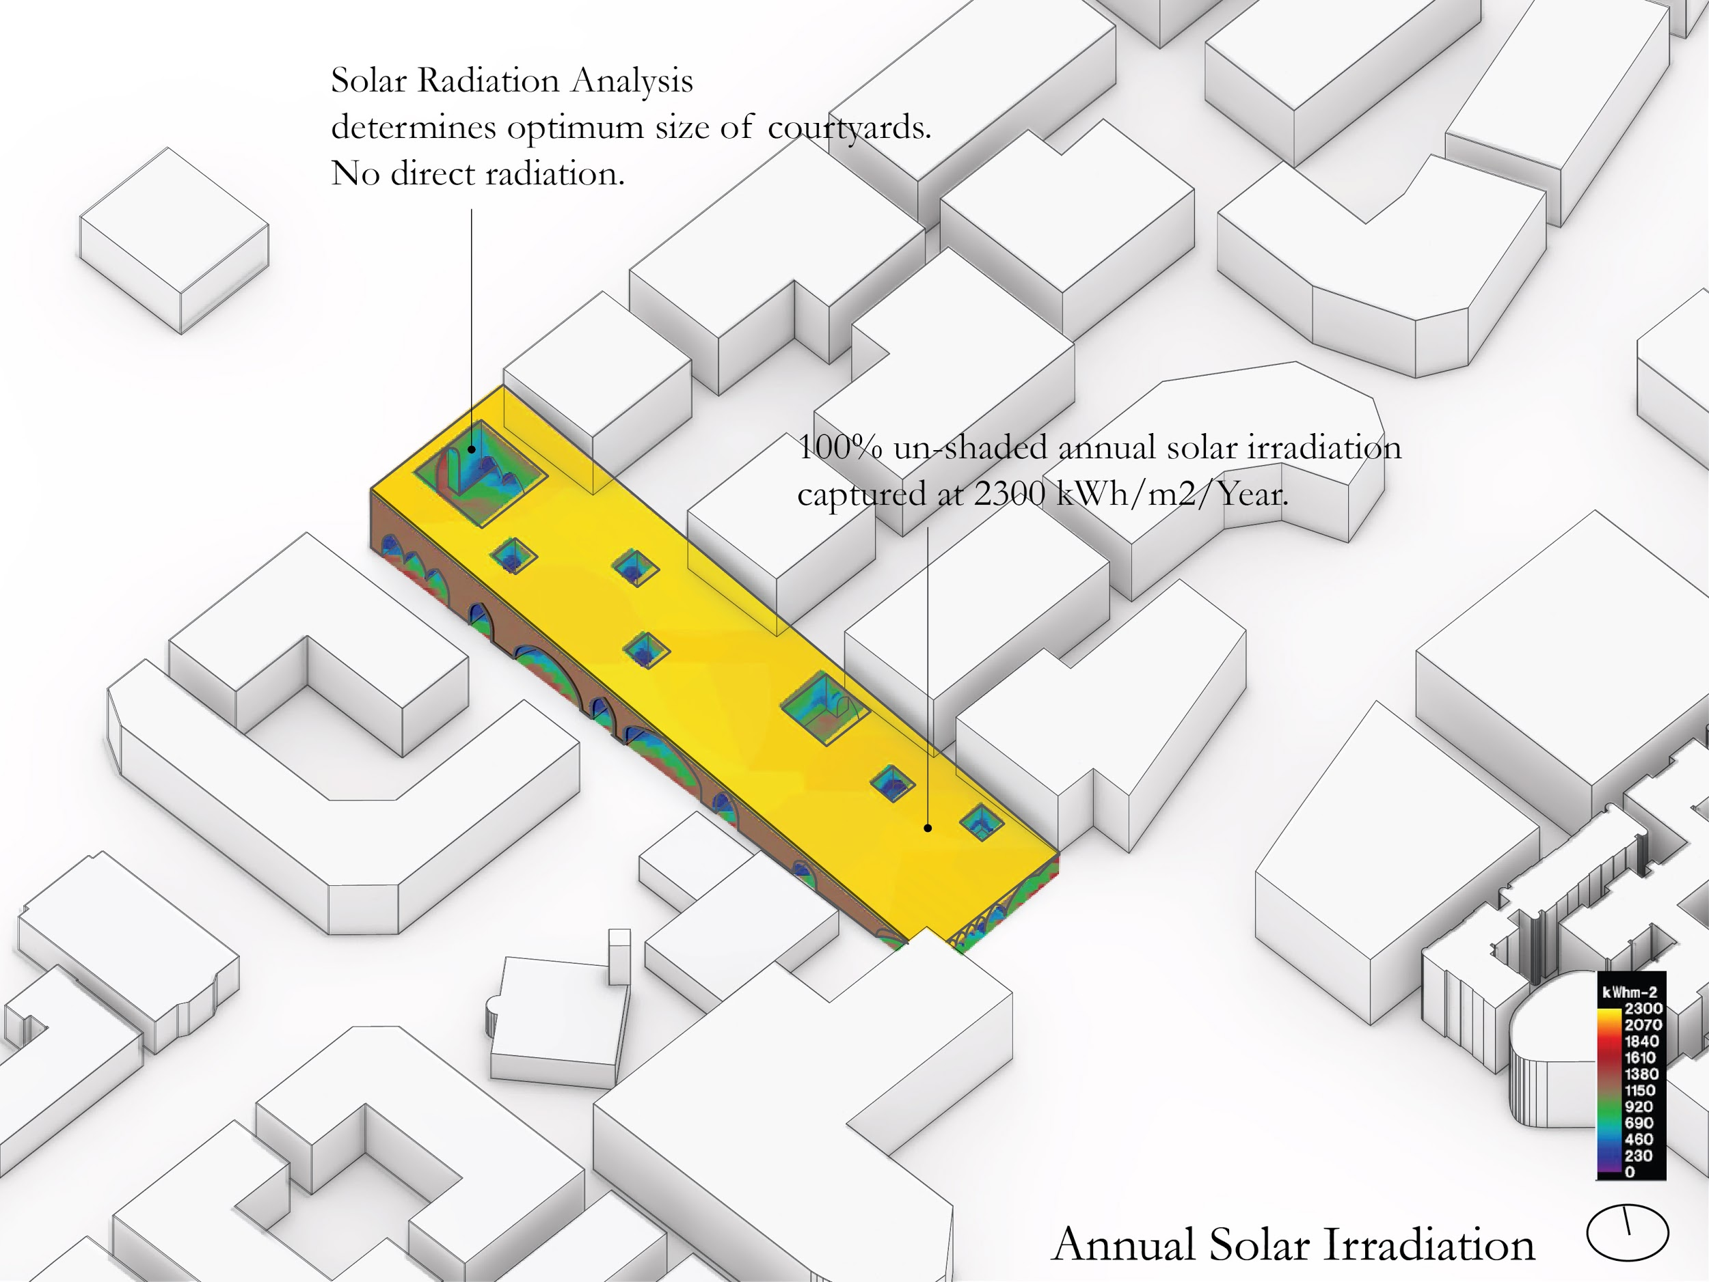

Algae Biofuel
Algae Biofuel has great potential to replace non renewable fuel sources. The UAE is uniquely positioned to capitalize on this renewable source, particularly because of the way the native algae has evolved to grow under varying salinities and temperatures. This means that an energy intensive desalination plant is not required. In addition to this, heavy machinery and vehicles are not required throughout the process, which strengthens the accessibility and integration in this design.
In addition, Algae thrives in abundance of CO2. Through our installation and Algae cycles, we are able to absorb 780 Metric Tons of CO2 from the atmosphere. The system also release a huge amount of O2 to make the environment quality better for the community,

Research at Masdar institute estimates that brackish to saline (BSW) algae outperforms FreshWater Algae. BSW was estimated to cost $20-$25 per gallon including infrastructure and operational costs while latest methods have brought the cost down to $12. The output of our structure is about 215,000 gallons annual based on an estimation of a 65% production efficiency factor.

Reference:
https://farm-energy.extension.org/algae-for-biofuel-production/
At night, the energy produce is used to light small LED’s, illuminating the algae like lanterns and augmenting the souq experience.
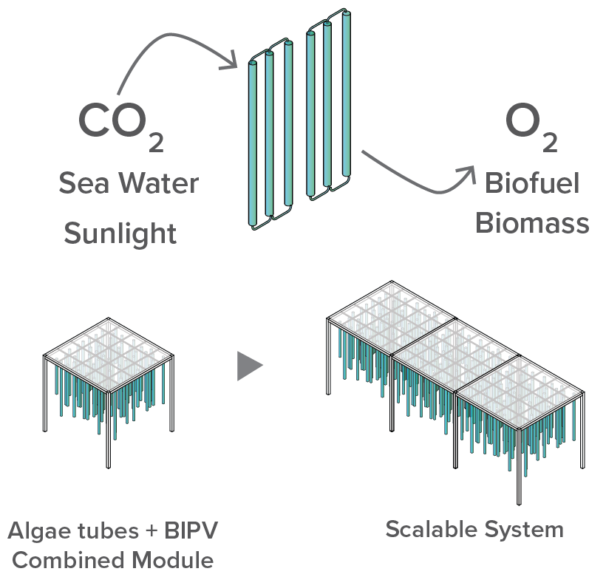
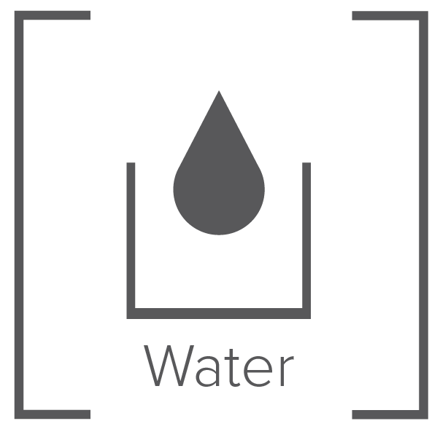
Rainwater
Fresh water is a scarce resource in the UAE and we want to capture every drop that falls on our surface most efficiently. The design of the sloped roof as well as the courtyards has the potential to capture 262,365 gallons of water annually.

3.0 FEASIBILITY AND LCA

Energy
Technology | Dimensions of unit | Nameplate Capacity | Annual Energy Output (MWh)/ Gallons | Carbon Emission Reduction | Unit Cost ($) | Total Cost ($)
Solar Panels | 0.58 m2 | 1073 kWp | 1750 MWh | 722 Tonnes CO2 | $5.03/ W | $ 5,397,190
Algae Biofuel System | 0.15 m diameter tubes | 330,000 Gallons | 215,000 Gallons | 780 Tonnes CO2 | $12/ Gallon | $ 3,960,000
Cost of Energy/ Carbon |  | -1502 Tons CO2 |  |  | $ 9,357,190

Carbon Neutrality of Structure (Return on Carbon)
Material | Weight of Material (Tons) | Embodied Carbon Factor (Kg CO2 equ./ Kg) | Embodied Carbon (Kg CO2 equ. ) *1000
Steel | 314 | 1.72 | 540.08 Tonnes
Concrete | 2764.8 | 0.211 | 583.372 Tonnes
Total Embodied Carbon of Structural Materials | 1123.45 Tons of CO2 equ.
Return on Carbon (ROC) | -399 Tons of CO2 equ.

Please refer to references in section 5 for above two tables.

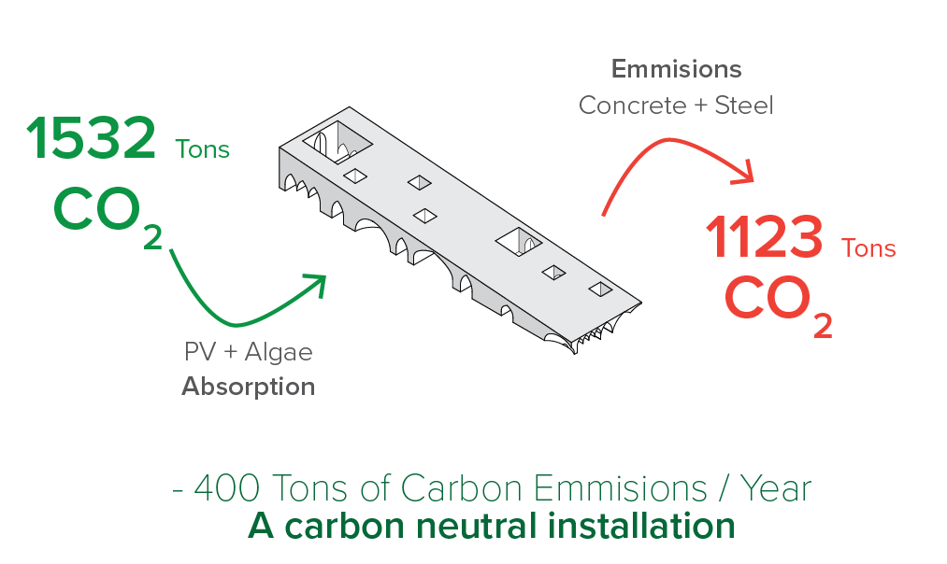

Installation Cost
Material | Quantity | Cost/unit | Total Cost ($)
Concrete  Columns and Foundations | 1152 m3 | $108/m3 | $ 124,416
Steel (16 mm rebars, joints, misc.) | 40 m3 | $936 / tonne | $ 293,905
Labour cost | 13,000 m2 | $ 36 /m2 | $ 468,000
Material transportation and misc cost | 1152 m3 | $ 40 / m3 | $ 46,080
Cost of Installation | $ 932,401
Total Cost (rounded) | $ 10,289,000

Return on Investment
Technology | Annual Yield | Investment | Return over life cycle ($) based on 0.11 USD/ kWh and $ 2.8 / gallon fuel | ROI (Years)
High-efficiency thin film Solar PV modules | 1750 MWh | $ 5,397,190 | $ 6,737,500 | 24
Algae Biofuel generation plant | 4,375 MWh (@ 35 kWh / Gal of Biodiesel) | $ 3,960,000 | $ 9,625,000 | 3
Algae Biomass by- products | 12,250 GJ/Year | $ 0 | $ 139,3623
ROI | 13.5

https://afdc.energy.gov/fuels/fuel_comparison_chart.pdf

4.0 ENVIRONMENTAL IMPACT SUMMARY

The mission of this design is to create a balance of environmental harmony and social wellbeing. This is done through the following strategies:

Sea Water Use
The native algae species selected puts no strain on fresh water reserves as it can grow under sea water salinity. It also does not compete with food supply as it does not replace agricultural land. In addition to this, Biomass produced can offset the growth of the Aquaculture industry in the region.

Carbon Sequestration and Embodied Energy
1,502 Metric tons of Carbon are sequestered and reduced in this design. It is estimated that between 1.6 and 2 grams of CO2 is captured for every gram of algal biomass produced (Herzog and Golomb 2004). The design becomes an active participant in the carbon cycle, as a negative contributor. The residual Biomass can also be used as fertilizer. Oxygen is also produced as a byproduct of this cycle.

Rainwater Capture
262,365 Gallons of rainwater harvested for reuse and for evaporative cooling strategies in the integrated water feature to enhance thermal comfort.

Reduction of Heat-Island Effect
This is done by the careful selection of light-colored materials and passively cooling spaces.

Social Impact and Education
Environmental measures are most powerful when understood and embraced by the local community. The spine of the structure houses a living lab that informs users on energy produced daily and exposes the process of algae harvesting.

Climate Change
The above strategies encompass a wide range of energy generation methods and outputs- implementing them would help in setting a good example on selection and use of renewables more responsibly. Masdar’s role in leading change and building expertise in combating climate change would also be demonstrated.

5.0 REFERENCES

Rashid Khalid, et al. “Techno-Economic Analysis of Algal Biodiesel Production in United Arab Emirates.” International Conference on Applied Energy,Pretoria, South Africa, ICAE, 2013.

Pruvost, J. “Cultivation of Algae in Photobioreactors for Biodiesel Production.” Biofuels, 2011, pp. 439–464., doi:10.1016/b978-0-12-385099-7.00020-6.

Beal, C.M., Gerber, L.N., Sills, D.L., Huntley, M.E., Machesky, S.C., Walsh, M.J., Tester, J.W., Archibald, I., Granados, J., Greene, C.H., 2015. “Algal biofuel production for fuels and feed in a 100-ha facility: a comprehensive techno-economic analysis and life cycle assessment”. Algal. Res. 10, 266-279.

Microalgae: The Potential for Carbon Capture | BioScience academic.oup.com/bioscience/article/60/9/722/238034.

https://www.ku.ac.ae/masdar-institute-presents-experts-details-on-uae-s-biofuel-from-algae-potential/

http://www.solar-nation.org/first-solar-breaks-the-efficiency-record-for-thin-film-solar-modules

https://farm-energy.extension.org/algae-for-biofuel-production/

https://www.nrel.gov/docs/fy12osti/53103.pdf

https://www.epa.gov/energy/greenhouse-gases-equivalencies-calculator-calculations-and-references
https://masdar.ae/en/masdar-clean-energy/projects/masdar-city-solar-photovoltaic-plant
https://www.epa.gov/sites/production/files/2018-02/documents/egrid2016_summarytables.pdf

https://gulfnews.com/business/energy/masdars-shams-1-solar-plant-now-powers-20000-homes-1.2291257
https://carbonfund.org/how-we-calculate/

https://hub.globalccsinstitute.com/publications/accelerating-uptake-ccs-industrial-use-captured-carbon-dioxide/appendix-e-co2-use-algae

Used in Masdar City C Study: reference
