"The protection of the environment must not be seen only as a matter of government and official authorities, but is a matter of concern to all of us. It is the responsibility of everyone in our society, citizens and residents"

The late Sheikh Zayed bin Sultan Al Nahyan

(The late Sheikh Zayed bin Sultan Al Nahyan says on sustainability, is engraved on the art work)

T H E A T O M S L I G H T
DESIGN CONCEPT
The study focuses on the geographical identity of the area in the past which was formed by desert land. The design reflects the original sand particles of the area, where the particles and molecule of the sand are the basic elements that shaped and influenced the design form and concept. The focus of the project is to create a platform that generates opportunities for the area to evolve through its heritage, economy and culture. The idea started by analyzing the abstractions of the land sand particles with the architectural language of the place which leads to identifying the form, space, and the function, thus these particles creates endless possibilities and opportunities for a design to transform.
The “ATOMS LIGHT” design consisted of 3 vertical masses each with specific high and width as shown in Figure 1. The various size and dimension of the form reflects the concept idea of the molecules and enhanced the total visual aspect of the design.
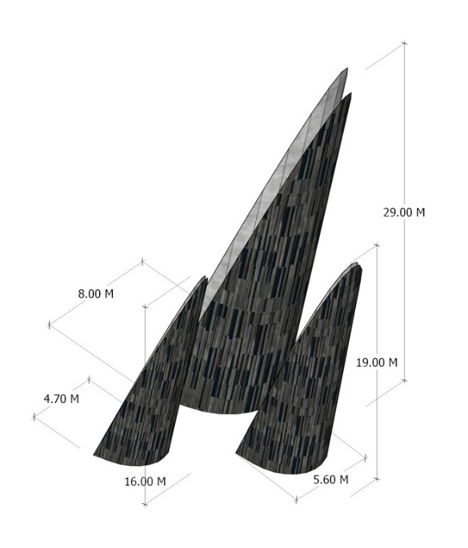
Figure 1: Dimensions of the Atoms Light form design

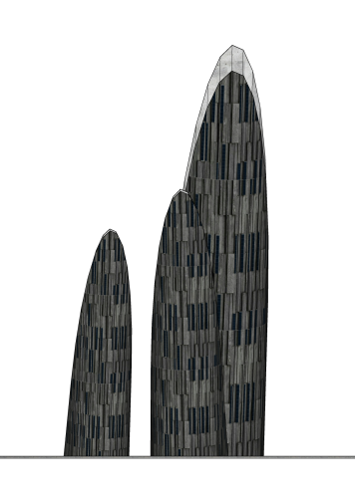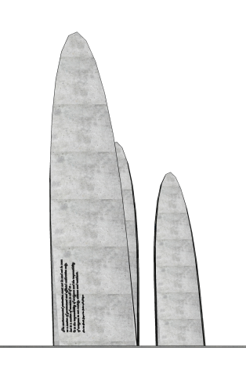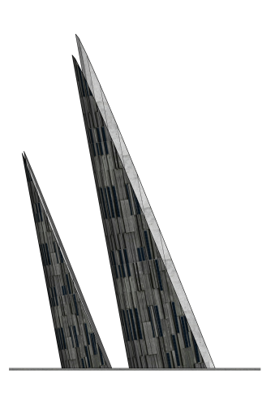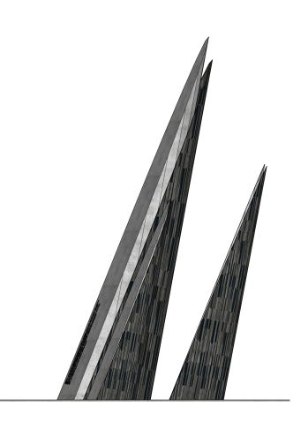
Figure 2: Different elevations of the design

USERS AND THE URBAN CONTEXT
The flow of the landscape design is generated to shape the urban activities of the spaces and the movement of the users, where people come and explore the space while enjoying the land mark which is integrated with the surface and the urban context of the town. The merge and the integration of the ground surface of the site with the shape reflect the sand particles and translate it to architectural language to create elements like floor surfaces, walls and roof. The organic roof surface is shaped around different spaces that create the urban zones for the visitors allowing them to explore the space from the public space to the iconic art form.
ENERGY GENERATION AND METHODOLOGY
The concept was analyzed further on the site to develop the pattern in depth to shape the form while considering the orientation and the sun position to capture the sunlight and transform it to energy. The solar surface is oriented to face the east west to capture the solar radiation during the day. While the landscape is opening to the North West to capture the prevalent direction of wind, which is an important aspect to cool the urban open spaces.
The “atoms light” is designed to generate about 28,776 KWh of electricity from organic flexible concrete solar photovoltaic modules for the public space in Masdar City. While the battery will be installed inside the solid art to store the electricity. The concrete solar photovoltaic modules will be installed within the concrete shell structure covering the stone. The concrete shell then will be expanding over the pedestrian walkway providing continuity to the shape and shade in the same time for the pedestrian. This will provide shade and distribute the source of electricity to light up the pedestrian walk way.
The cost of the installed capacity of the system equal $2 per watt in the UAE, which includes the solar panel cost ($/W 1), invertor cost ($/W 0.5), and the system cost (labor + structure ($/W 0.5)). Thus, the total installed cost of the PV system equal $39,200.
Table 1: calculation of the solar PV energy output of a photovoltaic system
GLOBAL FORMULA | E = A * r * H * PR
E = Energy (kWh) |  | 28776 | kWh
A = Total solar panel Area (m²) |  | 140 | m²
r = Solar panel yield (%) |  | 14%
H = Annual average irradiation on tilted panels |  | 2000 | kWh/m²
PR = Performance ratio, coefficient for losses (range between 0.9 and 0.5, default value = 0.75) |  | 0.73
Total power of the system |  | 19.6 | kWp
Losses details (depend of site, technology, and sizing of the system)
Inverter losses (6% to 15 %) |  | 8%
Température losses (5% to 15%) |  | 8%
DC cables losses (1 to 3 %) |  | 2%
AC cables losses (1 to 3 %) |  | 2%
Shadings 0 % to 40% (depends of site) |  | 5%
Losses weak irradiation 3% to 7% |  | 4%
Losses due to dust (2%) |  | 2%

MATERIAL
Concrete photovoltaic is the main element used to form the “The Atom Light”. The project is designed to use solar panels as a building material themselves, thus, the façade shell consist of concrete material within the concrete shell using flexible formwork and photovoltaic elements. These shells are concrete with built in ultra-solar panels that are integrated as it is the building material rather than add on elements. Creating an astatic concrete shell using concrete photovoltaic was the target of the design. The concrete photovoltaic is designed as a tempered glass tiles with dark tone color integrated inharmonic with the concrete shell which has a form of vertical irregular shape. According to resent studies, these concrete photovoltaic has CO₂ life cycle impact five times less than traditional crystalline photovoltaic.
CONCRETE PHOTOVOLTAIC TILE
Figure 3: close view to the material of the concrete photovoltaic
T H E A T O M S L I G H T
ENVIRONMENTAL IMPACT ASSESSMENT OF THE PROJECT
MATERIALS
The design is using photovoltaic concrete material that is considered as low emission materials that has low CO₂ emission to the environment
WATER
The design is not consuming water; water will be only consumed for irrigation system of the landscape area where we are using desert plantation type that requires minimum amount of water.
IMPACTS ON NATURAL RESOURCES
Although solar cells have some impact on the environment during their production phase, it is a clean source of energy when compared with conventional energy sources.it has many significant advantages, for example, it has lower cost and do not produce pollutants during the operation process, and it is an infinite source of energy when compared with other conventional energy.
VISUAL IMPACTS
Unlike conventional type of solar photovoltaic, there will be no visual impacts with this design due to its unique astatic design which is fitted to the form to come up with an artistic shape. Moreover, the selection of the solar cell color is carefully selected to fit the cladding material of the object to produce balanced and visual blessing artwork. The PV modules are installed with an angle makes it easy to clean and prevents the accumulation of the dust on the PV panels.

AIR POLLUTION
Solar cells are clean source of energy and don’t emit substances to the air during its operation process. However, there could be some emissions during the manufacturing and transportation which is not significant.
CO₂ EMISSION
PV systems do not require fossil fuels to generate electricity. Solar energy converted by using PV systems will result in a substantial reduction of CO₂ emissions. The equivalent CO₂ emissions avoided by using the PV systems have been calculated based on the CO₂ emission resulting from the conventional electricity generation in the UAE which is about 938 gCO₂eq/kWh. The amount of the CO₂ reduction by using solar energy is about 27 tones.

