The Frost Walk
A submission for LAGI 2019

The Frost Walk
Location: Masdar City, UAE
LAGI 2019

Design Summary

1 | Sustainable Energy Generating Technology Used | Monocrystalline Silicon Solar Panels
2 | kWp (Peak output measured in kilowatts of power) | 9181  (Detailed calculation to be provided in the later section)
3 | Annual MWh (Megawatt-hours) of energy expected to be generated | 3584
4 | Total Project Budget (based on 20 USD per Watt) | $196,364,890.06
5 | Total Project Cost | $79,070,380.00 (40.27% of project budget)  (Detailed calculation to be provided in the later section)

Abstract

To begin with, the world is challenged by extreme weathers. The melting of ice bergs, the extreme heat experienced in unprecedented areas, these are the real world problems that seemed really distant from the daily life of most people, in spite of efforts done to keep the world updated.

Energy releases when water changes its state, and which is what global warming is contributing. The installation wants to be something that could most directly express the fact that the world is constantly losing its climate through heat.

The site location itself is informative of its opportunities. The all year round heat is making the site almost unfit for a public area, and thus an outdoor cooling system will be a great approach for public space activation.

And the message that the site will be conveying is that human comfort comes at a price of damaging the climate. The expression is to create a public walk through a shaded and misty forest that brings comfort and sensual immersive experience of evaporated water.

The components

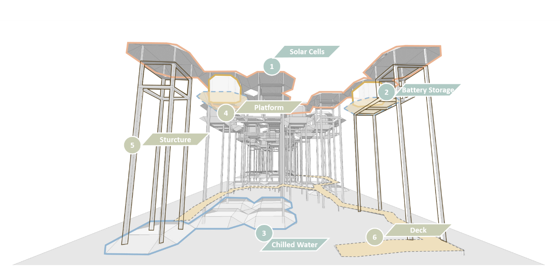

The components fall into 2 groups :

A) The energy and function performing components
B) The expression and structure components

As illustrated in the diagram above, group A consists of the Solar cells, Battery Storage and Chilled Water Storage; While group B consists of supportive and structural components, as well as the walking deck.

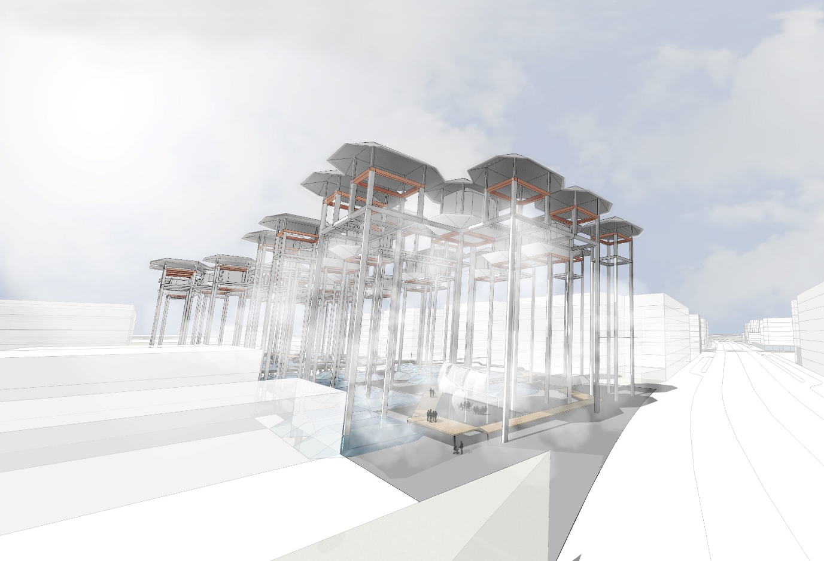
Walking Deck
Solar Cells
Battery Storage
Supporting Structure
Chilled Water Storage

The System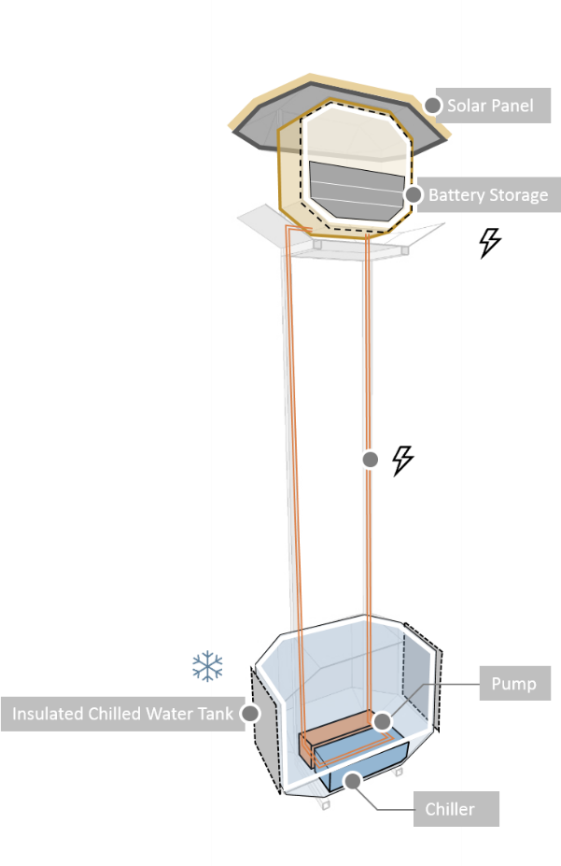
Power Storage and supply to system operation
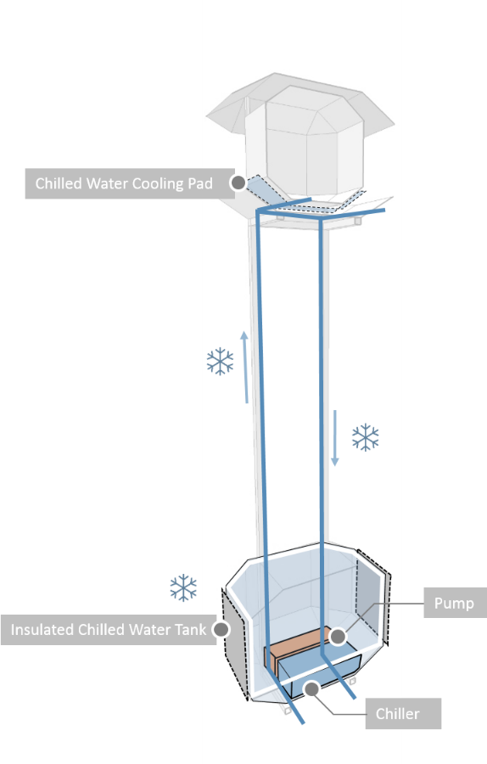
Chilled water used for cooling of battery storage
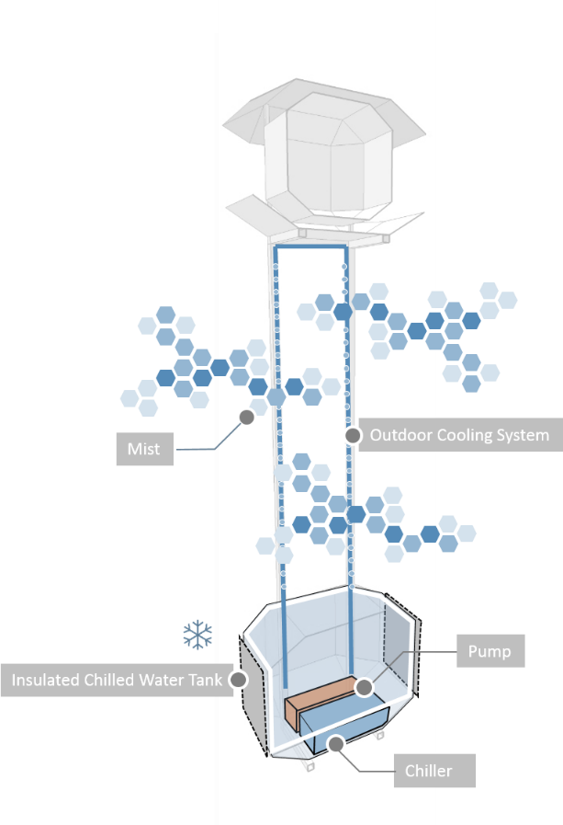
Chilled water used for outdoor misting system

Calculation

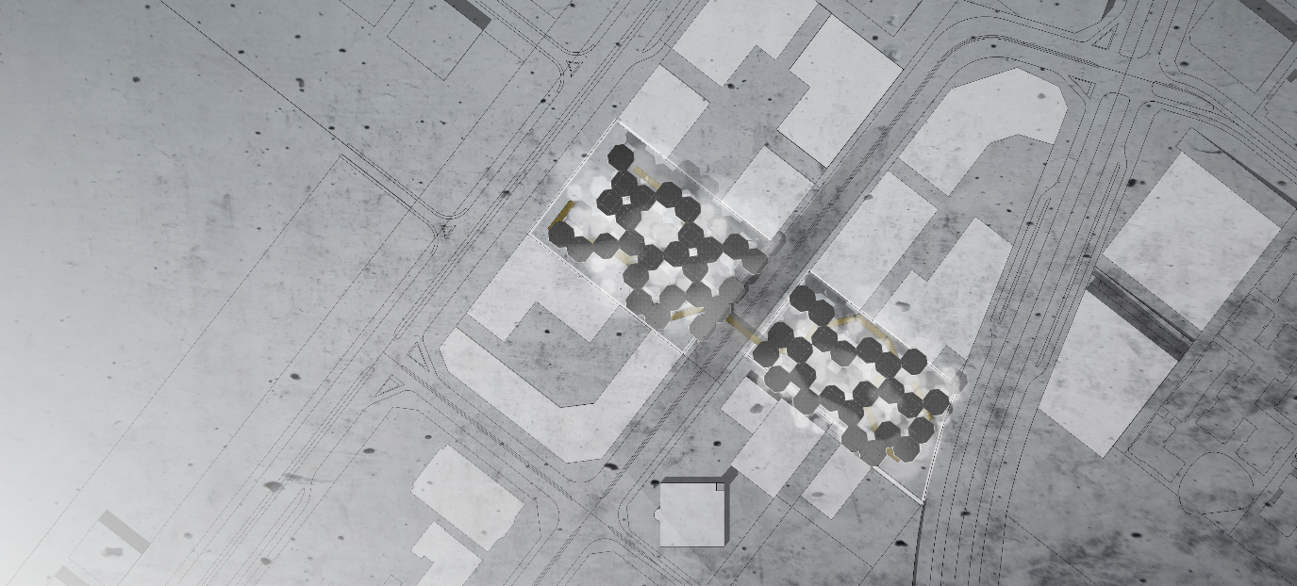

Basic Info |  | Info of Panels
 |  | Mono-crystalline Silicon Solar Panels
No. of units | 50 | Efficiency of Panel | 21%
No. of Panels per unit | 131 | Weight | 18.6
Total No. of Panels | 6550 | Dimension (mm) | 1558 x 1046 x 46
Site Peak Hour | 5.84 | Price (per watt) | 1.4 USD

Energy Output Calculation
Total Receiving Area per unit (m²) | 213
Output Calculation (kwh)/day  Formulae (Site peak x Area x Efficiency x 25% energy losses) | 196
Total site output (kwh)/day | 9818
Annual output (Mwh) | 3584

Battery Selection & Calculation
Capacity (kwh) | 15.36
No. of cycles | 5000  (13.7 years if cycle runs daily)
No. of batteries needed for storing of 7 days’ worth of overall energy output from the installation | 4474
Unit price | USD $14,399.95
Overall price | USD $64,432,005.83

Construction Cost Calculation
Price of vertical steel beams | $62,113.31 | 6.96%
Price of horizontal beams (USD) | $42,045.94 | 4.71%
Ground Walking Deck | $105,000.00 | 11.76%
Chilled water Cooling Pad (USD) | $1,500.00 | 0.17%
Thermal Chilled Water Storage (USD) | $405,000.00 | 45.36%
MISC | $56,850.00 | 6.37%
Infra Cost | $58,329.18 | 6.53%
Total Cost | $892,838.43 | 100%

Total Project Cost
Solar Panels | $13,745,542.30
Batteries | $64,432,005.83
Construction | $892,838.43
Total (USD) | $79,070,386.56

Project Budget  (20 USD per watt generated) | $196,364,890.06
Percentage of projected project cost to overall budget | 40.27%

Environmental Impact Summary

Energy

Assuming the average household electricity consumption is 28.9 kWh per day, the installation will be able to provide for approximately 400 household a day, approximately reducing 4 metric tons of carbon foorprint every day.

The Frost Walk is also able to store up energy for up to 7 days of the daily output of the site, providing energy security for the city.

Social

The outdoor temperature does not encourage too much outdoor activities in the UAE, especially with the special attire of the Muslim community. The key of the installation is to reduce the temperature by 40%, the shades from the solar panel layer above could contribute to make the space a more conducive for public activities.

The Frost Walk could serve as a park in the usual days, and has provided spaces for seating and stages which could encourage more vibrant activities to be held.

Educational

As described in the project abstract, the misting forest will bring a direct expression of climate impact from how mists are evaporating from the ground, and how appreciative people could get for having the chilled environment in such a hot climate place.

