ATMOSPHERIC MOISTURE MACHINE
The atmospheric moisture machine creating an opportunity to collect water from thin air
Valerie Clarke and Dhara Oza

Water in the United Arab Emirate is in very short supply. The UAE is one of the top 10 most water-scarce countries in the world and has one of the highest per capita water usages globally. The atmospheric moisture machine gives Masdar City the opportunity to collect water from thin air and increase water supply in an area with desert-like conditions.

Harvesting humidity is a passive process. The renewable energy generated is supplied by the wind. The proposed mesh panels capture the humidity converting it to fresh water. In addition, the water moves by gravity through these mesh panels to the underground cistern, so no pumps or electricity are required to either generate or to move the water. The collected water is further used to increase the vegetation on the site while creating a new cooler and wetter micro climate. The water is then dispersed through an irrigation system throughout the site. The environmental impact of installing and maintaining the technology is minimal. Once the component parts and technical supervision have been secured, construction of humidity harvesting technology is relatively straightforward and can be undertaken on site.

This result is a new form of public space, one that is more scenic and comfortable for cohabitation in Masdar City.

Proposed Mesh Panels

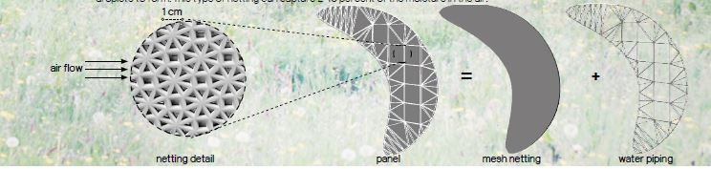

The most optimal mesh netting is made from stainless steel filaments the size of three to four human hairs and with holes that are twice as big as the filament. The mesh is coated in a chemical that decreases water droplet’s contact angle hysteria, which allows for more small droplets to form. This type of netting can capture 2-10 percent of the moisture in the air.

Water droplets that collect on the mesh run downwards by gravity and drip into a gutter at the bottom of the net. From there, the water is channelled via pipes to an underground cistern. Seventy-eight panels line the entire length of the site. Each panel has 2,386 square feet in area and generates on average 1105L per day. The entire site can generate more than 85,000 L a day. With the new vegetation proposed, the water capture can increase an additional 2-5%.

Water supplies from fog harvesting can help to counteract the desertification process. The newly planted vegetation can then sustain itself and contribute water to the ecosystem helping to build resilience against drier conditions.

Site Development
mesh panel
absorbs humidity to produce fresh water

water movement
catch basin for water storage and drip irrigation system
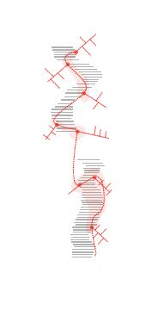
pedestrian movement
site accessible from all directions inviting people to access the new urban space
wind movement
wind flowing from northwest to southeast with mesh panels oriented at 90 degrees to the wind flow
