THE POWER OF THE DESERT
OPEN HERITAGE MUSEUM
MASDAR CITY- UAE
Blurring the lines between culture space and renewable power generator facility, the new proposed design concept of 30,000-square-meter heritage museum located in United Arab of Emirates is the main landmark and culture center in Masdar city principle landscape axis. The idea is to transform the traditional space of renewable energy generator facility into a heritage museum celebrating 50 years of modern development since the country union declaration.
The main Concept proposes the museum as an essential culture node in the center of the city urban fabrication, also it proposes impeding the renewable energy generators equipment within the museum Spatial scheme without affecting the main concept morphological forms that reflect the iconic historical key feature considering the UAE heritage, with the consideration of energetic efficiency and environmental characteristics of the surrounding.

THE MAIN CONCEPT
PHILOSOPHY
The project philosophy aims to integrate UAE heritage and culture aspects with the considerations of renewable power generators settlements through a unique design scheme capturing the spirit of surroundings, even as it asserts its own identity. Reflects the historical iconic elements, by introducing visual metaphor, appealing, healthy, comfortable, flexible, secure and efficient, a pleasure to be in. And adding real value for the city and users.
The design concept based on 3 connected approaches:
1 -Culture and Identity - Presenting iconic historical features to rehabilitate and emerge UAE character and integrate the variety of action locations forming the desired international image and city unique landmark.
2 - Environmental approach - As a sustainable project integrates considerations of energetic efficiency and a compatible material. It also presents a use of the territory in an ecological and social manner, allowing using of natural illumination and environmental air-conditioning systems in combination of power generating trying to redefines the idea of an iconic culture landmark.
3 - Renewable power generators settlements - Impeding and managing the power generators different types and features in an artistic innovative scheme as an added value to the design final image and main concepts. Reducing life-cycle energy and operating costs; improving brand recognition; and a quality of life that promotes health and wellness.

CULTURE AND IDENTITY APPROACH
The culture approach is the main spine of the project overall concept as by transforming a renewable energy generator sculpture and landscaping into a heritage open museum celebrating 50 years of the United Arab of Emirates development.
The museum will be shaped first of all as an open space, a multi-functional center reflects the country history and culture, a place to learn more about the community principles and identity features, and above all a place of entertainment for an expanded community.
The spatial scheme reflects key elements of the country heritage and combined it with the renewable energy features in a context of modern design forms, also the overall design context reflects the main advantage of renewable energy which is infinity and unlimited safe resources.

INFINITY CONCEPT
Inspired by the international infinity sign, the layout illustrates the renewable energy fact of being an unlimited resource of power energy, as the design main outline draw the infinity concept with a smooth unbroken border forming the spatial scheme of the museum.
MORPHOLOGICAL FORMS
As UAE historically known as an important market of pearl trading, the structure of the shading areas and ceilings took the shape of the pearl shell impeded inside it the photo cells used in generating electric power.
LANDMARK STATUE
Acting as the main landmark of the museum, the wind tunnel and solar generator sculpture, An Arabian statue as an image of the main development hero the emirates family.
The statue demonstrates a man and a woman, the man acts as a shelter and protector for the historical development journey where the woman as the main pillar of this development.
METAPHOR
The statue formation consists of seven main sectors as an image of the seven emirates union, together forming the creators of the country evolution in the past 50 years from the country union.
SKYLINE
The desert is a fundamental aspect in the history and also the present of the country heritage and culture, the museum skyline combines the main two morphological concepts of infinity and pearl shell in a desert formation skyline as the main context of the project sky borders.

INTEGRATED ENVIRONMENTAL AND RENEWABLE POWER GENERATORS APPROACH
The project as a renewable power generator source propose an integrated system between power generation and environmental methods which benefits the project main culture concept and use. The construction system impeded indirectly the renewable power generators different methods equipment and a natural ventilation and daylight illumination system within the spatial scheme of the project.
- The main factors of the integrated system:
1- Wind Tunnel System - The 2 towers located in the center of the main two entrances, one of them the major project landmark statue, act as a wind tunnels generator consists of vertical multi-system turbines from the bottom to the top which produce extremely highly efficient power harvest.
2- Photo-voltaic Cells (CSP) System - Impeded inside the shells construction form located the photo-voltaic cells oriented towards the sun light movement also located covering the inside skin of the main statue giving an artistic theme to the artwork.
3- Photo-voltaic Cells System (OPVC) - located within the fabric textile shading formations the OPVC system consider a part of the formation textile appearance as an artwork design.
4- Photo-voltaic 3D Cells - As a part of the boarder walls construction the 3D photo-voltaic cells integrate with the light ducts systems to reflect sunlight beams in purpose of illuminate the exhibited walls.
5- Natural Ventilation System (Underground air Tunnels) - The two towers act also as a ventilation access of an Underground Air Tunnels for Cooling the surrounding atmosphere inside the main passage of the museum, the tunnels go beneath the project into the Soil temperature, at a depth of about meter feet or more, which stays fairly constant throughout the year, and is approximately equal to the average annual ambient air temperature. The ground can, therefore, be used as a heat sink for cooling in the summer.
6- Natural Daylight Light Ducts System - Using the edge of the museum border walls and the shell covering ceiling as a light duct to illuminate the museum different exhibited items also the mirror light duct uses the 3D photo-voltaic cells to obtain electricity from the reflected sunlight beams.

- WIND TUNNELS SYSTEM
A wind turbine generator can have a vertical or horizontal rotation axis. A vertical-axis wind power generator is advantageous for installation in city centers because it is not affected by the direction of the wind as much as a horizontal-axis wind power generator. also, as the energy generated by a wind turbine is proportional to the swept area of the turbine and the third power of the wind speed, the Figure shows the illustration of wind speed vs. power relationship for the experimental wind turbine. Therefore, enlarging the swept area or increasing the wind speed can effectively increase the power output. In particular, since, the output is proportional to the third power of the wind speed, increased output will be obtained even with a slight increase in wind speed.

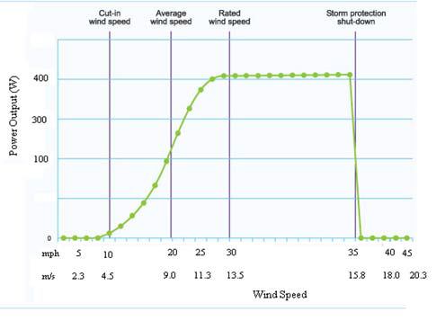
Wind Speed characteristic of experimental Wind
Turbine (Modified University of Northern Iowa, 2013)
The idea is to propose a system of several wind tunnels with vertical wind turbines integrated to produce about 126MWH yearly with the cost of 96,000 dollar.
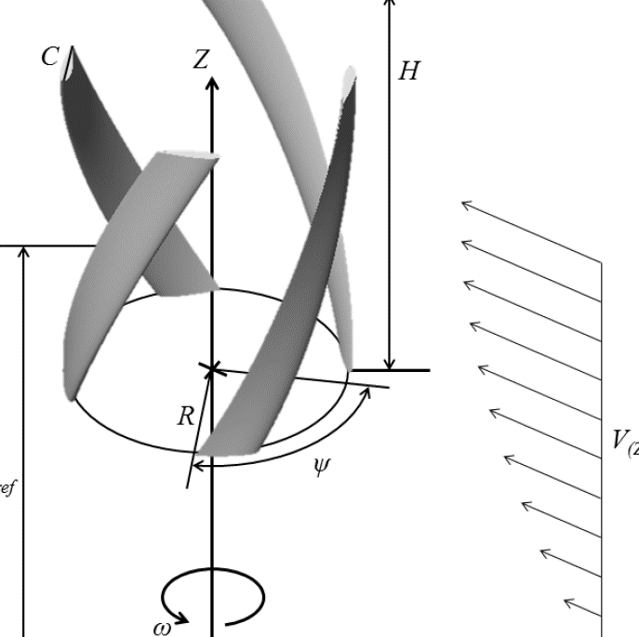
Basic design parameters of the vertical wind turbine.
- UNDERGROUND AIR TUNNELS
Soil temperature, at a depth of about 10 feet or more, stays fairly constant throughout the year, and is approximately equal to the average annual ambient air temperature. The ground can, therefore, be used as a heat sink for cooling in the summer and as a heat source for heating in the winter. A simple method of using this concept is to pass air through an underground air tunnel. And by integrate an open loop, underground air tunnel system cools or heats the ambient air passing through it with the wind tunnel system, this air is then introduced directly the semi contained space.
Measurements showed that for 1000 cfm air flow through a 100-foot tunnel, the temperature of the ambient air was reduced from 90°F to 83°F. This translated to a cooling effect of 127 Btu/min. (Fact Sheet EES 78, a series of the Florida Energy Extension Service, Florida Cooperative Extension Service, Institute of Food and Agricultural Sciences, University of Florida. Publication date: May 1993.)
Therefore, with the integration of the system with the wind tunnel system space temperature can be reduced naturally as an environmental edge to the project.

- PHOTO-VOLTAIC (CSP) SYSTEM
A system of flexible reflectors in the form of a parabolic channel cross section, impeded in the outer shell and the main land mark statue, where there are collector tubes in the focuses. The system approximately generates 2207 MWH per year with the cost of 4,200,000 dollar.

- PHOTO-VOLTAIC (OPVC) SYSTEM
The organic photovoltaics cell (OPVC) is very promising owing to their potential of providing environmentally safe, flexible, lightweight, and inexpensive photovoltaic cell. Using the (OPVC) Photo-voltaic in the fabrication of the covering shell allow the generation of approximately 693MWH per year with the cost of 1,320,000 dollar.

- 3D PHOTO-VOLTAIC AND LIGHT DUCT SYSTEM
The 3D photo-voltaic structure can pick up light when the Sun is at lower angles and internal reflections within the structure help increase the amount of captured light. Integrated with the light duct concept the system could be very useful in generating power and illuminate the exhibited items by natural daylight artistic effects. Amount of generated power approximately 473MWH by the boarder walls of the museum with the cost of 900,000 dollar.
Marco Bernardi and pals at the Massachusetts Institute of Technology in Cambridge say there is a simple fix that could dramatically increase the performance of photovoltaics. Instead of two-dimensional flat panels, Bernadi and co suggest using three dimensional structures.

RENEWABLE ENERGY GENERATOR | ANNUAL ENERGY | CAPITAL COST BY DOLLAR
VERTICAL WIND TURBINES | 126 MWH | 96,000
PHOTO-VOLTAIC (CSP) | 1800 MWH | 3,428,000
PHOTO-VOLTAIC (OPVC) | 350 MWH | 650,000
PHOTO-VOLTAIC 3D CELLS | 473 MWH | 900,000
TOTAL | 2745 MWH | 4,424,000

ENVIRONMENTAL IMPACT
Research on wind power generation has been actively pursued. At first, research on middle-size and large horizontal wind turbine generators was the main focus. However, due to factors affecting the environment such as noise, such wind turbines are difficult to install near residences and have negative effects on the ecosystem, such as the movement of birds. In contrast, small wind turbines can be installed near residential areas adjacent to power loads, and relevant research has been conducted.
A vertical-axis wind power generator is can be used in the project establishments because it is not affected by the direction of the wind as much as a horizontal-axis wind power generator. It is easy to maintain because it does not need complicated structure such as yawing devices. In the case of horizontal-axis wind turbines, the angle of attack due to the rotation of the wind turbine is constant. Many studies have been conducted on the prediction of the blades’ aerodynamic characteristics, and many proprietary technologies have been established. However, in the case of vertical-axis wind turbines, the angle of attack due to the rotation of the wind turbine changes continuously.

However, more design effort has to be introduced to minimize the effect of vibration and noise produced by the several small wind turbines installed, also a study for determine and control the air movement through the wind tunnels and the distribution of air in the underground air tunnels in order to understand the exact results of the whole system.

