AMBER FARM
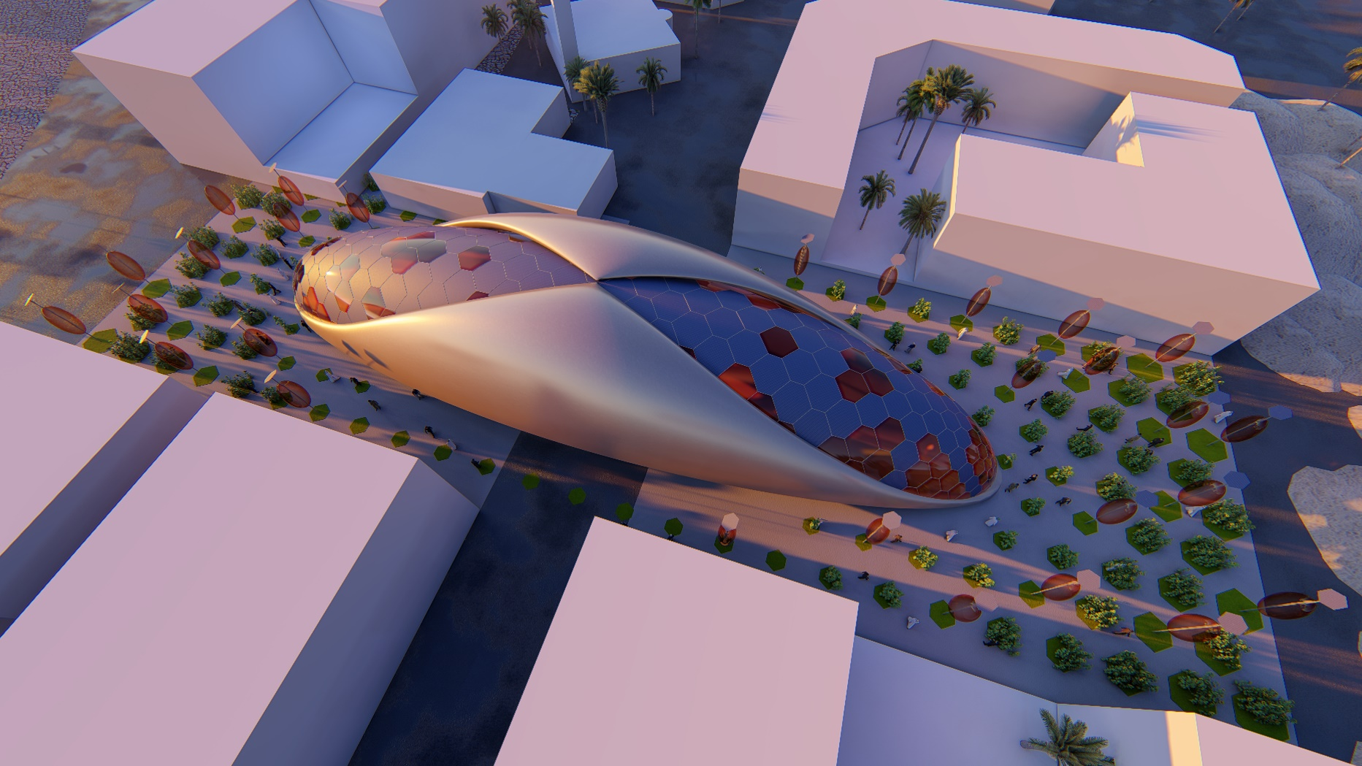

Description
This project consists of three main design principal and concepts:
- Sunflowers are sensitive to radiation of sunlight and During growth, they tilt during the day to face the sun.
- Human has used writing technology to store their knowledge during the history. Amber is fossilized tree resin, which has been appreciated for its color and natural beauty since Neolithic times. Therefore, Amber can be a symbol of maintaining small fingerprints of mummification. In this project, we used Amber as a mummification of energy.
- Throughout history human has used resources for his needs. This time, we wanted to reverse this process to generate energy feeding the nature.
As we know, renewable energy is one of the valuable resources of energy that is not depleted when is used. Our design concept began from a ring that was inspired by these renewable energy properties as an endless cycle. In process of designing, the body created in a way to induce an infinite concept so this can be an icon, symbol of Masdar city. The land is divided by street and this ring, like a bridge, connects two sides of the land together. As a result, the pedestrian users cross the bridge without interfering with the street. Pedestrians can enter the bridge from middle of the site. There are 3 lines designed at the inner side of the bridge for pedestrians, first line produces energies as people walk or run on the flexible pavement which moves like a treadmill, second line for walking and the third line is a moving ramp, and the mechanical energy is provided by the bridge itself.
Main three steps:
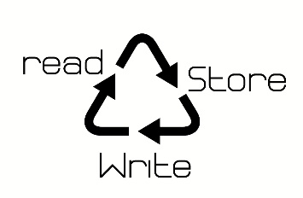
- Read: We inspired from sunflowers and used it in our technology as bio mimic, Using the intelligence of this plant to analyze sun direction. The solar panels are sensitive to radiation of sunlight and can rotate in three main axis and as a result, they can be exposed to the most efficient sunlight. Moreover, the ring has got a sensor and can read human motions as they walk on it.
- Store: the energy which is produced from both main form and land will be stored inside amber capsules also the energy which is produced by human motions will be saved as electricity and can change into mechanical energy to move the inner ring inside the bridge or it can be stored in Amber capsules which are distributed in land.
- Write: We use saved energy for different purposes. The energy which saved by solar panels can rotate the outside part of the ring. Also, the energy which saved by human motions can rotate the inside part of the ring. The saved energy can illuminate the capsules in land during the night and consequently, these energy capsules can be used independently in other locations for variety purposes and it can provide the other part of the city power supply as an energy farm.
Energy technology and price
- Main capsule (solar panels)
All panels: 1005 kwh per day
1005 x 365 = 36685 kwh/year
40 kw panel price = $ 85400
Price of capsule = $ 9394000
- Ambers in land
Each Amber: 4.10 kwh per day
365 x 4.10 = 1500 kwh/year
26 (number of Ambers) x 1500 = 39000 kwh
2 kw panel of Amber price = $ 4270
26 (number of Ambers) x 4270 = $ 111020

Total output energy = 405825 kwh/year
Total price = $ 9505020

Environmental impact
According to sun path, we put solar panels on a path with the highest amount of energy absorption. The higher the temperature of the panels, the higher the amount of energy you get and as a result, we designed the form in a way to increase the flow of wind in the land. Due to the nearby buildings, the height of our form is high enough.
Material
Body white composite (24397.8431 square meters), glass (2204.5257) square meters)
Solar panel silicon (3070.86451 square meters)

