Sun Flower.

Is a kinetic sculpture which utilizes the potential energy of its own weight, to store energy collected during the day through translucent solar panels in its petals. During day, the fully open petals collect energy from the sun through translucent photovoltaic panels and produce a comfortable shade for its visitors. At its maximum open state each structure may produce up to 200 KWh, powering electric motors which will slowly lift the petals up (close). At sunset, petals will have reached their closed position, and because the motors will no longer have energy to run the petals with the force of gravity will begin to fall. As the petals slowly open through the night, the rotation at their pivot point power generators at the base which will illuminate the entire site. Therefore at its closed position the structure will become a lantern of translucent solar petals. With its opening and closing, this self illuminating structure will announce a new era in sustainability, where art, energy production, and our built environment, can coexist symbiotically with one another.

Environmental Statement.

The inspiration for this project came from the 18th century by Scottish engineer James Watt who used horses to lift pails of water thus defining horsepower asa unit of energy equal to the energy required to lift a 550 lbs pail of water up 1 ft in 1 second.
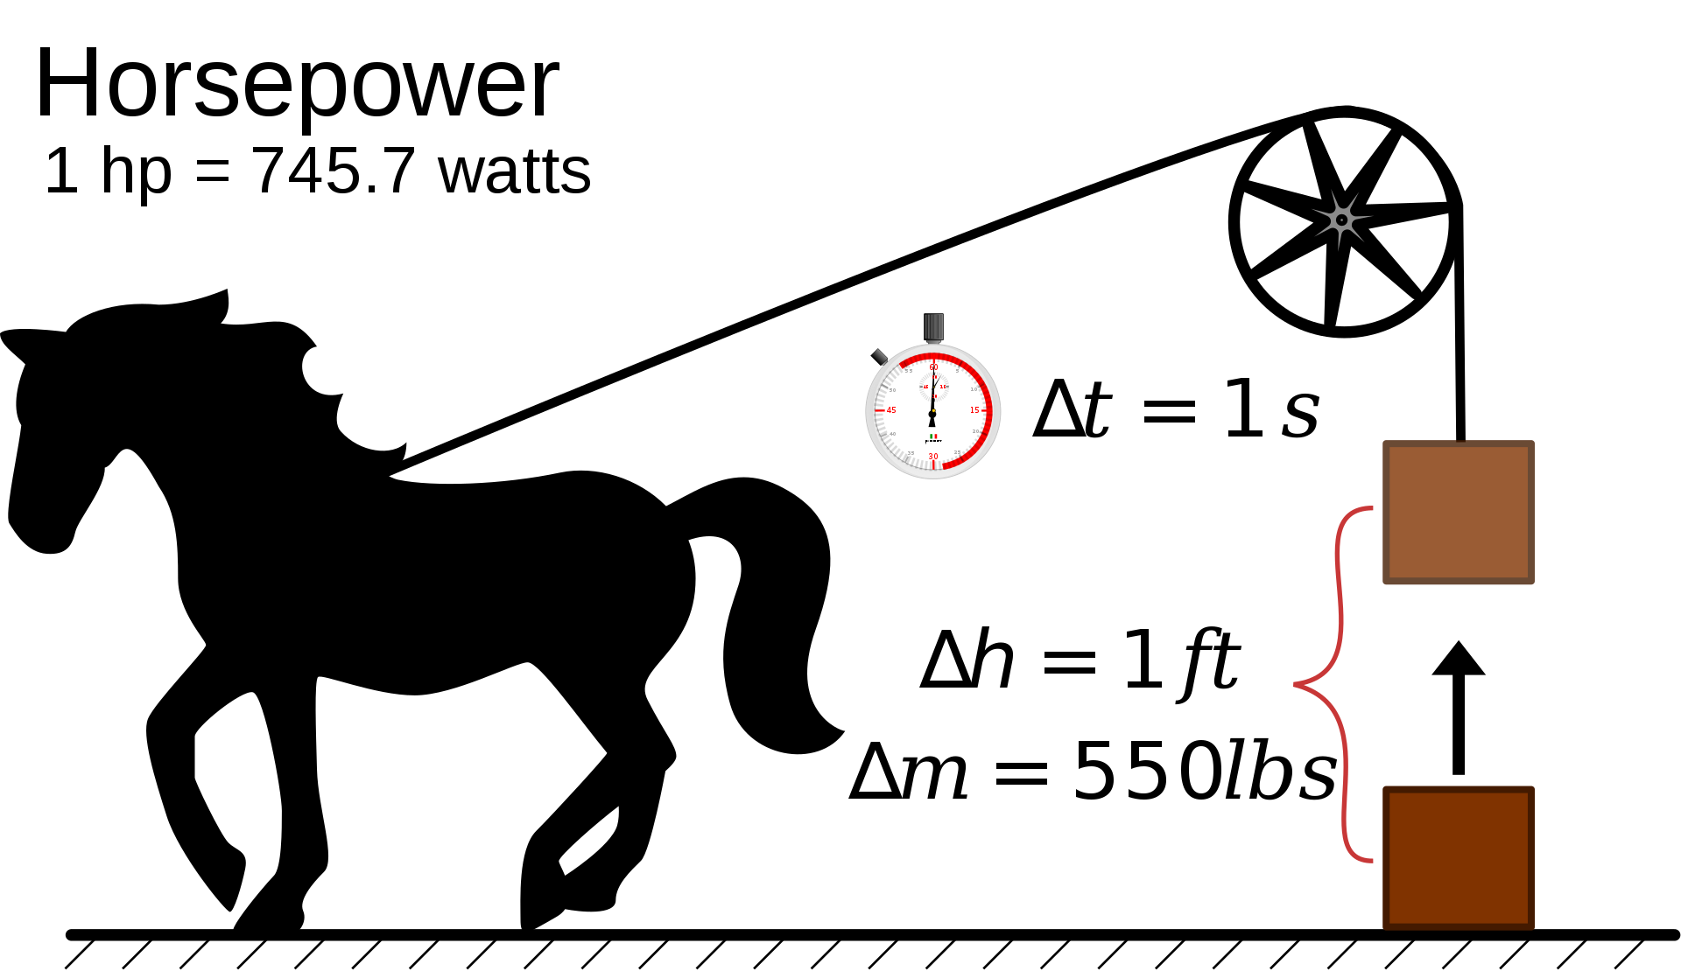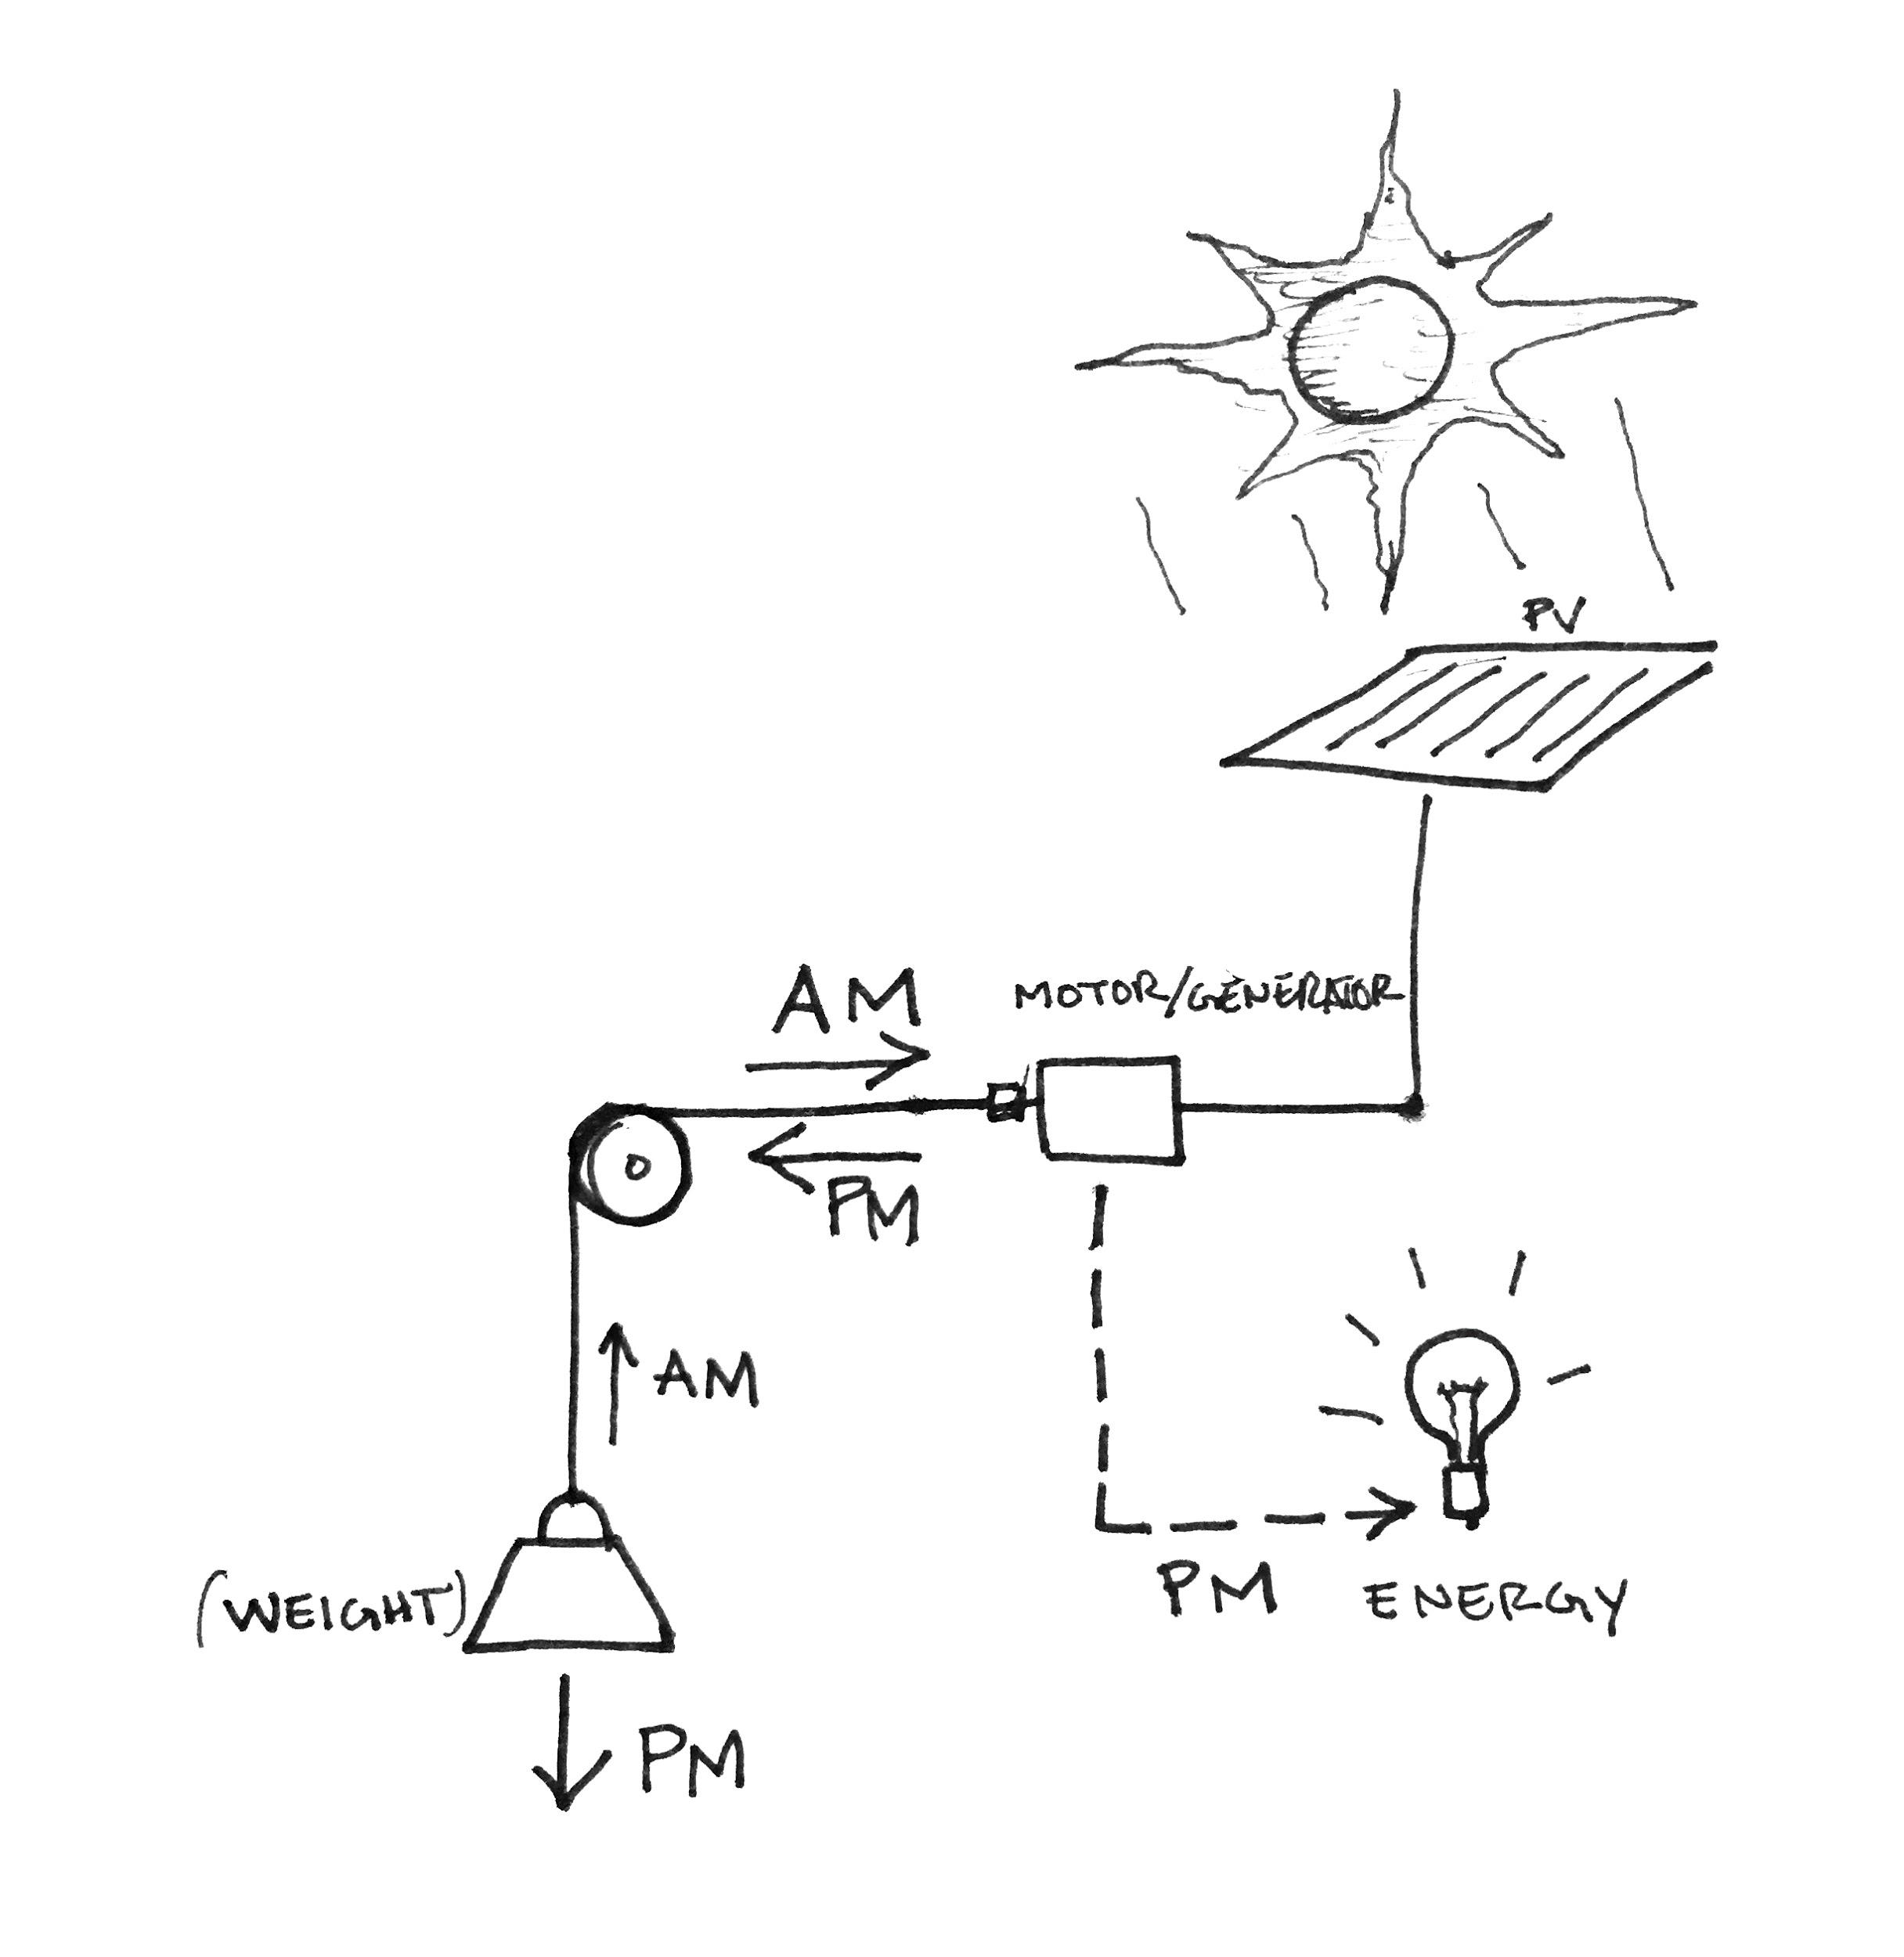
https://en.wikipedia.org/wiki/Horsepower Concept sketch for Sun Flower.

Instead of horses the proposal utilizes solar energy to drive electric motors which lift a series of structural petals throughout the day. As these petals are lifted they store potential energy which is released as the solar panels stop producing energy. This strategy does two things: it generates energy during the day, and it stores energy acting as a giant kinetic battery.

At its largest each Sun Flower may provide up to 2000 sqm of solar panel area. At an efficiency of 9.8% this could mean generating up to 200 KWh of energy during day time hours per structure. If built our in its entirety the project could generate up to 800 KWh of energy. Part of this energy is stored as potential energy which is released when the petals begin to fall.

