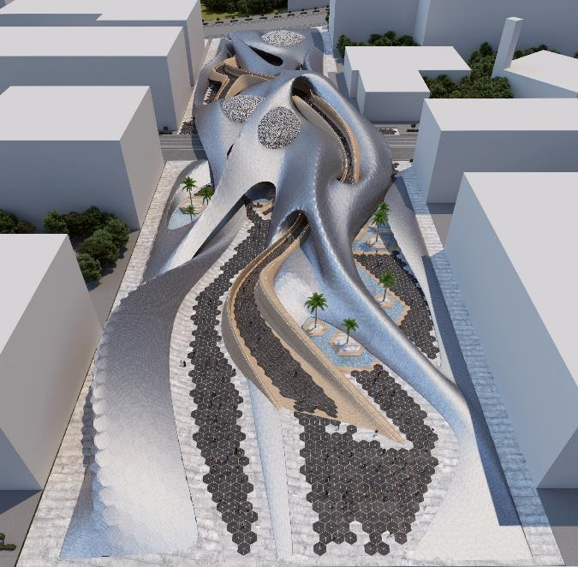

|  |  |
| --- | --- |
|  | THE PULSE |
|  | LAGI 2019 |
|  | 5/9/19 |

Nature and Sustainability

**ABSTRACT**

THE PULSE proposal is an artistic structure that addresses the ever-increasing demand of communities for innovative and renewable energy solutions as the world continues to fight back against carbon emissions and climate change.The PULSE is targeting to produce 5,248 MWh in annual capacity.

**INTRODUCTION**

The Pulse represents the beginning of life for living bodies to generate energy for survivability.

The **PULSE** incorporates a state-of-the-art approach to the standard concept of solar panels, unifying the organic, free-flowing style of nature with the innovative technologies of renewable energy in its design. The modern structure with its creative and sophisticated appearance aims to emulate the beauty of a natural environment and conveys to those who see the purpose and significance of sustainability. The **PULSE** encourages working towards a future that is clean and green while keeping up with the ever-changing techniques of contemporary design.

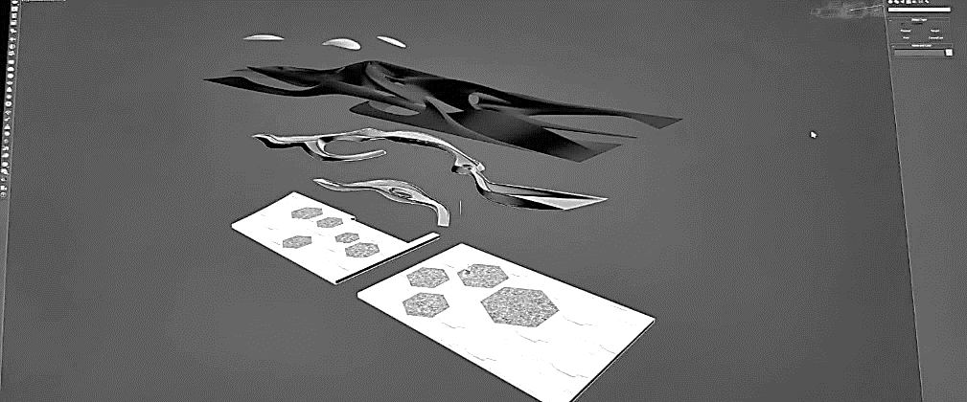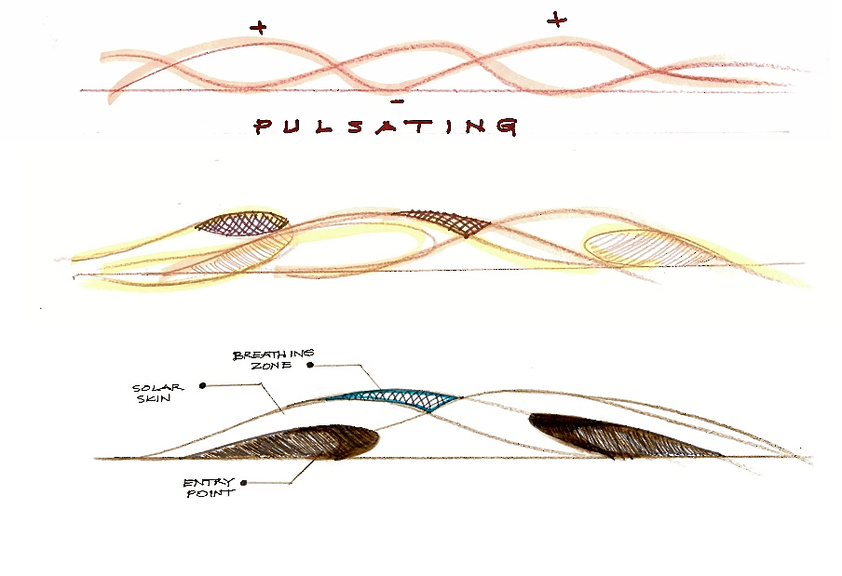

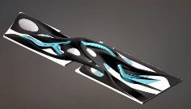

**SITE ANALYSIS**

The project is located on a sprawling 2.4 hectares of raw land, surrounded by roads and a series of residential buildings for future development, within the cutting-edge Masdar City in Abu Dhabi. The site’s geographical setting is of the Latitude 24.44 and Longitude of 54.62, which features several environmental and geographical advantages, making it a prime location for this large-scale project utilising direct sunlight to produce bountiful amounts of solar energy, making full use of a primary and valuable natural resource in this desert region.

SITE ACCESS AND CIRCULATION

**VEHICLE MOBILITY**

**PEDESTRIAN CIRCULATION**

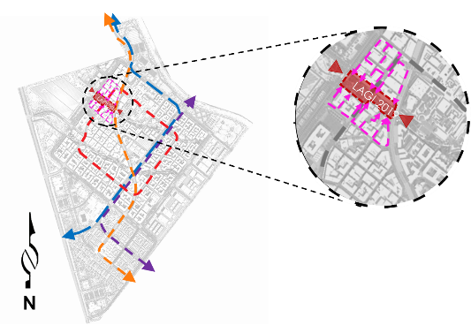

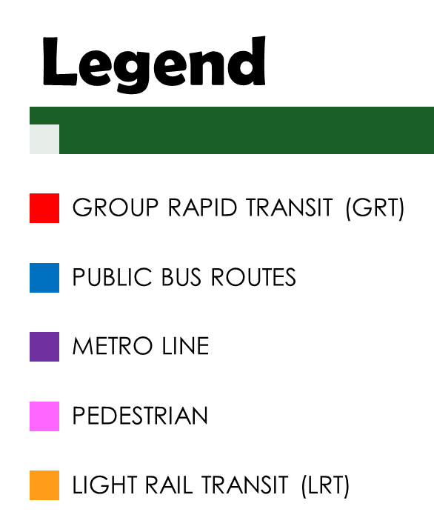

LAND USE ANALYSIS

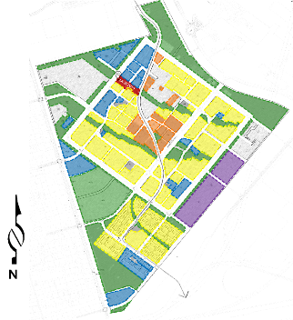

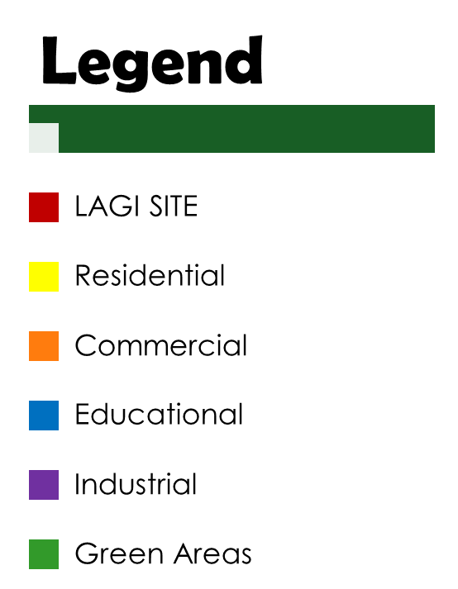

PV SOILING ANALYSIS

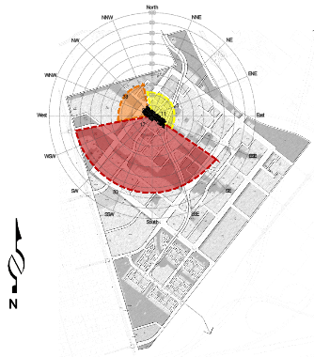

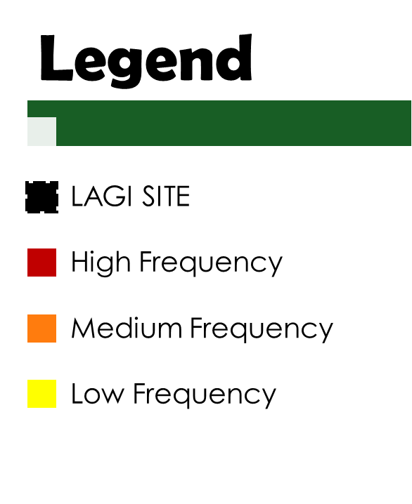

SURROUNDING LOCAL LANDMARKS

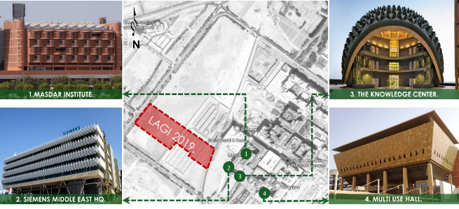

SUN AND WIND PATH

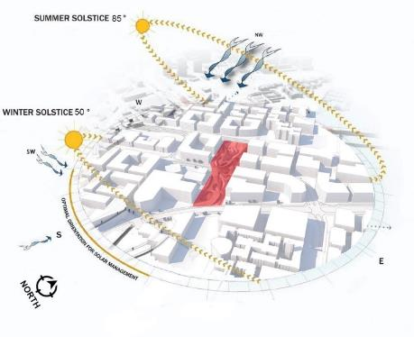



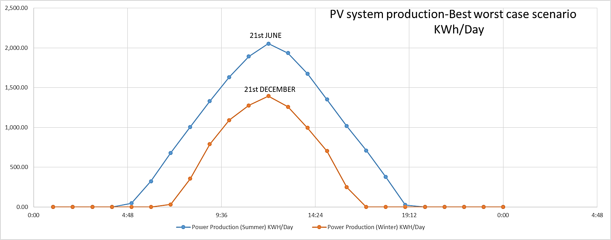

**PROJECT DESCRIPTION**

The project is an artwork formed by a curvilinear structural frame shaped by free-flowing lines and rising from ground level, on both ends of plot crossing. The structure gracefully glides over intersecting roads, right by a bridge made from recycled wood.

The structure’s outer layer is cladded with customised, hexagonal monocrystalline solar PV modules. Three (3) elliptical zones puncture through the surface, known as “breathing zones” imitate a heartbeat by its constant up and down movement following the sun, turning the site into its living being.

The open plazas beneath that provide gathering spaces for people incorporate human movement and local circulation as parts of the design itself. Not to mention, the area welcomes all visitors, as it is even accessible to people of determination, through the aforementioned bridge. The wooden bridge provides a raw feeling of nature while promoting stronger preservation of the environment by emphasising on the value of reusable, natural resources.

The flooring of the passageway boasts of an array of kinetic energy tiles which generates energy with every step and furthermore enhancing the annual capacity requirement for utilising renewable energy.

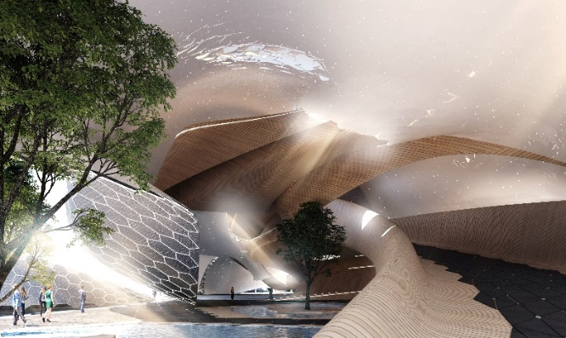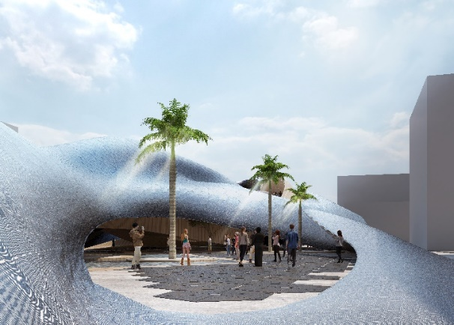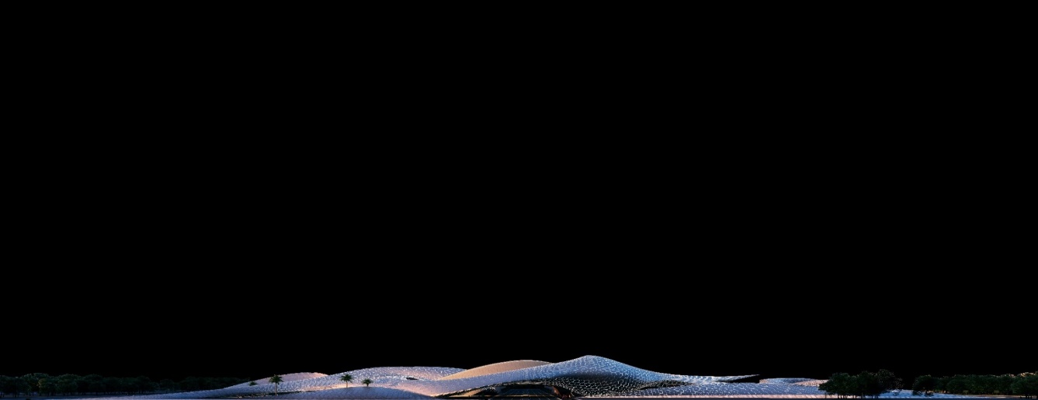Landscaped waterbodies assist a passive cooling technique underneath the structure, as when air passes through, a crisp and refreshing circulation of wind spreads throughout the building. The remaining paved area is from recycled material for maximising sustainability.

THE PULSE cooling capacity about 800 Tons with approximate volume of 300,000 m3. An innovative passive cooling system is proposed to achieve the thermal comfort and ensure good indoor environmental quality within the pulse utilizing Dehumidification and Energy Recovery Ventilation (DERV). The purpose-designed units represent a significant advance in ventilation technology for open spaces, commercial and residential buildings. This assisted in saving almost 50% of the load required for the ventilation needed to cool the space.

DERV units having the advantage of removing the moisture in a special cooling coil and absorbing the heat from high-temperature extracted air for being cooled. DERV units incorporate Heat Recovery Heat Pipe Heat Exchangers in addition to Heat Pipe assisted cooling coils to further precool the air and minimise the cooling load. The units will be strategically located within the structure.

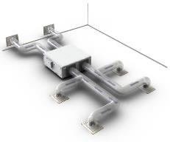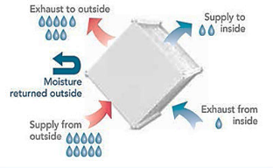

Ref: http://www.ahrinet.org/contractors?S=126

**Cooling System Diagram**

**The leading characteristics of THE PULSE**

**INNOVATIVE DYNAMIC PV STRUCTURE**

The PULSE creates a spectacular opportunity for innovation of PV modules industry. The design climax presents an outstanding element,which imitates a breathing rhythm; this employs the use of pulsating geometrical solar modules fixed on a steel frame. The purpose of innovative and dynamic PV structure is to increase the production of power by expanding the surface through applying automated mechanism programmed to track down the movement of the sun with different seasons along the year.

The concept truly breathes life into the elegant, complex structure and leaves a deep impression on any individual who sees such effect, as it creates a more distinct, personal connection.

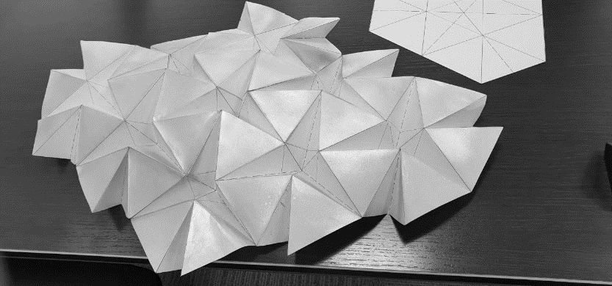

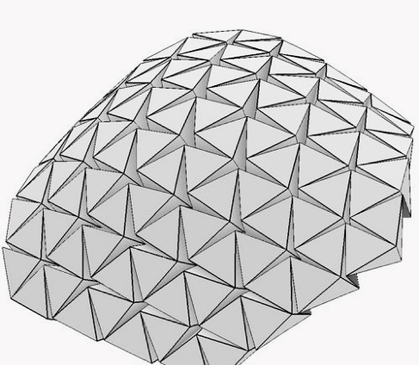

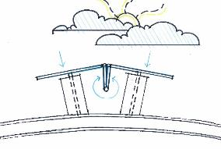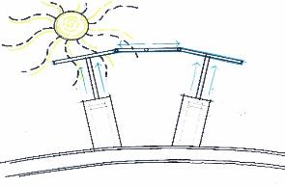

**Breathing Mechanism during day time**

**RENEWABLE ENERGY SYSTEMS DESCRIPTION AND ANALYSIS**

State of art customised hexagonal PV modules implement mono-crystalline technology. The hexagonal shape is adapted to blend with the design theme. The PV modules are glazed material, which employs a PIBV technique.The capacity of each PV module is **365Wp** with an overall efficiency of approximately twenty percent (20% depend on Almaden manufacturing resource). The expected annual capacity production is 5,248 MWh due to monocrystalline, flexible thin-film, and the energy floor considering the use of PVsyst V6.7.9 software for PV simulation.Utilised amount of PV panels reached to 9,726 modules. The proposed renewable is designed to be grid connected based on net metering scheme, to eliminate the use of the storage system (almost 40% of the system cost), considering the grid as a mega storage. The surplus power will be transferred to the dispatch center to be utilized according to Abu Dhabi energy demand.

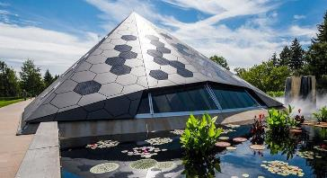

Ref: <https://www.onyxsolar.com/pyramid-science>

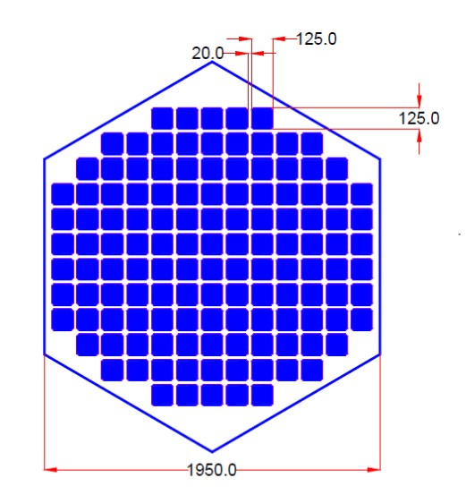

**2000.0 mm**

Kinetic energy tiles having a coverage area spanning to 2,000 square meters are applied to utilise people mobility in producing additional clean energy (KWh) that will be added to the overall power generation.

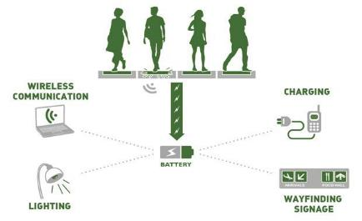

Ref: <https://medium.com/@rohitgurjar009/kinetic-footfall-energy-generation-e04c67ee4223>

THE PULSE Maintenance and operation are considered for the PV system to assure energy yield through the life cycle of the project by providing corridors for cleaning modules and reduce the soiling effect to maintain the system efficiency. (2% of the capital proposed for system operation and maintenance within the cost estimation)

**RETURN OF INVESTMENT ANALYSIS**

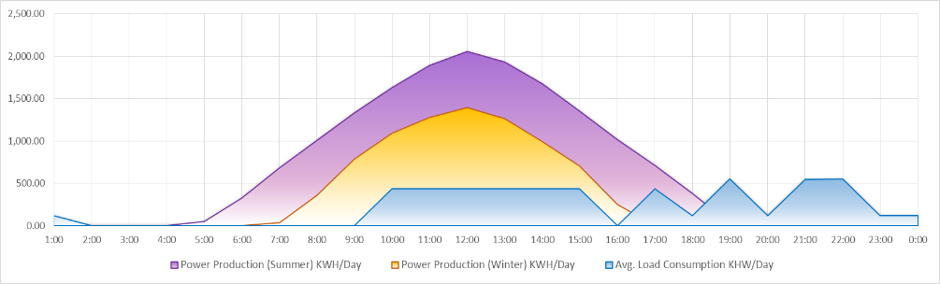

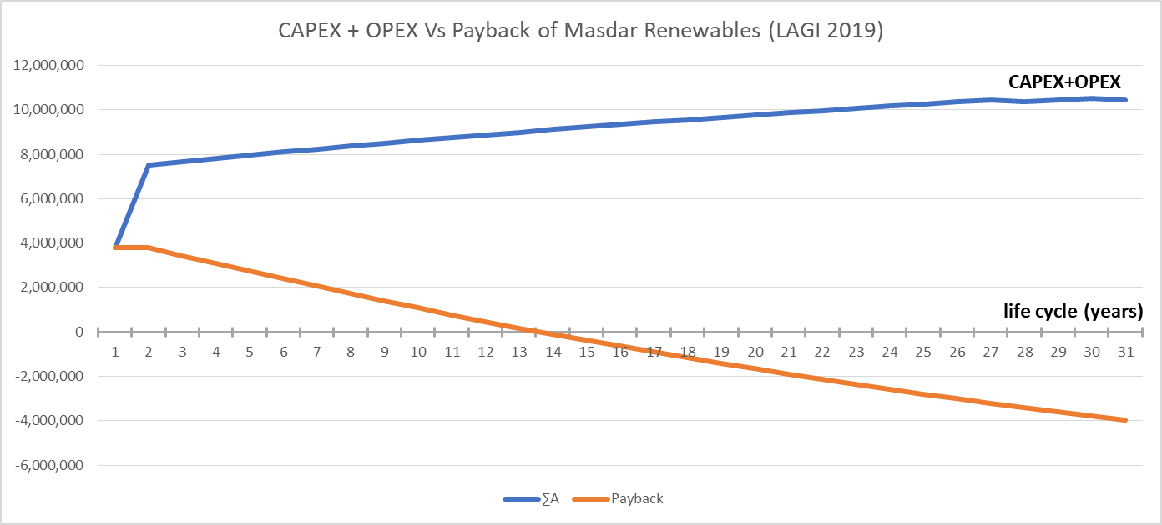

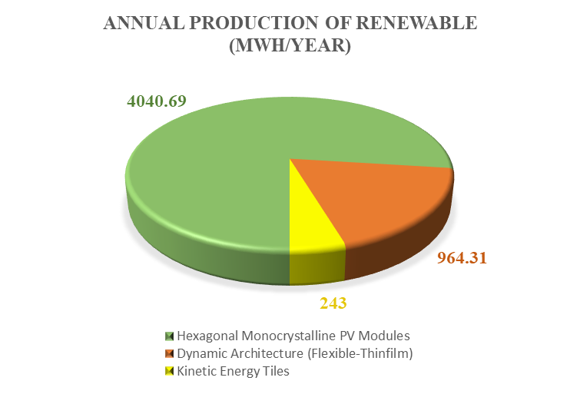

**COST ESTIMATE OF THE PULSE**

The PULSE elements designed to be within the pricing parameter (20$/Wp), taking into consideration the sculptural artwork that generates clean energy. The below schedule shows the cost estimate breakdown.



**CONCLUSION:**

* **Environmental aspect**

The project will have a positive effect to the environment by improving the climate change through reducing the carbon footprint due to the implementation of renewable energy with 3,000 tons of carbon omission annually. In addition, the materials proposed in execution of the pulse are recycled materials which have low carbon footprint too.

* **Social aspect**

THE PULSE design based on social encourgemnt for people gathering considering different culture and ages. The space has an objective to adopt human interaction with different activities.

* **Educational aspect**

THE PULSE project represents the outstanding approach which may motivates students to innovate and create unique ideas. Such a project can be also a case study where all specialists and experts can enhance their design capabilities in the utilization of renewable energy and it may support the research and development area as well.

* **landmark**

The aim of THE PULSE being proposed in UAE is to prove the rapid development in the green sustainable economy, which will lead UAE to be in the forefront of sustainability and renewable energy worldwide.