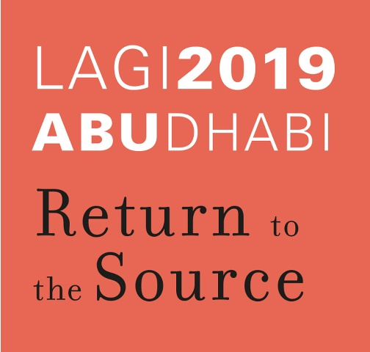

The design of the Entrance Complex in the city of Masdar, based in the United Arab Emirates, will be shaped according to the condition of context, its climate and the demands of LAGI design competition. The city of Masdar, a new-built city in a desert, warm and dry area near the shore is for academics and researchers with a sustainability approach and the use of technology and respect for nature.
According to the main goal of the contest "return to the source", a return must be made and inspired by nature. In addition to the use input, the form of the set will take the user's attention to the main goal. On the other hand, the input set should be separate from the sense Entering both the gate and the gate, must have a sensible fit to the city ahead, including sustainability and attention to the use of renewable energies and technology. The disconnection of the desert background and arrival, in addition to the above-mentioned conditions, also must follow memorizing and creating an image of the user's mind.
The input set is designed from single elements that vary in scale and detail. The complex is located in the middle of the center of the site, and is located close to the highway. It runs parallel to the spontaneous, and crosses the main road of the city. After passing through the main pivot of these three rows, they begin to move unitedly by circulating. Here, coming closer together, slowly rise and get up. And at the central point they reach their highest point and the tallest elements. This move is in line with the goal of the city, which can bring the most powerful moves together with the clutter of thoughts.
The design element is based on the conception of warm and dry genuine architectural designs in wind turbine frameworks for the use of renewable energy.
The whole form of element is like a palm tree and is formed from a trunk and a crown on it. The prospect of parallel rows of sensory elements is available in hot and humid climates.
In the crown and at the top of the element, there are two frames with a rotating plate that, like sunflower, rotates with sunlight. Smaller plates of solar photovoltaics that are wrapped around the back of the main frame angled and capable of absorbing radiant energy. Additionally, due to the angle at the frame and their lightness as wind turbine blades, the plates rotate and use They also provide wind energy. The energy is collected by small generators and transmitted by the two arms to the main body and ultimately the energy storage and generation.
The arms due to a predetermined program, are able to shake the pages and focus on the direction of radiation and to the point where they are most energy-intensive.
The rotation of the center of the main trunk and the hollow plates around the main axis of the frame and its orientation at different angles has led to the induction of palm tree and natural motion of the trees.
At the bottom of the trunk and base, it is used to induce a sense of lightness and on the other hand to stand the elemental element from the roots of the mangrove tree, which is native to the region, as well as the city of Abu Dhabi. The porosity created at the base allows the user to expand the viewing angle and sense of movement and movement.
The shadow of the crown of the element on the path and its displacement on the ground due to the change in the angle of sunshine from ascents to dusk, creates a dynamic space in the lower part and the input set. Every moment it's different from the moment it is.
Elements also require light and superficial designs due to their stylishness.
Generally, a collection of about 150 lightweight single elements, such as a winding router (30-100 square meters), and absorbent sunlight screens that look like sunflowers to sunlight. And have a form similar to a palm tree with mangrove roots on the ground, Which has the ability to get the maximum energy of the sun and wind. These elements are shaped according to the conditions and technology and the spirit of the present day, based on cheap energy and in accordance with their context. Also, the singularity of the elements will give the advantage that if the whole set is to be restored, it will not be a problem.
It should be noted that according to the "return to the source" ,the peresentation of the design is by hands and hand-held sketches without using the software.

