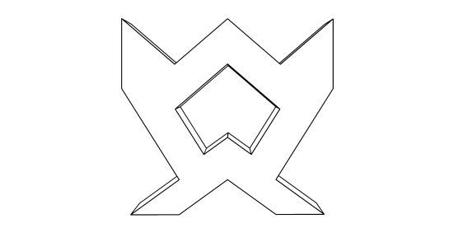

M I L E S T O N E

ENERGY + AESTHETIC :

Milestone is a signiﬁcant stage which is The development of something big and popular, from this the art of making or Designing a form which is familiar to the particular region or a state the ideology is To combine or generate Energy and as Well as Aesthetics from the sculpture being Proposed.

Heat Energy --- Electrical energy.

The strength and vital necessary for being In the ﬂow, Power derived from the Utilisation of physical or chemical resources Especially to Convert from heat energy to electrical energy.

Symbol of Force or Courage.

I have attempted to design a sculpture which Should generate energy and as well it will be a Architectural Marvel the ideology or Inspiration is the symbol or emblem of UAE.
IDEALOGY:

This is where my starting point of this design In which I inspired by the symbol or emblem
Of UAE and then started to abstracting without Losing its unique characteristics.

HEXAGONAL SOLAR PV PANELS:

These are easily available Commercially ultra high efﬁciency modules or panels which has been warranted and supported by Many reputable manufacturers around the globe. In this design I had created a character in my form for this Solar PV panels can be installed, There are exactly 7,450 panels in count, An single Unit can produce 1KW of electricity in four hours.

ENERGY CALCULATION:

PER PANEL CALCULATION:

Four hours of full sun - 250 watt/hour i.e 1 KW/4hrs.
Per day - 24 x 250 i.e 6 KW/Day.
Per week - 6 x 7 days i.e 42 KW/week.
Per month - 42 x 30 i.e 1260 KW/month.
Per year - 1260 x 12 i.e 15,120 KW/year.

FULL CALCULATION :

Per year one panel - 15,120 KW.
Total number of panels - 7,450.
Total energy produced - 15,120 x 7,450 i.e 11,26,44,000 KW/year.

Average house consumption:

Per day - 30 KW.
Per week - 30 x 7 i.e 210 KW.
Per month - 210 x 4 i.e 840 KW.
Per year - 840 x 12 i.e 10,080 KW.

So that the above calculation MILESTONE can easily produce Electricity for 11,175 homes for its
Average usage.

COST ANALYSIS:

Cost per watt - 12 cents. (Average)
Cost per KW - 12 cents x 1000 watts = 12000 cents i.e 12$.

STRUCTURE:

Lightweight precast metal reinforced panels for the frames and a pure brutal concrete shell for
The sculpture and a lighter Aluminium panel for the front perforated wall panels on the both
Sides of the sculpture.

