The Droplet
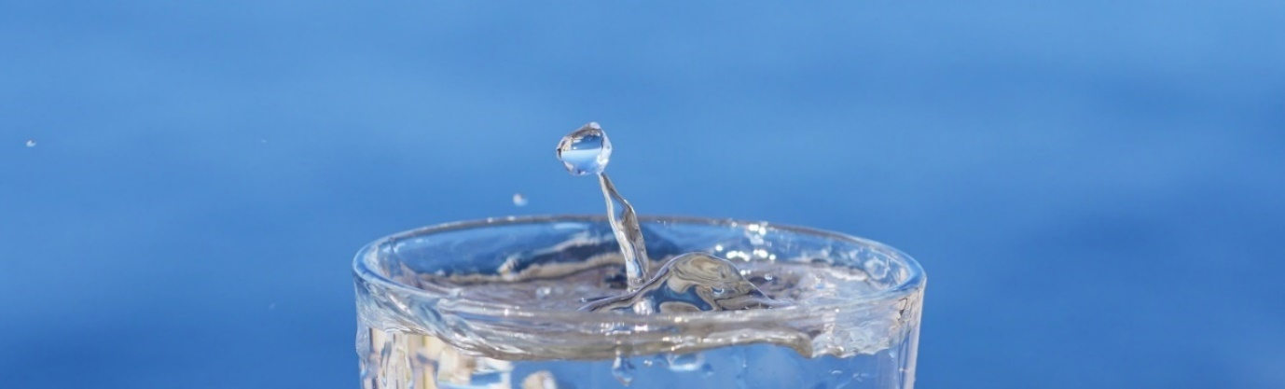

The fog settles in Abu Dhabi as the dawn arises. Here the cold ocean waters neighbour a strict desert, and, in despite of their unforgiving environments, a mist grows. A cool air carried from the sea. It sits down and comforts the land before the sun arrives. Droplets gather in the leaves of trees and shrubs, collected and directed to their stems. A moisture relaxes in the shaded sand dunes to which the small insects and creatures wait patiently to gather a morning drink. In the dawn before the day, the natural world adapts to the extremes to gather water out of thin air. In this desert, life endeavours to find water.

Humans are no different. Where water is sparse, people become nomadic. Tracking and observing the land in search of a safe place to drink. And where water is abundant, agriculture and urban civilisations rise. In the modern world however, our technologies have removed many of the barriers that once restricted our migration patterns and lifestyles. We see this in the UAE where desalinated seawater and pumped ground water are sourced to supply the country.

But as the world progresses, moving closer to a carbon neutral goal, the same resources we’ve relied on to collect water are proving to be unsustainable and potentially unreliable. Securing clean, drinkable and useable water sustainably is a challenge, but also an opportunity, that the world and UAE will face. We want to be future ready here by exploring the new environmental ways of collecting usable water.

The ‘Return to the source’ 2019 LAGI challenges creative thinkers to re-imagine ways to provide on-site energy in Abu Dhabi; emphasising the importance of solar energy. But our team takes a broader approach to sustainability. We believe the two problems of water security and energy collection are both significant in the discussion of environmental design in Masdar city. This project therefore combines renewable technologies. Exploring the possibilities of harvesting water and collecting solar energy.

In the desert climate where sun is abundant, solar power can easily provide a reliable source of energy. But in the pursuit of harvesting water as well, this challenge is more complicated. So we ask ourselves, what are the sustainable methods Abu Dhabi can use, to collect drinkable water in the desert? Our Droplet artwork takes a chapter from the natural world here. Like the plants and animals in the morning, our project explores the technological capabilities of fog and atmospheric water collection. From the hot and humid months of June to September, and through the cooler November to March seasons where fog and rain occurs, our design seeks to extract moisture from the air to supply clean drinking water for visitors.

The Droplet pavilion captures the imagination to how water and energy can be sustainably sourced in our cities. An oasis in the desert that brings sustainable technologies elegantly into the local community.

- Design Concept

We aspired to design an outcome that celebrates the renewable energy infrastructure. As a guiding principle, whilst exploring fog harvesting and solar technologies, our design sought to equally reference the natural environment that we were preserving. An artwork that not only is environmentally sustainable but takes inspiration from nature.

With water in mind, our form is inspired by the way droplets distort and ripple the surfaces of water. We saw a natural beauty in the organic movements and collisions of water and our design sought to mimic these geometries. Using computational methods, we were able to simulate the ripple effects of water architecturally. The resulting aesthetic celebrates water.

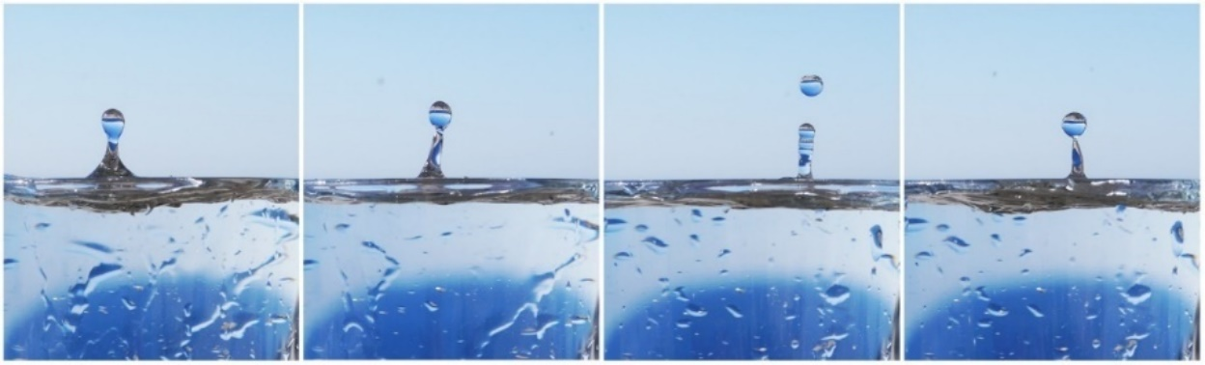
(rotated image of water droplets)

- Environmental Technologies: Smart Canopy

Our pavilion design extends through the site and has four main purposes:

  - Collecting drinking water by harvesting fog, dew and atmospheric moisture
  - Gathering solar energy to power the installation and provide energy to neighbouring buildings.
  - To educate and inspire the public about sustainability
  - To create a shaded, cool and useable flexible public space.

The pavilion consists of a lightweight steel canopy that is crafted to combine solar and water harvesting technologies into the structure. To harvest fog our roof uses a draped mesh surface, that whilst in the shape of ripples, directs collected droplets towards internal columns and an underground storage tank. As air and fog moves through the canopy the ripples pick up the moisture in the air, and small fans aid the droplet collection process; assisting the air circulation during non-windy days. Likewise, chilled metal pipes coil the structure to further extract moisture from the air through condensation in humid seasons.

Checkered above this mesh surface sits a layer of solar panels. The panels have been optimally placed, and spaced out, to collect solar energy whilst still allowing air to flow underneath freely.

Walking underneath, a person’s eye is drawn to the reflecting water like aesthetic of the interior. The interior skin of the canopy being clad with a semi-transparent membrane which collects dew. As visitors walk closer to the seven major pillars – a metaphor representing to the bonded seven states of the UAE - they’ll realise these columns act like vessels, collecting the moisture harvested from the roof above.

- Education and Community
The collected water by the canopy structure is directed into the vessel columns with a sphere at the bottom. The people can gather around to observe the water harvested. They can see the rate at which the droplet sphere fills up and varies depending on, for example, the fog conditions or the amount of humidity is in the air at that time.
This device could be compared to a water clock which reminds us about the time and the water availability in different times of the year. Once the sphere/droplet is filled up a release switch opens a hatch underneath to release it into the underground water reservoir.
As a local perspective, our pavilion also creates an open useable ground plane for the public. Shielded from the hot sun and cooled through evaporative mist, the design activates the public space throughout the day. We envision an area used for public art installations, religious events, markets, performances and other public gatherings.
From a distance the droplet project will appear as a water feature in the city. And up close the surrounding environment becomes an immersive experience. A contrast from the harsh sun and a relief point in the city. The design poetically captures the movement of water and demonstrates how sustainable technologies can be beautiful.

- Environmental Impact Statement & Budget
Summary Table
Total Kilowatts per hour per annum (KwH/year) | 950,000 kWh per year
Total harvested water from fog, dew, atmospheric moisture (Litres) | 38.5 million litres
Total budget: (kWh/year) x (20) | $19,000,000
Construction Budget (not including solar panels) | $16,150,000

The canopy design diagrammatically is a collection of layers that houses solar panels and water harvesting technology. These layers attach to a steel canopy which is supported by steel columns. The canopy surface area is measured to be 9360 square metres. After conducting sunlight hours testing on the roof canopy, we identified that 20% of the surface should be open to allow for the free movement of air. If we pattern the remaining area with photovoltaic panels we calculate that our structure produces 950,000 kWh (kilowatt-hours) per year.
Estimating the potential of our fog harvesting technology, using the surface area calculations and if each square metre can collect 22 litres of fog, per day, in 155 days of the year where fog is approximately present, our mesh surface will collect 32 million litres of water per year at a minimum.
Further calculations measure a collected, 4 million litres from dew water and 1.5 million litres from humid air. In theory the droplet project could harvest 12.8 to 37.5 million litres of water. (refer to our appendix for calculations).
Calculating the total kilowatts per hour by 20, our project has a budget of 19 million dollars. 15% of the cost will be used for solar panelling. Another 75% of the funding would be used to cover material costs. With 10% of the budget remaining this could be used to pay for labour or pay for future upgrades to further improve the materials and technologies in the artwork. Potentially linked with the neighbouring university our pavilion could serve as a testing ground for new materials to harvest water and more efficient photovoltaic technologies.
In the long term the droplet artwork will supply clean water and electricity to the site. It will also create awareness and make people familiar with renewable technologies by sending a positive message to the local community. This artwork, the Droplet, will further contribute to the sustainable ambitions of Masdar city and its residents.

Appendix
Dimensions
- Site: (260m)x(30m)=7800sq.m.
- Canopy Surface: (((260m)x(30m))/100)x20))+7800m=9360sq.m.
Total Solar Energy Harvested per Annum:
- 20% of the surface area is left open. Total surface area 7800sq.m.
- Formula: Total Solar Panel Area (m²) x Solar Panel Yield (%) x Annual Average Solar Radiation on Panels (MJ/day) x Performance Ratio x 365 days = Total KiloWatts Hours Produced in a Year.
- (7800m²) x (0.10) x (16 Mj/day or 4.44 KwHr) x (0.75) x (365) = 950,000 KwH/year
Total Fog Water Harvested per Annum:
- Fog days approximately 155.
- Fog catching nets can harvest 6-22 litres per square meter.
- Fog catching net surface area 9360sq.m.
- (155)x(22)x(9360)=31,920,000 litters per year. Approximately 32 million litres.
Total Dew Water Harvested per Annum:
- Average humidity in Abu Dhabi is 50%, which is ideal for dew collection at night. Dew membrane can collect approximately up to 1.5 litters per square metre per night.
- Total surface area 9360sq.m.
- (1.5)x(9360)x(365)=5,125,000 litres per year. Approximately 4 million litres.

Total Atmospheric Water Harvested per Annum:
- The Method: Wet desiccation.
- New research is currently conducted to find more efficient ways to extract water from atmosphere. Abu Dhabi has ideal conditions for atmospheric water extraction with 50% average humidity.
- Approximately we can extract 1.5 litters per 1kw of power.
- (1.5)x(950,000)=1,425,000 litters. Approximately 1.5 million litres.
Total Drinkable Water Harvested per Annum:
- 32+5+1.5=38.5 million litres.

