Cell
Factories
LAGI 2019

As energy generation necessarily comes in close proximity with the real estate that it powers, issues of aesthetics that drive acceptance is becoming debated. The landmark recognizes the importance of human culture to the realization of a change. Cell Factories convey visual beauty, experiences of wonderment, and storytelling through its dynamic attribute. Cell Factories represents a dynamic art by the oscillation of elements and the change in color by biomass concentration. Therefore, it has the ability to stimulate and challenge the mind of the viewer on a contemplative level.

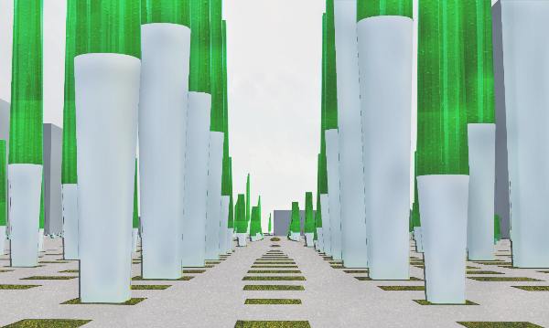

Cell  Factories  Proposal  The cell factories represent an iconic work of art for a landmark within Masdar. It employs innovative feasible low carbon renewable energy technologies that provide on-site energy production consistent with Masdar city plan. To integrate the landmark into the surrounding environment and landscape, respecting to urban porosity, infrastructure and accessibility have been taken into consideration. Beside comfortability of space is a primary aspect of public spaces. Comfort includes perceptions about safety, cleanliness, and the availability of places to sit. As a result, the project is more sensitive to the environment and to local and regional ecosystems while providing the family of form to respond to all the needs. | 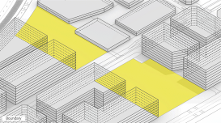  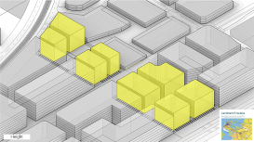  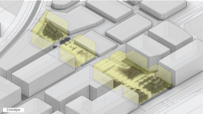
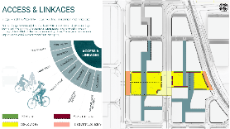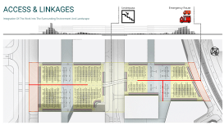

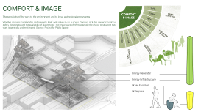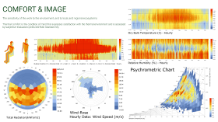

Low Carbon Renewable
Energy Technology

The landmark reference to the sun and wind, the source of energy that sustains life on earth, with the integration of mediator-free Microbial Fuel Cells (MFC) and Bladeless wind oscillators.

Algae are considered as one of the most promising sustainable ways to produce energy in the future. The Solar Leaf developed by ARUP is a mediator-free Microbial Fuel Cells (MFC) consist of microalgae cells that are rapidly growing microscopic solar driven ‘cell factories’. They can capture sunlight and CO₂ in low-grade water, producing O2, clean water and biomass. Based on the Arup reported data A Solar leaf bioreactor produces high-value biomass (10% ECS) and solar thermal heat (38% ECS). Based on Masdar solar radiation analysis, algae in the landmark receives 3,387 MWh radiation annually that gives us about 1,625 MWh Annual Capacity. | 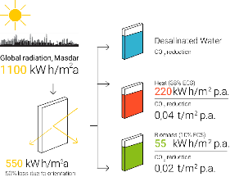
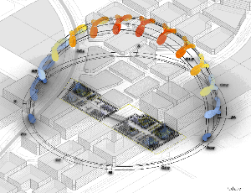 | 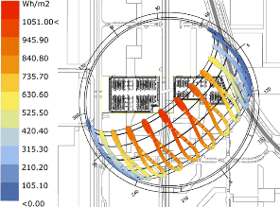

On the other hand, Aeroelastic resonance phenomena are traditionally considered a problem, but they can also form the basis of technology for wind energy transformation. Bladeless wind oscillators developed by the vortex induced vibration resonant wind generator that harnesses wind energy from a phenomenon called vortex shedding. Based on the vortex reported data the 13 m tall model produces 1 kW of renewable power. According to Masdar Windrose and CFD analysis done for the site, all the 350 Bladeless wind oscillators deliver about 600 MWh Annual Capacity. | 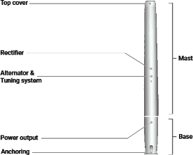
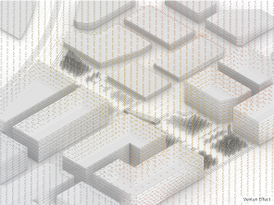 | 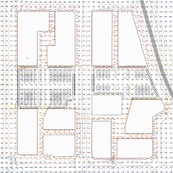
The amount of energy production is a significant consideration to be weighed fairly with the conceptual and artistic virtue and cultural relevance of the artwork (cost-effectiveness analysis). Whereas public art and creative placemaking are primary aspects of cell factories (landmark), the term "return on investment" should be considered in a broad cultural context.
Renewable Energy Technology | Nameplate Capacity  (kWp) | Annul Energy Yield (MWh) | Capital Cost | Return Over Life Span  (Based On UAE  Energy Value) | Return On Investment
Mediator-Free Microbial Fuel Cells | 0.057 /m² | 1,625 | 724,000 $ | 2,200,000 $ | 3.03
Bladeless Wind Oscillators | .4 – 2  (Based On Size) | 600 | 132,000 $ | 810,000 $ | 6.13
Total Renewable Energy Generation |  | 2225 | 856,000 $ | 3,010,000 $ | 3.51
Innovative and Feasibility

Implementation of a mass customization strategy and economic scope increase the feasibility of the concept. Therefore, the landmark consists of 350 modules with the same product family but slightly different characteristic. Beside in shaping the large-scale project, concepts like the scalability of technology and design, maintenance, warranty, safety, and insurance are fundamental. In this manner the landmark utilizes the technologies that are currently implemented on renewable energy project a with reliable companies.

Materials | Dimensions | Cost ($) | Total Cost ($)
Low Carbon Concrete | 2,4500 m³ | 134 | 328,300
Lighting Installation | 850 m² | 128 | 108,800
MFC Chemical Compound | 367,000 Liter | 0.05 | 18,350
MFC Membrane  (Including Structure) | 6170 m² | 38 | 234,460
MFC Supporting System | 350 Units | 960 | 336,000
Water Desalination Supporting System | 350 Units | 80 | 28,000
Vortex Nano | 100 Units | 200 | 20,000
Vortex Tacoma | 150 Units | 250 | 37,500
Vortex Grand | 100 Units | 750 | 75,000
Energy Storage  (Battery Cell Array) | 350 Units | 300 | 105,000
Total Cost | 1,186,410 $
Cost Per Watt | 5.025

Environmental Impact Statement

With rising energy consumption in the world, we have to make sure that energy security is guaranteed when conventional energy sources are depleted. Currently, the energy we consume is primarily from fossil fuel sources and the generation of energy releases greenhouse gases like CO₂. The energy needs to be generated locally and from a sustainable source to deliver energy security. Currently, popular sustainable energy harvesters are windmills and photovoltaic panels. These systems can sustainably generate electricity, but they cannot take up CO₂ to support the goal of net zero carbon future. Microalgae can mitigate CO₂ and produce energy at the same time. On the other hand, the by-product of microalgae is clean water that holds immense value in the region like Masdar.

Through the design process of the landmark (cell factories), simple design and lightweight elements with efficient use of environmentally friendly materials were wanted. As a result, the foundation of landmark elements is winds oscillators that act as small wind turbines and a base for microalgae membrane. They are Bladeless technology consists of a cylinder fixed vertically with an elastic rod.

Eventually, these tow integrated technologies make the landmark CO₂ emission minimal while generating nearly 2,000 MWh energy annually. The landmark (cell factories) could serve the Masdar net zero carbon goal effectively.

