DALI’S ELEPHANTS - in Masdar (893 words)
“In contrast to the passive, impartial, contemplative, and esthetic attitude of irrational phenomena [an illusion or a subconscious relation] stand the active, systematic, organisational and cognisant attitude of these same phenomena [reality and logical applications] considered as associative, partial, and significant events in the authentic domain of our immediate and practical experience of life.”
Salvador Dali, 1935
Practicality of the phenomena has led humanity to use up and continue to use the non-renewable sources of energy- their availability, their technology to convert to convenience was well established. Before all this, at the beginning, if man had considered harnessing renewable sources rather than these (non-renewable), it would have been phenomenal and fundamentally different from how we see things today. But then again, it wasn’t the case. Through this rational need arises an irrational thought of bringing back a symbolic presence of harnessing energy by using animals- for their brute strength and man’s capacity to program it all accordingly- an unlimited source, of unknown possibilities have been erected in a surreal world of Dali’s work brought to life by associations made practical and aesthetic.
An irrational phenomenon!
Explorations of the workings of the mind leads- makes one hope for a day towards a healthier planet. A place well-functioning with uninterrupted source of energy(-ies), an uphauling place ready to produce and accept cleaner forms of energy. All this served on a platter, wouldn’t that be nice! This Art installation is a service “on-platter”, served by the largest land mammal on the planet expected to bring in the symbolic presence, pleading for their right and consciousness exploited by the inveterate nature of human being of ‘taking’ constantly!
An unexpected being in a desert!
A spindly presence in bulkiness of urbanity!
An utter disregard to the subconscious expectations!
A rejection of conventionality!
At the “Source” (Masdar) anything can happen. It is not our world of known, it is a world of unknown granted to us in the illusions, elusive nature of our mind. So, lets march on with these ‘Elephants’ of Dali into a so surreality and a want and wished by everyone.
PARADE OF ELEPHANTS
Dali’s Elephants have always carried a symbolic object- obelisk on their backs. Dali’s rhetoric to use an Elephant (a portrayal of strength) but questioned by their long spindly legs- and to top it the heavy loads they carry one wonders how will they be able to balance it.
Metaphorically intending to use Dali’s Elephants that hint at looking like Elephants – one wonders if they are a school of jelly fish or the parade of Elephants marching across a dense urbanity! This extrapolation of a known situation of Elephants walking in forests- now placed in a different unknown context or a city with its population or an entirely unheard-of visualised scenario of a school of jelly fish mesmerisingly floating in a desert one wishes for answers, a directionality to what are they doing there? In Breton’s words from the Surrealist Manifesto,
“So strong is the belief in life, in what is most fragile in life- real life, I mean- that in the end this belief is lost.” Andre Breton (1924)
GLYPHS as ENERGY SYMBOLS

SOLAR | TIDAL | HYDRO | WIND | GEOTHERMAL | BIOENERGY | HYDROGEN
Each Elephant is topped by a Glyph representing the seven renewable sources of energy that can lead us- humanity to the new era; SOLAR- TIDAL- HYDRO- WIND- GEOTHERMAL- BIOENERGY- HYDROGEN, as symbolic glyphs. Parade of the Elephants showcasing the several identified renewable sources of energy are at a march in the city of Masdar. Showing the world immense power stored in the earth, for a future protected and possible. The Elephants of Masdar are a manifestation of a resolution at the ‘source’ to use technology to create an experience of normalcy, to hold things as they should be, will be, and can be. To keep life moving at its pace, and world a healthier place to be in. A walk of fame and glory is orchestrated unfashionably bold and clear of their agendas. Is it a burden they carry, is it a capping, a test if strength, a test of valour? Can Elephants be spindly like arachnids, and while they seem to be spindly can arachnids carry such loads. These glyphs, symbols representing each renewable source of energy, are being held atop this fragile nature of the thought that has capacity to carry the world to a newer tomorrow.
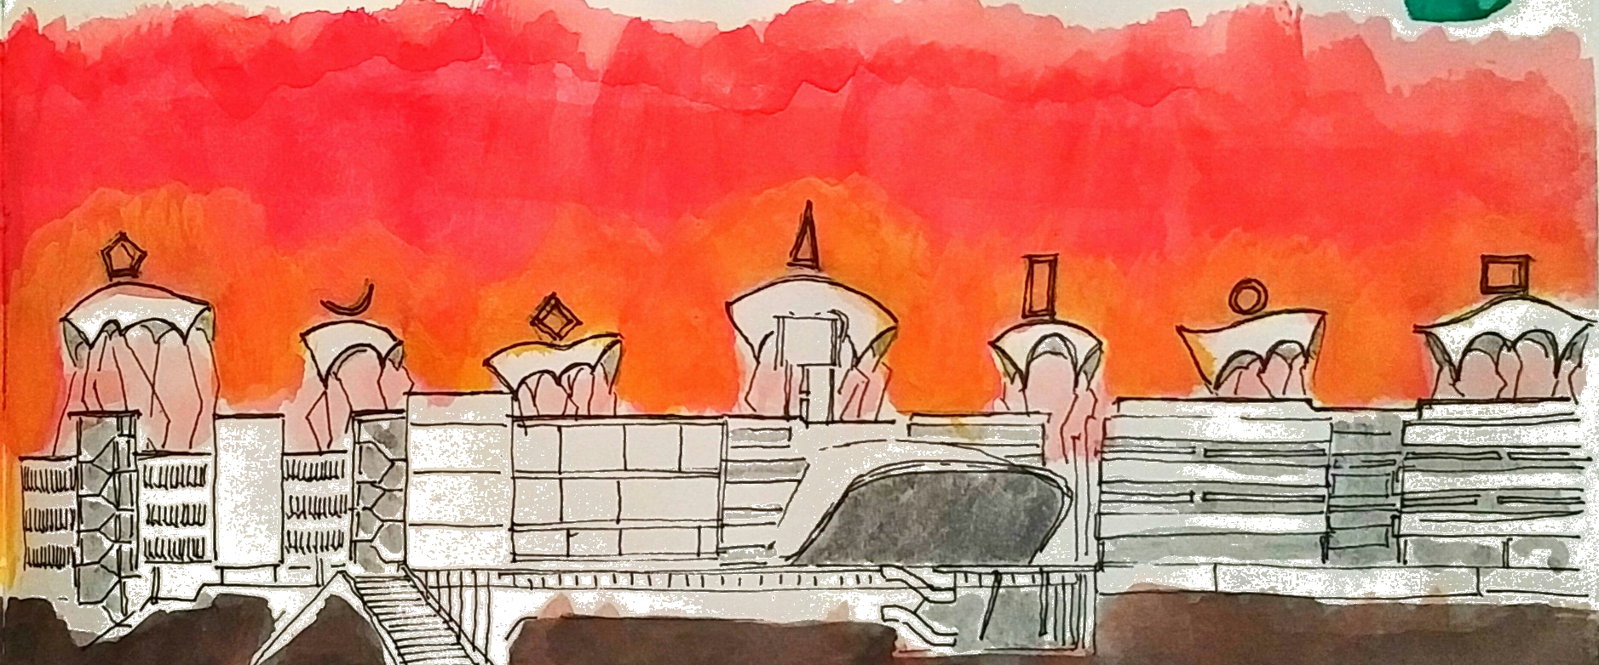
A fragile concept emboldened with strong principles of hope and future is the transformation of Dali’s Elephants in Masdar.
ARCHITECTURE OF THE ELEPHANTS
Mounted on Mild Steel skeleton each Elephant measures an average of 12 Meters width, 18 Meters length and 36 Meters height allowing an uninterrupted supply of incident solar radiation. At their peak each one of these Elephants can generate 150MW per annum. Approximate weight of each Elephant is about 150 Tons. Glyphs are made of ALUMINIUM and mounted on the Elephants. Sensor based lights illuminate the Elephants from underside of the shell. Illuminated these Elephants look like bioluminescent jellyfish of the deep sea.
CHARACTER OF THE ELEPHANTS (150 MW per Annum)
The body of each Elephant comprises of SOLAR BIPV (building integrated photovoltaic) thin film polycrystalline cells sandwiched between toughened glass panels. Each panel is of 7mm thickness of an approximate measurement of 1Mx2M and weighs around 32Kg and can produce up to 162W/M² per annum. These Elephants can generate 150MW per annum.
ENVIRONMENTAL IMPACT OF THE ELEPHANTS (219 words)
The Elephants are made and comprised of recently developed thin film Building Integrated Photo Voltaic (B I P V) that are used as an alternative for conventional solar PVS in facades, roof tops and other architectural elements (like awnings, shades etc) have varied applicability; these are typically made of Poly Crystalline Film sandwiched between thin glass panels creating a laminated panel, and based on the type of crystalline film and the spacing of the cells a BIPV panel can behave as a translucent or even (near) transparent photo voltaic panel achieving anywhere between 10-45% transparency. They can either be used as a standalone (off grid) or can be interfaced with active grid. Commercial thin-film materials deliver about 4-5 watts per ft² of PV array area (under full sun). These are considered lower in cost due to reduced use of active materials and energy in their production. These thin films each panel weighs a mere 32kg. The design is also such that the slender surrealist idea is not compromised neither is the productivity expected in the wide backs of each Elephant. Since the weight of the panels is considerably lower, the structural support is also reduced considerably leading to use of less material, lowering of both manufacturing and transportation costs. The impact is not only environmental but economic as well.


