POLARITY_LAGI 2019

Analysing the historical and urban development and the society of the United Arab Emirates we can see how the cities developed along the coast and how the hinterland was completely deserted.
The desert is the place where all these new cities of the Arab emirates have originated from and has been considered since ancient times as a malign element, where you can find shelter. In contrast to the desert is the oasis, a place of refuge and shelter, identifiable with an earthly paradise.
The polarity in philosophy is the expression of the relationship of mutual dependence of two opposing elements. It implies a condition of complementarity between the opposites, so that each of the two poles, although limited and opposed by the opposite pole, also finds in its latter its reason for being and its constitutive foundation, because the one could not exist without the other and vice versa.
The complementarity between opposites is the source of inspiration for the project. Desert and oasis are the poles of the project that find their connection through the path or journey.

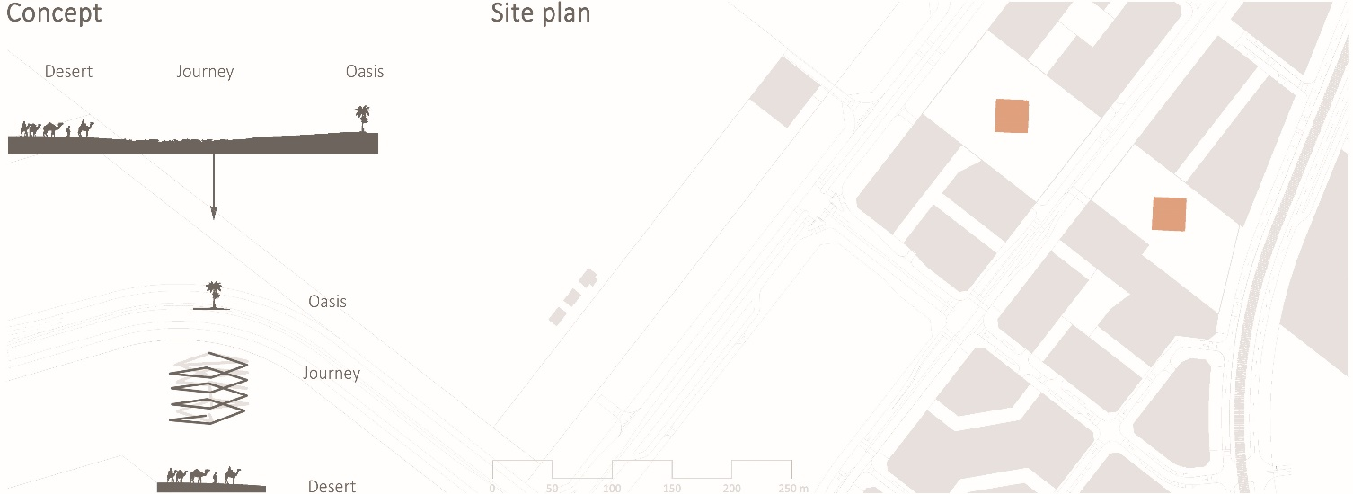Concept and site plan.

Studying the masterplan, we can see that the site is inserted along the view path, so we choose to leave the square almost empty, to give the feeling of being in the desert and create a strong contrast by bringing the vegetation only inside the project.
The ground landscape of the two public spaces are covered with tiled pavement and in the centre, we find two monolithic cubes (27 m) clad in compressed earth and with a south-east facing façade covered with transparent solar cells. The arid and monolithic exterior reveals a completely opposite interior, where the green walls, water, flowers and plants give life to the cube.
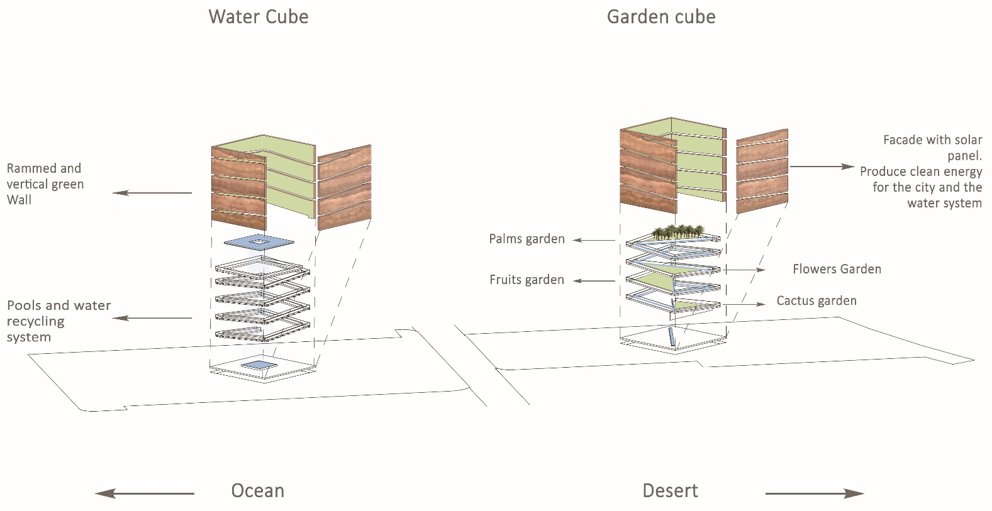 Axonometric view and project description.

The first cube (garden cube) is formed by a series of triangular gardens each with different types of plant families, from the ground up we can find in sequence these gardens: cactus, flowers, fruit trees, palms.
The second cube (water cube) is a hanging garden, where a cascade of light and water acts as a spatial pivot.
The path, formed by an almost evanescent glass ramp, is the connecting element between the ground floor and the top of the monolith. It determines the shapes of the cuts in the perimeter walls and facade, which make the two blocks less rigid.
Similar to the art of sculpture, these two monolithic blocks of earth seem to have been carved out of the desert to become two magnificent urban sculptures.
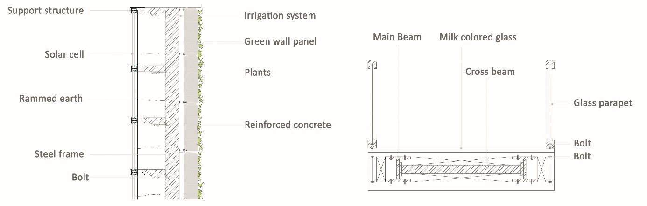
Section of perimetral wall and ramp.

The primary materials used in the design are as follows: Steel frame structure; rammed earth (30cm); vertical wall of vegetation (20 cm); one facade with solar panel cells.
The supporting structure is composed of a stainless-steel mesh with rammed earth. The many advantages of building with rammed earth include superior thermal mass, temperature, noise control, strength, durability, low maintenance, fire proofing, load bearing and pest deterrence, as well as its beauty and the pleasure of building with a natural and environmentally friendly material.
The vertical walls of vegetation are a sure-fire way to enhance a building’s interior visuals, improve air quality as well as energy levels. the vertical walls of vegetation function to cool the air in the warmer summer months by a process known as “evapotranspiration”. This kind of wall build-up can reduce the wall surface temperatures by as much as 10 degrees °C, resulting in significant energy savings and air conditioning costs.
Solar transparent cell are essential to exploit solar energy as a renewable energy source and to still show the texture of the rammed earth at same time.
The materials used for the ramp are milk coloured and clear glass to give a feeling of transparency and lightness.
To distinguish the public area around the two cubes in the green path and to recall the idea of the desert, we have chosen to use Sand colour brick pavement.

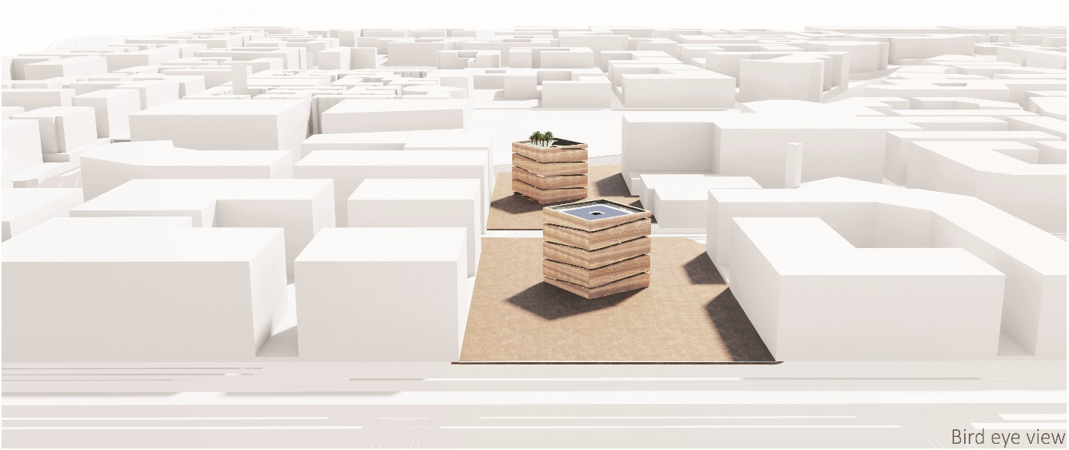

Bird eye view.

Environmental impact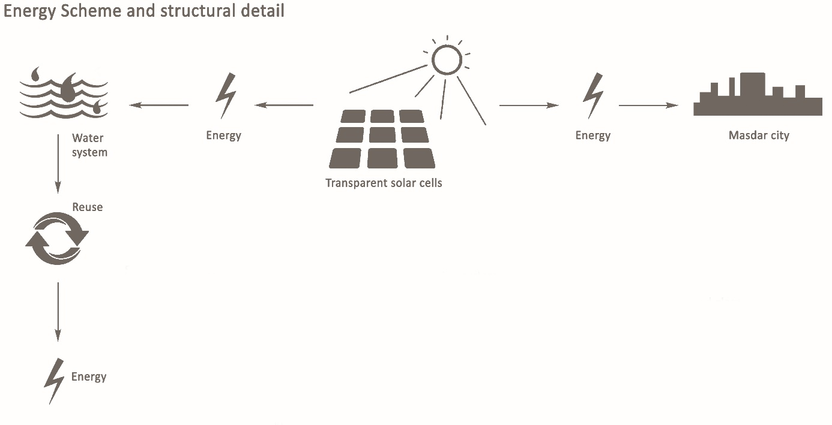

Energy scheme.

These pieces of artwork do not produce emissions; indeed, they are composed of natural, recycled, renewable and local materials.
The steel supporting structure is composed of recycled steel bars.
The external facade is covered with compressed earth, a local natural land that reflects the sand and the colours of the desert. Thus, it absorbs the heat of the sun, lowering the temperature inside the two cubes.
The internal facade is formed by a vertical wall of vegetation, in which the plants of the surrounding areas are present. The use of vertical wall of vegetation provides clean air and reduces the internal temperature up to a maximum of 10 degrees °C.
The facade most exposed to the sun of both cubes, is covered with transparent photovoltaic cells, allowing it to exploit and absorb solar energy to produce electricity.
This electric energy serves to supply the irrigation system and the water system pump.
In addition, the water recycling system in turn produces electricity, when the water shocks from top to bottom in the Garden cube and when it cascades down in the Water cube.
Thus, we have a double production of energy, one internal (mechanical) and one external (electric) that work together. The excess energy goes to the Masdar city.

