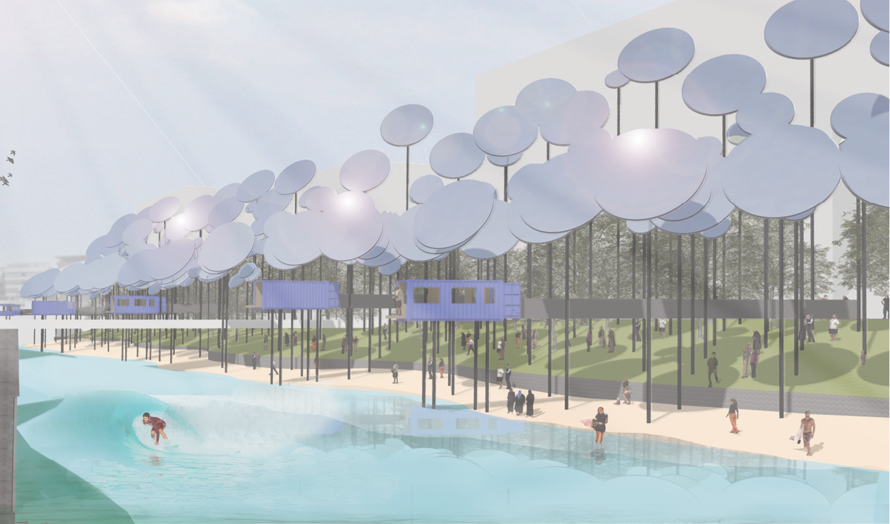
HELIO-SURF-FOREST
ABU DHABI

OVERVIEW

Surfers have been tapping into natural energy for generations. Ancient Polynesian cultures even considered the activity of surfing to be on a spiritual level. HELIO-SURF-FOREST adds another dimension; connecting people to waves driven directly from the sun’s rays. Here, surfers and onlookers alike can be immersed in the physical transformation of solar energy into electricity and perfect, ridable waves.

HELIO-SURF-FOREST is the integration of a 1.1MWe concentrated solar power (CSP) plant with inland surfing facility that incorporates hydro-energy recovery. A series of solar towers along the edge of a proposed urban lagoon house receivers that are fed condensed solar energy from an elevated heliostat ‘forest’ opposite. The receivers super-heat a sodium heat transfer fluid which is converted to steam and stored to drive a turbine that generates electricity all day and into the night. Enough power is provided to pump continuous two metre waves all year round and supply electricity to the grid for domestic and commercial use. Hydro-turbines are placed under a boardwalk on the southern side of the lagoon to recover otherwise lost energy from the waves and return further electricity to the system.

ENERGY SUMMARY

      - Total energy from 1.1MWe CSP solar towers:
1,100,000W x 8760 (hours) x 0.65 (capacity factor) = 6,200 MWh annually.

      - Total energy recovery from hydro-turbine:
(12) x 10kW low head hydro turbines x 8760 (hours) x 0.2 (capacity factor) = 210,000KWh annually.
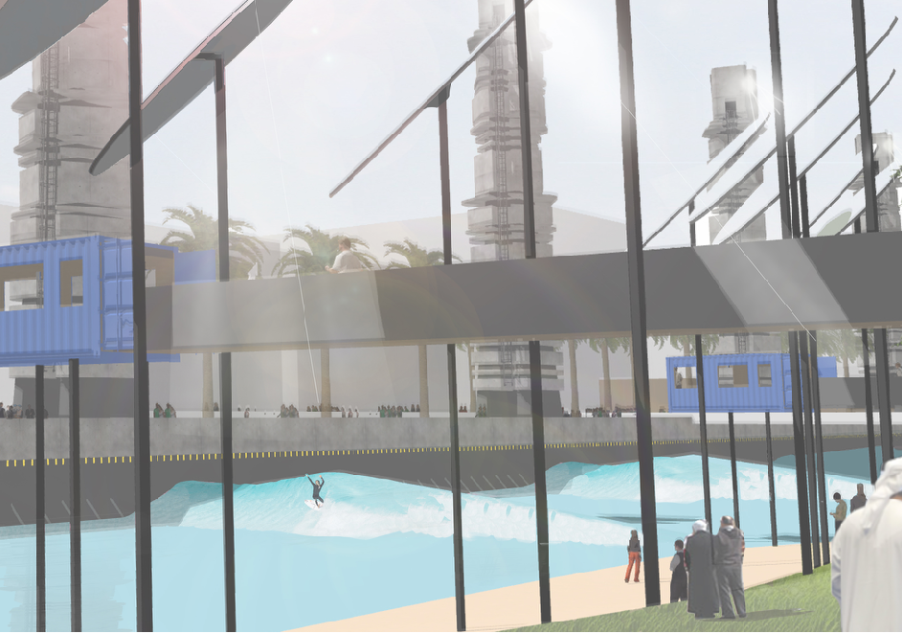

SUITABILITY OF (CSP) SOLAR TOWERS

“Solar towers might become the technology of choice in the future, because they can achieve very high temperatures with manageable losses by using molten salt as a heat transfer fluid. This will allow higher operating temperatures and steam cycle efficiency, and reduce the cost of thermal energy storage by allowing a higher temperature differential. Their chief advantage compared to solar photovoltaics is therefore that they could economically meet peak air conditioning demand and intermediate loads (in the evening when the sun isn’t shining) in hot arid areas in the near future.” (IRENA Working Paper “Renewable energy technologies - Cost analysis series” June 2012.)

While many of the existing examples of CSP plant generation requires far more land than that available on this site, there are some interesting examples of small-scale plants being tested. In particular the “Vast Solar” 1.1MWe CSP plant in Jemalong, NSW, Australia.

LAGOON

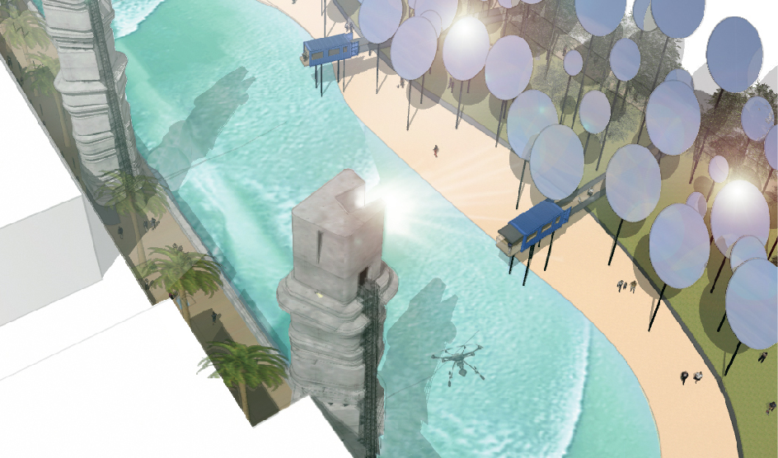
It is proposed that the majority of the site is excavated several meters to create the lagoon which would be filled with water from abundant underground sources. This water would be treated, however desalination is not considered to be necessary. Wave making infrastructure is safely housed under a boardwalk on the southern side of the site similar to working models available in todays market. It is anticipated that currently available wave producing equipment could be adapted to be driven directly from thermal power thus minimising inefficiencies through electricity conversions. Potentially, wave generation could simply be a bi-product of the plant. The proposed wave power hydro-energy recovery system could also be used a means to store further energy for re-use during peak load evening periods.

HELIOSTAT FOREST

The configuration of the heliostat forest challenges the conventional planar heliostat arrangement. In this proposal, heliostats are gathered to the northern side of the site rather than spreading them across the entire space. While a little unconventional, the idea of staggering heliostats vertically as well as horizontally can be seen in solar tower pit applications that utilise open cut mine sites. In those cases the sloped edges of the mine are used to mount heliostats in a way that takes advantage of existing terrain.

In our case, a simple shadow analysis reveals that significant overshadowing will occur on the southern side of the site from adjacent neighbouring buildings. Effectively, more than 50% of the site will be shaded from sunlight from 3pm for 6 months of the year (September - March). Thus, further strengthening the case to gather heliostats on the northern side of the site.

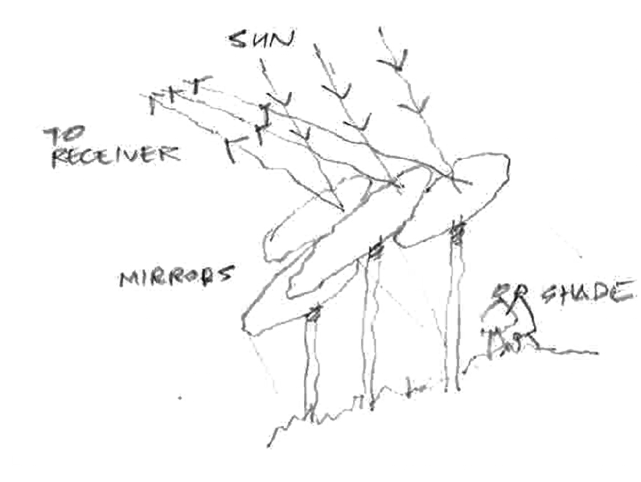
Mirrors are raised well above ground level to not only maximise usable land, but provide a shaded, grass embankment below. Automated hydraulic mounting poles extend and retract heights to avoid overshadowing from adjacent mirrors as the sun tracks across the sky. Combined with the ability to tilt up and down and left to right, all heliostats would receive maximum exposure to sunlight throughout the day. Retractable heliostats also make cleaning and maintenance more accessible when brought to ground level. Larger mirrors are formed from a series of smaller mirrors, slightly concave in shape to condense solar rays further on the target receiver tower.

SOLAR TOWERS

The five solar towers sited opposite the heliostat forest house high temperature receiver equipment at the upper level. While this zone is clearly off limits to the public, lower levels can safely be accessed via internal stairs to get an elevated perspective of the activity below.

Made from pre-cast elements for simplicity and efficiency of construction, they are industrial-looking but sculptural at the same time. Formed as a series of extruded ribs, spiralling upward, each rib is interspaced with openings and planting.

WAVE POWER GENERATION (RE-CLAIMING ENERGY FROM WAVES)

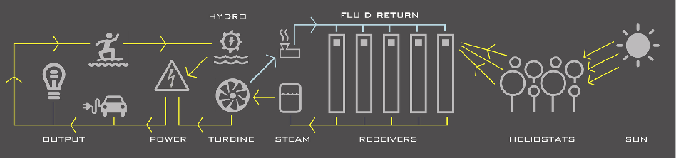
Once waves have been produced, a significant amount of energy (in the form of return water flow under the boardwalk) is generally lost in similar wave producing sites. In this case a series of simple weirs and low head hydro-turbine devices are proposed to ‘reclaim’ some of this energy back to the system. Visible through openings in the boardwalk, this could be an engaging, demonstration of natural energy transformation for visitors to the site.

COMPONENT / MATERIALS SCHEDULE

Solar tower (CSP) plant:
- (5) Fly ash concrete receiver towers (40m high) with internal stairs and viewing platforms. (Pre-cast elements)
- Sodium heat transfer fluid thermal storage system (linked to towers)
- 1.1MWe steam turbine
- 3500m² heliostat mirrors (700m² per tower)
- (300) hydraulic steel heliostat support columns
- (5) autonomous bird-diverter drones

Wave pool
- 8,100m² Lagoon liner
- Ground water pump and filtration/treatment system
- Hydraulic wave generating equipment
- 270m x 6m boardwalk with concrete weirs below - Fly ash concrete + reclaimed timber

Wave power energy collector
- Series of 12 Low head hydro-turbines (10kW each)

Viewing pods
- (6) converted 20’ shipping containers + steel support structure and galley access ramps

Facilities buildings (wc, change rooms, admin, mechanical storage)
- 1200m² of support buildings (pre-cast Fly ash concrete with accessible green roofs)

CONSTRUCTION COSTS

It has been reported that construction costs for CSP Solar towers is likely to fall from a cost of around $8/W in 2010 to below $6/W by the year 2020.
While difficult to ascertain accurate figures at this point, based on predicted reductions to CSP plant construction costs into the future it is anticipated that this proposal could be realised within the suggested $20/W budget.

ENVIRONMENTAL IMPACT STATEMENT

For this proposal, natural power generation in the form of (CSP) solar towers and low head hydro generation will produce clean energy with zero emissions. Embodied energy in construction is minimised by using long lasting, recycled or reclaimed, robust materials where possible. Concrete elements will use Fly ash cement (a silica-based waste-product of coal burning power stations) instead of regular cement.

Given the scale of proposed development in the general area, earth spoil from excavation of the site will likely be utilised on neighbouring sites thus minimising waste. The lagoon will be supplied from existing groundwater; filtered but without need for desalination.

Wildlife would be encouraged to share use of the site as much as possible, however bird casualties around towers have been an issue raised amongst existing CSP solar tower plants in the past. In order to reduce this problem autonomous bird-deterring drones could be used around the immediate receiver area.

Tower heights of 40m are somewhat higher than surrounding buildings which means potential issues of glare from receivers is minimised. Receivers are also baffled to the south so light from the towers would only be visible from the lagoon side of the site during daylight hours and well above eye-level.

Consistent with the site zoning “Park and open spaces” HELIO-SURF-FOREST provides a focal point to a spine of adjacent green space linked and accessible from all directions. Shaded lawn, trees, beach, water and boardwalks invite multiple recreational uses and embraces the public realm.

https://surfcareers.com/blog/the-history-of-surfing-part-1-origins/
https://www.irena.org/documentdownloads/publications/re_technologies_cost_analysis-csp.pdf
http://helioscsp.com/tag/aora-solar/ https://vastsolar.com/portfolio-items/jemalong-solar-station-pilot-1-1mwe/ https://pdfs.semanticscholar.org/b0bc/fa5da47ec46f21665025242423d000acc047.pdf
www.wavegarden.com , www.kswaveco.com
https://www.altenergymag.com/article/2009/02/pit-power-tower/501/
https://www.irena.org/documentdownloads/publications/re_technologies_cost_analysis-csp.pdf
https://precast.org/2010/05/using-fly-ash-in-concrete/
https://bird-x.com/bird-products/drones/prohawk/

