C O L L I D E R S C O P E
The ‘Colliderscope’ proposes creating the world’s most renewable bridge in the capital of sustainability, Masdar City.
Inspired by the theme of ‘return to the source’, the concertina bridge creates a billboard for the latest advancements in renewables energy harvesting and collection – a scalable instrument for continuous renewable energy experimentation and scientific data collection.
The Colliderscope design provides a focal point for reflection, with a frame that extends into the horizon. Using conical geometries it is constructed using a kit of part structure, which acts as a scalable scaffold to mount new solar technologies in a testing and data collection environment. It allows Masdar City to extend or shorten the structure to meet energy demand and cost of energy targets, as well as renew its design with different solar collection technologies.
At present, the proposal suggests utilising Rawlemon’s Solar Orb concept, among the leading technologies of its type in the world. These spherical solar concentrators focus sunlight – and even moonlight – onto a photovoltaic thermal solar cell, thereby able to more efficiently generate the same amount of power using a smaller photovoltaic cell rather than larger panels. Using this technology, the Colliderscope could generate approximately 895MWh per annum. Alternative technologies available also include the Sphelar® cell, which takes on a spherical shape to generate power with greater efficiency (http://www.sphelarpower.com/product/).
As well as providing a testing platform for these technologies, and billboard for their manufacturers, the design of Colliderscope will be a drawcard for visitors to Masdar City. Here is where we see the Colliderscope support the ambitions of the City with striking sustainable architecture and real-world solutions for efficient energy generation.
Visitors will experience a unique perspective of these technologies from a viewing platform inside the telescopic bridge. The heat generated by the interconnected orb structures, or spherical solar panels, will reflect excess sunlight away from the interior of the bridge and power a cooling system. Glare will be minimised by lining the interior of the scaffolding with anti-glare reflective fabric.
The Colliderscope will connect a scientific testing space at the entry point to the Masdar City Solar Photovoltaic Farm, to the City itself.

COLLIDERSCOPE Energy Production
ZONE | 1 |  | 2 |  | 3 |  | 4 |  | 5 |  | 6 |  | TOTAL
SPHERE TYPE | A | B | A | B | A | B | A | B | A | B | A | B
Diameter (m) | 1.12 | 1.08 | 1.07 | 0.91 | 0.9 | 0.75 | 0.74 | 0.58 | 0.57 | 0.41 | 0.4 | 0.38
Radius (m) | 0.56 | 0.54 | 0.54 | 0.46 | 0.45 | 0.38 | 0.37 | 0.29 | 0.285 | 0.205 | 0.2 | 0.19
Average Radius (m) | 0.55 |  | 0.50 |  | 0.41 |  | 0.33 |  | 0.25 |  | 0.20
Average Area (m2) | 0.95 |  | 0.77 |  | 0.53 |  | 0.34 |  | 0.19 |  | 0.12
No of Spheres | 540 |  | 1008 |  | 705 |  | 456 |  | 184 |  | 6 |  | 2899
Electrical Power Generation Name Plate Capacity (W/m2) | 220 |  | 220 |  | 220 |  | 220 |  | 220 |  | 220
Thermal Power Generation Name Plate Capacity (W/m2) | 350 |  | 350 |  | 350 |  | 350 |  | 350 |  | 350
Time (hrs/yr) | 8760 |  | 8760 |  | 8760 |  | 8760 |  | 8760 |  | 8760
Capacity Factor | 0.25 |  | 0.25 |  | 0.25 |  | 0.25 |  | 0.25 |  | 0.25
Electrical Power Generation kW/yr (EPG): No of Spheres [Electrical Nameplate Capacity x Time x Capacity Factor] / 1000] | 247249.72 |  | 373841.58 |  | 181574.01 |  | 75163.91 |  | 16717.32 |  | 345.33 |  | 894891.87
Thermal Power Generation kW/yr (EPG): No of Spheres [Thermal Nameplate Capacity x Time x Capacity Factor] / 1000] | 393351.83 |  | 318614.98 |  | 221260.40 |  | 141606.66 |  | 78052.71 |  | 49445.30 |  | 1202331.87

References
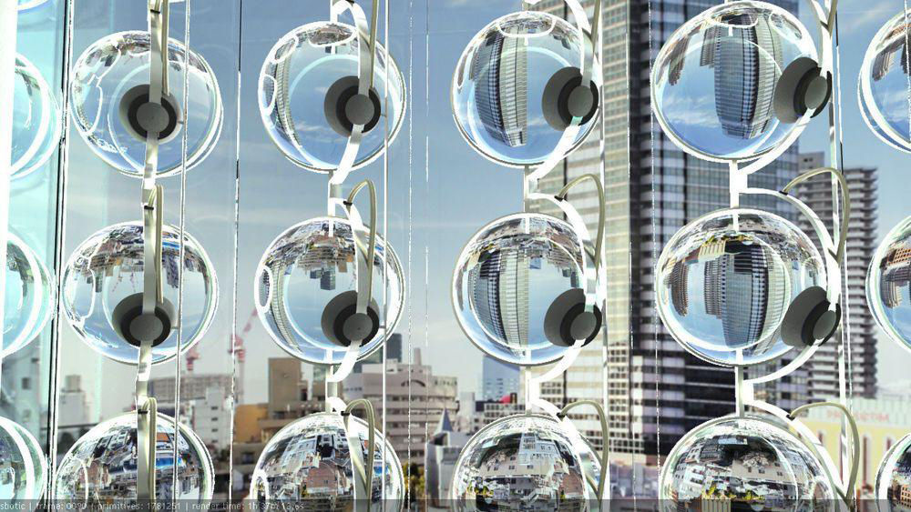
Rawlemon Spherical Sun Power Generator panel. Courtesy of Rawlemon & Sun Robotics

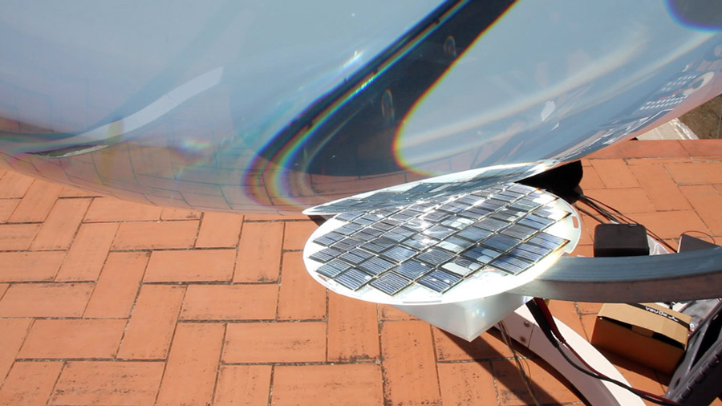
Photovoltaic thermal solar cell. Courtesy of Alternative Energy News

Guidance
Return to the Source—invites you to create an iconic work of art for a landmark site within Masdar City, Abu Dhabi. Your artwork will use renewable energy technology as a medium of creative expression and will provide on-site energy production consistent with the master plan of the city.
Masdar is the Arabic word for “source.” As the name of Abu Dhabi’s multifaceted renewable energy company and most ambitious low-carbon development, it is a reference to the Sun, the source of energy that sustains life on Earth, drives the wind and waves, and that over millions of years powered the transfer of ancient carbon dioxide out of the atmosphere and into the ground, creating a climate habitable to humans.
“Source” also has meaning within the context of the Land Art Generator initiative, which was established in the UAE in 2008. The first LAGI design competition was supported by Masdar and the award ceremony took place at the 2011 World Future Energy Summit, where eight years later the 2019 LAGI design competition is launched.
LAGI 2019 presents a new kind of challenge from the Land Art Generator initiative. This year’s special edition is in partnership with the 24th World Energy Congress, the largest and most influential global energy event, that has been a forum for innovation and dialogue on energy issues for 95 years. The 24th World Energy Congress will be the venue for the exhibition of 25 shortlisted projects designed for Masdar City.
LAGI 2019—Return to the Source—invites you to present your vision for what public art looks like within the public spaces of Masdar City—the global capital of sustainability.

