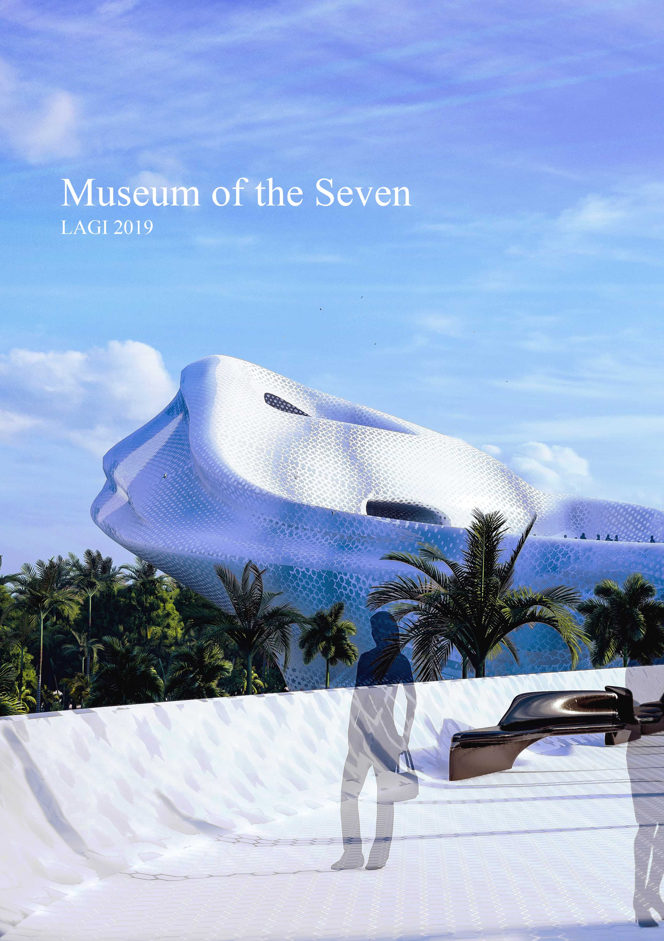

Proposal

The idea for this project is to create the first sustainable energy museum in the Middle East, where the location of Masdar City, the first sustainable city, is very suitable. We believe the best way to advance sustainable energy in the UAE is to educate the public of the best sustainable energy practical applications around the world where all 7 sustainable energy sources will be explored and demonstrated to the visitors. Creating a unique sculptural landmark with integrated public spaces would encourage visitors from all over the world to visit.
We believe this project uses practical, cutting-edge, sustainable energy technologies already existing in the market to make it a possible project to construct that will benefit not only the UAE but its residents, as well as through education and eventually usage of practical, sustainable energies in their own homes.

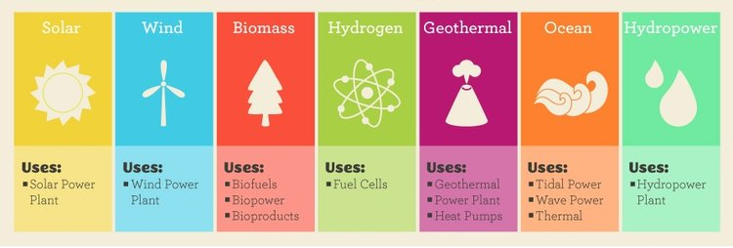

Design Concept

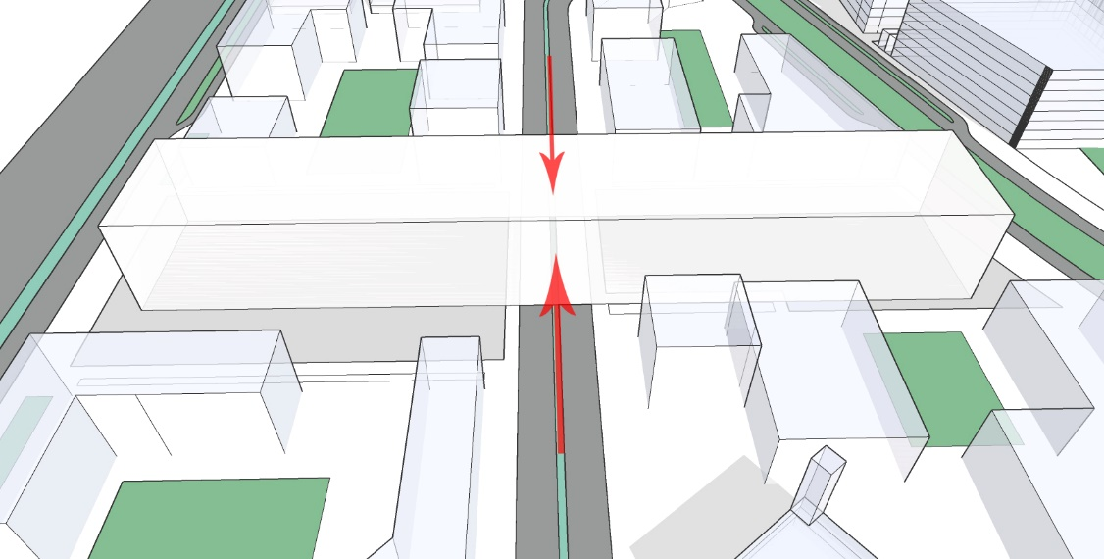
- First objective is connecting both sites to create a sense of unity between them and the building design while allowing the existing roads and environment to infiltrate and react with the design proposal.

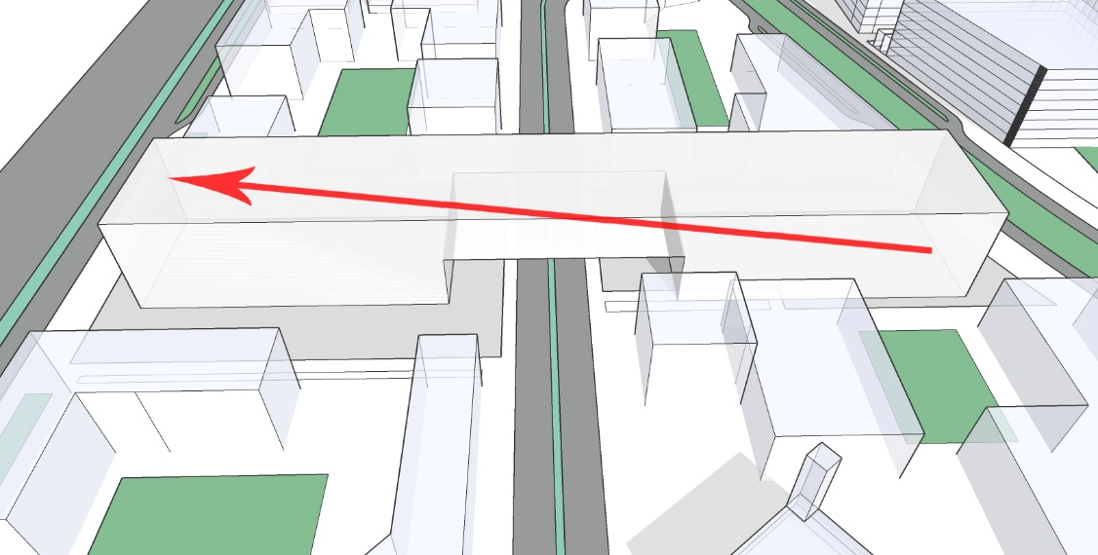
- The building design explores the idea of allowing the rooftop of the building to be used as a pedestrian path taking you from the main site entrance to the main building entrance at +15m, while enjoying the scenic sculptural mass on the path that is clad with Tesla solar roof tiles, allowing the visitors to walk on the material and fully engage in the sustainable energy process.

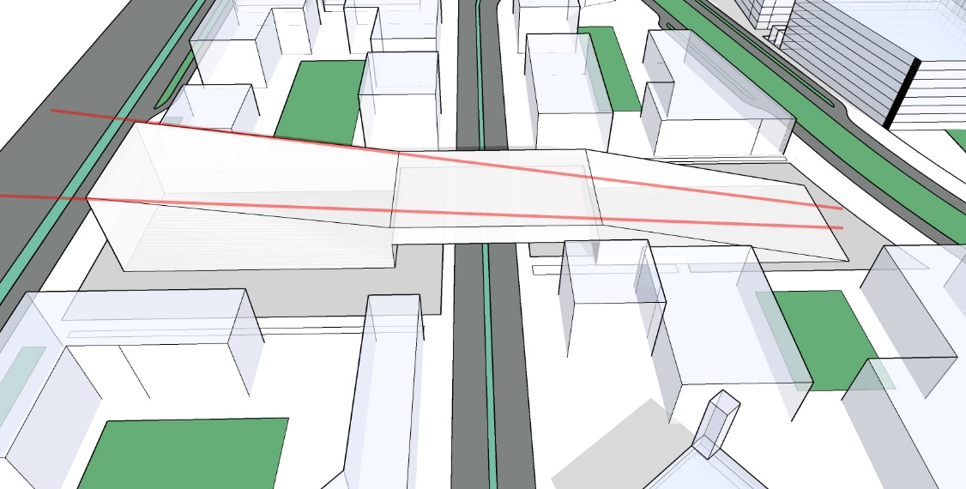
- To emphasize the scenic route from the main site entrance to the building main entrance, we created a temple-like effect where the visitor starts at the narrowest, lowest point and can see the highest, widest point getting closer as he walks towards the building entrance on the path.
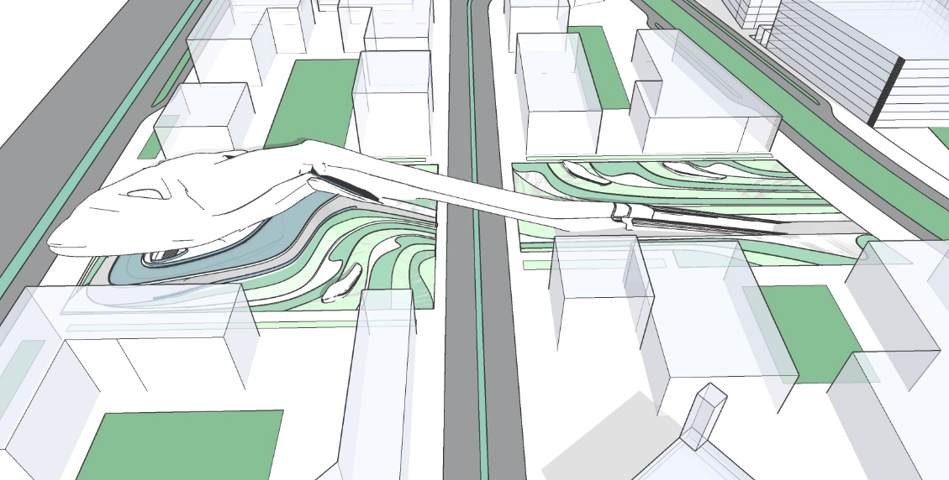
- We created a sculptural mass that would stimulate and challenge the minds of the visitors inspired by organic curves found in the natural environment of the desert that gives you the feeling of a lizard on a sand dune soaking in the sun rays. To emphasize the metaphor of a desert lizard on a sand dune, we raised the main body of the building on several levels of landscape planes resembling the curves you would find in a desert.

- The overall lines and curves of the project was inspired by Masdar’s concept of organic curve confined in a polygon.

Structural Concept
The building construction consists of two systems: a concrete structure combined with a space frame system. In order to achieve large-scale column-free spaces that allow the visitor to experience the fluidity of the interior, vertical structural elements are absorbed by the external envelope. Glass Fibre Reinforced Concrete (GFRC) is the cladding material used over the frame system with a thick insulation layer between, as they allow for the powerful plasticity of the building’s design while being perfect to receive the final component of the shell which is the solar panel sheets.
Sustainable Technologies
The technologies used in this building are a mixture of a fast advancing technology of printed solar sheets on the facade of the building from a cutting-edge solar ink technology where an Islamic parametric pattern will be printed and incorporated in any building material required, and an already existing technology of Tesla solar roof tiles to be added on the building roof pedestrian passage way from first to second site.
We explored using these two technologies in different ways that have not been used in the architectural design process yet. The Tesla roof solar tiles are already in the market, but have never been used as a walkway material, despite the product being described as indestructible and weather proof. This unique way of using the technology will open up a new way of designing buildings with large roof areas that are constantly in exposure of the sun, while allowing the visitors to get their first glimpse of sustainable, clean energy technology and interact with it from the beginning of their museum journey.
The other technology being used is solar ink injected in transparent sheets to create a light sheet of parametric pattern. While this technology currently exists, it has not yet reached the point of mass production. Our proposal to print parametric Islamic patterns that will be clad on the building will have an lasting impression on the visitors along with the designers of the world, where in future projects, any works of art can be printed in solar sheets and clad to any building (walls, windows, roof, etc.), and not only look amazing but actually generate that building’s electric energy required.

Printed Solar Panels
Practicality: Available in market, commercially ready in 1-3 years
Cost: 1 Dollar per watt

Revolutionary solar cell technology created by University of Newcastle physicist Paul Dastoor, the organic printed solar cells are printed on an ultra-lightweight, laminate material, similar in texture and flexibility to a potato chip packet. The material delivers unprecedented affordability at a production cost of less than $10 per square meter. The material is made by printing an advanced electronic ink onto paper thin, clear laminated sheets using conventional printing presses. This technology will be used in this project to create a parametric Islamic pattern on the mass of the building, like a skin on the actual mass.
Beresfield-based logistics company CHEP has become the first commercial owner of the technology in Australia and most likely the world. The commercial-scale installation is the final stop before the technology becomes widely available.
“Our printed solar cells are now considered to be at the ‘top of the technology readiness tree’.
“On the university’s lab-scale printer, hundreds of meters of material can be produced per day, however upgrading production to a commercial-scale printer would increase this output to kilometers. No other renewal energy technology can be manufactured as quickly.
“The low cost and speed at which this technology can be deployed is exciting as we need to find solutions, and quickly, to reduce demand on base-load power – a renewed concern as we approach another summer here in Australia,” Professor Dastoor said.
Incredibly simple and fast to install, 640 meters of material was installed at the CHEP site by a team of five in just one day. So lightweight, the material is secured using standard double-sided tape.
Credit: Newcastle.edu & Theharold.com

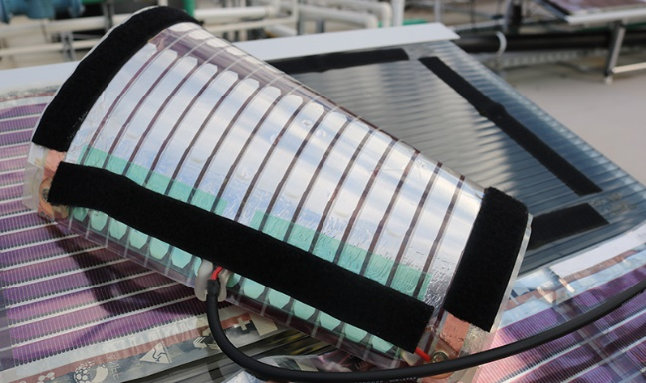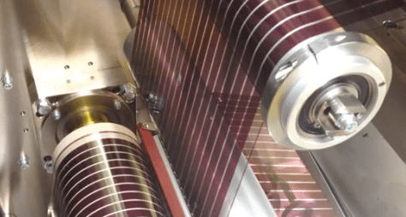

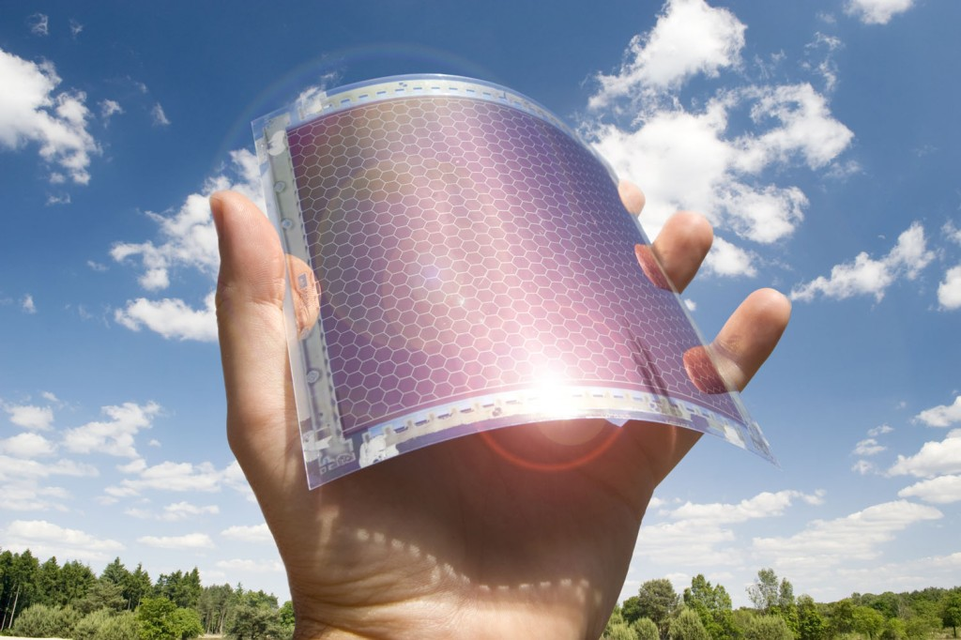

Tesla Roof Solar Tiles
Practicality: Available in market
Cost: 3.5 Dollars per watt

A solar panel includes a back sheet layer, a bottom encapsulant layer adjacent the back sheet layer, a plurality of photovoltaic cells adjacent the bottom encapsulant layer, a top encapsulant layer adjacent the plurality of photovoltaic cells having a plurality of louvers constructed therein to block side view of the plurality of photovoltaic cells, and a top layer adjacent the top encapsulant layer adjacent the plurality of photovoltaic cells having a plurality of louvers constructed therein to block side view of the plurality of photovoltaic cells, and a top layer adjacent the top encapsulant layer.
Credit: Tesla Patent for solar roof tiles

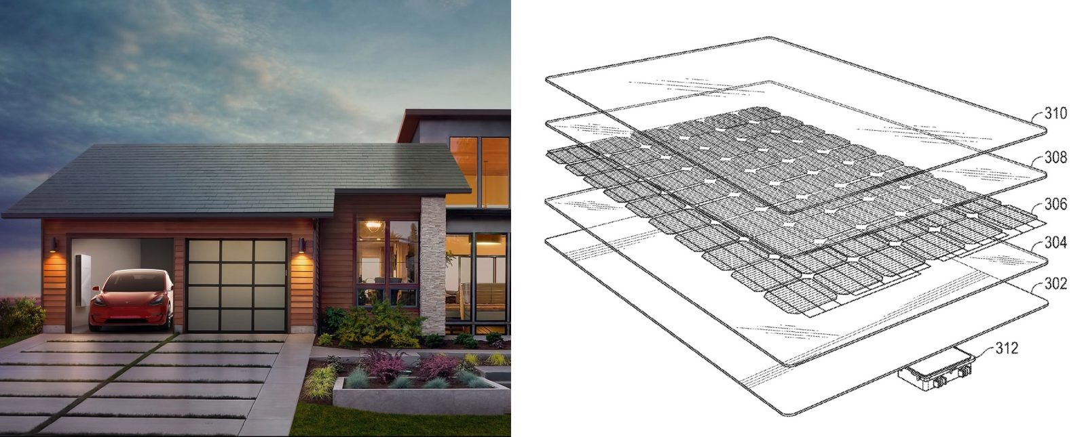

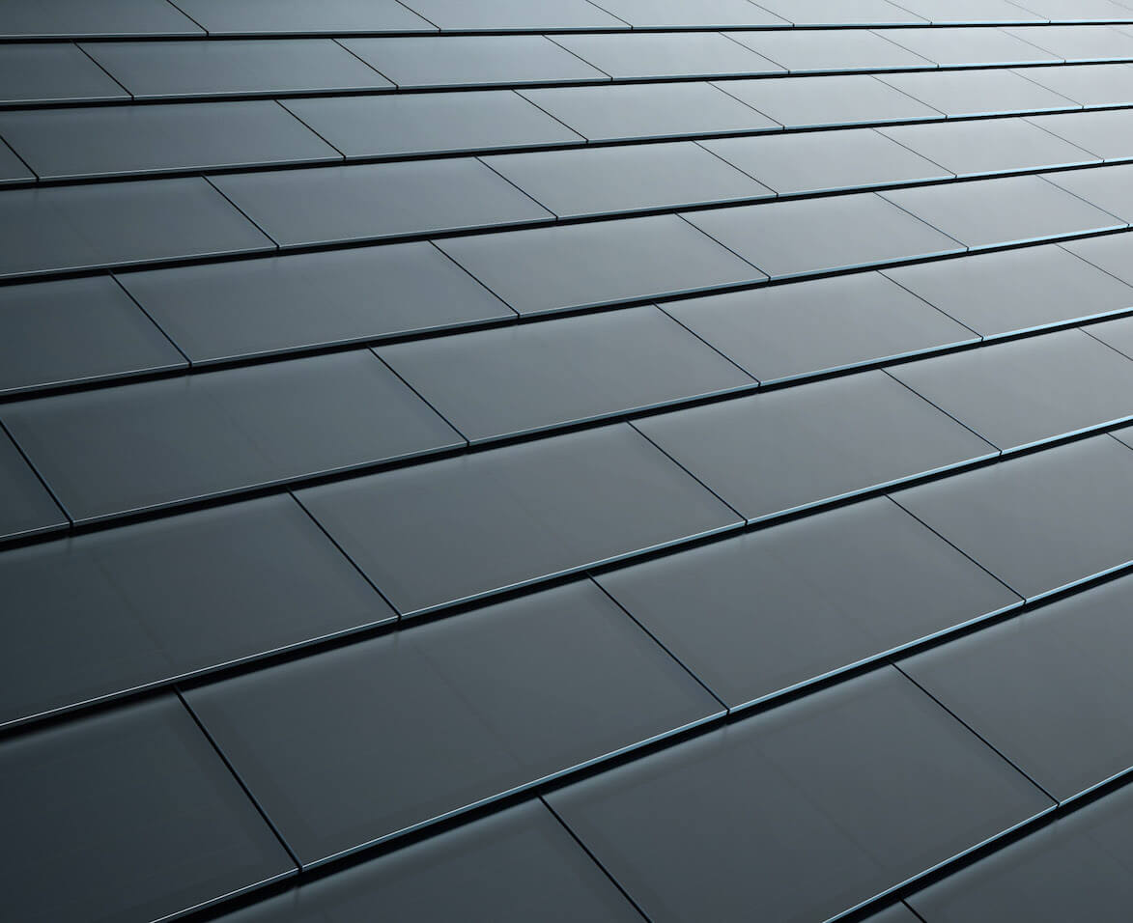

Tesla Powerpack
Practicality: Available in market
Tesla Powerpack will be used to store the energy created, where they will be located in the MEP area on the ground floor level.
Powerpack is a fully integrated, AC-connected energy storage system with everything needed to connect to a building or utility network. It dramatically simplifies installation, integration and future support, offering system-wide benefits that far outweigh those of standalone batteries.
Credit: Tesla.com

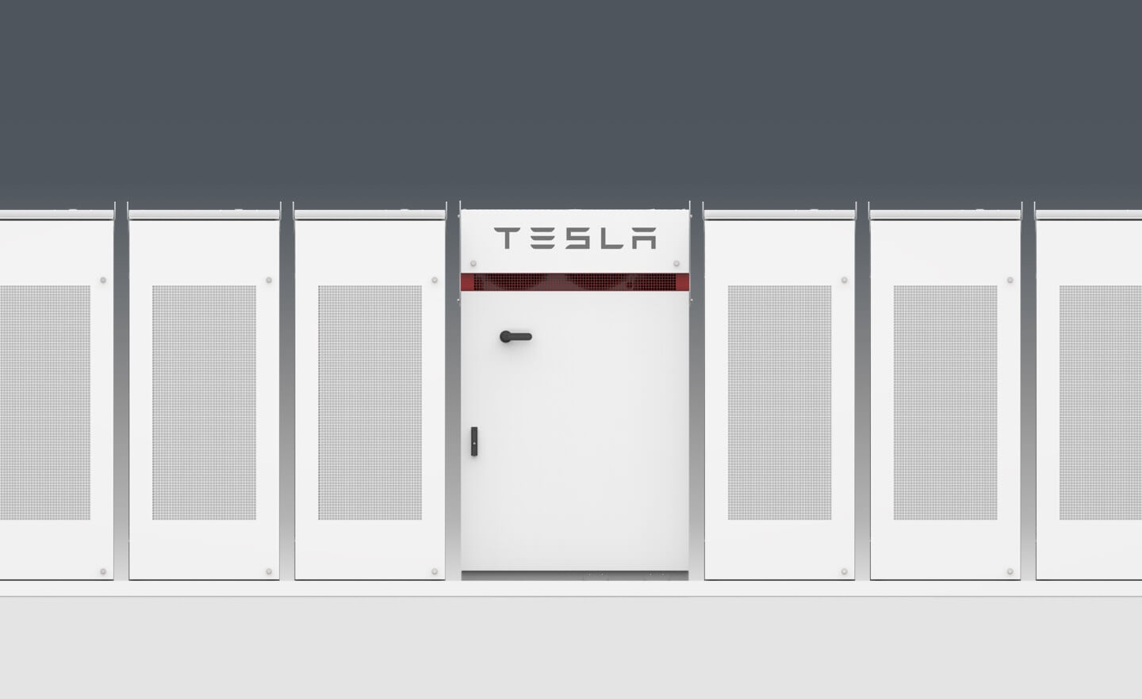

Estimated Power Generated

Printed Solar Panels:
Power: 80 watt/sqm
Available area to apply: 10,000 sqm
Total power generated per day: 800 Kw
Total Annual power generated: 288 Mw

Tesla Solar Roof Tiles:
Power: 290 watt/sqm
Available area to apply: 4,000 sqm
Total power generated per day: 1176 Kw
Total Annual power generated: 423 Mw

Overall power generated per Annum: 711 Mw

Additional Revenues for the project:
- Museum Tickets
- Gift Shops
- Restaurants
- Cultural benefits

Environmental & Cultural Impact

The project‘s environmental impact is definitely positive, as the project will produce its own energy onsite. The goal will be to construct a near zero carbon emission building as the project was designed to have very few openings which will lead to better insulation and less need for cooling, which in turn will save a lot of energy.
The project was designed to achieve LEED Platinum certification as it follows all the rules to achieve that grade, not only through the solar generated energy, but through having an efficient envelope that leads to a better insulation and energy savings, and by using a thick insulation layer between the GRC and the steel frames.
The massive amount of landscape and public gathering areas in the project will have a positive impact on the surrounding environment as it will create an opportunity for the visitors and residents of Masdar City to enjoy the site and the building even if they are not visiting the actual museum.
The main axis for the project was inspired by Masdar City’s concept of having organic curves confined in a rigid polygon; this allows a strong relationship between the project as a public building and the city as a whole.
The cultural benefits of the project were the driving concept in the design process, as the UAE is a pioneer in encouraging the usage of green, sustainable energy in all the projects under construction as a whole, and this project will allow it to take the next step of educating the residents on the practical usage of different sustainable energy technologies on the personal home level, where it will provide exhibits for new technologies to display here in the UAE. In addition to that, the nature of the sculptural massing of the building will encourage visitors from around the world to visit the first sustainable energy museum in the Middle East.

