Make sustainability More Colorful
There are an Arabic saying:
(If you do something(that the speaker thinks is difficult) I will cover the Desert with colorful ceramic)
our design is inspired from this saying, the shelters and their shape Act as the desert ground, and we tried to dress it with colorful glass Instead of Ceramic.
Solar energy cell panels are not only energy generating parts that we put onHigh places and roof of buildings away from sight mostly and try to hide them, only To use them to supply energy for us!
But it can be a part of architecture and play the main role in the aesthetic values of the architectural form.
we are using two types of towers, with the same form.
-The first is a wind tower providing cool fresh air as a passive cooling strategy.
-The second type is a tower containing energy storing devices which store the energy collected by the solar panels.
Colorful transperant solar cells are used to change the atmosphere provided different colors of light
Under the shelters to give a happy and poetic sence.
As far the environmental strategies suggested in the design (3000)m sq of solar cell panels:
-semi-transparent solar panels are integrated in the shalters and stored into the energy storing towers,
Then used to provide the adjacent buildings with electricity. -The second passive strategy in passive cooling which is provided through
-The wind towers which transmit cool air into the area and also transmitted through Ground pipes to the adjacent buildings.
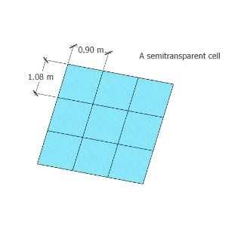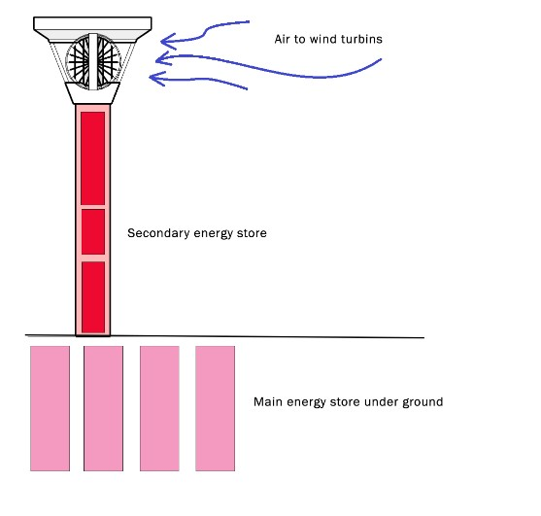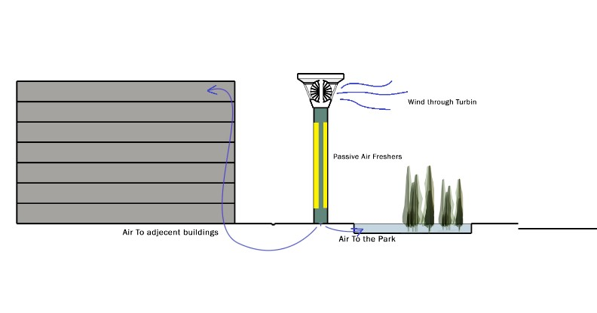
The biggest colored solar energy station in the world!
we are looking to put a distinct monument in a distinct city
like Masdar, Because of that we used apx. 3000 m sq of
semitransperant colored solar energy Panels to supply
more than 4500 MW/year.with 500 MW/year for turbin energy,
It means 5000MW/year total. We are looking to give people nice time under shelters as well as supply More as we can of the energy to provide the near buildings.
It costs 100$ for every 1 m sq, it means the solar cells Costs 300,000$

