Sunshine Catcher

LAGI 2019

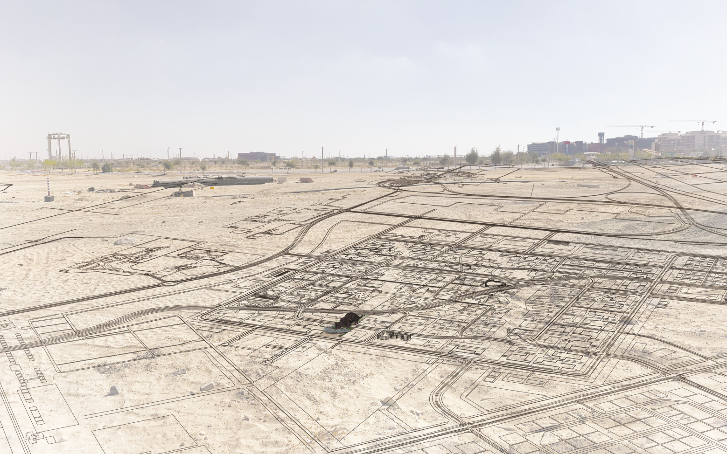

Brief
For thousands of years we have relied on burning fossil fuels to generate energy, but in today’s world using oil, gas and coal for our energy needs is becoming a problem. Solar power is becoming a popular alternative source of energy. It is a clean, inexpensive, renewable power source that is harnessable nearly everywhere in the world.
Sunshine Catcher is proposed to provide maximum conversion of solar energy into electrical energy and collect it in hydrogen storage. Moreover, SunCat may become not only the significant cultural attraction of Masdar City, but also the amazing place for family activities. Everyone can choose the most appropriate activity there: play on a playground for kids, play sport, relax in a hammock, sit by the fountain, visit the public aquarium or just have a cup of coffee.

Project description
The construction as a silhouette of a cat may become the symbol of Masdar City and attract big quantity of visitors among tourists and country residents due to the different activities, organized under the solar panels.
The construction consists of 3 levels, each of them have their own function:
- The upper level maximum height is 45 meters. It consists of solar panels installed on the light metal frameworks spacing of columns 15 meters. Solar panels automatically change their position depending on sun rays which one always goes under 90 degrees for getting the maximum of sun power. Due to the movement of solar panel an illusion is created that the silhouette of the cat is soft and fluffy. The location of solar panels relative to wind flow (6 km/h) allows to cool solar panels for getting more energy. The direction of the wind at elevations from +45 to +4500 meters predominantly on North-West (51%) and North (22.6%). The highest quantity of energy is achieved in April, May and July due to increase of wind speed more than 7 km/h and in December, January, February due to constant air temperature (+23…25) which is optimal for producing energy.
- The ground level has zones for family activities, sports, relaxing, shopping and entertainment. Fountains zones give the opportunity to fill the freshness of the rain. Relax and walking zones are proposed for contemplation of nature and rest.
- The underground level is planned to become the storage of energy, public aquarium and fountains technical rooms, underground parking. Also there is a public aquarium and safe underground crossing of road via travolator.

technical and economic indicators
The primary materials used in this project:
- Low-carbon cement;
- Natural stones;
- Solar panels HH-Poly-280W;
- Glass with thermal protection;
- Metal;
- Sand.

Energy efficiency:
- Annual power generated 2 067 651 KWh;
- Annual consumed energy 788 400 KWh;
- Annual saved energy 1 279 251 KWh;
- Peak output 11317 KWh per day;
- Cost per watt $0,008.

Space usage efficiency:
- The total space of the land plot 22 413,69 sq.m.;
- Built area 6 975,4 sq.m.;
- Open areas 2 877 sq.m.;
- Underground structures 7 537,7 sq.m.;
- Pedestrian walkways 1 360 sq.m.;
- Lawns and planting 11 201,29 sq.m;
- Solar panels total space is 12542 sq.m. (panels quantity 6601 pc, S=1.9 sq.m.)

Approximate cost of the project is about $17 000 000.

Technology description
The Sunshine Catcher is based on the hybrid Solar Hydrogen Power Plant (SHHP) technology. Beyond meeting the day’s energy requirements, the solar photovoltaic power plant will generate surplus energy during the day that will be converted into hydrogen and stored for later use.
The use of electrolysis to produce hydrogen from water is an efficient method from small to large scales. Energy for supplying water electrolysis systems is provided by photovoltaic arrays. During the daylight hours, the sunlight on the photovoltaic arrays converts into electrical energy which can be used for electrolyzer. The hydrogen produced by the electrolyzer is compressed and stored in hydrogen vessel and provides energy for the fuel cell to meet the load when the solar energy is insufficient.
This system is proposed to generate annually 2 067 651 KWh. Annual saved energy is about 1 279 251 KWh. Approximate cost of generated energy is $0.008 per watt.

Environmental impact
It is concluded by environmentalists, that the Hydrogen Energy-system is the most efficient and economical energy-system possible, and that it results in the environmentally most compatible and permanent energy-system when coupled with solar energy as the primary energy-source.
On top of that, hydrogen is like other fuels, it doesn’t degrade like a battery. It stays hydrogen and does not change its energy content. Batteries have a limited lifetime: they degrade and lose their capacities over time.
Transition to the solar–hydrogen energy system could help to save our economy and our planet.

