LAGI 2019 - HYPERCUBE

General Description
The project aimed to create symbolic profile to Masdar City while employing pragmatic proven technologies. Multiple large cubes finished with PV solar films will generate sufficient energy to illuminate the site and city's streets at night. The opening between panels will create a positive-negative wireframe optical effect during day and night cycle. Cubes’ interior spaces are dedicated for energy storage and tourist / academic amenity such as learning center, digital information dashboard and kiosks.

SITE CONTEXT
Receiving one of the world’s highest solar radiation (2600kWh/m2.y) at the given site, we decided to use solar power as a primary source of energy production. In a neighborhood scale context, we focused on site specificity as well as site inclusive design. According to city's master plan, site is located along circulatory green belt, thus walkability is important. The iconic cubes helped segments the site into something more of human scale rather than industrial scale. The primary pedestrian walkway with several bridges run across the site connecting from Khalifa University campus to periphery of the city's boundary. Multiple gathering spaces as well as tourists amenity provided by the cube will contribute to a more vibrant pedestrian environment within the site.
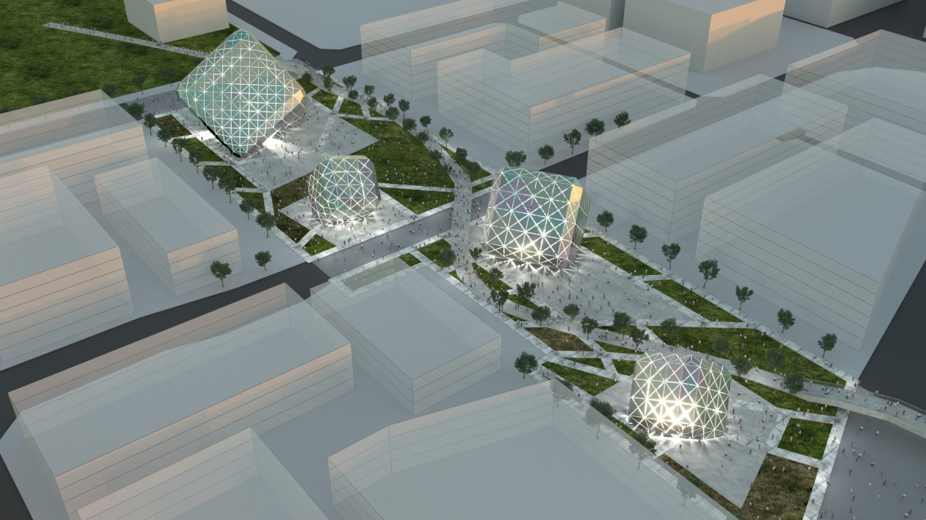
DESIGN ELEMENTS
THE CUBE: The cubes have top three faces covered with panels that are finished with light-weight solar cell films. The interior space is open to the public - enhanced by optical effect created by the thin gap between modulated solar panels. There are four cubes with each having different configuration placed within the site;
1. CUBE - L
40 meter at each edge, the towering giant cube will have a inside space dedicated for the park’s energy production information dashboard. The cube will invites visitors into futuristic platform equipped with digital information signage.
2.CUBE - M
Located closer to the university campus,
the medium sized cube (30m in each edge) will provide visitor amenities such as gift shop and restrooms.
3. CUBE - S
Smaller cubes will provide energy storage solution. Interior space will still be accessible to public - and will create educational opportunity for academics and Eco-tourists.
4. CUBE- S
Same as above.

BRIDGE / WALKWAY: The pedestrian bridges integrate the site into the city’s green belt circulation. The walkway is equipped with piezoelectric generator that harvests energy from vertical pressure created by walking pedestrian. High-efficiency LEDs embedded in the generator pad can illuminate choreograph the visitors’ activity at night.

LANDSCAPE: While the cubes and circulatory walkway distributing programs and defining spaces, smaller pathway that stems from major walkway will provide an environment for meandering and exploration. The strategically placed plaza areas are intended for big gathering and events. The iconic cubes will create shading and photo opportunity for curious visitors. The topology of the site were manipulated in a way that the hard concrete surface will reflect the solar radiation towards panels at the cubes; enhancing the energy production efficiency.
TECHNOLOGIES
We have deployed following technologies in our design.
- PV Film (cube): CdTe PV film has 16% conversion efficiency. The strength of the method is that it is extremely thin and light compare to conventional solar panels. This will minimize the need for supporting substructure.
- Piezoelectric Generator: the bridge and pedestrian system are covered with piezoelectric generators. This system has three layers: top layer is metal plate that absorb all the pressure and movement on it; the middle layer is PZT that transfer the energy into electricity; the bottom layer is the electricity receiver and battery storage
- Wind Tunnel(Landscape+cube): The corner shaped by the cube and the landscape around cube is a natural wind tunnel. It’s a nice shaded public space with breeze blowing people

ENERGY PRODUCTION CALCULUS
To estimate the approximate amount of energy produced, we used following model.
E = A * r * H * PR
E = Energy (kWh)
A = Total solar panel Area (m2)
r = solar panel yield or efficiency(%)
H = Annual average solar radiation on tilted panels (shadings not included)
PR = Performance ratio, coefficient for losses (range between 0.5 and 0.9, default value = 0.75)

The energy that solar panels alone can create would be following.
1235.52 MWh/m2.y = 9.9k* 16% * 2600k * 0.3
E = Energy (kWh)
A = 9.9k (4800 + 2700 + 1200 + 1200)
r = 16% (PV Film efficiency)
H = 2600 kWh/m2 (Annual / UAE)
PR = 0.3 (due to panel angles)

We do have other means of energy production (Piezoelectric Generator) however energy generated by them are not counted due to unpredictable nature of the method.

Material Cost Estimate
The following is a rough estimation of the material cost (including labor cost)
Grand Total : $8,570,980
Steel
482 tons (10km of r=0.4m member) x 1890 = $910,980
Concrete:
5000 tons (metal frame foundation / bridge / paver) x108= $540,000
PV film:
99,000 x30 = $2,970,000
Piezoelectric Generator:
10,000 x 15 = $150,000
Energy Storage / Transformer / Switchgear
$1,000,000
Transportation, Civil Works, Construction Management:
$3,000,000

Environmental Impact
Sitting in the center of Masdar City, Hypercube is being a connector of the neighborhood. First of all, the huge amount of energy it is generating every day can be a stable supply for the university and office buildings around it. In the meantime, this huge art installation space that is provided for visitor and residence is a great opportunity to level up people’s happiness, which is unmeasurable and priceless.
Land Art Generator should not only be a pretty object to look at. What’s more important is how to better serve people and have more positive influence on people’s life. That’s why we are trying to create educational interior spaces, the long bridge and sophisticated pedestrian system. The more people use it, the more meaningful it is.
A good sustainable design should be more beneficial when more usage is engaged. We modulized and prefabricated all the components of our design, which makes maintenance much easier. If one day any part break down, we can easily replace the module without having more construction work.

