ARCHITROPISM
LAGI 2019 | ABU DHABI | MASDAR CITY

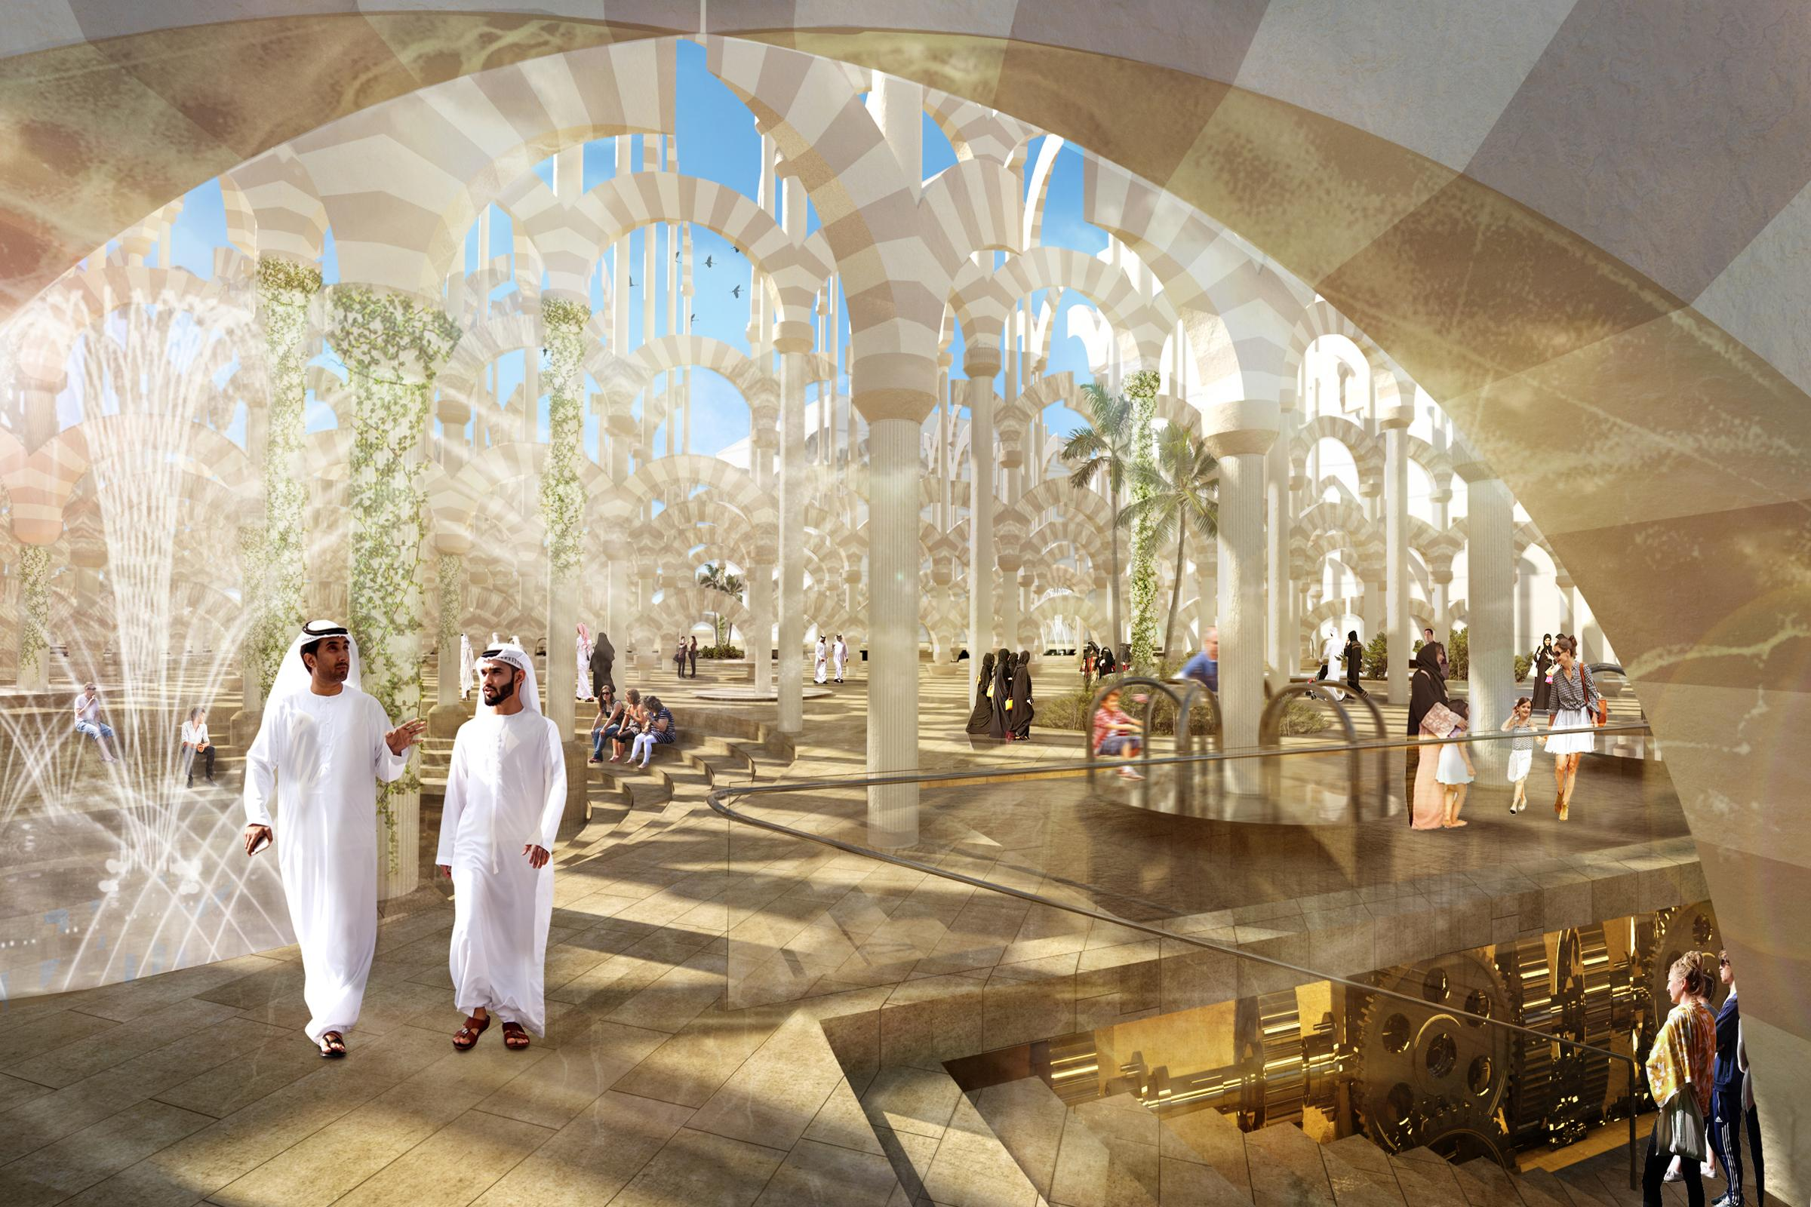
ARCHITROPISM

Masdar City, Abu Dhabi has taken on one of the most pressing demands for our species’ survival— climate change and the absolute necessity of renewable energy and sustainable technologies— and it advocates not only the advancement of sustainable technologies but also a design and architecture that represents a culture of optimism and hope for the future.

While much sustainable architecture draws inspiration from the natural world to justify new biomorphic and complicated forms, ARCHITROPISM, proposes an alternative solution. This project seeks to answer the following questions:

How can we make the architectural forms that have defined our civilizations for centuries become technologically and environmentally savvy?

How can we make the architecture that has become so deeply connected with how we understand the built environment new again?

To help create a throughline to the culture of the Middle East, studying the design of mosques proved to be a clear and helpful approach. Specifically, the hypostyle halls of the Grand Mosque of Cordoba presented itself as an example of Islamic architecture that also evoked the feeling of being in nature. Indian poet, Muhammad Iqbal, described Cordoba as “countless pillars like rows of palm trees in the oases of Syria.” As in most mosques, its design was largely influenced by the ‘first’ piece of Islamic architecture— the house Mohamed built where he fashioned a colonnade from the trunks of palm trees and taught his theology. Surely this literal translation from forest to architectural-forest of tree-trunk columns was a realized metaphor seen throughout the history of the hypostyle hall.

To return to the source of architecture and nature is something this project is interested in. How can one extrapolate the feeling of being in the “forest” of the halls of Cordoba and understand it in a contemporary, sustainable way? How can we take this notion of Cordoba, contextualize and contemporize it, and have it create energy and a place to congregate in an urban context?

What resulted in ARCHITROPISM is not a design that returns to nature in form, but rather an architecture that responds to nature in function.

DESIGN

On the site sits a field of arched colonnades (ranging in height from 18m-25m) that move and re-orient themselves to directly respond to nature. Walking through these halls evokes both the feeling of being in the holy prayer halls of mosques, as well as the date palm oases of the Middle East. The idea of tropism, the turning of organisms in nature in a particular direction in response to an external stimulus, helps demonstrate how this project reacts to the environment. There are 3 primary types of tropism employed on the site.

The first is anemotropism; the reorientation of organisms in response to the wind. Inside the top layers of the arches on each column are 12 vertical-axis wind turbines sheathed in a completely permeable fabric material. These arches at the top rotate to face the wind in order to create the most advantageous conditions for energy generation. On the site, there is an array of 1,040 columns and each is home to an arch that contains these turbines. Each turbine produces an average of 0.3 kWh. Ideal conditions are almost always present since the arches can rotate to capture wind most efficiently.
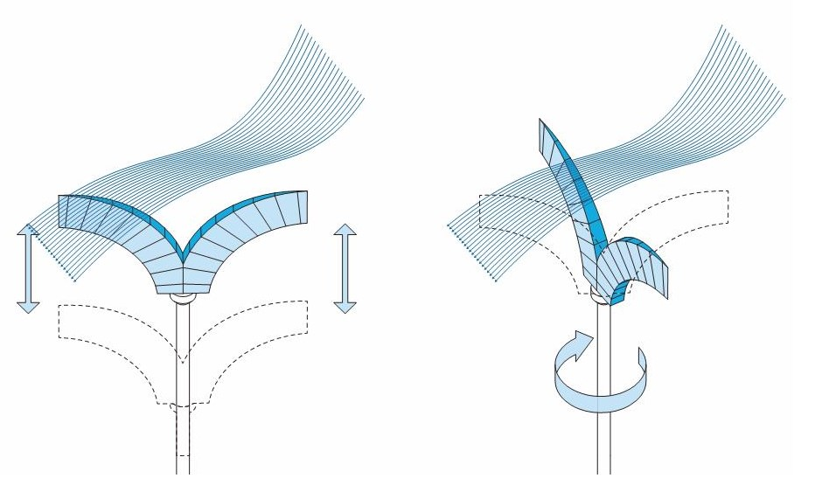

The second is heliotropism; the diurnal motion of plant parts (flowers or leaves) in response to the direction of the sun. The most famous example of this can be seen in sunflowers, which re-orient themselves over the course of a day to capture the most sunlight and encourage the strongest amount of growth per day. In our case, the columns are placed on a grid which directly curves and follows the sun path to allow the ground plane of the site to receive the most possible shade from the arches. Over the course of the day, the heliotropic arches slowly rotate to track the sun just as sunflowers do. This helps foster an ever-changing environment, where the arches are always in new positions and only once a day line of perfectly.
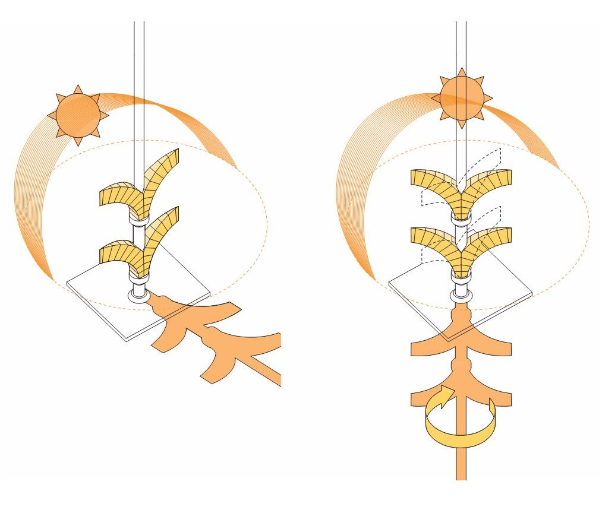
The third is anthrotropism; this is a term coined to describe a human or anthropological type of tropism. Each column on the site contains different types of base capitals that encourage the users of the site to generate power themselves. There are programmatic pieces like playground merry-go-rounds, benches, tables, amphitheaters, sunken spaces for solitude, stages, and more that can each be directly controlled by the users. By turning these pieces like one winds a watch to keep time, an underground gear is turned to store energy which powers all the architectural elements on the site.
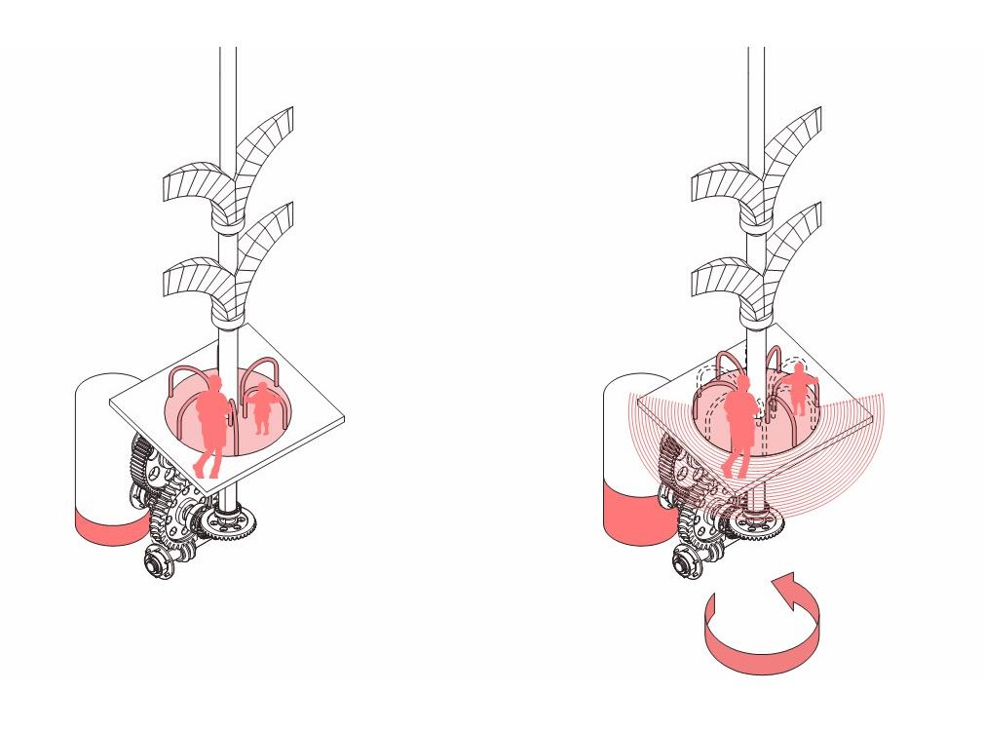

ARCHITROPISM is a field of effects, where circulation and program emerge organically, where architecture is not static but dynamic, moving with the earth, the sun, the wind and human life, and enabling its users to interact with the fourth dimension of time. This is an architecture that responds to nature and moves in time creating energy and experiences blurring the rift between our origins in the trees and our future in an urban society that moves in harmony with the natural world.

ENVIRONMENTAL IMPACT STATEMENT

Making op ARCHITROPISM, there are 1,040 interactive power generating towers. Each unit contains 12 vertical wind turbines and 15% of the units are also equipped with the base that can generate power from the rotation created by human interaction. If each turbine produces an average of 0.3 kWh, Masdar will be provided an annual energy surplus of 1,367 mWh. In 2014, the average electricity consumption per capita is 11,263 kWh in the United Arab Emirates¹. ARCHITROPISM will then produce enough energy to power nearly 120 homes in the Masdar area. Built materials are composed of locally sourced steel with cladding made of sandstone and limestone such as Jerusalem and Nubian stones², which have proven their durability and longevity from the ancient archeological structures in the Middle East³. Locally sourced materials allow low-carbon footprint for the means of delivery, construction, as well as onsite maintenance.

Calculations:

Vertical wind turbine⁴:
0.3kW/unit/day * 12,480 units * 365 days/yr = 1,366,560 kWh/an = 1,366.56 mWh/yr

Formula: E * U_{v} * 365 = E_{f}
E = Average daily energy generated per each unit
U_{v} = Number of vertical wind turbines
E_{f} = Total wind energy output per year

Human-powered rotational generators⁵:
0.1kW/unit/hour * 156 units * 1.5 hours/day * 365 days/yr = 8,541 kWh/an = 8.541 mWh/yr

Formula: E * U_{h} * D * 365 = E_{f}
E = Average hourly energy generated per each unit
U_{h} = Number of human-powered rotational generators
D = Average interaction time per unit
E_{f} = Total wind energy output per year

General Statistics:

Total volume: 13,000 cubic meters
= 1,040 units * 12.5 cubic meters per unit

Total units of vertical wind turbines: 12,480 units
= 1,040 units * 12 vertical wind turbines per unit.

Total units of human-powered rotational generators: 156 units
= 1,040 units * 0.15 vertical wind turbines per unit.

Total budget: $ 75,192,000
= (12,480 units * 300 W/unit)+(156 units * 100 W/unit)*20$/W
------------------------------------------------------------------------------------------------------------------------------------
- “Electric Power Consumption (kWh per capita): UAE” World Bank, 2014. Web. Accessed 10 May 2019. https://data.worldbank.org/indicator/EG.USE.ELEC.KH.PC?locations=AE
- “Geology of Emirates” Angelfire, 2014. Web. Accessed 10 May 2019. http://www.angelfire.com/az3/mohgameil/emirates.html
- “Seven Emirates One Destination: Archaeological Sites” United Arab Emirates Ministry of Culture & Knowledge Development. 15 August 2016. Web. Accessed 10 May 2019. https://mckd.gov.ae/sites/MCYCDVar/en-us/pages/archaeological-sites.aspx
- “Evaluation of different turbine concepts for wind power". Eriksson, S; Bernhoff, H; Leijon, M. 2008. Renewable and Sustainable Energy Reviews. 12 (5): 1419–34.
- “Merry-Go-Round Human Powered Generator” Ashe, Sarah & Navarro, Salvador. 2013. Web. Accessed 10 May 2019. https:// digitalcommons.calpoly.edu/cgi/viewcontent.cgi?referer=https://www.google.com/&httpsredir=1&article=1251&context=eesp

