**CALYX**

-

Land Art Generator Proposal 2019

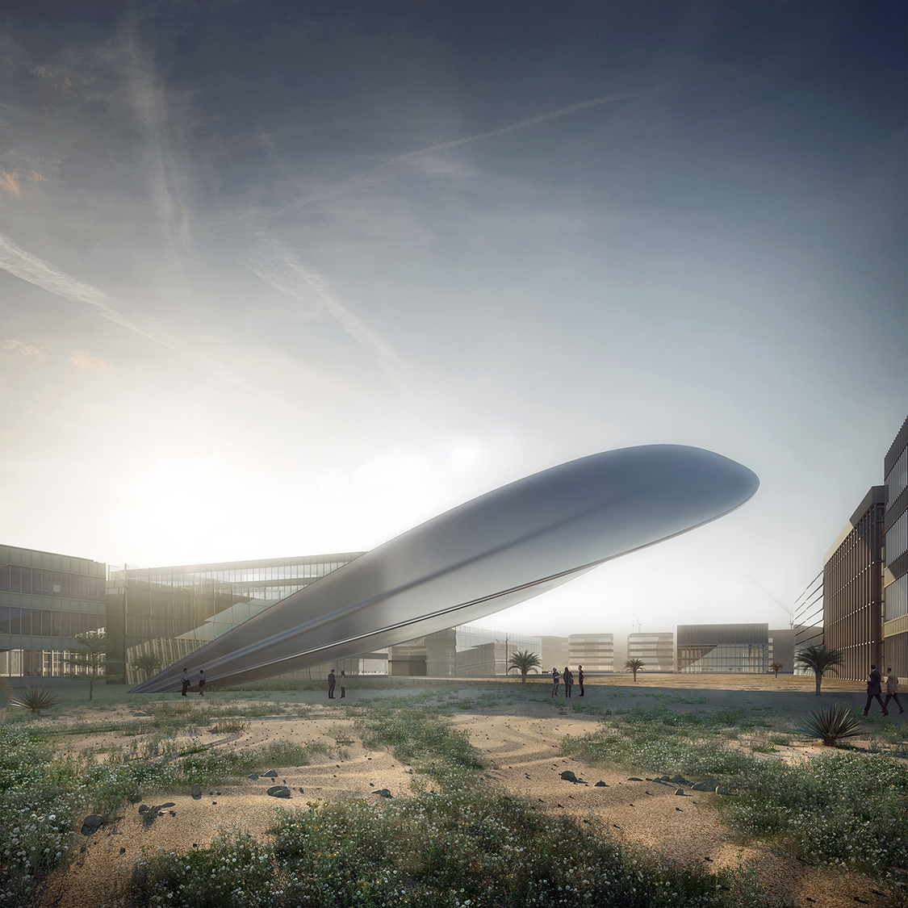

**Contents**

-

01 CONCEPT INTRODUCTION

02 PLANNING AND DIRECT SITE

03 SOLAR TECHNOLOGIES

04 BUILDABILITY

**01 Concept Introduction**

**CALYX** hopes to fuel Masdar with electricity, whilst also acting as a beacon for positive change. The urban grid within Masdar has been constucted for solar efficiency and our sculpture will do no differently.

Our LAGI proposal will harvest energy from the sun through the use of proven and existing technology. Firstly, it will absorb light energy through its transparent photovoltaic roof. Secondly, it will funnel and concentrate the suns heat within its body to generate electricity. Working on a vast scale, the structure will fuel over 1000 homes and/or institutions.

Curiosity will also become an important part of the scultures existence. From every approach the piece will appear as if a different form. As you navigate around the building it adapts and changes shape. The material choices that have been made are on one hand for solar efficiency, but also to heighten this curiosity. Partial views inside will engross visitors and encourage conversations to happen whilst its reflective qualities will allow people to see themselves and encourage them to reflect on their own decisions.

Its body is devised to protect this technology and allow for easy cleaning when necessary. Once navigated it will give vistors a vantage over Masdar and back to the college in the east.

**02 Planning and Direct Site**

02.1 Shadow Study

**Time: 0700**

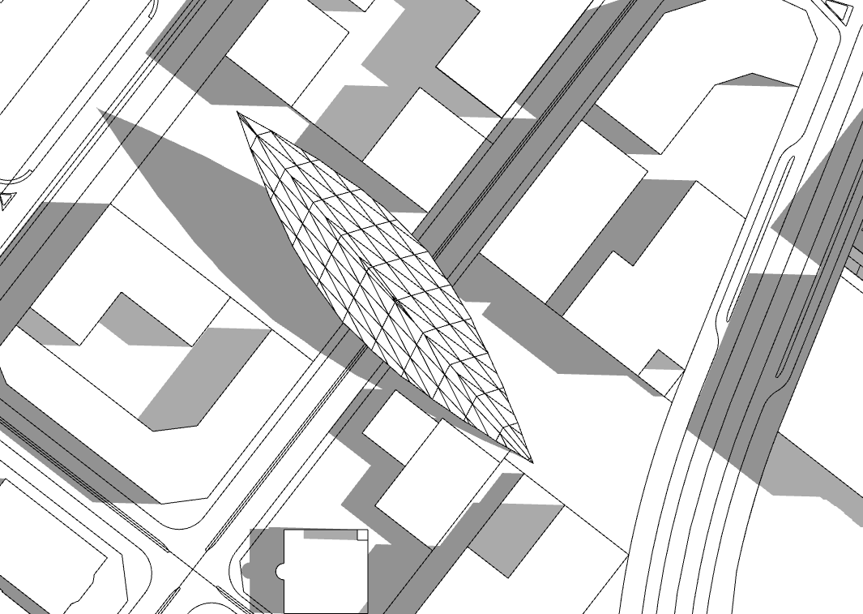

**Time: 1200**

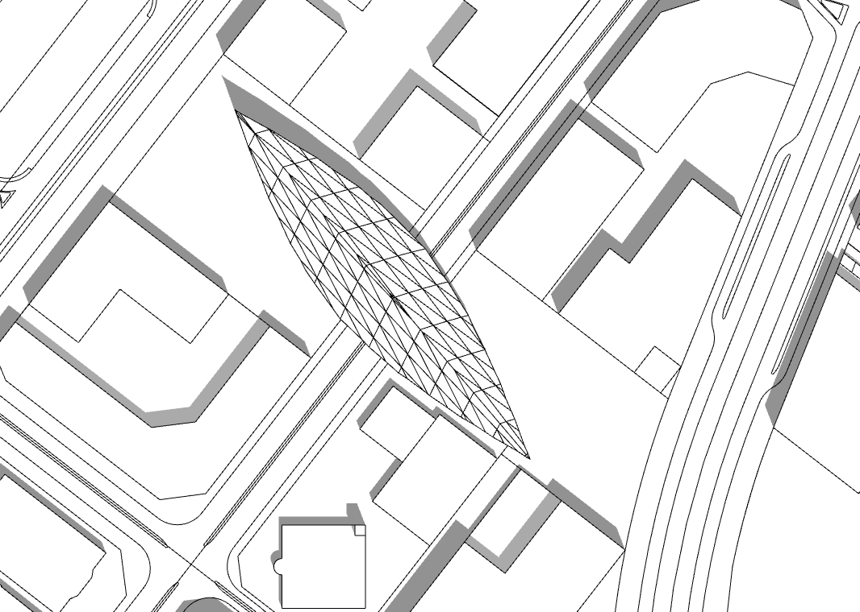

**Time: 1800**

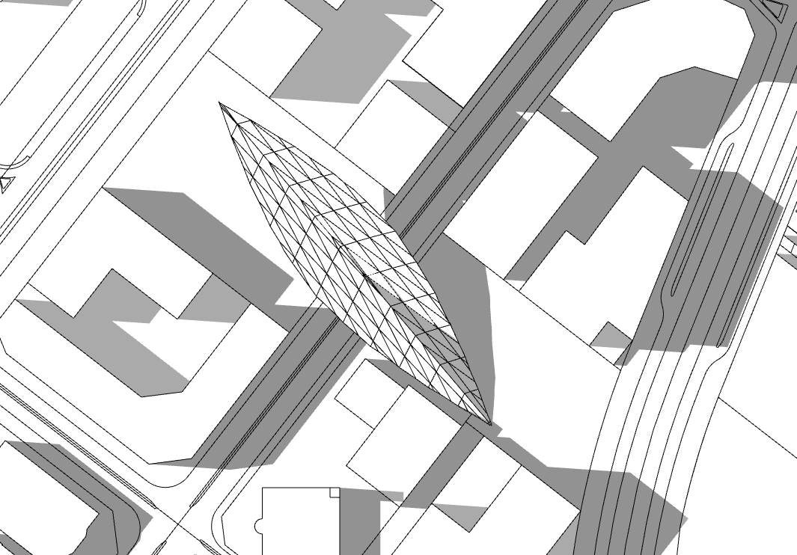

**Positioning:**

As seen from this shadow study, the positioning of **CALYX** manages to carefully avoid the shadow of any of the neighbouring buildings.

**Form:**

The shape of **CALYX** allows for the sun to make contact with its entirity for upwards of 90% throughout the day.

02.2 Context

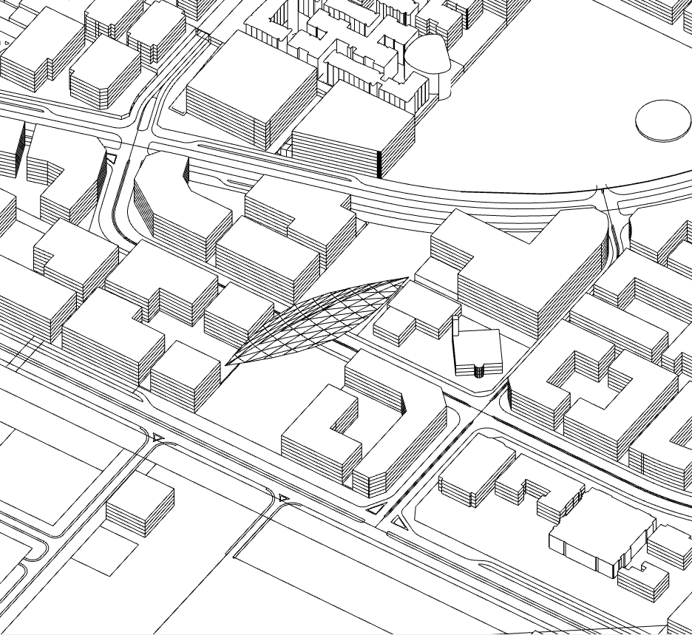

When seen in context you can begin to see how **CALYX** will start to ignite conversations. A busy road passes underneath the structure, meaning that passers by and Masdar inhabitants will interact and engage with **CALYX** without actually visiting on foot.

The ‘tip’ of **CALYX** reaches to 45M’s ensuring high visibility from long distances within the Masdar masterplan.

02.3 Vegetation

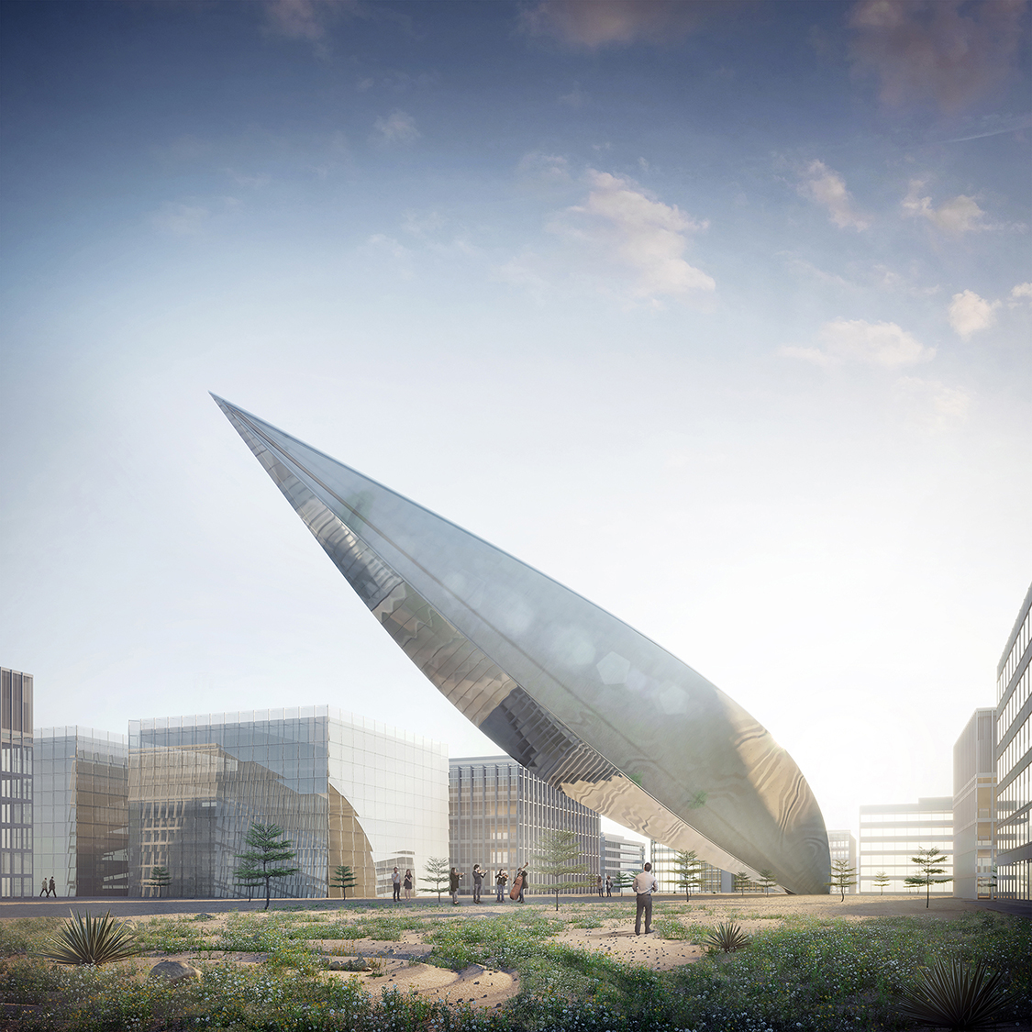

Within the UAE a lot of water, rubber tubing and man power is spent on encouraging plant growth. Whilst this has many benefits it could not be deemed as sustainable. Rather then fully landscaping and injecting huge amounts of energy in to the land surrounding **CALYX**, we want to leave a degree of ‘fallow’. We hope to plant dureable, desert faring plants that will multiply and leave a natural approach to the structure. This will contrast to the refined finish of the piece and also encourage guests to feel like they are discovering something for themselves.

**03 Components and Technology**

03.1 Transparent Photovoltaic Glass (TPV)

For the roof of our structure we are going to use solar glass, which will replace conventional window cells. Its **transparency can be increased to almost fully opaque and it will control what radiation will enter the structure. Our TPV will harvest Ultraviolet Radiation in to electricity.**

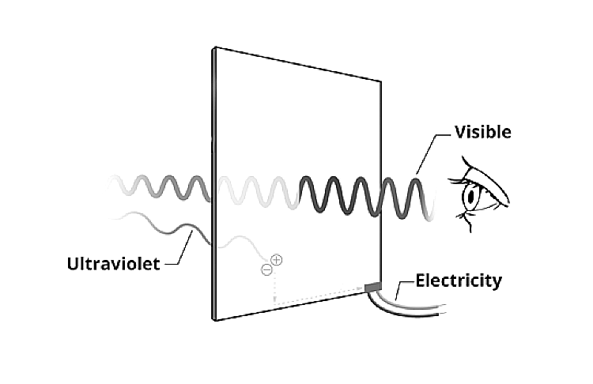

**TPV Calculations:**

**Calculation:** E = A * r * H * PR

Area x Yield Efficiency x Annual Radiation x Performance Ratio

* Area = 8064M2
* Yield Efficiency = 15%
* Annual Radiation = 2600 kWh/m2
* Performance Ratio = 0.6*

*(The performance ratio is calculated based on the expected losses such as – Shading, degradation factor of the PV performance, AC/DC cable losses, Inverter losses, losses due to environmental factors -i.e. dust)*

* An annual degradation factor of 6-8% has been considered.
* 1,886 MWH annual power generated ($3 per watt) - Peak value.
* A remaining $17 per Watt is considered viable for the structure itself.

03.2 Concentrating Linear Fresnel Reflector (CLFR)

Our ‘Concentrating Linear Fresnel Reflector’ technology will use internal mirrors to concentrate the sun's radiation energy to approximately 30 times its normal [intensity](https://en.wikipedia.org/wiki/Intensity_(physics)). Using long, thin segments of mirrors to focus sunlight onto a fixed absorber, which will be located as a spine that runs through the center of the structure. This concentrated energy is transferred through the absorber into some thermal fluid (this is typically oil capable of maintaining liquid state at very high temperatures).

The fluid then goes through a [heat exchanger](https://en.wikipedia.org/wiki/Heat_exchanger) to power a [steam generator](https://en.wikipedia.org/wiki/Boiler_(steam_generator)). As opposed to traditional LFR's, the CLFR utilizes multiple absorbers within the vicinity of the mirrors.

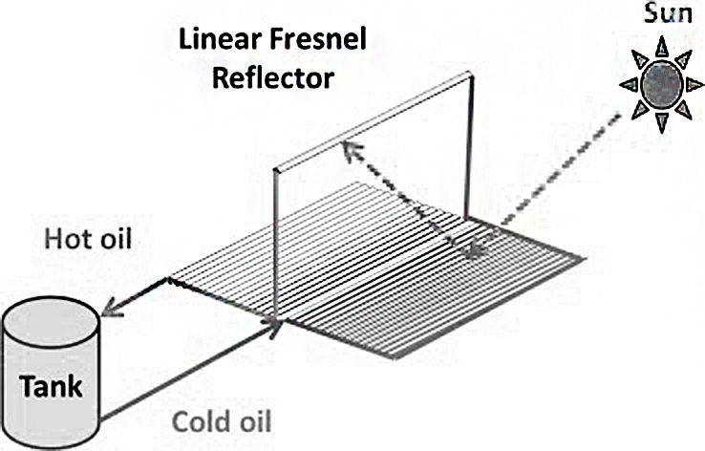

**CLFR Calculations:**

**Calculation:** = A * r * H

Area x Yield Efficiency x Annual Radiation

* Area = 8064M2
* Yield Efficiency = 15%
* Annual Radiation = 2600 kWh/m2

*(The efficiency of a solar thermal power plant is the product of the collector efficiency, field efficiency and steam-cycle efficiency. The collector efficiency depends on the angle of incidence of the sunlight and the temperature in the absorber tube, and can reach values up to 75%. Field losses are usually below 10%. Altogether, solar thermal trough power plants can reach annual efficiencies of 15%.)*

The total useful energy absorbed by this system is described by the HottelWhillier-Bliss equation, which gives the total useful energy absorbed by the linear collector prior to powering the steam engine.

Qu = FRA[Iτα-UL(Ti-Ta)

A overall efficiency of 15% has been used, assuming that the system includes energy storage of sufficient capacity

Calculation: = A * r * H = 3,144 MWH annual power generated.

**04 Buildability**

Macintosh HD:Users:DE0015:Desktop:BUILDABILITY.pdf

* Structure Buildability = 5 – A Unique Commercial Product
* Photovoltaics Buildability = 6 - Market Competition
* Linear Fresnel Buildability = 6 - Market Competition

All structural and technological elements recommended are derived from existing and tested precedents.

