LAGI 2019

Masdar City

Drop of Blessing & Arabian Horses

Design Report
- Analysis of competition Objectives

The competition calls for “an iconic work of art”, producing energy using renewable technologies, fitting in the context of Masdar City, in terms of mission and physical environment. Accordingly, it was found very important to derive relevant forms from Arab Culture, not letterally, but in abstract, in order to communicate with the users of the place in a way that inspires them, and give identity and memorable image to the place. This challenge is obviously compounded by the basic challenge of integrating powerful public art, with renewable energy production, with least (or no) compromise in all directions - - hopefully solving contradictions by INNOVATIVE HIGHER SYNTHESIS.

- Site Analysis

- The North-West edge of the site can be considered the “Gate” to Masdar City, in visual and symbolic terms, given the newly required nature of the site.
- Even with possible multiplicity of art work and energy producing elements, the main Landmark should be located as near as possible to this edge.
- Since the site consists of two parts, the other “half”, South-East, should contain another “node” of relevant activities.
- A raised platform on the whole site, one storey up, was found useful to accommodate needed equipment and technical connections, in addition to parking as needed.

- Concepts Generating Form

- Energy generation through P.V.C. demands basically a horizontal form, which may be logical for Energy production, but not the best answer in terms of artistic visual impact. Furthermore, the “industrial” image of conventional P.V.C. or vertical chimneys should be avoided.
- The proposed form combines P.V.C. considerably higher than human heights in the form of “wings” of a group of four “jumping” horses and around 40 m. high “drop” of water, with a dish-like umbrella in its upper third. The “drop” stands on a “wall” made of a group of vertical Solar Stills in ascending heights towards the “drop”.
- The basic two forms, horizontal and vertical, give a strong image, with rich contrast, extending further in the details of both. The Arabian Horse is in itself a strong symbol of Arab- Culture, and simultaneously an energy symbol (horse power). The abstract planner sculpture and dynamic movement of the jump and the wings elevates the artwork from letteral naif representation, to inspirational symbol, with cultural roots. The “drop” of water is equally rooted in Muslim Culture, especially in the desert environment. Accordingly, the same result of an inspirational symbol, with cultural roots.
- The two symbols were grouped together in an open theater, where terraced seats are shaded by horse wings and the “drop”, combined with the Solar Stills give the stage and its background, that are illuminated with dynamic projections at night. Hence, dynamic socio-cultural interaction with art and renewable energy is maximized in an entertaining environment.
- In the South-Eastern half of the site, it was found necessary to have an indoor space to be utilized as a gym, displaying energy generating athletic practice equipment, in group competitions (possibly between schools), watched by audience on terraced seats. The half-domed building with coloured painted glass has another layer of P.V.C. moving on track, with sun movement. Again, dynamic socio- cultural interaction with art and renewable energy.
- Pedestrian, including handicapped and Golf cart, movement is facilitated by ramp and steps entry, on both sides of the site, through a landscape of multi terraces. The landscape treatment of the site provides series of varied spaces and sizes, to accommodate varied social needs in an enjoyable environment. Further work is anticipated to maximize sustainability in landscape design details. Kiosks offering refreshments and printed materials are distributed throughout the site.

Production of Energy and Potable Water:

- Electric power generation is done mainly by photo-voltaic collectors, integrated with “Horse Wings”, “gym Sun –Tracking Roof”, and “Kiosk Roofs”. In addition, Wind –Driven Electric Generators, used usually on a vertical axe, are utilized on a horizontal axe (above head level), at the bottom end of “wings”, to benefit from the air-funnel effect, created by tilted wings.

In addition, a limited electric power is produced through athletic equipment in the gym, for demonstrative interactive purposes.

- Potable water is produced through three systems, operating day and night. The three systems benefit from being integral parts of form design. The first system condenses atmospheric humidity, naturally, by relatively cooler underground earth and ground water. Air movement is augmented by the funnel effect of the tilted “wings”, day and night. It is also augmented by the “solar Stack” effect, day time.

The second system produces water through “solar Distillation”, inside near vertical “Solar Stills”, with ground water (pumped up) cascading on steep slope rough surface of dark rocks. Condensation occurs mostly on the inner surface of the “Drop”, being far wider and cooler, day time.

The third system produces water through “Dew Collection” at night, on the upper surface of the “Dish”, utilizing maximum surface to volume mesh.

Additionally, a hybrid system (partly active, mostly passive) can augment both Dew Collection and solar Distillation at night, by utilizing a Freon cycle that cools the Dew Collecting mesh, and heats saline water in the Solar Still.

Cost & Capacity Calculations

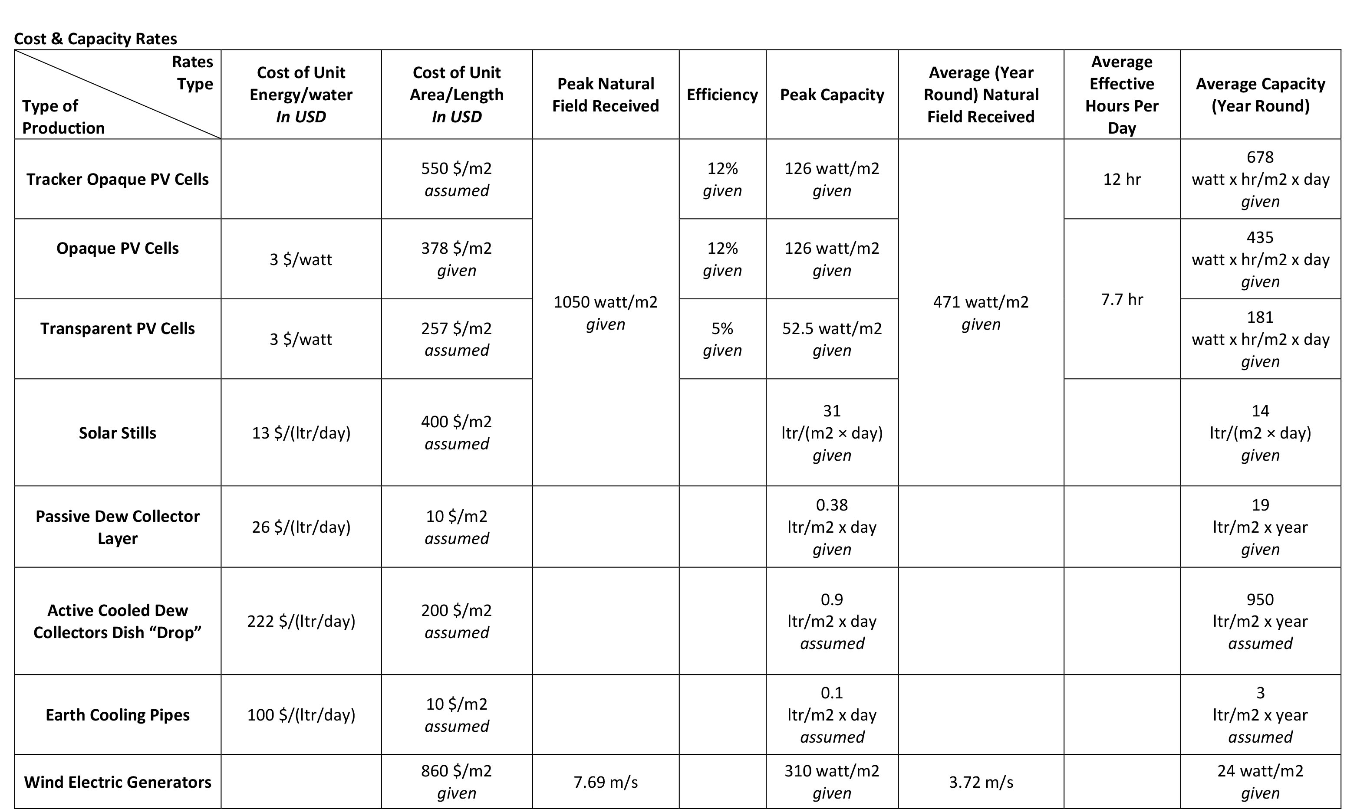
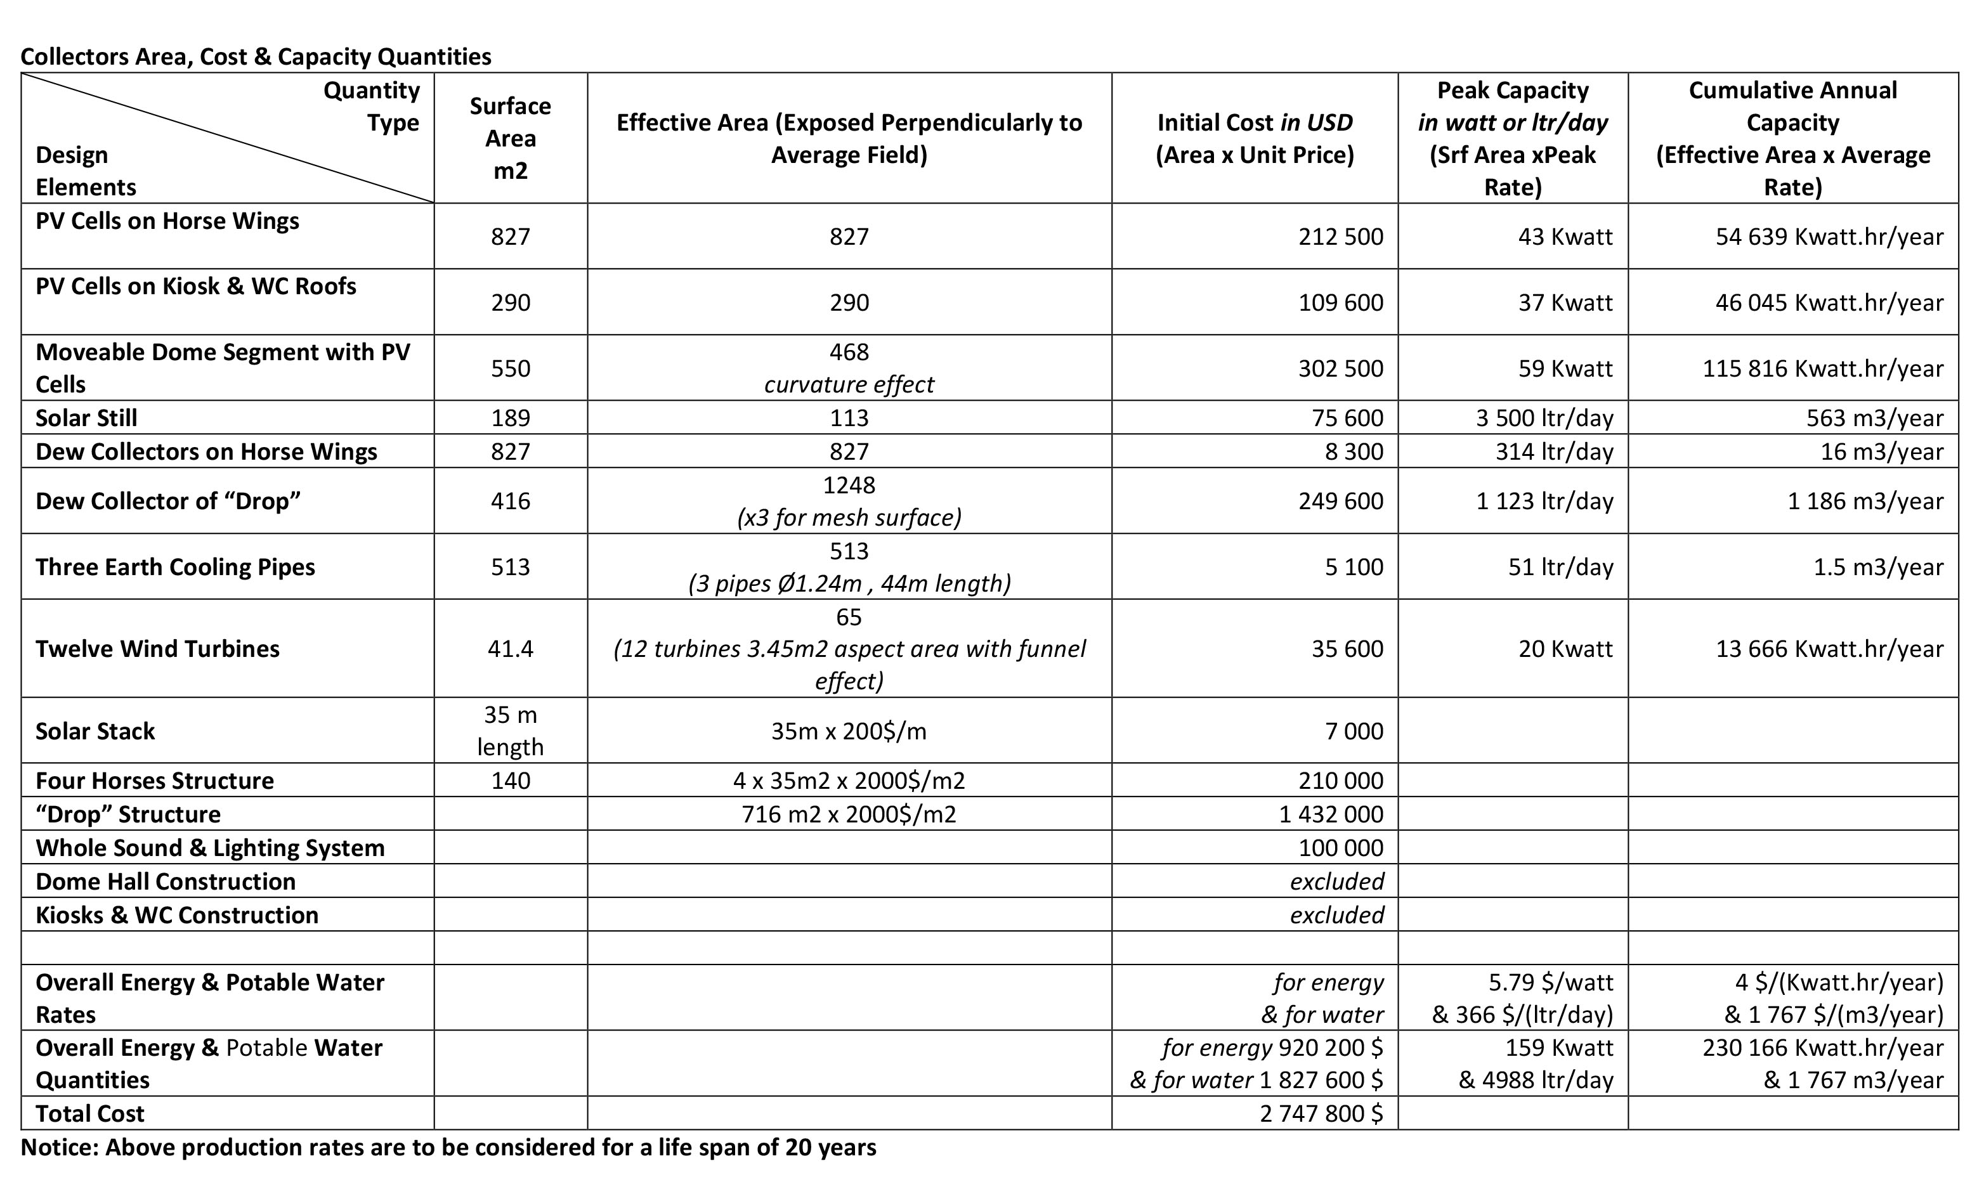

Environmental Impact Brief

Positive Environmental Impacts:
- Production of electric power and potable water, through well tested renewable means and technologies, day and night.
Accordingly, decreasing dependence on fossil fuel generators and desalination plants, with their CO2 emissions plus other pollutants.
- Creation of considerable green area in the city.
Accordingly, purifying air, decreasing CO2 and other pollutants, decreasing heat-island effect and improving micro-climate.
- Maximum use of natural materials in hardscape elements.
- Minimum Use of air-conditioning.
- Positive Direct and indirect impacts on peoples health, awareness of environmental/cultural issues, and entertainment through visual arts, performing arts, athletic activities and social interaction.
Unavoidable Negative Environmental Impacts:
- Needed production of metal works and other manufactured materials in various equipment, P.V.C., sculptures, athletic equipment and night illumination.
- Needed use of limited amounts of electricity in partly active Freon Cycle, limited air –conditioning, illumination and control equipment.

