Back to square one

Concept
Inspired by the great Piazza’s (Squares) in Europe or the infamous Times Square in Manhattan, for Masdar City, ‘Back To Square One’ proposes to be a major commercial intersection, tourist destination, an entertainment hub for the City. It is a Larger than life open ended square structure with walkway ramps on either two ends of the site that approach the intersection, The Square, i.e. the main Focal point of attraction. These ramps have canopies for shade.
The central superstructure and the canopies are entirely made from ultra-high efficiency flexible solar photovoltaic modules that are tiled in a pixelated fashion and mounted across prefabricated high steel exoskeleton structure giving it a poetic illusion of integrating-disintegrating form of the formation of the ‘Square’.
During the day time, the walkways have a dramatic aesthetic caused by the grid patterned shadow of the pixelating photovoltaic panels falling on the ramp. The skeleton of the sculpture also has led lighting system throughout the structure which lights up in the dark thus giving a futuristic aesthetic around night time.
These photovoltaic modules will be coated with solar skin a.k.a a thin film specially coated with ultra-durable graphics; in our design case - graphics mimicking flora of that of a garden thus giving it an illusion of a vertical garden, integrated onto high- efficiency solar panels. The technology employs selective light filtration to simultaneously display an image and transmit sunlight to the underlying solar cells with minimal loss in efficiency. The end result: transforming the industrial solar panel aesthetic into an elegant way to generate electricity.
Back to Square one proposes to generate lighting for over 800 homes. This project integrates solar energy with seamless storage of its battery within the landscape of our site, i.e. underground storage.
‘Back to Square One’ has an amphitheater incorporated in the setup. The Square area works as an ideal platform for any kind of light and soundscaping, art display, concert performance,etc.
The periphery area around the sculpture is completely landscaped with greenery and authentic regional flora. Thus, making ‘Back to Square One’ a cultural hub and a Surreal Green Haven of The City of Masdar.

Technology
Technology used is Ultra high efficiency Flexible Photovoltaic Solar Panels.
Solar Skin on the panels is produced by Sistine Solar Technology.
Possible number of Photovoltaic Panels - approximately 3500
Total Energy produced by the structure = 4000 units/day
Annual Energy Produced = 1460Mwh
Back to Square One can generate lighting for about 800 households (assuming consumption of 5units per household, which is above average consumption)
Or, About 160 households can completely sustain on the energy produced by the structure
(Assuming consumption of 25units per household)
Conceptual Cost Estimate for the Project is approximately about 17,500,000 dollars

Dimension
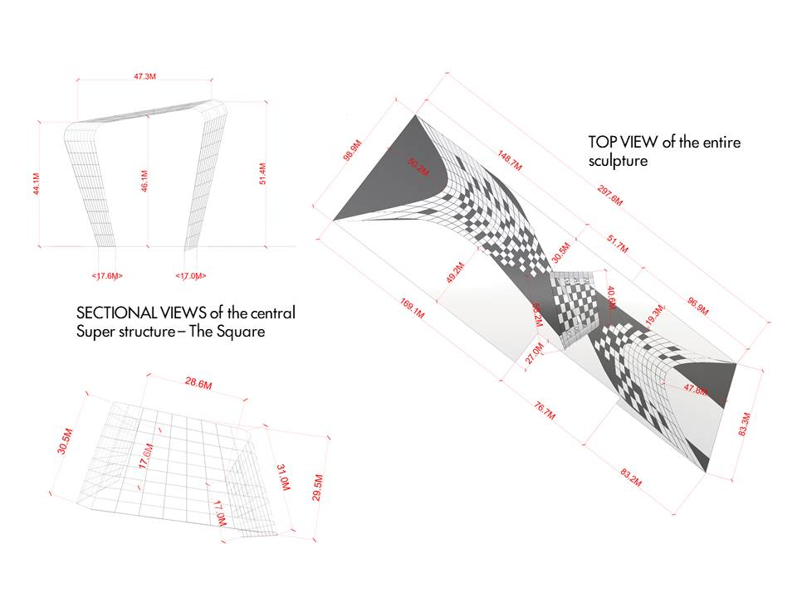

List of Primary Materials
Prefabricated Steel Exoskeleton with flexible photovoltaic panels mounted along the canopy and the central superstructure.
Sistine Solar Company’s solar film coating on the panels.

Environmental Impact
Our goal for this project was the usage of simple and readily available resources leading towards achievable yet impactful outcomes. Hence, mass produced photovoltaics have been our go to material and technology for our art installation and source of renewable energy primarily since,
Solar energy is a lot cleaner when compared with conventional energy sources. Solar energy systems have many significant advantages, like being cheaper and not producing pollutants during operation, and being almost infinite energy source when compared with fossil fuels or any other resource.
Back to Square one is an impactful piece of art in spite of being feasible in terms of materiality and its renewable energy return. In today’s digital, concrete jungle and indoor lifestyle world, Back to square one provides a modern version of a green Oasis with its luscious natural flora and green landscaping along with that of visual illusions mimicking the same on the sculpture.
Much like the theme for this year’s brief – ‘Return to the Source’ , Back to Square One has the potential to compel a change in lifestyle, i.e. , going back to nature, bringing back ‘the public park’ culture; bringing back the culture of communal gatherings and activities amidst nature just like the good old days!

