The Beacons

“In order to change an existing paradigm,
do not struggle to change the problematic model.
Create a new model and make the old one obsolete”
-Buckminster Fuller

The intent and purpose of The Beacons is in the name itself. These are function leading form aesthetic tests of concepts that could integrate clean energy into the built environment and begin to resolve issues with ever increasing population, building height, and heat produced in the urban environment. In addition to the fundamental energy supply problem that cities pose (a need met increasingly with Natural Gas from within the city), fresh water supply and economic growth are moving in opposite directions. Figure 1 shows the supply of electricity by type in the US (left) and the 300% growth of Las Vegas, while Lake Mead (its water supply) shrunk by 50%.

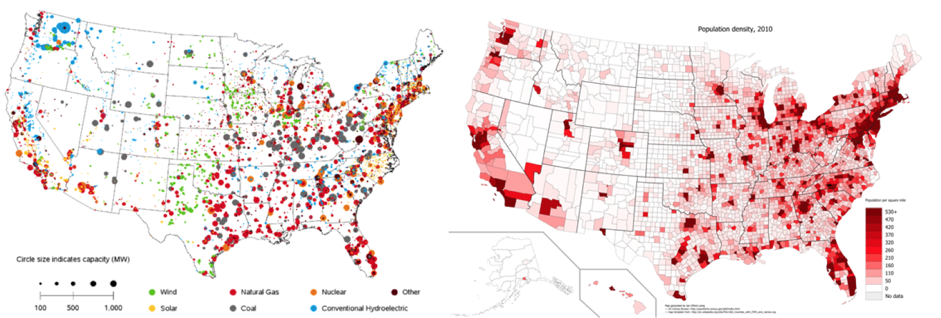

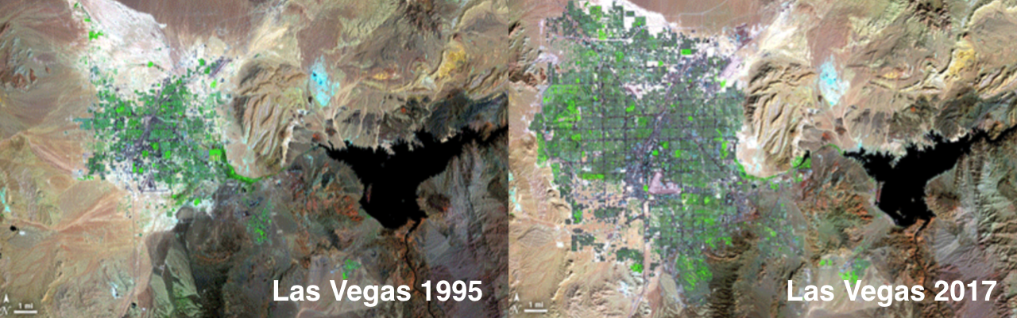
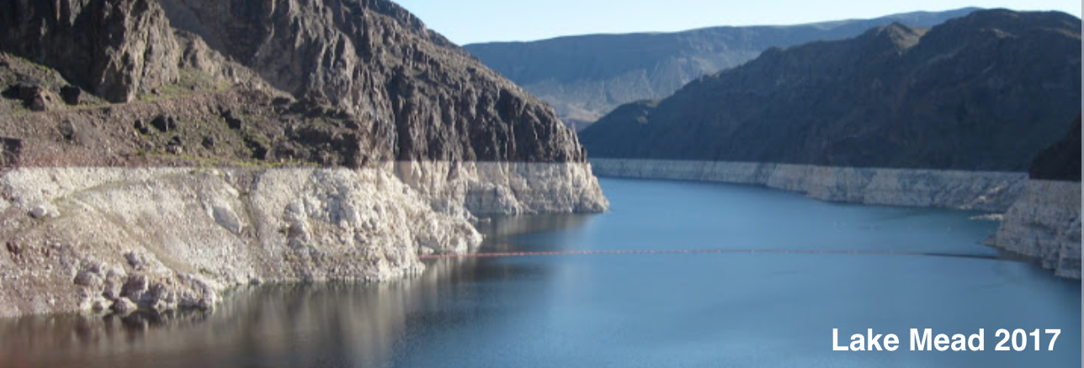

Notably, Natural Gas electricity supply (EIA, red is Natural Gas) and are population (US Census) are highly correlated. The challenge the city poses is how to supply 3-dimensional, energy and population intense, urban environments from 2-dimensional diffuse energy sources. NYC extends more than a quarter mile up and down, all of it consuming energy. NYC can supply less than 2% of its electricity demand with available clean energy technologies, Solar panels and Wind turbines.

Additionally, variability of clean energy resources is problematic in an environment that requires a mission critical supply of electricity. EV’s will exacerbate this problem, more than doubling the urban load, as transport energy shifts to the grid. The level of storage necessary to replace current Fossil electricity remains unstudied in the art (Edenhoffer, SRREN, 40% clean electricity supply “System LCOE”, 2015).

The Beacons present a solution path to more integrated 3-dimensional energy production and stabilization with technologies that already exist: Wind Accelerator Arrays, Thin film PV tubular conversion (per Solyndra, could be resuscitated), and Pumped Hydro Storage. The Beacons tower consists of:

1) a modular truss superstructure (similar to Mero systems) with a reflective envelope film to allow the structure to act as a solar concentrator, a wind “turbine” tower, and elevation for PSH. The twist is designed to optimize reflectance onto the solar array and orient the Wind array toward the predominant wind direction. This could as easily be integrated into an inhabited structure.

2) a tubular Solar array, per Solyndra, that will have the concentrated irradiance from the tower and from the reflecting pool. While Solyndra is defunct, The Beacons exhibit the proper use of Solyndra as a building integrated PV. The Beacon tower uses tubular Solar as architectural curtain wall.

3) An accelerating wind array covering 15 x 5 meters, comprised of 75 1.5 m² converging diverging nozzles with a novel rotor at the throat (an advanced future version could use electrostatic conversion supplied by the seawater). The array is oriented primarily toward the NNW but will have the ability to rotate to the wind direction. The Wind array is designed to operate in 5 m/s winds and the module rating, .3KW, is sized at that speed. Since the Wind Array is not paying for the tower, there is no reason to pay for electrical capacity (the other major cost) that is only used a fraction of the year.

4) A pumped hydro storage system. The PSH system is comprised of a spring loaded buried reservoir using gravity to bring the water to the storage reservoir. The floor of the reservoir is mounted on a series of springs. Storage begins when the source valve is open. The floor is drawn down by motors and the weight of the water. When the reservoir is full, the valve is closed. Storage is activated by a controlled release of the floor, allowing the force of the springs to push the floor upward and create pressure in the reservoir forcing the water into supply piping integrated into the modular super structure. The pressure head is then used in a turbine at the base to recover the reservoirs stored energy. This system is designed to stabilize the output of the tower to allow it to be used as dispatchable power. The reservoir also serves as the foundation for the tower.

The proposers anticipate that the cost per KW will be in the $4,000-$6,000 range. However the primary purpose is to highlight a new path to integrating clean energy and storage into the built environment.

The Beacons tests a new concept of dual or multi-use to achieve economic advantage. Large-scale Hydro is a dual-use system that shares the basic infrastructure cost with flood control and drinking and agricultural water supply. The concept has just not been applied to Wind or Solar or PSH. Using Solyndra as an example, the cost of a Solyndra panel was $240/m² and stainless steel curtain wall is $220/m². Tubular Solar’s effective dual-use cost of energy when used as curtain wall is $20/m², more than 4x less than the lowest cost commodity module today.

On top of the problems with clean energy (except Hydro) individually taking the entire cost hit, the grid is wasteful. The grid wastes between 30-40% of all energy put into the grid. One of the Beacons will be assigned to test the combination of on-site desalinization with the water from the harbor used for the Pumped Hydro Storage. Direct application of the power will improve the systems economic positioning against in-city Natural Gas.

We have deliberately ignored relying too much on the specifics of Masdar City in preparing this proposal other than the site and the local resources and needs. Too often clean energy solutions are focused on far to specific a set of parameters. Systems that can be deployed flexibly on their own in 3-dimensional space or be bundled with inhabited spaces or urban farming or desalinization are scalable. Abu Dhabi is notable for its organic style of architecture. The twist optimization is not absolutely necessary but it does simply the Wind system and a nod to the built environment. System such as the Beacons could easily be skinned in many ways and take various forms. Clean Energy needs to get much more creative and analytical in its solutions and start designing the entire system, not just some neat machines.

Beacons Tower Specification
Height | 100 |  |  | m
width | 10 |  |  | m
Solar |  |  |  |  |  |  |  | Wind
% producing |  | 70% |  |  |  |  |  | Number of rows |  |  |  |  | 15
1m |  | 0.15 |  |  | KW |  |  | area per unit |  |  |  |  | 1.5 |  |  |  | m^2
1m insolation |  | 6 |  |  | kWH |  |  | number of units |  |  |  |  | 75
capacity |  | 150 |  |  | KW |  |  | constriction rate |  |  |  |  | 2.5
daily output kWh |  | 1200 |  |  | kWh |  |  | rating per unit |  |  |  |  | 0.15 |  |  |  | KW @ 5 m/s
Daily insolation |  | 6000 |  |  | kWh |  |  | capacity |  |  |  |  | 11.25 |  |  |  | KW
hourly output (24 hours) |  | 50 |  |  | kWh |  |  | unit output per day |  |  |  |  | 3.6 |  |  |  | kWh
Stored kWh |  | 600 |  |  | kWh |  |  | Tower output per day |  |  |  |  | 270 |  |  |  | kWh
Storage output per hour |  | 50 |  |  | kWh
AEP per tower |  | 10,512,000 |  |  | kWh |  |  | AEP per tower |  |  |  |  | 98,550 |  |  |  | kWh
Number of towers |  | 8 |  |  |  |  |  |  |  |  |  |  |  |  |  | 8
Total output (solar) | 84,096,000 kWh |  |  |  |  |  | Total output |  |  |  |  | 788,400 kWh
PSH
height |  |  | 100
number of conversion devices |  |  | 1
pipe radius |  |  | 0.076200152 |  |  |  |  |  |  | m
area |  |  | 0.018232295 |  |  |  |  |  |  | m^2
height |  |  | 100 |  |  |  |  |  |  | m
Total pipe area |  |  | 0.018232295 |  |  |  |  |  |  | m^2
Nozzle area |  |  | 0.003646459 |  |  |  |  |  |  | m^3
v |  |  | 44.29446918 |  |  |  |  |  |  | m/s
CMS |  |  | 0.161517962 |  |  |  |  |  |  | m^3/s
Power |  |  | 158.4491204 |  |  |  |  |  |  | KW
Eff |  |  | 110.9143842 |  |  |  |  |  |  | KW
Storage m^3 |  |  | 13955.15188 |  |  |  |  |  |  | m^3
cube size |  |  | 23.32181829 |  |  |  |  |  |  | m

