CONCEPT:
-generate renewable and clean energy from wind and solar energy while preserving aesthetic and heritage values.
-using abstract heritage visual image which is close to the soul, used to generate energy, the tower was chosen as a heritage element and was simply redesigned to give the visual image of pigeons tower, in addition to generating the electricity required from wind energy, also the height helped to maximize the benefits.
-Pigeons tower is a steel structure skeleton, inside the frame there are 2 INVELOX wind generators, its idea is to capture the wind and increase its speed by approximately 4 times to produce annually 2600 MW. With cladding consist of wind turbines ranging from 40 to 120 cm to generate about 400 MW annually.
-INVELOX generates about 600 – 800 MW per year. When using 3 turbines instead of 1 turbine the capacity increases by 2.2 times.
-in the proposed design the capacity of one generator is about 1300 MW per year. By using two INVELOX wind generators it can reach 2600 MW annually as detailed in the attached calculations.
-the first generator captures wind from a height of 40m, while the second generator captures wind from a height of 32m, both generators are designed to increase wind speed to about 4 times at peak before they reach the turbines.
-External Turbines:
-72 Turbines with 400watt capacity distributed to the cantilever spread on the perimeter of the tower to give a visual image of birds standing on the tower especially the their colors are distinctive.
-364 Turbines with 200watt capacity were placed inside the large openings with a diameter of 80cm which allow the air flow.
-676 Turbines with 75watt were placed in the small holes all over the tower with a diameter of 40cm.
-In order to use the solar energy which can’t be ignored in the UAE, about 2000 solar panels been used, Each has 365watt to generate total 1500MW annually. They were designed to create the form of bird swarms on their way to the Tower to complete the picture. The solar panels supported on wooden skeleton that resembles the shape of Birds bungalow.
-elements of landscape are simple, by using wood along with tree logs and hay to emphasize the design idea of the project.
-the tower can be used as aesthetic element in parks and public squares while generating clean energy.
-Idea of developing the project is still under study, to pump the air from the return back to the air duct flowing to the turbines in order to increase air velocity, till it reaches the maximum velocity the turbine can handle, this method maximize the energy generated to 3 times the current capacity (6800MW) annually, this idea allows increasing the energy generated by the installation of turbines with more abilities to produce electricity in the future, the idea can be developed by building a compressed air pumping station, consist of several Pigeon Towers that give a distinctive aesthetic shape while supply the houses with compressed air. The owners of the buildings will install air generators that are sufficient to feed the buildings with the necessary electrical energy.

-Technology Used:
1-INVELOX wind turbine.
Power Calculation
P = ½ ρ A v³ Cp
P: Turbine output power (watt)
ρ: Air density = 1.1839 kg/m³
V: Velocity at turbine entrance = 74 m/s
-Calculated using data from table based on free stream wind speed of 66.8 km/hr
Cp: Turbine power coefficient = 0.4
A: Area subjected to air = π (rt²– rh²)
rt: Turbine blade radius = 0.8668 m
rh: Turbine hub radius = 0.0476 m
Turbine used: 3 blades axial flowing turbine
Used airfoils: NERL S801, S803, S804
P= ½ (1.1839)(0.4)π ((0.8668)²-(0.0476)²) (74)³ = 226.5 KW
With using 3 turbines power increased by 220%
P= 226.5 x 2.2 = 498.3 KW
Annual Capacity: 498.3 x 8760 x 0.3 = 1300 MW
2-Wind turbine.
1-Wind Turbine A( 1.2 meter diameter )
Total Number of wind Turbine A = 72
2-Wind Turbine B ( 0.8 meter diameter )
Total Number of wind Turbine B = 364
3-Wind Turbine C( 0.4 meter diameter )
Total Number of wind Turbine C = 676
3-Solar Panels.
Total number of solar panels = 2000

CAPACITY
Nameplate capacity = 1878.9KW (peak output measured)
Annual energy expected = 4511.244MW

Dimensions :
Tower Height 45 meter
Tower Diameter 12 , 14 & 8 meters
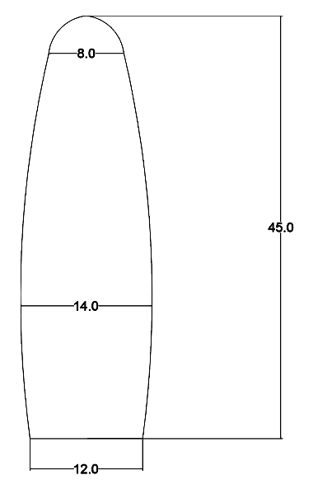

Solar Panels Holders consists of modules
Every module 4 meter span and 5 – 7 meter height group of wood panels 4.5 * 0.5 * 0.1 meter dimensions

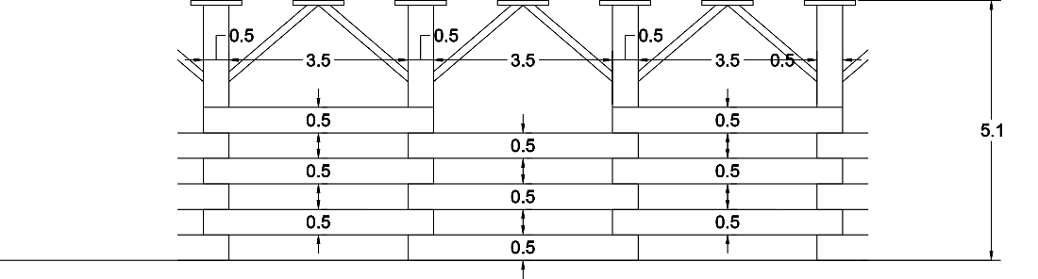

List of Primary Material used in Design
1-Invelox Wind Turbine Tower
.Structure Skelton is Steel Structure
.All Art Work are made of Pressure Treated Wood
2-Solar Panels Holders are made of Pressure Treated Wood panels & Columns
3- Landscape mixed between Pressure Treated Wood panels , Rough Wood , Sand & Stubble

Estimated Cost:
Artwork Cost Estimated:
1-2000 Solar Panel HoldersCost Estimated :
Cost per holder = 100 $ including construction cost
500 Holders = 500 * 100 $ = 50000 $
2-Tower Steel Structure Cost Estimated :
8 Steel Columns total steel volume ( 6 m3 )
12 steel beamstotal steel volume ( 4 m3 )
Two Invelox turbine cores total steel volume ( 4 m3 )
Total Steel Volume = 14 m3
Steel Density = 8750 kg / m3 = 8.75 Ton/ m3
Total Steel Weight = steel volume * steel density = 14 m3 * 8.750 = 122.5 Ton
Cost per Steel Ton ( including construction work ) = 1100 $
Total cost of Steel Tower Construction = 122.5 * 1100 = 134750 $
Foundation cost approximately =30000$
Total Cost of the tower including foundation work = 134750 + 30000 = 164750

Total Artwork Cost Estimated = 164750 + 50000 = 214750 $
Technology Cost Estimated:
1-Solar Panels Cost Estimated :
Total number of solar panels = 2000
Cost per solar panel = 98.55 $
Total cost of Solar Panels = 2000 * 98.55 = 197100 $
2-Wind Turbine A( 1.2 meter diameter ) Cost Estimated
Total Number of wind Turbine A = 72
Cost per wind turbine = 300 $
Total Cost of Wind Turbine A = 300 * 72 = 21600 $
3-Wind Turbine B ( 0.8 meter diameter ) Cost Estimated
Total Number of wind Turbine B = 364
Cost per wind turbine = 200 $
Total Cost of Wind Turbine B = 200 * 364 = 72800 $
4-Wind Turbine C( 0.4 meter diameter ) Cost Estimated
Total Number of wind Turbine C = 676
Cost per wind turbine = 100 $
Total Cost of Wind Turbine C = 100 * 676 = 67600 $

5-Invelox wind turbine ( two sets of turbines each set include three three Blades axial flowing turbine 1.7 meter )
Total wind turbine number = 6
Cost per wind turbine = 5000$
Total cost = 6 * 5000 = 30000 S

Total Cost Estimated for Wind Turbines = 21600 + 72800 + 67600 + 30000 = 192000

Total Cost Estimated for Solar panels & Wind Turbine = 197100 + 192000= 389100 $
-Does not include cables and all electric equipment cost.
Total Cost including Artwork construction = 389100 +214750 = 603850 $

NOTES | TOTAL  COST  US $ | COST/UNIT  US $ | ANNUAL CAPACITY PER TOTAL UNITS  (MW) | TOTAL CAPACITY PER TOTAL UNITS  (KW) | CAPACITY PER UNIT  (WATT) | COUNT | UNIT
TWO INVELOX WIND TURBINES EACH ONE HAS THREE TURBINES TO INCREASE POWER 2.2% | 30,000 | 15,000 | 2600 | 996.6 | 498300 | 2  (EACH HAS 3 ROTORS) | INVELOX  WIND TURBINE
 | 21,600 | 300 | 75.686 | 28.800 | 400 | 72 | WIND TURBINE A
 | 72,800 | 200 | 191.318 | 72.800 | 200 | 364 | WIND TURBINE B
 | 67,600 | 100 | 133.240 | 50.700 | 75 | 676 | WIND TURBINE C
 | 197,100 | 98.55 | 1511 | 730.000 | 365 | 2000 | SOLAR PANELS  2M X 1M
 | 389,100 |  | 4511.244 | 1878.9

Wind annual capacity: Capacity x 8760 x 0.3
Solar panels annual capacity: Capacity x 8760 x 0.18
Total Cost Including Artwork Construction = 389100 + 214750 = 603850 $
TOTAL WATT AT PEAK= 1881100 Watt
WATT Cost = 0.32$

Environmental Impact :
- Environmental Impact for solar panels
. Renewable Energy Source
.Reduce Electricity Bills
.Divers Applications
.Low Maintenance Cost
.Technology Development
.Maximize landscape Area by raising Solar Panels on wooden Holders
.Used as a part of the Architectural Concept to give the image of Pigeon Flocks
.No water consumption

- Environmental Impact for Invelox Wind Turbine
.No Harm to Humans or Animals
.Will not disrupt bird migration
.Minimal noise or vibration
.Installation close to end user
.Used as a unique Architectural Land Mark
.No optical flicking
.Unlimited applications and designs
.No water consumption

