THE VORTEX
LAGI 2019

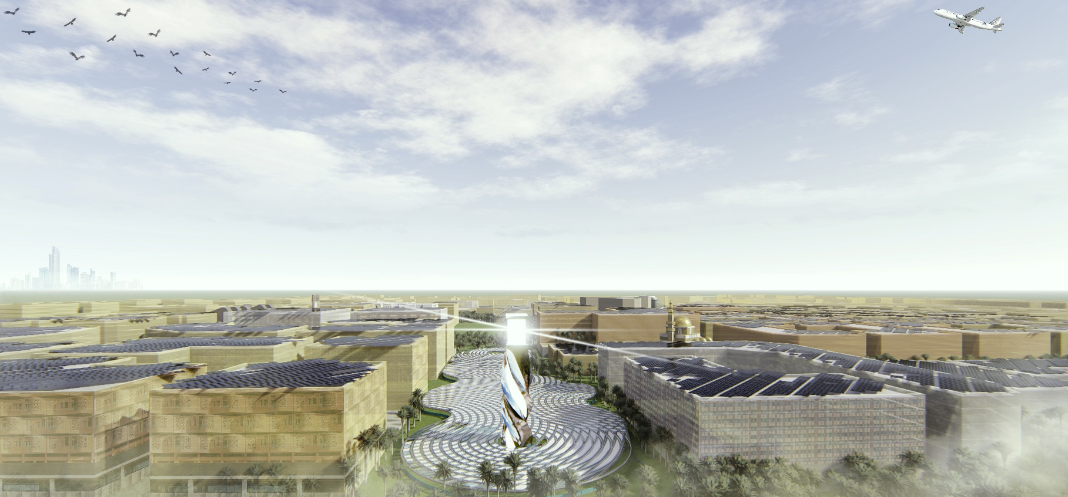
“Renewable energy can be beautiful.”

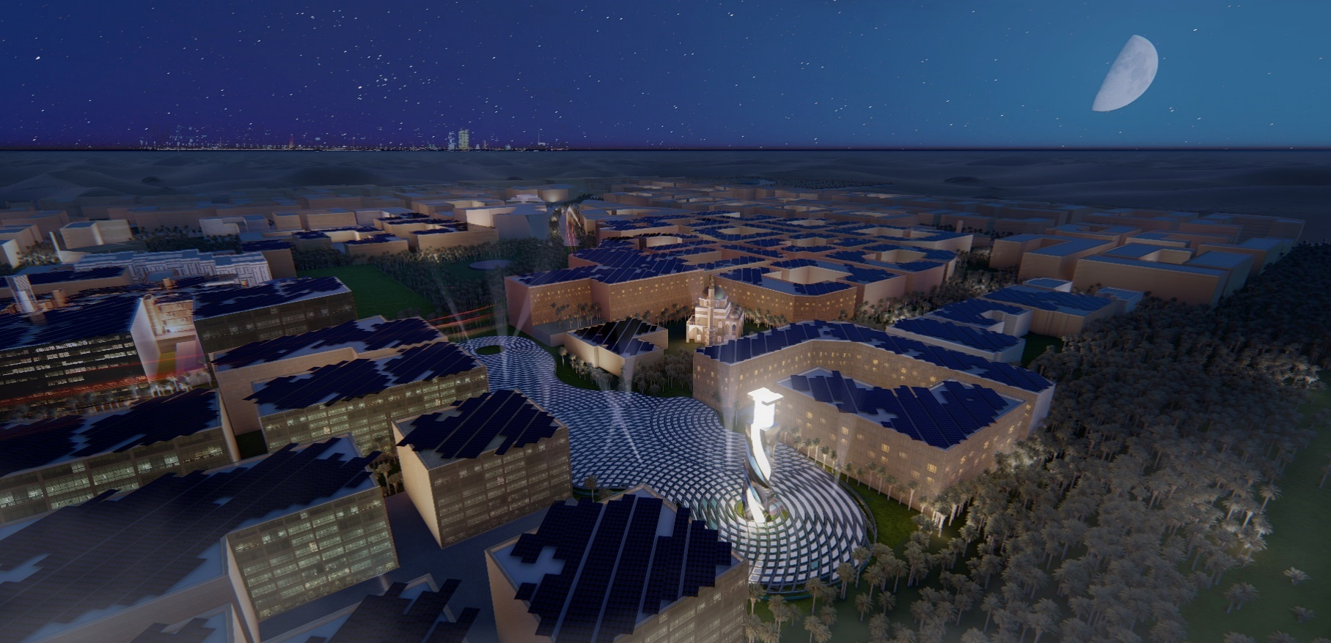

1.1 Written Description

THE VORTEX
PROPOSAL
The Vortex proposes a radical design re-envisioning the concept of land art combined with renewable energy, in order to become the key producer to Masdar City’s power generation. The molten salt energy technology embedded within the design features the site’s sustainable landmark, a 45-metre tower which can be seen from all adjacent boundaries. The tower will complement the proposed minaret outlined in the Foster Plan to promote the future of Masdar City. The scheme will become the interface of the city and the gateway to Masdar, elevating the site as a work of public art, a civic space with the renewable initiative to power homes all over the City.
In order to maximise the effectiveness of the molten salt technology, an array of reflective mirrors configures the expanse of the site emulating ripples across the surface of water. Each ripple utilises state of the art heliostat technology that harness concentrated solar power and act as a solar deflector to create the main heat source which converts salt water to energy. The opportunity is created to take advantage of the need for a large area to maximise the effectiveness of the tower, which resulted in the spacious underground design of public space.
In contrast to Masdar City’s contextual climate which doesn’t allow for activity during the daytime, The Vortex offers an underground level which will form the core of the City’s cultural hub whilst simultaneously integrating it within the proposed urban framework of the Foster plan and also connecting it to the City’s personal rapid transport system. Using ramps and lifts to connect to the surrounding context, the design allows for complete wheelchair accessibility. Passive cooling processes and ventilation provide a climate-controlled space in comparison to Masdar’s humid environment. By going underground, acoustic generation is minimised to reduce impact on the surrounding residential context.
This level will consist of three main spaces for program, with each area focusing on public interaction. The largest area proposing to house programs such as a cinema and recreational activities. The middle, comprising of educational activity, exhibition space and food stalls. The smallest will house the proposals passive recreational programs such as yoga and meditation. The underground level will also offer markets selling fruit, spices and textiles. In addition to the proposals use of molten salt technology, kinetic/static fabrics have been utilised to produce energy. Using these fabrics, intimate spaces are created to provide the public with the opportunity for privacy and seclusion in contrast to the proposals large and highly public space underground.
The Vortex creates juxtaposition between night and day using program to influence how public space can be inhabited at different hours of the day. This is best displayed through the design of the infrastructure zone which integrates all essential HVAC (heating, ventilation and air-conditioning), and electrical services whilst also providing storage for programs when not in use. This space will also include public toilet facilities.
The well positioned to the right of the site provides the connection between source and energy. Water and tower form a dialogue which flow throughout the site where nothing is wasted, and the process is continuous. Salt is extracted from groundwater and heated by the sun, where molten salt is then converted into power. The evaporated water is then returned to the source and the process starts again. Proving that renewable energy really is beautiful.

1.2 TECHNOLOGY USED IN THE DESIGN

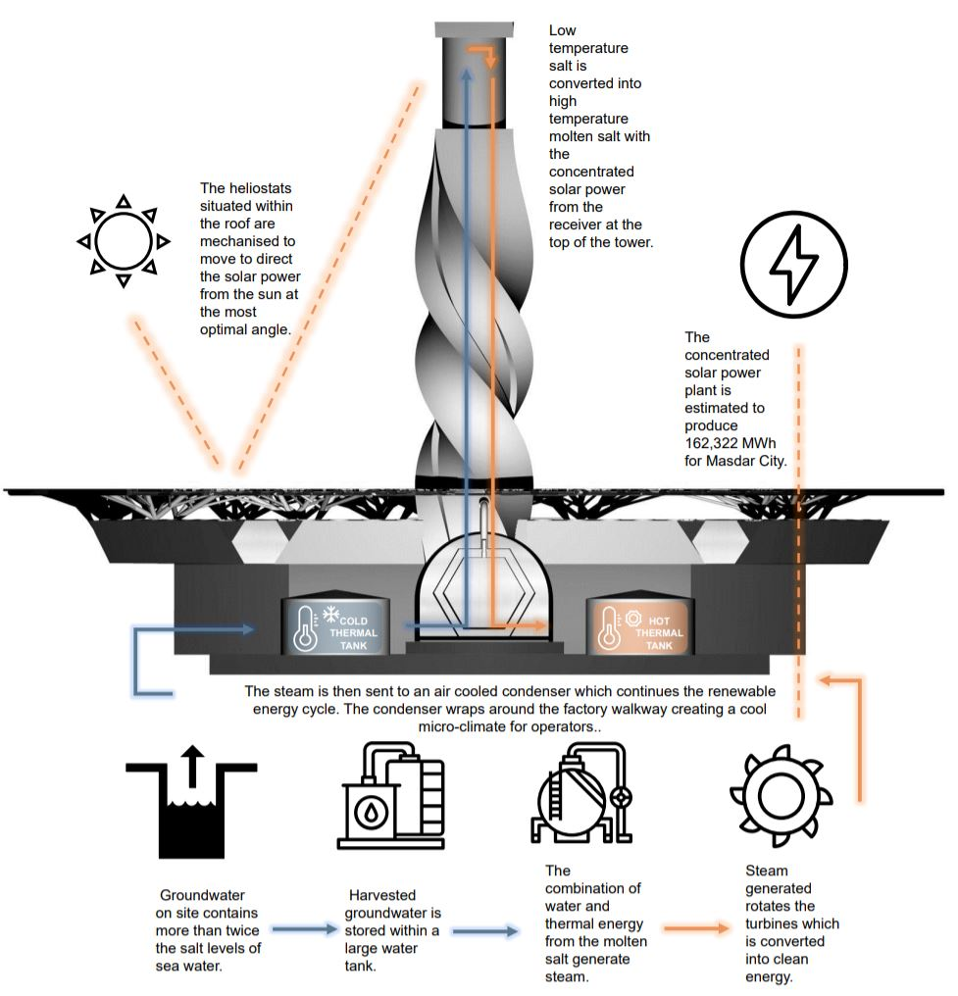
MOLTEN SALT ENERGY GENERATION DIAGRAM

MOLTEN SALT TOWER PROCESS DIAGRAM

1.3 NAMEPLATE CAPACITY IN KWp (peak output measured in kilowatts of power)
ENERGY GENERATION
Nameplate capacity was calculated based on the precedent, “Crescent Dunes Solar Energy Plant” which has an electricity production of more than 500,00 MWh annually based over a 1,200,000 m2 site with over 10,000 heliostats. The basis of the energy is dependent on the heliostat dimensions and the total area of each solar panel. Due to this, the roof was maximised to ensure the heliostats could collect an efficient amount of sun with a total heliostat area of 13,948m2. Conclusively, from this area a total peak output is predicted to be 18,530 kWp.

1.4 ANNUAL kWh (kilowatt-hours) of energy expected to be generated under average site conditions
Calculating from the previous energy generation analysis the annual output of the Vortex is 162,322,800 kWh.

1.5 LIST OF PRIMARY MATERIALS USED AND AN ORDER-OF-MAGNITUDE CONCEPTUAL COST ESTIMATE
PRIMARY MATERIALS
ROOF
- Structural Steel Piping
- Supporting structural columns constructed from steel
- Heliostat mirrors on roof surface with polycarbonate fill
- Glass and metal frame/surface
- Lightweight pavers
FACTORY AND TOWER
- Condensers
- Molten salt tanks
- Water storage tanks
- Steam Turbines
- Ground water pump
UNDERGROUND AREA
- Pavers with vegetation/grass
- Fabric

CONCEPTUAL COST ESTIMATE
A major task within the built environment industry is estimating the total cost of the project, where this forecasted cost may be considered during the tendering process. This project has been costed conceptually in $ AUD by methodically creating a Work Breakdown Structure (WBS). The Work Breakdown Structure has been divided into five main categories as follows: Foundations, Temporary Works, Permanent Works, Factory Construction, Roof Construction, Underground Transport Tunnel, Landscaping, Fit out and Finishes. The total cost estimate of the project was calculated as approximately $30,094,357 AUD. As this is only a conceptual cost it should be noted there would be many other variations to factor in such as labour, transportation and productivity rates.

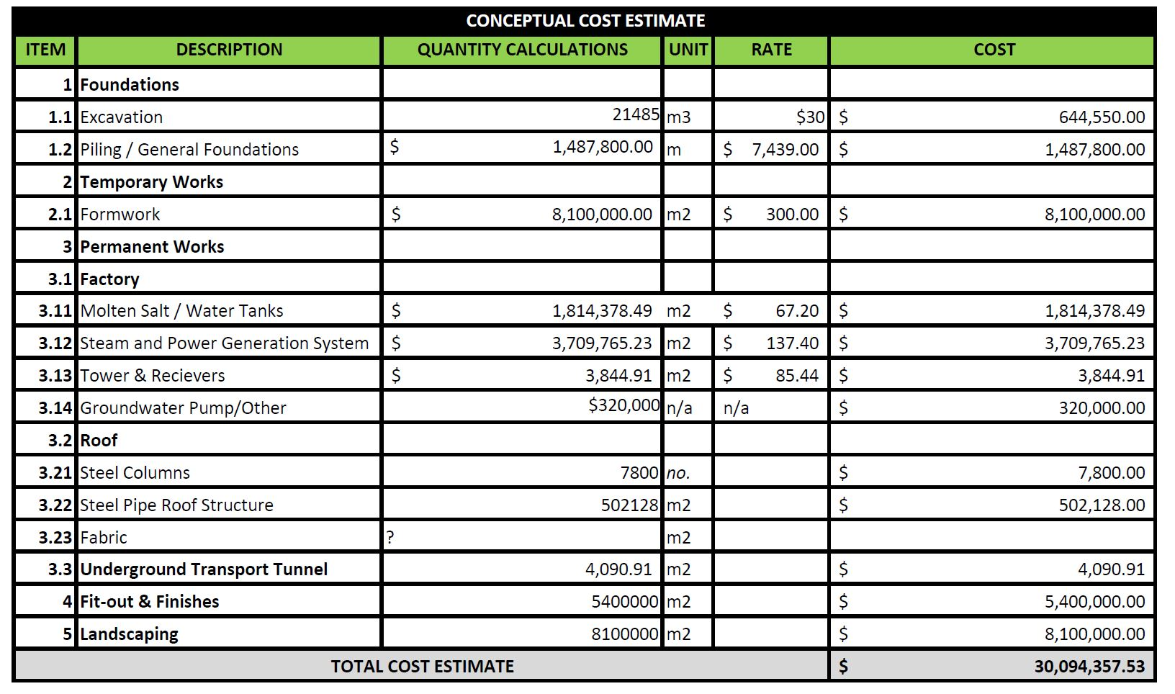

Environmental assessment / & Management plan
An Environmental Management Plan (EMP) is a vital component to be factored in within a renewable energy initiative to ensure there are minimal immediate and long-term negative impacts on the environment and community of Masdar city regarding the proposal of The Vortex. The figures below display the Impact Risk Assessment Matrix which generate a potential cumulative risk and provide control measures that may be implemented during construction. The environmental impacts have been divided into: Geology, Geomorphology and Soils, Water Pollution, Noise Pollution, Air Pollution, Traffic and Transport, Catastrophic Events and Miscellaneous Negative Events. It is imperative that these mitigations be considered as these risks could increase and lead to long-term negative consequences for the environment of Masdar.

