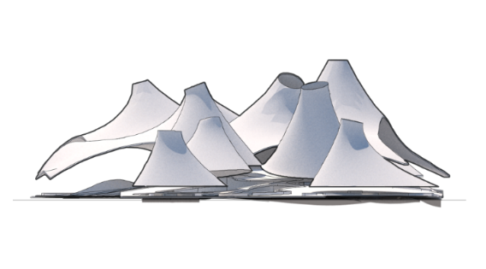

Place.
Masdar City represents an innovative experience, with one objective, give to the residents of the city, an excellent quality of life with a very clear purpose, keeping the identity of the region, and protecting the environment and the population health.
Located in this important area, BEDUINO, seeks in conjunction with Masdar City, be the impulse that launches Abu Dhabi into next growth phase and consolidates a new model in terms of renewable energies.
Concept.
Our design proposal was conceived from generating a cultural attraction inside Abu Dhabi and Masdar City, where art, culture, and education are promoted, besides a social interaction.
The concept starts with one idea, taking those elements who represent and have an important meaning for the region and the history of his population.
Dunes are natural elements, found it almost everywhere in Abu Dhabi landscape. Being elements with fluid shapes create a unique landscape in the world, which describes almost the middle east zone.
On the other hand, the Bedouin tribes, stand out among the history of many Arabian countries. A lot of the important African and Middle East cities that today we know, were created by the settlement of these nomadic tribes.
For the design, we decided to honor them taken up the traditional design of the Bedouin tents, as well for the important role in the middle east architecture and culture.
BEDUINO takes inspiration of these two elements to bring a unique piece that reflects the identity of Abu Dhabi and his population.

Project.
For the Cultural Complex, the most important challenge to face was the extreme weather of the region: high temperatures, sandstorms, and long droughts. Taking these natural factors, we choose to design independent volumes with natural shapes to provide protection, comfort, and shadow all over the complex.
The independent volumes start to join and warp to create a fluid shape which generates a large cover that extends throughout the complex. These elements represent an abstraction of the Bedouin tent and as they become part of the landscape of the desert.
The Project counts with a flexible architecture program which allows the users to have different experiences and do indoor or outdoor activities. The complex is made up of 3 different layers and each one has a goal, which together creates a whole experience. The ground floor host 3 buildings, where are:
- Multiple use room.
- Museum of energy.
- Library.
- Sports.
- Botanical garden.
The second roof begins at ground level, rises to the slab buildings, as well as becoming an extension of the landscape and connecting both terrains. This layer contains public space, outdoor activities, and rest areas, promoting interaction among users. Here are:
- Children area.
- Bikeway.
- Rest areas.
- Plazas.
- Water Bodies (recycling water of the near buildings)
For the third floor, the layer serves as protection for vegetation and the complex users before the strong temperatures, also contain solar panels and the system to recycle the radio frequency waves, which provide energy for the park.
Technologies
SOLAR ENERGY
The solar energy comes in entirety through the "flexible monocrystalline silicon photovoltaic solar panels" of 105cm x 54 cm each one. these are located in the complex cover allowing to capture as much solar energy as possible.
The roof has approximately 4,000 panels, each one generating 100 watts. Resulting in 630.72 Mwh throughout the year.
4,000 solar panels x 100 watts x $20= $ 8, 000,000
8,760 hours per year x 400Kw x 18 % capacity factor = 630.720 MWh

WIND TURBINES
The energy collected through the air currents will be transformed into electrical energy using 27 wind turbines, located in the south plaza. Allowing them to have a better performance, receiving the air more directly. Each of the turbines generates 400 watts, resulting in 28 Mwh per year.
27 wind turbines x 400 watts x $20= $216,000
8,760 hours per year x 10.8Kw x 30 % capacity factor = 28 MWh

E- TEXTILE (RECYCLING RADIO FREQUENCY WAVES)
Broadcasters, televisions, satellites, etc., send radio waves continuously. These waves are received by electronic devices, another part remains free in the environment without being used again. through mixing the textiles with the devices that are responsible for capturing the energy that is in the environment, we seek to collect that wasted energy and reuse it
It is estimated that a textile of 1 m2 can accommodate 224 devices, resulting in a power of 679 uwh which would mean that in a canvas of 1 m2 we would obtain 152 mwh.
6 m2 x 821.3 ml x 152.1= 749, 518.4 mwh
749.518 wh x 8,760 hrs.= 6, 565,781 wh = 6.6 MWh
It turns out to be low the energy collected but generated all the time, it can be used to charge small devices. Recycling radio frequency waves is an alternate source of energy that continues to develop. In the not too distant future could become one of the main and most efficient sources of alternative energy.

Environmental impact
We firmly believe that BEDUINO, in addition to becoming an important cultural center for Abu Dhabi, means a great contribution to Masdar City. As it continues with the commitment that maintains the city to preserve the identity of a region, without renouncing innovation and new technologies.
BEDUINO was designed with minimal environmental impact. For the elaboration of the installation, it is decided to use mostly recycled materials (recycled steel beams, recycled plastic) and modified organic textiles.
The wind turbines do not represent a danger for the endemic fauna since it was decided to use vertical axis wind turbine (VAWT). Because besides that they are at a height that allows to receive and collect the energy coming from the air currents, they don't interfere with the bird's flight.
The cover in addition to collecting the largest amount of energy within the complex serves as a refuge, allowing the growth and development of flora from other regions without affecting the endemic species. This is important because it continues with the Masdar City philosophy, promoting green spaces within the city to purify the air.

