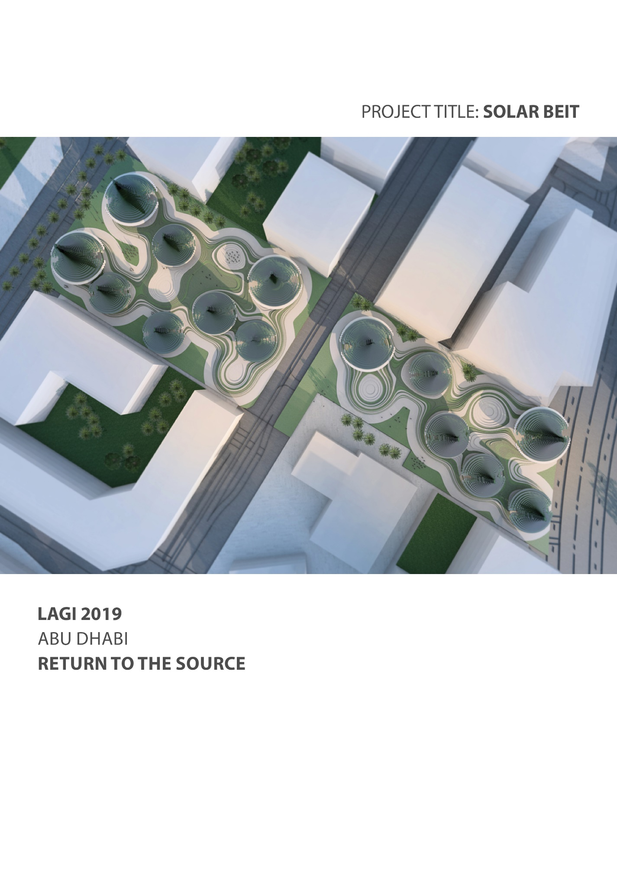

**Design Statement**

**Solar Beit (Sun House) reflects the past, it is conscious of the present and it is looking into the future. The concept design is a site-specific art installation that uses solar radiation as a prime renewable energy source and represents local identity.**

***Design Concept:***

Encompass the idea of time and progress as a design strategy.

PAST:  
The formal language of the design proposal is informed by the bedouin tent silhouette and translates into archetypal-structure, called Solar Beit Tower (SolB).

PRESENT:  
The design proposes the re-use and re-purpose of oil drums, steel cylinders that are available in abundance. It contributes to reduction of the investment and lowers the carbon footprint.

FUTURE:  
The design presents a fully biotic system that generates electricity with simultaneous biomass production. It operates on basis of renewable energy technology - biological solar-cells, in which photosynthetic organisms (Algae) are used to harvest the solar energy and to convert it into electric current.

***Design of site-specific art installation***:

The proposed concept design SolB not only respects the initial purpose of the given area according to Masdar city Masterplan for recreation and green area (park), it also has an ambition to enrich it, by creating high quality public zones: green alleys, piazzas and amphitheaters for vibrant city life.

The set-up positions of the SolB towers and the fluid landscape topography create spatial rich configuration that provides shadow and cooler areas. The exact position and rotation of the SolB Towers is determined by the specific local sun exposure map under consideration of buildings that surround the site. The SolB towers are placed on the platform which is meant to elevate them and to cover the whole infrastructure.

***Towers***

The overall shape of the tower structure is not only informed by the bedouin tent silhouette but also influenced by available sun exposure parameter specific for the chosen site and tower position on it. The SolB Tower is divided into upper and lower part by the ring with a maximal diameter. The upper part has a conical shape to maximize the solar radiation exposure and this is where bio solar cells (BPVs) are installed.

The structure of each of the towers is organized into a polar array containing cylindrical cell components fabricated from oil steel drums. The array matrix forms the skeleton on which BPVs are installed. The SolB structure is design the way, that it allows replacement of proposed technology as soon as a new, more progressive one   
is developed and available.

The bottom and the top of the steel drum (cylinder) are removed to make the structures semi open and visually transparent. This allows a natural air circulation on site - taking in hot air from the top and cooling it down (cooling down effect) - creating   
a microclimate.

**The Solar Beit Site project turns into an open site solar technology lab, an experimentation hub, a living creature that will be the ultimate manifestation of time and life itself.**

**Technological Statement**

The threat of climate change, with its potential devastating consequences for our ecosystem, increases demand for sustainable energy sources, which are renewable and carbon neutral. One of the available options is the sun, which provides around 10,000 times more energy to the Earth in a given time that is required by human consumption.

The Project “Solar Beit”, presents a fully biotic system that generates electricity with simultaneous biomass production. It operates on basis of renewable energy technology - biological solar-cells, in which photosynthetic organisms (Algae) are used to harvest the solar energy and to convert it into electric current.

Algae is the term for a large and diverse group of photosynthetic organisms. They use light energy (or other forms of energy like sugar), water, carbon dioxide and a few inorganic nutrients to grow. Algae contain proteins, carbohydrates and lipids in different shares. Thus, algae biomass can be turned into a variety of fuels, such as (bio-) ethanol, diesel or hydrogen or methane. It can also be used for making food, livestock feed and other products.

Algae can grow faster under specific conditions, which are: enough light, concentrated CO2, certain pH level and salt concentration. The fact that growth of algae doesn’t require arable land, but on the other hand needs abundant solar radiation and saline water for growth makes the U.A.E. suitable place for this kind of technology. In the proposed project local algae, available in the U.A.E. dessert will be used, as according to Dr Hector H. Hernandez from Masdar Institute “it can withstand major changes in temperature. It can also live under high salinity ranges, one of the ‘highest’ to date of any algae species, and can be used throughout the year”.

In a biological photovoltaic system photosynthetic material (algae) is employed in the anodic half-cell. Algae use the sun energy to drive the photolysis of water. Electrons generated during this reaction are than transferred to an electrode (anode). A relatively high-potential reaction takes place at the cathode, consuming electrons and creating potential difference between the two electrodes, which drives electrical current through an external circuit.

In the Solar Beit two-chamber biological solar-cells are being applied, where the two core processes involved in the operation of a solar cell – generation of electrons and their conversion to power – are separated. This new technique was developed by the researchers from the departments of Biochemistry, Chemistry and Physics of the Cambridge University. Building a two-chamber system allowed the researchers   
to optimize the performance of the processes. According to current studies such Biological Solar Cells should reach a power density of 5-6 W/m2.

The advantage of biological photovoltaics systems over non-biological is the ability to self-repair and self-assemble, which allows generating constant electric power. Due to the fact that algae grow and divide naturally, bio collar cells also work on days with less sunshine, thus less energy investment is required, compared to conventional silicon-based solar cells The ability of algae to store energy (excess electrons being stored inside the algal cells during daylight hours) helps generating energy during the night and circumventing the [grid](https://en.wikipedia.org/wiki/Electrical_grid) supply and demand problems sometimes faced   
by conventional photovoltaics in the dark.

*Estimation of Capacity of Solar Beit*



**Environmental and Social Impact**

With the project it is proposed an alternative to fossil fuels energy source that is both sustainable and societal acceptable. The cultivation of algae has several advantages over other biomass feedstock: they require less space, have higher growth rates, and do not compete with food production for arable land - making use of non-arable land (improving the land productivity). Algae grow naturally and abundantly in coastal areas near the seas and also in the sabkhas, in high saline conditions or wastewater thus reducing fresh water use. An additional advantage is that Biological Solar Cells capture and consume carbon dioxide (CO2) and emit oxygen as they grow, as a byproduct of photosynthesis so they help reduce the total amount of CO2 in the atmosphere.

Moreover, there is a large potential for the development of algal based systems for wastewater treatment. The capture of the energy locked within the organic contaminants of wastewater to produce electric energy and the improvement in nutrient recovery, contributes even further to higher energy recovery balance.

**Source**

<https://www.sciencedirect.com/science/article/pii/S0961953415300052>

<https://aiche.confex.com/aiche/2016/webprogram/Paper452691.html>

<https://www.cam.ac.uk/research/news/harnessing-the-power-of-algae-new-greener-fuel-cells-move-step-closer-to-reality>

<http://www.asente.ch/alternative-energy-biological-photovoltaics/>