What if humanity was lost in an ocean of uncertainty?
What if we couldn’t find our way towards a sustainable future?
Maybe all we need it something to point us in the right direction.

THE SOLAR COMPASS
Masdar City has for years been a beacon of hope and innovation in our quest for a sustainable future. It has been a compass for creativity and technology since its inception, and it would only make sense to symbolize that through an inspiring work of art that engages not only the visitor’s creativity but mostly their sense of hope through an optimistic and innovative approach.
The solar compass seeks to do just that; to mobilize our minds and enthusiasm through a power generating work of art that draws its inspiration from a largely relatable “object”. Engaging curiosity might in fact be our most powerful tool in our quest for sustainability. Technology is here already; we just need to make it creatively stimulating.
The Solar Compass uses a proven technology to produce roughly 3000kW through a polar array of flat heliostats that concentrate solar heat onto a receiver located on top of the compass´ needle (pinnacle). Solar Tower Power plants are reliable and tested infrastructure that currently works in mostly desertic and sunlight abundant areas of the world. Their ground-based heliostats, though, make it uninviting to the public. By lifting the heliostats array and placing it on top of the compass, the ground is freed to the visitors, thus prioritizing public space and generating a contained but simultaneously inviting plaza. The top of the needle (pinnacle) allocates the heat receiver, or heat collector, that contains a heating medium (molten salt or water).
The concentrated bean of solar heat produced by the heliostats reaches the receiver which in turn is coated with a special absorber surface that multiplies the transfer of heat from the sun to the heat transfer fluid inside the receiver. The heat transfer fluid is therefore heated to temperatures over 600º C. The HTC is later transferred to a heat exchanger chamber in which water is transformed to steam that runs a turbine generator.
Part of the energy produced is directly transferred to the city’s electrical grid and the rest is stored in batteries contained within the compass structure.
The heliostats contain a two-axis motorized arm that allows them to efficiently track the movement of the sun, therefore maximizing the heat concentration onto the collector on top of the pinnacle.
Environmentally, the impact of the structure is minimal. Two point of contact ground the compass, leaving most of the surface underneath and surrounding the structure untouched and free for public access and circulation. The overall low profile of the structure blends in appropriately with the average height of the surrounding buildings, not blocking views or direct sunlight to any of them.

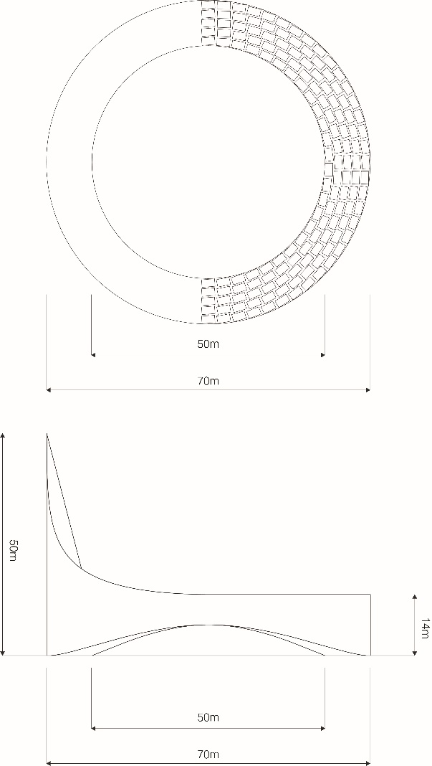

As a concentrated solar power plant that employs molten salt as a HTF, the Compass should account for a 30% capacity factor, and with a diameter of 70m, the 1120sqm polar array of heliostats would concentrate enough heat to produce roughly 3000kw, which would be enough electricity to power over 400 homes. The structure is built majorly out of recycled steel and aluminum extrusion, guaranteeing excellent performance over long periods of time and thus creating no run-offs, by products or emissions of any kind.

