SOLARCLOUD

technology used

pixsol : a double stratified solar balloon tethered to auto-weight triggered wheel pulley
fabsol : a woven solar fabric imposed into solar balloon
finite : low carbon footprint desert sand concrete

annual capacity
estimated annual: 2.070 mwh/yr

background
energy production, which is no older than two centuries, has triggered industry age and shaped our cities from the beginning of the 20th century. day by day, industries and cities has spread and grew all over the world and produced an endless need for energy. while on the verge of the first quarter of the 21st century, we are not just looking forward to producing energy, we are also inventing ‘green’ and ‘user friendly’ power plants and energy production. thus, in a more near future, as the technology gets more user-friendly and accessible, energy production will be a part of the daily routine of urban life, and nature would be more clean and independent and humanity will also be more self-sufficient.

idea
masdar is a 21st-century urban laboratory, not only with its energy and sustainable policy but also urban and environmental approach. masdar would be a sustainable, efficient, high tech, but also the innovative proud face of our century. technology is not always and only the most efficient way of creating optimum solutions for urbanism and the environment. it should be touching ‘the souls of the population’ and generate a ‘communication’ with ‘inhabitants’ and remind that “we are living here together”. with this sense of humor, our project offers ‘a place for the community’ ‘a gathering place for all’ while creating energy for electricity and also creating energy for life within the biologic rhythm of earth, connecting to the anima of earth and sun to the ‘neighbourhood’ also with the possibilities of ‘an attraction point’ which may become the ‘heart of the city’ that everyone can find something to connect.

creating landmark
a landmark is not only a memorable space with its spectacular and well-known imagery but also an appeal on the sense of individuals and society and unites them virtually under its roof with its symbolism for different kinds of emotions flowing into the same pot and still being worthy to feel.

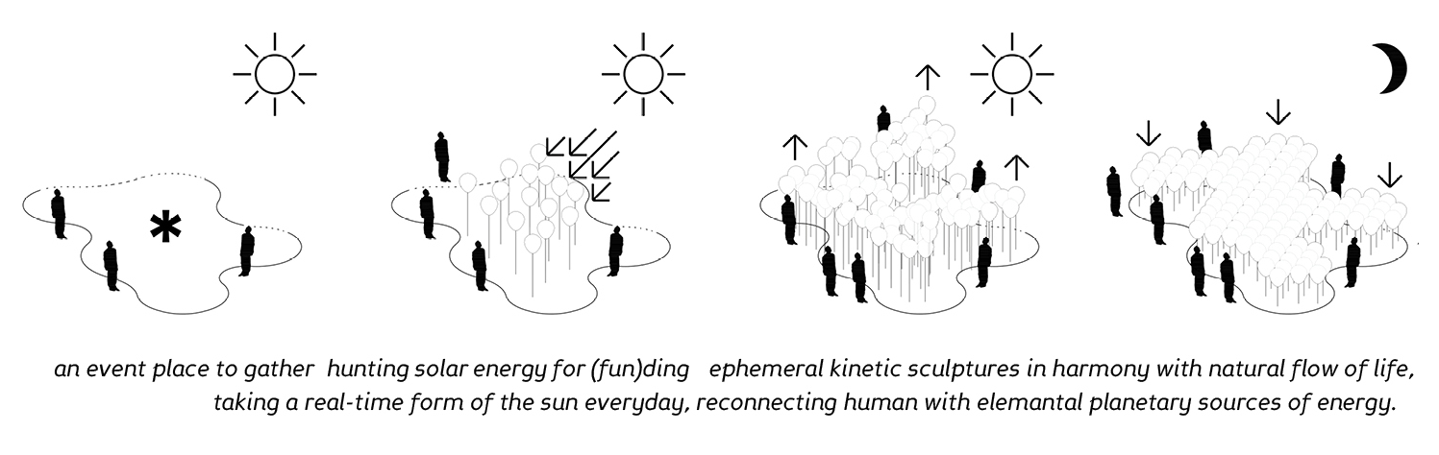
in that manner, our project consists of a group of mini ‘solar balloons’ gathering together as the society comes together for a bigger reason, in this case, hunting renewable energy; a modular and holistic sculpture, which starts moving by the day for catching the worthy and limitless energy of the sun, a relaxable shaded aggregation square for inhabitants, turns itself into a digital art platform at night, as the moon lits up, having ‘limitless’ amount of shapes and light, a sculpture that is hung in the air, a sculpture that never settles down, a sculpture, like a living creature, living as humans and many other animals and plants go with circadian rhythm of life.

a place for community
the cities are designed around a center to gather people together, for thousands of years. from ancients to rome, and today's most crowded and demanding cities, squares, open spaces, parks, voids, attraction points making the cities alive and they are all indispensable parts of the cities. today ‘experience’ is one of the most important element to form new urban life in future cities. our project creating a strong ground level, shaded and climatized by a ‘solar cloud’ at day time, turned into a ‘media cloud’ hosting many artists and artworks all over the world, bringing a great experience for its visitors.

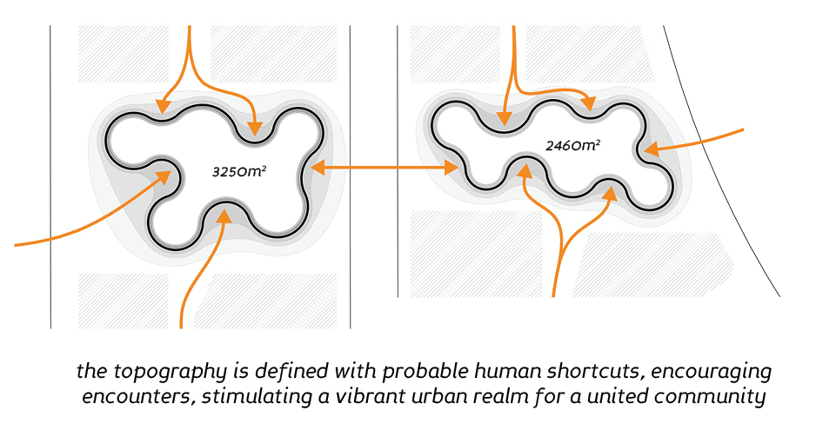

a field of balloons
there are too many ways for harvesting the sun.. we are planting 1500 solar ‘balloons’ on our field of community, covered with a ‘solar fabric’ which is one of the latest products of the solar industry. once planting a balloon on the site, it would behave like a crop, growing daily and catching the sun for ‘electric energy’.

a moving sculpture
like ‘sunflowers’ triggered by the ‘sun’ and followed it every day like a ‘moving sculpture’, our ‘solar balloons’ would start to ‘rise’ by using the heat of the sun to catch more daylight to generate electric energy from the sun, also triggering the ‘roller’ for mechanical energy. it would generate an ‘endless variational cloud’ every single day, also generating and providing a moving shade underneath.
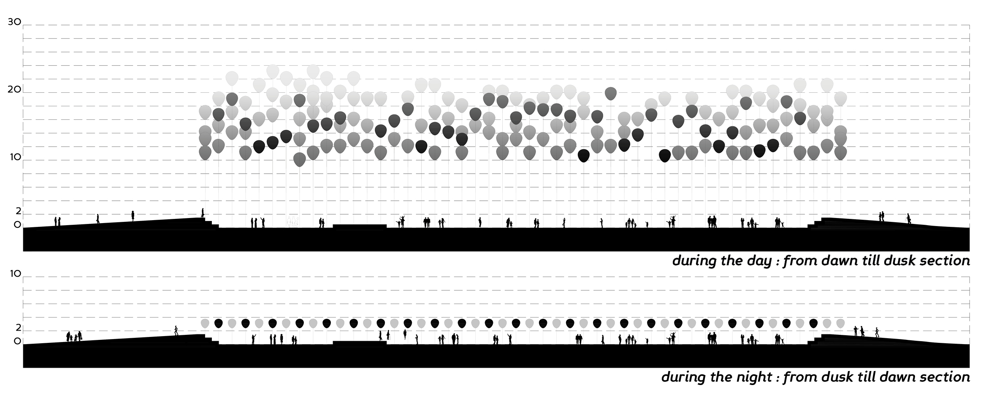

a media art platform: solartcloud
while the cloud is hunting sun at daytime and shading for the podium, nighttime balloons descend to a specified height, after losing their heat energy inside, and becoming individual ‘pixels’ of a 1500 balloon ‘media cloud’
solartcloud is a programmable digital platform, which would become an open-air ‘new media museum’ that host many artists all over the world, scheduled for a ‘changing and refreshing content’ monthly, weekly and daily programs from different artists.
in this era of internet and digitally enhanced iot technologies, a community fosters not only in actual spaces but also in virtual ones, and sometimes more than easily.
this place could serve as an interface for both, even living a double simultaneous life of dark and light in the realms of cyberspace and masdar at the same time. new technologies can be promoted. mixed reality applications could also be of service in special events or festivals.

materials

pixsols
pixsol is a 2m wide modular solar balloons filled with air and helium and tethered to ground via automatic weight triggered pulley wheels. 1500 module covers an area of approximately 5000m2 acting like a big cloud. being one of the main modules of the system pixsols ascend with the increasing temperature during the day creating a buoyant force ready to turn on 1500 units automated pulley wheels which convert kinetic energy to a mechanic and electric energy for self-assembled floating land art. kinetic energy 30w/m2

fabsols
fabsol is lightweight carbon-fiber reinforced fabrics woven with an array of solar cells coated in the conductive polymer material, created by a chemist and a fabric designer, in the process of development for the next five years. fabsols cover the pixsols and with a spherical surface tracks the sun where ever she goes. solar energy 120w/m2

finite
finite is a biodegradable construction made from desert sand - a resource that has been useless until now - and as strong as concrete but has half the carbon footprint. it is non-toxic and can be left to decompose naturally, or remoulded to be used in another project. finite takes on the colour and gradation of the filler, but natural dyes can be added in the mixing process.

energy output

solar power:
solar fabric power output: 120 w/m²
solar panel energy production per square meter (%18)( 4,32 hours a day）: 518 w/day
the area of solar fabric at each balloon: 6.0 m²
the total energy output of per balloon per day: 3,10 w/day
total balloons around the field: 1500 pieces

energy output per day: 4,66 kW/day
energy output per year: 1,702 MW/year

kinetic power:
mechanical roll output: 56w/hour
average active production time: 12 hours
power output per per balloon: 672 w/day
total balloons around the field: 1500 pieces

energy output per day: 1,008 kW/day
energy output per year: 368 MW/year

total energy output per year: 2,070 mw/year

energy consumed by the ‘solartcloud’
energy consumed per balloon: 6w/h
average energy consumed daily by per balloon : (8,2 hours a day) 49 w/day
total balloons around the field: 1500 pieces

energy consumed per day: 74 kW/day
energy consumed per year: 27 MW/year

estimated value and feasibility
the materials and features used in the solarcloud system are in simple logic and innovative systems, however, fabsols are in the stage of development for mass production, they are already on the phase for test drives for efficient solutions. finite is also a new material which is on the verge to be in the market and it is also much more feasible for logistics. pixsols have been on the market more than two centuries so a test model run on engineering programs should be sufficient for the efficiency of this pixelated mini solar balloons. the capital cost could be estimated at approximately 2million $ for the whole system up and running for a year.

environment impact

solarCLOUD is a sun harvesting system supported by a helium balloon, solar balloon, woven solar fabric, a cable, windlass generator, battery, and sand concrete. solarCLOUD, likewise in its name, is a shading and energy absorbing system, also providing a climatized shade underneath. ecologically, creating a ventilated and shaded square helping to create the natural shaded and ventilated territory. using low carbon footprint desert sand concrete as a ground, totally using natural and low cabon materials to shape landscape to imply solar cloud balloons. its materials nearly to find and do it yourself. while woowen fabric is a new inventing technology from ‘solar fabric’ it would be one of the cleanest solar technology in the world because it would be wearable by humans. helium-filled 0.18mm transperent polyvinyl cloride derivative balon, used inside of the fabric produced from recycled thermoflex material, memraned with monolayer graphene to prevent helium leakage, to protect our sources successfully. using zero emission led lights for media art, and low emission vanadium flow battery module, the project aims low impact or recycled materials to stay clean.

