EL WASL ILLUMINATE ….
.… ينِير الوصل
LAGI 2019
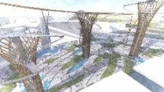
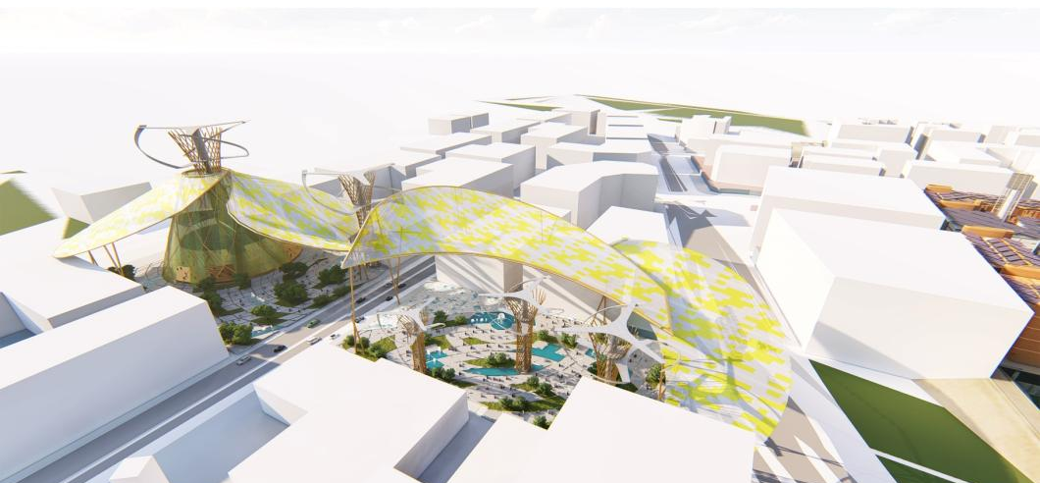

LAGI 2019—Return to the Source—what public art looks like
within the public space of Masdar City—the global
capital of sustainability.

El WASL ILLUMINATE produces 12 287.5 MWH annual energy that will be used for the lighting of 600 houses,offices and outdoor lighting. This energy is generated by several sources at once: Solar Energy, Plant Microbial Fuel Cells, Wind Energy, Power Generating Slabs. It will be stored in battery.
Water plays an important role in space, for which we thought to collect rain water by Water Absorption Surface system.
El Wasl Project, Its harmonious flexible photovoltaic panel structure, with the considered landscape of demonstration garden, winding paths and shaded enclave, produces 2000 MWH per year. This cover is sunscreen of the landscaped space. Its structure is in aluminum a pulling system will be set up from every angle or change of direction to support the load of the structure that takes a large area. The choice of aluminum is made with respect to its lightness.
5 wind turbines of a large size produce 10,000 Mwh annual, consisting of a central metal tube with a turbine and a lightweight aluminum cladding. The soil also produces 100 kwh annually of energy through pedestrian circulation.
The culmination is towards the Spiral Place an evenmential space consisting of aluminum structure with glass and photovoltaic panel. The Spiral Place is composed of balconies and terraces overlooking the town of Masdar.

Project Ideation:
Abu Dhabi, Masdar city represents the natural environment, economic development, and cultural heritage. For us MASDAR, is a source of energy. The spiral shapes are designed to mimic the eddies of energy. the town of Masdar is in the shape of a square on which spiral intersections are drawn. This form can be seen on the soil treatment as well as on the cover. The wind turbines also take this principle. We think that the continuity of the Transit Rail line and the junction with the green line requires a moment of pause for citizens, employees and tourists.
We think Masdar City as a productive source around which radiates spiral energy, in a planimetric and 3D point of view which makes us think of Fermat Spiral
The idea of ​​EL WASSL, signifies a connection, is the result of the intersection of several spirals. Hence the shape of the project that is inspired by the spiral.
El WASL Project summarizes the different types of production, a field test that can be developed on public space in Masdar City.

Integration and Fonctionlity :
The scultural conception of the project is inspired by The Source of the City. El WASL,
Is designed not only for its striking form, but also for its demonstrative capabilities, inspired by natural processes, the dynamic form is at the service of its function, capturing energy.
.

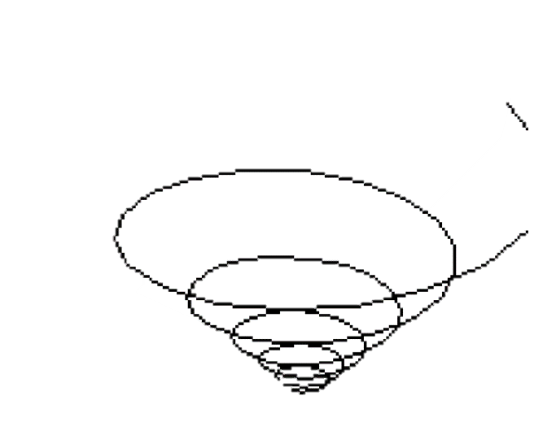
El Wasl (Intersection)
Spiral Energy
Source of energy
A space of meeting and exchange is to create, accessible for all with an incentive of used the means of gentle displacement: the presence of interesting routes, Sport space evennementiel, observatory, exhibition event space.The idea of ​​the project is to develop along Masdar City's Green Lane.

Thin Film Organic Photovoltaic Cell

Spiral Place
Wind Energy
Plant Microbial Fuel Cells
Power Generating Slabs
Water Absorption Surface
Event Place

Park
Group Rapid Transit
Light Rapid Transit
Research and development
Residential
Office

Construction and Manufacturing :
The objective of this work is to provide the necessary tools for the realization of this project within the framework of LAGI 2019.
10 000 MWH Annual
187,50 MWH annual
2 000 MWH annual
100 MWH annual

= 12 287,5 MWH annual
Houses,Offices, Exterior light

A variety of renewable energy systems and passive design techniques have been integrated into the design including rainwater harvesting, solar panels, wind turbines, photovoltaic cells. It allows mitigating the impact on infrastructure, the collection of systems will reduce half of the consumption and carbon emissions. the exterior effect of the steel construction is produced with vertical and inclined perimeter as well as tie rod system.

The presence of leaning vertical comprised of 80mm diameter hollow tubes – will provide lateral stability from wind and earthquakes loads. comprised of two intertwined units, the spiral beams stitch together the outer and inner row of columns from the ground floor to the roof plane, preventing buckling due to their slender proportions.
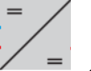
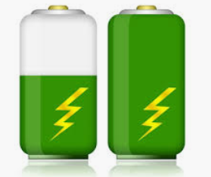
Energy Source
Regulator
Storage Battery
Converter
Uses

The technologies :
1-Thin film organic Photovoltaic Cell :
Its organic and plastic nature means that it can be easily fabricated into flexible shapes and adhered to fabrics. It functions well under low light conditions and at non-perpendicular angles to the sun such as vertical walls.
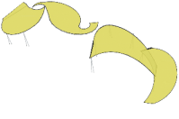

Non-silicon thin-film solar cells are much easier to manufacture. The biggest recent breakthroughs recently have come with CIGS-on-foil manufacturing. Nanosolar makes its solar cells using a process that resembles offset printing.
The folded steel cells filter the intense sunlight, casting shadows on the ground and creating local micro-climate in the shade.

Photovoltaic panels are mounted to the top surface of the structure, taking advantage of the optimally oriented geometry of the steel cells. Power generated by the photovoltaic panels is stored in batteries, allowing the canopy to be illuminated from within in the evening time. Clusters of shade structures create respite from the desert sun by offering a public parasol at an urban scale.
2-Vertical Axis wind turbine :
A Darrieus wind turbine is voluminal and axisymmetric so the direction of the wind does not influence its operation.
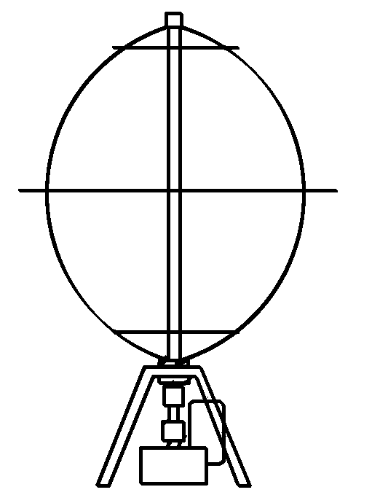
Rotor diam
Generator
Gearbox
Blade
Vertical axis wind turbines (or VAWTs) have the main rotor shaftarranged vertically. Key advantages of this arrangement are that the turbine does not need to be pointed into the wind to be effective. This is an advantage on sites where the wind direction is highly variable.
The wind speed is slower at a lower altitude, so less wind energy is available for a given size turbine. Air flow near the ground and other objects can create turbulent flow.

3-Power Generating Slabs :
A system of slabs on springs, equipped with generators converting the impact of the pedestrian step into electric current. This one is transmitted to batteries which themselves feed sources. Each passer can generate 4 to 6 watts per step. Convert the energy released by the feet by walking or tapping the ground to the rhythm of music in electricity.

Energy production

Storage

4-Microbial fuel Cells : generating Electricity from Rhizodeposits of rice plants :
Living plants transport substantial amounts of organic material into the soil. This process, called rhizodeposition, provides the substrate for the rhizospheric microbial community. This process offers the potential of light-driven power generation from living plants in a nondestructive way. Sustainable power productions up to 330 W ha−1 could be attributed to the oxidation of the plant-derived compounds.
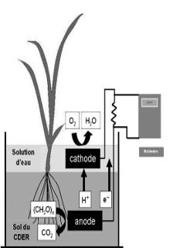
Microbial Fuel Cell majorly constitutes Electrodes, Anodic and Cathodic Chamber and Salt Bridge. The Anodic chamber is an anaerobic chamber, which holds the substrate and the biocatalyst- Microorganisms.

5-Batterie , Energy Storage :
Solar PV systems and wind turbine that do not have a method of energy storage will transport surplus energy to the local energy grid, and when the PV panels are not generating enough energy for your needs, electricity needs to be supplied by the grid.
The design and installation of these systems involve conducting a load analysis and specific wiring in specific subpanels. Battery sizing is based upon the average daily electrical load and the number of days of battery storage.

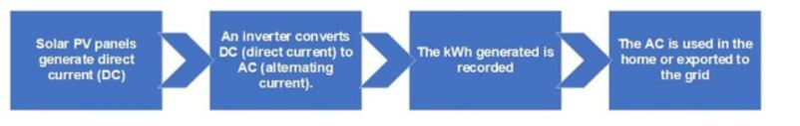
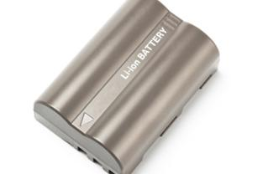
Lithium-ion batteries a longer lifetime than lead-acid batteries. They will give you around 4,000 – 6,000 cycles at 80% discharge – so they will have a lifespan of 13-18 years.
This all depends on the brand of battery you choose to go with. As I have outlined in another post, there are a number of competitors in the lithium-ion battery storage space, with a great deal of variance in pricing-per-kWh.
A 14kWh Tesla Powerwall 2 is expected to retail for around $8,750 AUD.
As a very rough guide, a 5kW solar power system with a battery-ready inverter costs around the $8,000 mark. If you add the Powerwall 2 price to this, you wind up with a total cost of around $16,750.

6-Water Absorption Surface :
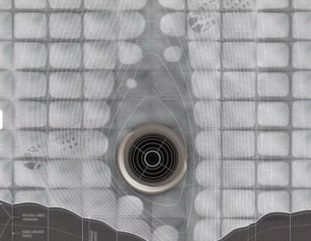
Poreform is a concrete surface capable of rapid water absorption. The poreform surface can be used in a variety of sites and a varying scales. As it is cast in place and made from fabric formwork itcan fit whithin existing urban conditions and tap into existing infrastructure.
Poreform, a porous concrete surface poured in place with fabric formwork, manages to absorb water, capable of rapid saturation and slow release, the pores of this “urban skin” are inlets to a new infrastructure that reframes water as a valuable resource rather than a liability.
Poreform is a design proposal to recast floodwater and runoff as a local resource instead of a collects water like a skin for the city.

Cost and Energy estimate :
Renewable Energy Technology | Annual Energy Production (KWH) | Energy Contribution (%) | Cost Estimate $
Thin film organic Photovoltaic Cell | 2000 | 16.27%
Vertical Axis wind turbine | 10 000 | 81.38%
Power Generating Slabs | 100 | 0.81%
Microbial fuel Cells generating Electricity from Rhizodeposits of rice plants | 187.50 | 1.52%
Total Energy | 12 287.50 | 100 %
Exterior Light | -500 | -4.06%
Total Energy Benefit | 11 787.50 | 95.94 | 2 357 500‬ $

EL WASL ILLUMINATE
LAGI 2019

