THE OASIS

LAGI 2019

THE OASIS

**«Oasis» takes on the challenge of being both an architectural object with bold contemporary design features, a sustainable power source, a lush independent eco-system, and a fully integrated urban landmark of Masdar city.**

**The Oasis is conceived as several autonomous steel and glass units, that can be combined to become a spectacular architectural construction.**

**Its primary purpose is to provide sustainable energy and water to local buildings, but it is also meant to act as an urban connexion, providing shadow and temperate space for pedestrians to walk through.**

**Each one of these units was inspired by simple and proven concepts: solar energy, above-ground planting, terrarium... These prevalent technologies are assembled in one device, designed with timeless and basic materials: steel and glass. The result is no-less futuristic: lush plantfalls suspended above ground, nesting birds, plays of light and shadows really draw the landscape of a 21st century oasis, blended into the city life.**

1. Renewable energy use

**The Development of the Oasis started with a study of different aboveground farming techniques, that do not require a huge amount of water: for example, the hydroponic Sundrops Farm, and the Aerofarms that can be found in Jeddah . This study was really useful to conceive a realistic and efficient system.**

1. Organic Solar Panel

One of the reference materials for Organic Solar Panels, is the one manufactured by ASCA. It is one of the most powerful organic solar panels on the market, and provides optimal efficiency for 10 years . The material uses no rare or toxic component, a low carbon process and is 100 % recoverable.

* Main Specification : Lightweight : 450g/m2, Flexibility, Semi-transparency, Indoor / outdoor, Heat resistance, Large-scale manufacturing, Impact Resistance .

Average Power produced by the ASCA solar Panel :



* Cost of the Organic Panel :

The cost of this kind of solar panel is between 60$-100$, The Oasis is around 7000m2 – 560 000$ - For 1000 MWh per year

1. Microbial Electrolysis Cell

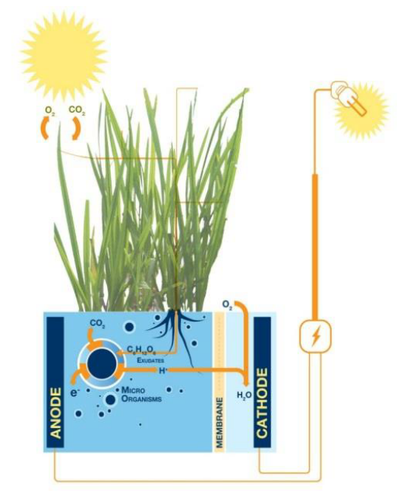his process combines a microbian-fueled cell, with hydrogen powering system, which will become a major clean energy source in the near future





This technology is available right now, and the scientists expected to a system really efficient with a 5 year forecast. It is an important part of the Oasis project : the micro-climate created in the Oasis can therefore be one of the main energy sources.

1. **Harvesting the fog**

Harvesting fog sails are settled in strategic spots to retain wind and fog water. This technique arouses a lot of interest in the UAE : a research and design project was conducted by the final year engineering UAE students, and the result was a success. In Masdar the Institute of science and technology is also working on it.

In the Oasis, we expect a capture rate of 55 liters/m2/day : for 2 150 m2 of sails, we can capture 115 000 liters of fresh water per day, which represents the average daily water consumption of 770 people.

This water can be immediately brought to the buildings all around the project.



1. Humidity extraction from plant

Part of the Oasis module is made of a terrarium : a hermetic space made of glass, hosting various species of plants. The sun brings heat inside the module, and the plants give water, forming a steam, trapped inside the glass. During the night, when temperatures drop, this steam « rains » back in the terrarium dirt. If the plant needs more water, the oasis is connected to the grey water network of the buildings all around. This system allows the aboveground garden to live on a very minimal water supply.

1. **Bioluminescence**

The Oasis module is equipped with a line of bioluminescence system. A specific bacteria living in the terrarium dirt substrate, and feeding on it, provides us with a cost-free, and zero-energy urban lightning.

1. Master plan

The oasis modules are placed considering future real estate projects for the city of Masdar. The idea is to create pedestrian connections between different buildings through the Oasis, while forming a spectacular contemporary architectural object.

This space will encourage social interactions between the different inhabitants of the city, and the microclimate created by the Oasis could be a unique experience and a new way to see the outdoor space in the desert.

The module itself is independent, and can by settled in various spaces of Masdar, becoming a recognizable, recurrent landmark of the city.

1. A place for the Masdar Biodiversity

One way to sensitize citizens on climate change, is to be in contact with the beauty of the nature in daily life. The Oasis is conceived as the pedestrian connection for the city, so it can really touch the people and help the country save energy and water.

The micro-climate, the planting, and the development of various species in the Oasis are a unique chance to show and nurture the native biodiversity of Masdar, and make it a part of our own human growth.

1. Cost of The Oasis

* Organic solar panel

560 000 $ for 1000 Mwh year

* Microbial

370 000 $ for 310 Mwh year

* Harvesting Fog

55 500 $ for 40 million Liters of water a year

Ref:

- <https://www.greenprophet.com/2012/12/water-energy-desert-fog/>

- <https://en.asca.com/cell-solar-flexible-transparent/?_ga=2.162093564.1917624991.1557491332-767621876.1554207443>

- <http://aerofarms.com>

- <http://www.sundropfarms.com>

- <https://www.climatetechwiki.org/content/fog-harvesting>

- <https://www.researchgate.net/publication/316688510_Fog_Harvesting_Project_in_UAE_A_Research_and_Design_project_conducted_by_the_following_Final_Year_Chemical_Engineering_UAE_Students_Advised_by_the_Faculty_Member>

- <https://www.glowee.com>