List of Primary Material:
-Green Concret
- Photovoltaic glass
Green concrete:
Concrete which is made from concrete wastes that are eco-friendly are called as “Green concrete”. Concrete that uses less in energy in its production and produces less carbon dioxide than normal concrete is green concrete. The other name for green concrete is resource saving structures with reduced environmental impact for e.g. Energy saving, co2 emissions, waste water.
Concrete wastes like slag, power plant wastes, recycled concrete, mining and quarrying wastes, waste glass, incinerator residue, red mud, burnt clay, sawdust, combustor ash and foundry sand. Green Concrete is a term given to a concrete that has had extra steps taken in the mix design and placement to insure a sustainable structure and a long life cycle with a low maintenance surface. e.g. Energy saving, CO2 emissions, waste water. The goal of the Centre for Green Concrete is to reduce the environmental impact of concrete. To enable this, new technology is developed. The technology considers all phases of a concrete construction’s life cycle, i.e. structural design, specification, manufacturing and maintenance(www.madhavuniversity.edu.in/green-concrete.html).
Photovoltaic glass:
Photovoltaic glass (PV glass) is a technology that enables the conversion of light into electricity.To do so, the glass incorporates transparent semiconductor-based photovoltaic cells, which are also known as solar cells. The cells are sandwiched between two sheets of glass. Photovoltaic glass is not perfectly transparent but allows some of the available light through.The PV power generated is considered green or clean electricity because its source is renewable and it does not cause pollution. In addition to energy cost savings, potential benefits from the use of photovoltaic glass include reducing the carbon footprint of facilities, contributing to sustainability and consequently, enhancing branding and public relations (PR) efforts.
In environments where too much heat gets in with light, the reduced transparency can also save on air-conditioning costs. Variations have been designed for environments where more light is desired(whatis.techtarget.com/definition/photovoltaic-glass-PV-glass)
Technology Used:
- In general, solar energy is used in the design. We suggest solar mular panel which is located around the building. During the day the panels received and save the energy, by the night the panels will be as an artwork.
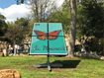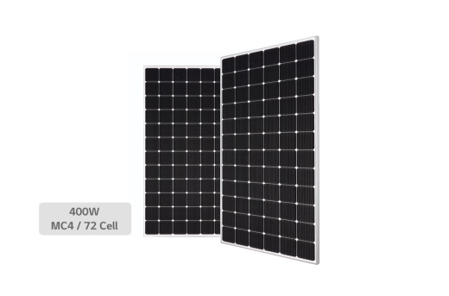
Item Name | Solar Panel
Model | LG400N2W-A5
Product Series | Neon2
SV Code | 121203AAUS3
Brand | Lg
Material | Glass
Size | 161.7 x 161.7mm
Voltage | 1000-1500V
Wattage | 400W
Amps (A) | 20A
Number of Cells | 72
MPP Voltage | 40.6V
MPP Current | 9.86A
Open Circuit Voltage | 49.3V
Short Circuit Current | 10.47A
Cell Type | Monocrystalline
Cable Length | 2 x 1200mm
GlassFrame-Material | Anodized Aluminium
Ingress Protection (IP Rating) | IP68
Brand Origin (not manufacture) | Korea
Certification | CE
Warranty (Subject to Conditions) | 25 Years
Efficiency | 19.3 Percent
Operating Ambient Temperature (Degree Celsius) | -40 to 90 Deg.C
Connector Type | MC4
Product Size L x B x H (Cms) | 202.4L x 102.4B x 4H
Delivery Time | 2-7 Days
Packing Quantity | 1
Unit | Piece
Source: (https://www.supplyvan.com/lg-solar-panel-lg)
- The shape of our design is like a cone so the air in the upper part of the volum has become heat and move to the top so the natural vent will happen. By moving the air to the upstream Savonius Vertical Wind Turbine will be turned.
Savonius wind turbines are a type of vertical-axis wind turbine (VAWT), used for converting the force of the wind into torque on a rotating shaft . The turbine consists of a number of aerofoils, usually-but not always-vertically mounted on a rotating shaft or framework, either ground stationed or tethered in airborne systems .
Vertical axis wind turbines are advocated as being capable of catching the wind from all directions, and do not need yaw mechanisms, rudders or downwind coning. Their electrical generators can be positioned close to the ground, and hence easily accessible. Another advantage of VAWTs is that they can be located in closer proximity to each other than can HAWTs. (Ferry & Monoian)
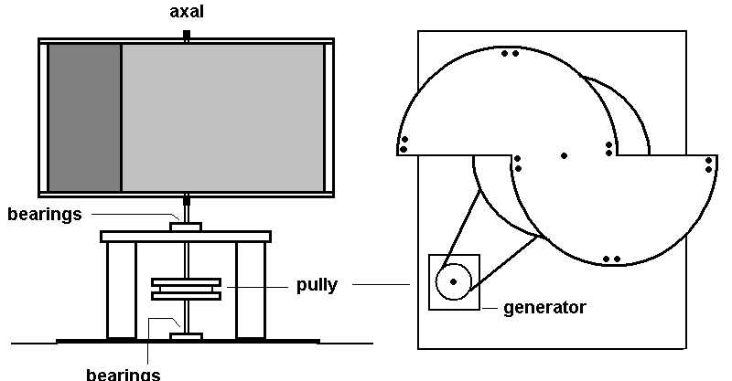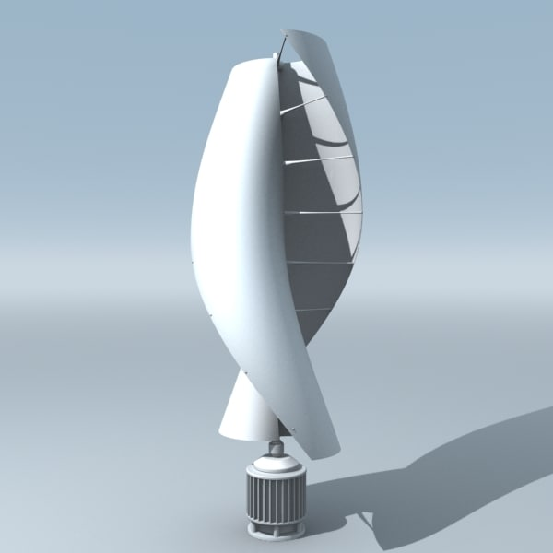

Controller system: | Electromagnetism | MPN: | XZCXZ0091451556007166
Speed regulation: | The wind engle automatically | Started wind speed: | 1.3 m/s
Color: | white | Rated Wind Speed: | 11 m/s
Design service life: | 10~15 years | Rated Voltage: | 12 V DC
Cut-in wind speed: | 2.5 m/s | Rated Power: | 400 W
Work environment temperature: | 25~+45℃ | Max Power: | 450 W
enerator protection grade: | IP65 | Max Wind Speed: | ≤40 m/s
Over speed protection: | Electromagnetic brake | Gross Weight: | 48.5 lb (22 kg)
feature: | Low vibration,Low start wind speed | With the controller: | Yes
Blade material: | Glass fiber | Generator: | Maglev generator
UPC: | 803567390320
- The new technology proposed in the design is the production of electric flooring. Electronic will be produced When people crossing on that floor. Like all cutting-edge technologies, kinetic tiles are relatively expensive. Today, they cost £80 per square foot which means that installing the tiles in the average kitchen would come close to £6000.
Kinetic tiles also currently have a lifespan of just five years, making it difficult to recoup the cost. Even if you are repaving Trafalgar Square or the O2 Arena before a U2 concert, you wouldn’t come close to breaking even for the time being ( https://theswitch.co.uk/tech/energy-harvesting-tiles)
PRODUCT SPECIFICATIONS
Dimensions: 500mm each edge
Power rating: 5 Watts continuous power from footsteps
Voltage: 48V (Range 12V - 48V)
Materials: Steel, recycled Aluminium, Composite.
Minimum order size: 2x4m array.
Certification: EMC compliant, CE marked, UL‌compliant(http://www.pavegen.com/product)
Estimate of Cost
Type | n | Unit price | Total price
Solar Panel | 1049400 | 327.50 $ | 343678500$
Savonius wind turbines | 235 | 410-500$ | 96350-117500$
Floor electronic generator | 2542 | £80 | 203360

Source
-A field guide to renewable energy technology, Ferry & Monoian.
- http://www.pavegen.com/product
-https://theswitch.co.uk/tech/energy-harvesting-tiles
- https://www.supplyvan.com/lg-solar-panel-lg
-https://www.madhavuniversity.edu.in/green-concrete.html
- whatis.techtarget.com/definition/photovoltaic-glass-PV-glass

